*Date of preparation : March 25th, 2025 Name: Le Ngoc Thuy*

*Department of subjects: English, Arts, Physical Education*

**Period 86 : Looking back & Project**

**I. Objectives:**

By the end of this lesson, Ss will be able to:

**1. Knowledge:**

- Review the vocabulary and grammar of Unit 10

- Apply what they have learnt (vocabulary and grammar) into practice through a project.

**2. Competences**

- Develop communication skills and creativity

- Develop presentation skill

- Be collaborative and supportive in pair work and teamwork

**3. Qualities:**

- Be encouraged to attend school activities.

- Actively join in class activities

**II. Teaching aids and materials (referenced)**

- Grade 9 textbook, Unit 10, Looking back and Project

- Computer connected to the Internet

- Projector / TV

- *hoclieu.vn*

**III. Teaching procedures**

**1. ACTIVITY 1: START/ WARM UP (5ms)**

**a. Aims:**

- To create an active atmosphere in the class before the lesson;

**b. Content:**

- Brainstorming

**c. Expected outcomes:**

- Ss can list as many Unit 10 vocabulary as possible.

**d. Organisation**

**Brainstorming**

- T has Ss play in two groups.

- T gives each group slips of paper with words / phrases / short sentences to stick to either of the column ( Habitats / Actions to protect habitats). T gives them more phrases then needed.

* *Examples of words and phrases: flora and fauna, oceans , landforms, waterbodies, grassland, forests, animals, stop cutting down forests, bring home more new plants and animals, change climate, preserve habitats, habitat loss, maintain ecological balance*

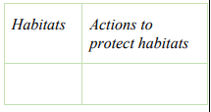

- Ss work in groups to play game

- T sets a time limit for the game. Stop the game when the time is up.

- T checks Ss’ answers and declare the winner.

**2. ACTIVITY 2: KNOWLEGDE FORMATION ACTIVITIES (5ms)**

**a. Aims:**

- To help Ss review the knowledge of Unit 10

**b. Content:**

- Unit review

- Project presentation

**c. Expected outcomes:**

- Ss can tell the teacher what they have learnt in unit 10.

**d. Organisation**

**Revision**

- Teacher asks Ss to think of what they have learnt already in Unit 10.

**Questions:**

- What have we learnt in Unit 10?

- Ss work in pairs to do the task.

- Teacher calls some students to retell.

* Use the words related to ***Planet Earth***
* Have the right rhythm in sentences.
* Use non - defining relative clauses

- Teacher confirms and leads them to do all the exercises in books

**3. ACTIVITY 3: PRACTICE ACTIVITIES (20’)**

**a. Aims:**

- To help Ss review the vocabulary of Unit 10

- To help Ss revise non-defining relative clauses.

- To have Sscombine sentences from pairs of sentences.

**b. Content:**

- Task 1: Fill in the table with words and phrases about habitats.

- Task 2: Complete the passage, using words/phrases in the box.

- Task 3: Complete each sentence (1-5) with a non-defining relative clause (A-E)

- Task 4: Combine the two sentences into one, using a non-defining relative clause.

**c. Expected outcomes:**

- Students can use the knowledge they have learnt in this unit to complete the tasks successfully.

- Recall the uses of the grammar that they have learnt in this unit (non-defining relative clause.)

**d. Organisation**

**VOCABULARY**

**Task 1: Fill in the table with words and phrases about habitats (Give mark)**

- T has Ss work individually to write down the words / phrases in the columns. Remind them of the words / phrases they have just used in the game. Have Ss read out their phrases.

- Ss do activity individually

- T checks answers as a class.

- Correct Ss pronunciation if necessary.

***Answer key:***

|  |  |
| --- | --- |
| **Types of habitats** | **Things in a habitat** |
| Poles  grassland  water bodies  landforms  forests  oceans  seas, rivers, lakes, ponds…. | flora and fauna  plants and animals  humans  air, light, heat, water… |

**Task 2:Complete the passage, using words/phrases in the box**

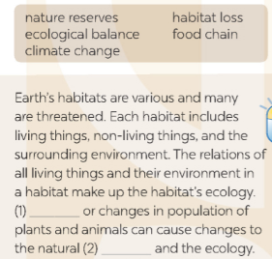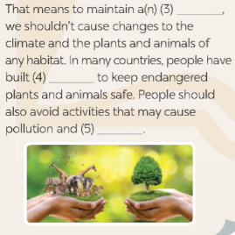

- T has Ss work individually to fill in each blank with the correct words /phrases from the box.

- Ss do the task individually

- T checks answers as a class.

- T asks some Ss to read aloud the passage. Correct Ss’ pronunciation if necessary.

- Ss read aloud the passage

***Answer key:*** *1****.*** *Climate change* ***2.****food chain 3. ecological balance 4. natural reserves*

*5. habitat loss*

**GRAMMAR**

**Task 3: Complete each sentence (1-5) with a non-defining relative clause (A-E).**

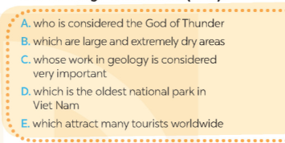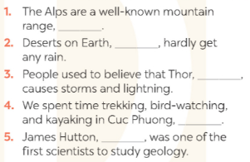

- T has Ss work individually to match the clauses 1-5 with non-defining relative clauses A-F.

- Ss work individually to do the task.

- T reminds them to pay attention to the nouns before the commas (,) if the noun refers to persons, possessions or something or somebody. Then choose the appropriate clauses A- F.

- Then T asks Ss to work in pairs to swap and check their answers.

- Ss work in pairs to swap and check answers.

- T checks answers as a class.

***key:*** 1. E 2. B 3. A 4. D 5. C

- T asks one student to read out the sentences. Correct his / her pronunciation if necessary.***Answer***

**Task 4: Combine the two sentences into one, using a non-defining relative clause**

- T asks Ss to work individually to combine the pairs of sentences as requested in their book.

- T asks one or two students to go to the board and write their sentences with non-defining relative clauses.

- Ss work individually to do the task

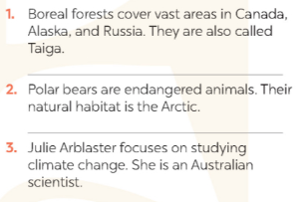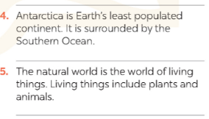

- Then T asks the class to work in pairs.

- T tells them to swap their writings and check their partner’s answers.

- Ss work in pairs to swap and check answers.

- T checks the sentences that some Ss have written on the board.

- T has all Ss correct their partner’s answers.

- T asks some Ss to read out their sentences. Correct Ss’ language and pronunciation if necessary.

***Suggestions:***

*1. Boreal forests, which are also called Taiga, cover vast areas in Canada, Alaska, and Russia.*

*2. Polar bears, whose natural habitat is the Artic, are endangered animals.*

*3. Julie Arblaster, who is an Australian scientist, focuses on studying climate change.*

*4. Antarctica, which is surrounded by the Southern Ocean, is Earth’s least populated continent.*

*5. The natural world is the world of living things, which include plants and animals.*

**4. ACTIVITY 4: APPLICATION AND EXTENSION ACTIVITIES :(10 ms)**

**a. Aims:**

- To provide Ss a chance to develop their research and collaboration skills and to practice giving an oral presentation.

**b. Content:**

**-** Poster presentation

**c. Expected outcomes:**

**-** Students are able to present their posters aboutthe flora and fauna of their neighbourhood or of a place they like.

**d. Organisation**



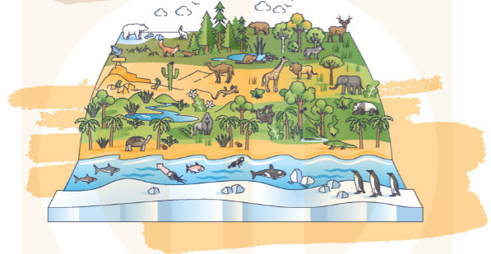

- T has Ss work in groups to choose an area to study about its flora and fauna and asks them to consider their neighbourhood as it is more familiar to them.

- T asks them to gather pictures of the flora and fauna of the area. Tell them that they can also draw or take pictures by themselves.

- Ss work in groups to prepare the presentation.

- T reminds them to create a poster with pictures and key words.

- Ss tick in the checklists

- T has groups present their posters to the class.

- If time is limited, T can assign the project in earlier lessons such as in **GETTING STARTED** lesson. Make sure you guide them in detail and check their progress after each lesson. In the last lesson (**LOOKING BACK**), ask Ss to present their poster.

### **NOW I CAN…**

Finally ask Ss to complete the self-assessment table. Identify any difficulties and weak areas and provide further practice if need be.

### **\* FEEDBACK FORM FOR POSTER PRESENTATIONS**

### **1. Self assessment**

### 

**2. Peer assessment**

