*Date of preparation : November 1st, 2024 Name: Le Ngoc Thuy*

*Department of subjects: English, Arts, Physical Education*

UNIT 4: REMEMBERING THE PAST

***\* Subject: English 9***

**\* *Time expected to complete the topic: 07 periods (26-32)***

## Period 26 : Getting Started – At an English lesson

**I. Objectives:**

By the end of this lesson, Ss will be able to:

### 1. Knowledge:

- Use the words related to the topic *remembering the past*

- Gain vocabulary to talk about some historical places.

**2. Competences**

- Develop communication skills

- Be collaborative and supportive in pair work and team work

**3. Qualities**

- Actively participate in class

- Develop self-study skills

**II. Teaching aids and materials (referenced)**

- Grade 9 textbook, Unit 4, Getting started

- Computer connected to the Internet

- Projector / TV

- *hoclieu.vn*

**III. Teaching procedures**

**1. ACTIVITY 1: START/ WARM UP (5ms)**

**a. Aims:**

- To activate students’ knowledge on the topic of the unit.

- To lead in to the unit.

**b. Content:**

**-** Think!

- Memory lane

**c. Expected outcomes:**

**-** Students can answer some questions of the teacher about school

**d. Organisation:**

**Option 1: Think!**

- Begin the lesson by reviewing the content covered in Unit 3. T may ask some questions.

***Questions:***

*+ Do you care about healthy living?*

*+What do you often do to keep fit?*

*+ What did your parents / grandparents do to keep fit / to keep themselves healthy?*

*+ What do you know about your grandparents’ lifestyle(their clothes/cooking / eating habits, …)?*

- Ss answer the questions

**Suggested answers:**

**-** Students own answer

- Then tell Ss that they are going to learn about the topic *Remembering the past* in this unit.

- T asks Ss to open their books. Draw their attention to the THIS UNIT INCLUDES box and introduce what they are going to learn in this unit.

**Option 2: Memory Lane**

- T asks ss to close their eyes and imagine themselves walking down a memory lane.

*+ What memories do you see?*

*+ Are they happy or sad?*

*+ What do you smell?*

*+ What do you hear?*

- T asks Ss to share one of their memories with the class.

- Ss listen and follow direction

- T writes the words *Remembering the past* on the board and lead in the unit.

**2. ACTIVITY 2: KNOWLEDGE FORMATION ACTIVITIES (8ms)**

**a. Aims:**

- To provide students with vocabulary.

- To help students be well-prepared for the listening and reading tasks.

**b. Content:**

**-** Vocabulary pre-teaching

**c. Expected outcomes:**

**-** Students can identify some new words about *historical place*

**d. Organisation**

**Vocabulary pre-teaching**

- Teacher introduces the vocabulary.

- Teacher explains the meaning of the new vocabulary by showing pictures or giving explanations

- Students guess the meaning of words

*1. complex (n)* /ˈkɒmpleks/ : khu phức hợp, quần thể

*2. religious (adj)*/rɪˈlɪdʒəs/ : (thuộc ) tôn giáo

*3.* *monument (n)* /ˈmɒnjumənt/: tượng đài

*4. magnificent (adj)* /mæɡˈnɪf.ɪ.sənt/: tráng lệ

*5. preserve (v)* /prɪˈzɜːv/: bảo tồn

*6. heritage (n)* /ˈher.ɪ.tɪdʒ/: di sản

*7. occupy (v)* /ˈɒkjupaɪ/: chiếm giữ

*8. occupied (adj)* /ˈɒkjupaɪd/: có người ở

*9. ancient (adj)* /ˈeɪnʃənt/: cổ đại, lâu đời

*10. generation (n)* /ˌdʒenəˈreɪʃn/: thế hệ

*11.found (v)* /faʊnd/: thành lập

**3. ACTIVITY 3: PRACTICE ACTIVITIES (20ms)**

**a. Aims:**

- To help Ss read for specific information about *historical place*

- To help Ss learn words and phrases related to *historical place*

- To help students use the words in context.

**b. Content:**

-Task 1: Listen and read.

- Task 2: Read the conversation again and answer the questions.

- Task 3: Complete each sentence with a word or a phrase from the box.

- Task 4: Look at the pictures and complete the sentences.

**c. Expected outcomes:**

**-** Students understand the conversation and topic of the lesson and can complete the tasks successfully

**d. Organisation**

**Task 1: Listen and read.**

- T begins by asking Ss some questions.

***Questions:***

*What do you see in the picture(s)?*

*What do you know about it / them?*

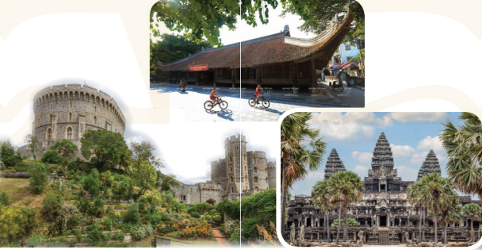

- Ss look at the pictures and answer questions

- T sets the context for the listening and reading: Ask Ss to look at the title of the conversation and the picture. Ask them some questions like: *What do you think they are discussing?*

- Then T asks Ss to look at the title / the picture and guess what the conversation between the teacher and the Ss might be about.

- T plays the recording one or twice for Ss to listen and read along. Then have some pairs of Ss read the dialogue aloud.

- Ss listen to the recording and read the conversation aloud.

- T asks Ss what they are talking about. Now confirm the correct answer. *(They are talking about historic buildings / our history / the past / life in the past …)*

- T has Ss say the words in the text that they think are related to the unit’s topic. Have them pronounce the words containing the sounds /m/ and /l/.

- Ss find the words in the text that are related to the topic.

-T quickly writes the words on the board *(Cambodia, complex, monuments, build, communal, …)*

**Task 2**: **Read the conversation again and answer the questions**.

- T has Ss read the questions without reading the conversation again.

- T explains that they focus on some ideas of the conversation.

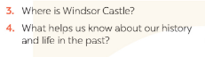

- Ss work independently to do the activity.

- T has Ss read the conversation again and answer the questions. Check their answers and explain if necessary.

***Answer key:***

*1. About 900 years old/ Nearly a thousand years old.*

*2. It’s magnificent.*

*3. In England.*

*4. preservation*

**Task 3: Complete each sentence with a word or a phrase from the box**

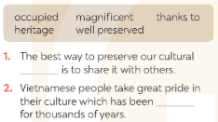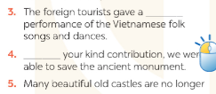

- T asks Ss to read the sentences and find the words and phrase from the box to fill in the gaps. Ss may read the conversation again and find the words / phrases in it. T goes around and offers help, if needed.

- Ss read and do the task

- T allows Ss to share answers before discussing as a class. Write the correct answers on the board. If there’s time, call on some Ss to read the sentences.

***Answer key:*** *1.heritage 2. well preserved 3.magnificent 4.Thanks to 5. occupied*

**Task 4: Look at the pictures and complete the sentences**

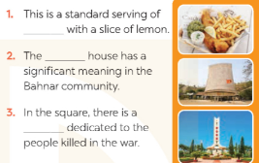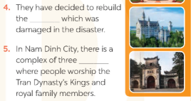

-T has Ss work in pairs. Invite them to look at the pictures and complete the sentences with the word / phrase related to each picture.

- Ss work in pairs to do the task.

- Then T asks some Ss to read the sentences correctly. Check and correct their pronunciation.

***Answer key:***

1. *fish and chips*
2. *communal*

*3. monument*

*4. castle*

*5. temples*

**4. ACTIVITY 4: APPLICATION AND EXTENSION ACTIVITIES:(10 ms)**

**a. Aims:**

-To help Ss get to know about / remember past events.

- To check students’ vocabulary and improve group work skills.

**b. Content:**

- Task 5: Game: Remembering past events.

**c. Expected outcomes:**

- Ss can know more about past events.

**d. Organisation**

**Task 5: Game: Remembering past events**

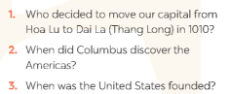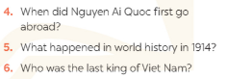

- T has Ss work in groups. Ask them to answer all the questions.

- Ss work in groups to answer questions.

- T sets a time limit (3-4 min.) for Ss to discuss and finish the task.

- T may need to explain to the Ss if they don’t know the answers.

***Answer key:***

*1. King Ly Thai To (Ly Cong Uan).*

*2. In 1492.*

*3. In 1776.*

*4. In 1911.*

*5. World War I started/ broke out.*

*6. King Bao Dai (1913 – 1997)*