*Date of preparation : September 4th, 2025 Name: Le Ngoc Thuy*

*Department of subjects: English, Arts, Physical Education*

## Period 03 : A closer look 1

**I. Objectives:**

By the end of this lesson, Ss will be able to gain:

**1. Knowledge**

- Vocabulary: The lexical items related to *Leisure time*

- Pronunciation: Correctly pronounce words that contain the sounds /ʊ/ and /u:/

**2. Competences**

- Develop communication skills and creativity

- Be collaborative and supportive in pair work and teamwork

- Actively join in class activities

**3. Qualities**

- Love talking about activities in leisure time.

- Develop self-study skills.

**II. Teaching aids and materials (referenced)**

- Grade 8 textbook, Unit 1, A closer look 1

- Computer connected to the Internet

- Projector / TV

- *hoclieu.vn*

**III. Teaching procedures**

**1. ACTIVITY 1: START/ WARM UP ACTIVITY (5ms)**

**a. Aim:**

- To create an active atmosphere in the class before the lesson.

- To lead into the new lesson.

**b. Content:**

**-** Task 1. Match a word / phrases in column A with a word in column B to make expressions about likes.

**c. Expected outcomes:**

- Students get some vocabulary from the lesson and be ready for the lesson.

**d. Organisation**

**Matching game:( GIVE MARK)**

- T shows the questions and divides the class into pairs and explains the rules.

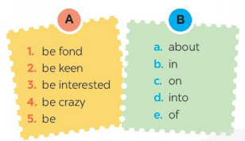

- Ss match the prepositions to the phrases and they have to say “Bingo” as fast as possible.

- Teacher elicits answers from students and announces the winning pair

***Answer key:*** 1. e 2. c 3. b 4. a 5. D

- T sets the context for the lesson.

**2. ACTIVITY 2: KNOWLEGDE FORMATION ACTIVITIES (8ms)**

**a. Aim:**

- To prepare vocabulary for students to do the tasks.

**b. Content:**

**-** Vocabulary pre-teaching

**c. Expected outcomes:**

- Students know how to use the target vocabulary.

**d. Organisation**

**VOCABULARY**

- Teacher asks students to guess the uses of the phrases that they have matched in Warm-up activity.

- Teacher introduces the vocabulary.

*1. be interested in*

*2. be fond of*

*3. be crazy about*

*4. be keen on*

*5. be into*

- Teacher checks students’ understanding by the follow-up tasks in student’s book.

- T confirms that when we want to change the expressions into those about dislikes, we can put *not* after the forms of the verb be. Give them the example: *is fond of*, which is changed into *is not fond of*. Invite some Ss to do the same with other expressions.

- T asks Ss about the form of the verbs placed after these expressions. Tell them that the verbs need to be in *- ing* form. Give them one example: *I’m fond of making paper flowers.*

**3. ACTIVITY 3: PRACTICE ACTIVITIES (20ms)**

**a. Aims:**

- To present some phrases to express “likes”.

- To teach Ss phrases to talk about their hobby or leisure activities.

- To help Ss identify how to pronounce the sounds /ʊ/ and /u:/;

- To help Ss practise pronouncing these sounds in words.

**b. Content:**

- Task 2. Fill in each blank with a correct word from the box.

- Task 3. Complete the sentences about what you like or dislike doing. Use the word or phrases from the box or your own ideas.

**-** Task 4. Listen and repeat the words. Pay attention to the sounds /ʊ/ and /u:/. Then put the words into the correct columns.

- Task 5. Listen and practise the sentences. Underline the bold words with /ʊ/, and circle the bold words with /u:/.

**c. Expected outcomes:**

- Students know how to use the target vocabulary.

**-** Students repeats the words correctly

**d. Organisation**

**Task 2. Fill in each blank with a correct word from the box. (GIVE MARK)**

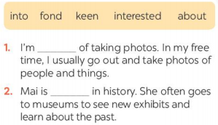 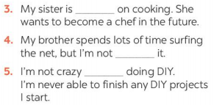

- Teacher has Ss do this activity individually. Have Ss read all the sentences carefully to make sure they understand the sentences and fill in the blanks with the words in the box.

- Teacher lets them share their answers in pairs. Invite some Ss to give the answers and confirm the correct ones.

***Answer key:***

1. fond

2. interested

3. keen

4. into

5. about

- Teacher asks Ss to make sentences with some of the expressions they have learnt. Then T invites Ss to share their sentences.

PRONUNCIATION**:** the sounds /ʊ/ and /u:/

**Task 4. Listen and repeat the words. Pay attention to the sounds /ʊ/ and /u:/. Then put the words into the correct columns.**

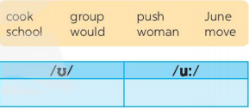

- Teacher asks some Ss to read out the words first. Then play the recording for them to listen and repeat the words they hear. Asks them to pay close attention to the two sounds. T plays the recording as many times as necessary.

- Explains to Ss that these words have the sounds /ʊ/ and /u:/. Tell them the difference between the two sounds if needed. Tell Ss that /ʊ/ is a “short vowel” sound while /u:/ is a “long vowel” sound.

- Invites some Ss to say some words they know that include the two sounds.

***Answer key:***

**/ʊ/:** cook, push, would, woman

**/u:/:** group, June, school, move

**Task 5: Listen and practise the sentences. Underline the bold words with /ʊ/, and circle the bold words with /u:/.**

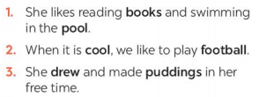 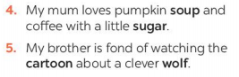

- Teacher asks Ss to quickly read the sentences. Now play the recording for Ss to listen to the sentences. Ask them to pay attention to the underlined parts and tick the appropriate sound.

- Invite some Ss to share their answers. Confirm the correct ones.

- Play the recording again for Ss to repeat the sentences.

- Have Ss practise the sentences in pairs. Invite some pairs to read the sentences aloud. Comment on their pronunciation of the sounds.

- Teacher gives corrections and feedbacks to students’ pronunciation

***Answer key:***

1. She likes reading **books** and swimming in the **pool**. 

2. When it is **cool**, we like to play **football**. 

3. She **drew** and made **puddings** in her free time.

4. My mum loves pumpkin **soup** and coffee with a little **sugar**. 

5. My brother is fond of watching the **cartoon** about a clever **wolf**.

**4. ACTIVITY 4: APPLICATION AND EXTENSION ACTIVITIES:(7ms)**

**a. Aim:**

- To teach Ss phrases to talk about their hobby or leisure activities.

**b. Content:**

- Task 3. Complete the sentences about what you like or dislike doing. Use the word or phrases from the box or your own ideas.

**c. Expected outcomes:**

- Students know how to use the target vocabulary.

**d. Organisation**

**Task 3. Complete the sentences about what you like or dislike doing. Use the word or phrases from the box or your own ideas.**

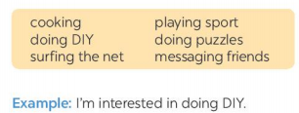 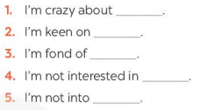

- Teacher tells Ss to share their ideas with a partner. After 1 minute, they can change to another partner. Let Ss do it for some rounds, then call some students randomly to share about their friends’ ideas.

- T asks them to share whether they have the same ideas with their friends.

- Teacher corrected the answer for the whole class.

***Suggested answer:***

1. I’m crazy about collecting stamps.

2. I’m keen on making crafts.

…

.