Unit 2: Our homes
Lesson 3 (1, 2, 3)
A. OBJECTIVES:
By the end of the lesson, Ss will be able to:
1. Knowledge:
- Correctly pronounce the two-syllable words with the stress on the second syllable as in ﬁf’teen and six’teen in isolation and as in the sentences I live at fifteen Ba Dinh Street; She lives at sixteen London Street
- Identify the stress on some two-syllable words and circle the word with a diﬀerent stress pattern from the other two words;
- Say the chant with the correct pronunciation, word stress and rhythm.
- Vocabulary: Review
- Skills: speaking, listening, reading and writing.
2. Competences:
- Communication and collaboration: work in pairs and groups to complete the learning tasks.
- Self-control and independent learning: perform pronunciation and listening tasks.
3. Attitude/ Qualities:
- Show their pride in their personal home and address.
B. TEACHING AIDS:
- Teacher: Teacher’s guide Pages 42, 43, 44; audio Tracks 22, 23, 24; website hoclieu.vn, posters, laptop, pictures, textbook, lesson plan, TV or projector.
- Students: Students’ book Page 20, notebooks, workbooks, school things.
C. PROCEDURES:
Time | Teacher’s activities | Students’ activities
5ms  9ms  17ms  4ms | 1.Warm- up and review:  Game: Matching game  *Aims: to revise the number.  *Procedure:  - Explains how to play the game:  + Ss take turns to open two cards, trying to find the pairs of numbers (as numbers and words).  + If the cards don’t match, teacher clicks to turn them back.  + If the cards match, praise Ss and give them points for their team.  - Says “Open your book page 20” and look at “Unit 2, Lesson 3 (1,2,3)”.  2. Presentation  Activity 1. Listen and repeat:  *Aims: Ss will be able to correctly pronounce the two-syllable words with the stress on the second syllable as in ﬁf’teen and six’teen in isolation and as in the sentences I live at fif'teen Ba Dinh Street and She lives at six'teen London Street.  *Procedure:  - Has Ss point at the words ‘ﬁf’teen and six’teen and the sentences I live at fif'teen Ba Dinh Street and She lives at six'teen London Street.  - Plays the recording for Ss to listen and repeat in chorus and individually until they feel confident.  - Lets Ss work in pairs or groups, saying the words and reading the sentences.  - T invites some Ss to practice.  3.Practice:  Activity 2. Circle, listen and check.  *Aims: Ss will be able to identify the stress on some two-syllable words and circle the word with a diﬀerent stress pattern from the other two words  *Procedure:  - Tells Ss circle the word having a different stress from each line. Then listen to the recording to check their answers.  - Sets a time for Ss to do the task.  - Plays the recording, once or twice, for Ss to listen and check their answers.  - Gets Ss to swap books with a partner and check their answers before checking as a class.  - Plays the recording again for Ss to double-check their answers.  - Invite a few Ss to read aloud all the words in the three lines.  Key: 1.c 2.a 3.a  Activity 3. Let’s chant  *Aims: Ss will be able to say the chant with the correct pronunciation, word stress and rhythm.  *Procedure:  - Introduces the title and lyrics of the chant.  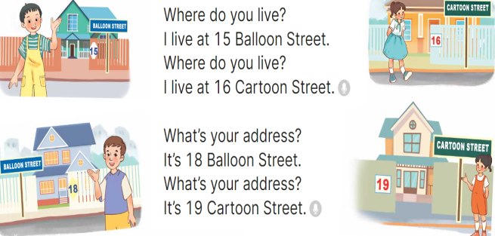  - Plays the recording for Ss to listen to the whole chant.  + Has them repeat the title and lyrics line by line.  + Asks Ss to attend to two-syllable words with the stress on the first syllable in the chant, fifteen, sixteen, eighteen, nineteen, balloon and cartoon.  - Plays the recording all the way through for Ss to listen to pronunciation and melody.  - Plays the recording line by line for Ss to listen and repeat  - Plays the recording for Ss to chant and clap along.  - Asks Ss to practice chant and clap along in pairs or groups.  - Invites groups to the front of the classroom to perform the chant  3. Fun corner and wrap- up  Game: Jumping  - Tells Ss they are going to play the game Jumping.  + If teacher reads a word that is the same as what she writes on the board, Ss jump. + If it is not, they keep still.  + Asks Ss to say the word written on the board.  - Asks Ss to stand at their desks.  - Writes a number from the lesson and say a word. Has Ss play the game. | - Ss listen  -Ss listen the rules  - Ss play the game  - Ss open their books  - - Ss pay attention  - Ss listen to the recording again and repeat.  -Ss work in pairs and practice  -Ss say the language in front of the class  - Ss pay and listen to the teacher’s explanation.  - Ss do the task  - Ss listen to the recording to check their answers (individual)  - Ss swap books with a partner and check the answers  - Ss listen again and check their answers again.  - Ss stand up and read aloud the words.  - Ss look and listen.  - Ss listen to the chant  - Ss listen and repeat line by line without clap their hands  - Ss note the rhythm and pronunciation.  -Ss listen to melody of the chant  - Ss listen and chant line by line.  - Ss chant and clap along.  - Ss work in groups (two groups) to chant  -Ss perform in front of the class.  -Ss listen  -Ss listen  -Ss play the game
D. ADJUSTMENTS (if necessary):
………………………………………………………………………………………….…..……………………………………………………………………………...………………………………………….…..………………………………………………

