Unit 2: Our homes
Lesson 2 (1, 2, 3)
A. OBJECTIVES:
By the end of the lesson, Ss will be able to:
1. Knowledge:

- Understand and correctly repeat the sentences in two communicative contexts focusing on asking and answering questions about someone’s home and address

- Correctly say the words and use What’s your address? – It’s ____. to ask and answer questions about someone’s address

- Use What’s your address? – It’s __________. to ask and answer questions about someone’s address.

- Vocabulary: address, 45, 23, 38, 93 and 116
- Structures:
A: What’s your address?
B: It’s 45 Ba Trieu Street.
- Skills: speaking and listening
2. Competences:
- Critical thinking and creativity: learn how to ask and answer questions about personal information correctly and fluently.
- Self-control and independent learning: perform pronunciation and speaking tasks.
3. Attitude/ Qualities:
- Show their pride in their personal information and where they live.
B. TEACHING AIDS:
- Teacher: Teacher’s guide Pages 38, 39, 40, audio Tracks 18, 19, website hoclieu.vn, posters, laptop, pictures, textbook, lesson plan, TV or projector.
- Students: Students’ book Page 18, notebooks, workbooks, school things.
C. PROCEDURES:
Time | Teacher’s activities | Students’ activities
3ms  15ms  7ms  6ms  3ms | 1.Warm- up and review:  Game: Roll the dice  *Aims: to revise the words about different types of homes.  *Procedure:  - Divides the class into groups of six. Has each student count the numbers from one to six.  - Asks a student from each group to roll the dice to choose a student asking the question.  - Asks that student to put up a picture and ask the question and invite another student of the group to answer the question about their homes.  - The student who answers the correct answers will continue rolling the dice.  - Says “Open your book page 18” and look at “Unit 2, Lesson 2 (1,2,3)”.  2. Presentation  Activity 1. Vocabulary.  *Aims: Ss will be able to know the vocabulary in the new lesson.  *Procedure:  -T elicits the new words  + address : địa chỉ (situation)  + twenty- three : số 23 (picture)  + thirty- eight : số 38 (picture)  +ninety- three : số 93 (picture)  +forty- five : số 45 (picture)  - T models (3 times).  - T writes the words on the board.  - Checking: Rub out and remember  Activity 2. Look, listen and repeat:  *Aims: Ss will be able to understand and correctly repeat the sentences in two communicative contexts (pictures) focusing on asking and answering questions about someone’s home and address.  *Procedure:  - Has Ss look at Pictures a and b and identify the characters and say what they are talking about.  + Who is he/ she?  + Where is he/ she?  + What are they talking about?  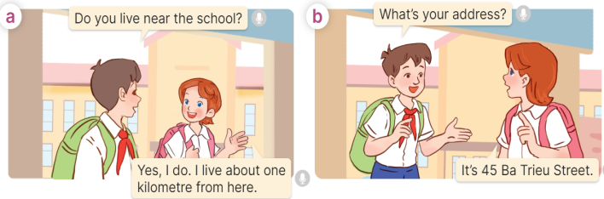  - Plays the audio twice (sentence by sentence). Corrects their pronunciation where necessary.  - Has Ss to practice the dialogue  - T invites a few pairs to the front of the class to practice.  - T checks pronunciation for ss.  Activity 3 Listen, point and say.  *Aims: Ss will be able to correctly say the words and use What’s your address? – It’s _____. to ask and answer questions about someone’s address.  *Procedure:  * Structures:  - T asks Ss look at picture b in activity 1 and helps Ss know the structure from the dialogue.  - T introduces new structures for Ss.  - T explains, models and gives meaning.  - Has Ss repeat the model sentences.  A: What’s your address??  B: It’s 45 Ba Trieu Street.  3.Practice:  *Drill pictures  - Has Ss look at the pictures and say what they can see in the pictures.  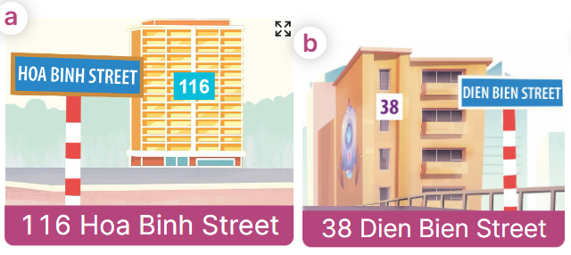  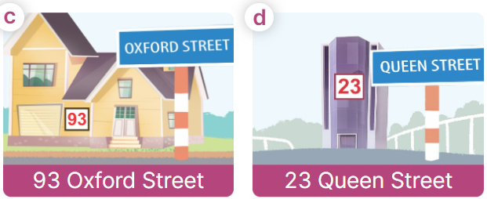  - Has Ss point at pictures, listen and run through all the pictures.  - Has Ss point at the bubbles, listen and run through model sentences.  - Has Ss to practise:  + T asks the first picture, Ss answer  + Ss asks the second picture, T answers  + Group A asks the third picture, group B  answers  + Group B asks the last picture, group A  - Asks Ss to work in pairs to practise asking and answering the question What’s your address? – It’s _____.  - T controls and corrects.  - Invites a few pairs to point at the pictures and say the questions and answers in front of the class.  4. Production:  Activity 4. Let’s talk.  *Aims: Ss will be able to use Do you live in ___? – Yes, / No, ___. and What’s your address? – It’s___. to ask and answer questions about someone’s address in a freer context.  *Procedure:  - Asks Ss to look at the pictures and elicit the addresses.  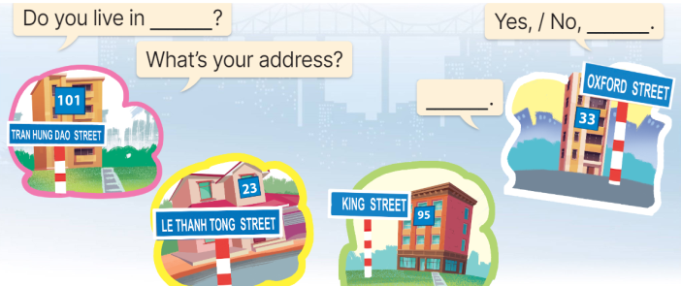  - Points at the ﬁrst building and elicit the question in the ﬁrst speech bubble Do you live in __? and the answer in the second speech bubble Yes, / No, ____. as an example. If the answer is No, then point at the question What’s your address?  - Gives Ss time to work in pairs and take turns pointing at each picture to ask and answer using Do you live in ____?  – Yes, / No, ____. and What’s your address? – ____.  - Invites a few pairs to come to the front of the classroom and act out the exchanges.  5. Fun corner and wrap- up  Game: Racing  - Divides the class into three groups. Each group has equal numbers of Ss.  - Asks Ss to stand in lines. Set the timer.  - Asks the first pupil from each line What’s your address? he/ she must answer and in turn ask the second student in the line. The second pupil then answers and asks the third, and so on.  - The group which has the shortest time to finish asking and answering wins the game. | -Ss listen and pay attention  - Ss listen to the teacher  -Ss play the game  Ex: A: Do you live in this house?  B: Yes, I do.  -Ss continute playing the game  - Ss listen and open their books  -Ss listen and answer  - - Ss listen and repeat  + Choral repetition (3 times).  + Individual repetition (3 ss)  - Ss take note  - Ss look, remember and write  -Look at the pictures and say.  + In picture a:  Nam: Do you live near the school?  Lucy: Yes, I do. I live about one kilometre from here.  + In picture b:  Nam: What’s your address?  Lucy: It’s 45 Ba Trieu Street.  -Ss listen and repeat in chorus (twice)  -Ss work in pairs to practice  -Ss come to the front of the classroom to practice.  -Ss listen  - Ss look at the picture and answer.  -Ss listen  -Ss listen and repeat  -Ss repeat to the structures  - Ss look, listen and repeat  +Picture a: 116 Hoa Binh Street  + Picture b: 38 Dien Bien Street  + Picture c: 93 Oxford Street  + Picture d: 23 Queen Street  Notes:  We say: 116: one-sixteen or one-one-six.  Don’t say: one hundred and sixteen  -Ss point at pictures, listen and repeat  -Ss point at the bubbles, listen and repeat  -Ss practice in chorus  -Ss practice in chorus  -Ss work in pairs to practise asking and answering the question  - Pairs of Ss point at the pictures and say in front of the class  -Ss look at the picture and say  - Ss look at the first building and elicit the missing words in speech bubbles and say the completed sentences.  - Ss role-play to practise asking and answering questions  - Ss practise asking and answering questions in front of the class.  -Ss listen to the teacher  -Ss play the game  -Ss congratulate the winner
D. ADJUSTMENTS (if necessary):
………………………………………………………………………………………….…..……………………………………………………………………………...……
Week 4 Preparing date: September …….., 2024
Period 14 Teaching date: September ………., 2024

