Unit 2: Our homes
Lesson 3 (4, 5, 6)
A. OBJECTIVES:
By the end of the lesson, Ss will be able to:
1. Knowledge:
- Read a letter and show understanding by deciding if the sentences are true or false
- Write the answers to the guiding questions based on their personal information
- Present the results of a survey of pupils’ homes to the class.
- Vocabulary: Review
- Skills: speaking, listening, reading and writing.
2. Competences:
- Communication and collaboration: work in pairs and groups to complete the learning tasks.
- Self-control and independent learning: perform reading and writing tasks.
3. Attitude/ Qualities:
- Show their knowledge about houses and addresses.
B. TEACHING AIDS:
- Teacher: Teacher’s guide Pages 44, 45; website hoclieu.vn, posters, laptop, pictures, textbook, lesson plan, TV or projector.
- Students: Pupil’s book Page 21, notebooks, workbooks, school things.
C. PROCEDURES:
Time | Teacher’s activities | Students’ activities
5ms  8ms  3.Production: (18’)  4ms | 1.Warm- up and review:  Game: “Board race”  *Aims: to review the vocabulary and structure about greet and respond to greetings.  *Procedure:  - T numbers the students in each team.  - T plays the recording then calls out the number, the ss of that number from each team comes to the board, write the number they hear and read it aloud.  - Says “Open your book page 21” and look at “Unit 2, Lesson 3 (4,5,6)”.  2.Practice:  Activity 1. Read and tick True or False:  *Aims: Ss will be able to read a letter and show understanding by deciding if the sentences are True or False.  *Procedure:  - Tells Ss the goal of the activity and explains that they should read the letter and tick True or False for the sentences provided.  - Models number 1. Has Ss read the sentence number 1; then scan the letter above quickly to find the correct fact (Sydney). Then tell them to compare with the information given in the sentence provided (London). Tell the Ss to tick the box False.  - Sets a time limit for Ss to do the task independently.  - Gets Ss to swap books with a partner and check their answers before checking as a class.  - Invites one or two Ss to read aloud the letter.  Key: 1. F 2. T 3. T 4. F 5. F  Activity 2. Let’s write  *Aims: Ss will be able to write the answers to guiding questions based on their personal information  *Procedure:  - Tells the class the goal of the activity and explain that they should read the questions and write the answers based on their personal information.  - Models question 1.  - Gives Ss time to do the writing task independently.  - Gets Ss to swap books with a partner and check their answers before checking as a class.  - Invites one or two Ss to stand up and read aloud their answers.  Key: Pupil’s answer  Ex: 1. Where do you live?  I live in the countryside.  2. What’s your address?  It’s Nghia Lam Village.  3. Where does your best friend live?  She lives in the city.  4. What’s his/her address?  It's 77 Nghia Lam Road.  Activity 3. Project.  *Aims: Ss will be able to present the results of a survey of pupils’ homes to the class.  *Procedure:  - Checks Ss’ preparation of their survey.  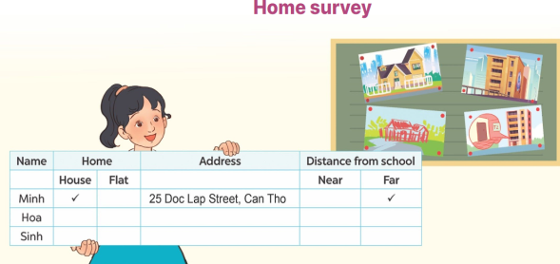  - Invites a student to report his / her survey with your help.  - Has Ss work in groups to practise reporting their own surveys.  4. Fun corner and wrap- up  - Invites a few Ss to report their surveys in front of the class.  - Praises Ss when they do a good job.  Game: Mystery Box  - Divides the class into two groups: Boys and Girls.  - In teams, Ss take turns to choose the letters and answer the questions.  + If they have the correct answers, they can give the mystery box or keep it to the other teams.  +The group with more points wins the game. | - Ss listen  - Ss listen to the rules  -Ss play game  - Ss open their books  - Ss listen to the teacher’s instruction.  - Ss read the letter as a class.  - Ss do sentence number 1  - Ss do the task individually.  - Ss swap books with a partner, and check answers  - One or two Ss read aloud the letter.  - Ss listen to the teacher’s explanation.  - Ss follow the teacher’s instructions.  - Ss do the task individually.  - Ss swap books and check their answers  - Ss read aloud their answers.  - Ss listen to the teacher’s instruction.  - One student does an example with the teacher’s help.  - Ss show their posters that they have made at home and tell the group about different types of homes.  - Ss show their work and talk  -Ss listen to the teacher  -Ss play the game  -Ss congratulate the winner
D. ADJUSTMENTS (if necessary):
………………………………………………………………………………………….…..……………………………………………………………………………...……

