Unit 2: Our homes
Lesson 2 (4, 5, 6)
A. OBJECTIVES:
By the end of the lesson, Ss will be able to:
1. Knowledge:
- Listen to and understand two communicative contexts in which speakers ask and answer questions about their addresses and circle the correct pictures;
- Complete two gapped dialogues with the help of picture cues;
- Listen to and complete the song Homes and to sing it with the correct pronunciation, rhythm and melody.
- Vocabulary: Review
- Skills: speaking, listening, reading and writing.
2. Competences:
- Communication and collaboration: work in pairs and groups to complete the learning tasks.
- Self-control and independent learning: perform listening and reading tasks.
3. Attitude/ Qualities:
- Show their pride in their personal information and where they live.
B. TEACHING AIDS:
- Teacher: Teacher’s guide Pages 40, 41, 42; audio Tracks 20, 21; website hoclieu.vn, posters, laptop, pictures, textbook, lesson plan, TV or projector.
- Students: Pupil’s book Page 19, notebooks, workbooks, school things.
C. PROCEDURES:
Time | Teacher’s activities | Students’ activities
5ms  25ms  5ms | 1.Warm- up and review:  “Listen and choose the number”  *Aims: to revise the learned numbers.  *Procedure:  - Asks Ss to take out the board and chalk or marker.  - Plays the audio and have Ss listen to the audio and write the number they hear in 5 seconds.  - Asks Ss to hold the board up to show the answer.  - Checks the answer with the whole class.  - Says “Open your book page 19” and look at “Unit 2, Lesson 2 (4,5,6)”.  2.Practice:  Activity 1. Listen and circle:  *Aims: Ss will be able to listen to and understand two communicative contexts in which speakers ask and answer questions about their addresses and circle the correct pictures.  *Procedure:  - Draws Ss’ attention to the pictures and asks questions to elicit the addresses  + What can you see in this picture?  + Is it at 67 Tay Son street?  + Is it a flat?  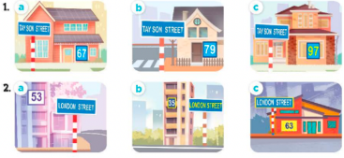  - T ask Ss to guess the answers.  + T writes Ss’guessing on the board.  - Listen to the tape:  + Plays the recording  + Plays the recording again for pupils to do the task.  + Plays the recording a third time for pupils to check their answers.  - Gets Ss to swap books with their partner, then check answers as a class.  + Writes the answers on the board for Ss to correct their answers. Then checks Ss’ guessing.  - Plays the recording, sentence by sentence, for Ss to listen and repeat individually and in chorus  Key: 1. b 2. a  Activity 2. Read and complete.  *Aims: Ss will be able to read and complete two gapped dialogues with the help of picture cues.  *Procedure:  - Has Ss read the dialogue. Draw Ss’ attention to the address and the distance from the address to the place.  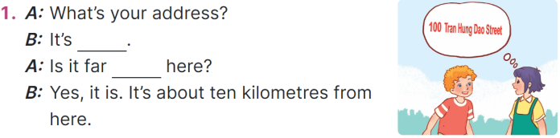  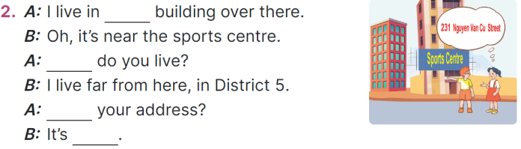  - Reads the second dialogue. Point at the building and draw Ss’ attention to the boy’s hand toward the building on the left-hand side.  + Elicits the missing word (that).  - Gives Ss a time limit to read the gapped dialogues, looks at the pictures and fills in the gaps independently.  - Gets Ss to swap books with a partner and checks their answers before checking as a class.  + Invites one student to write the answers on the board.  - Invites two pairs of Ss to act out the completed dialogues.  Key: 1.100 Tran Hung Dao Street; from  2. that; Where; What’s;  231 Nguyen Van Cu Street  Activity 3. Listen, complete and sing.  *Aims: Ss will be able to listen to and complete the song Homes and to sing it with the correct pronunciation, rhythm and melody.  *Procedure:  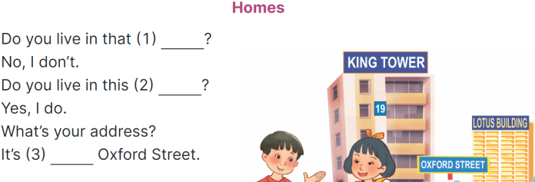  - Has Ss read the song lyrics and guess the missing words with the help of the picture.  + Gives Number 1 as an example (building).  - Gives a time limit for Ss to read and fill the gaps.  - Plays the recording again for  Ss to check the answers.  - Plays the recording again for Ss to listen and sing along before they practise singing the song.  3. Fun corner and wrap- up  Game: Lucky number  - Divides the class into 2 teams.  - Each team takes turns to choose the number and answer the question.  - T checks the answer with the whole class.  - Ss get the point(s) if they answer the question correctly.  - The team with more points is the winner. | - Ss take out the board and chalk or marker.  - Ss listen and write the numbers.  - Ss show the answer and check.  - Ss open their books  -Look at the pictures and say:  + Picture 1a: a private house at 67 Tay Son Street  + Picture 1b: a private house at 79 Tay Son Street  + Picture 1c: a private house at 97 Tay Son Street  + Picture 2a: a block of flats at 53 London Street  + Picture 2b: a block of flats at 35 London Street  + Picture 2c: a block of flats at 63 London Street  -Ss guess the answers  - Ss listen to the tape  - Ss listen again and do the task.  - Ss listen and check their answers  - Ss swap books with their partner, then check answers as a class and guessing  -Ss listen and repeat  -Ss look at the picture and say  - Ss read the second dialogue.  - Ss follow the teacher’s instruction.  - Ss complete gapped exchange 2 independently.  - Ss swap books with a partner and check their answers.  - Pairs of Ss read the completed dialogues aloud  - Ss read the song and guess the missing words.  - Ss follow the teacher's instructions.  - Ss work individually, listen and complete.  - Ss listen to the recording to check their answers again.  - Ss listen and sing along.  -Ss listen to the teacher  - Ss play the game.  - Ss cheer up whenever the guess is correct.
D. ADJUSTMENTS (if necessary):
………………………………………………………………………………………….…..……………………………………………………………………………...…..…

