Week 5 Preparing date: October 8th, 2024
Period 18 Teaching date: October 10th to October 11th, 2024

Unit 3: My foreign friends
Lesson 1 (4, 5, 6)
A. OBJECTIVES:
By the end of the lesson, Ss will be able to:
1. Knowledge:
- Listen to and understand four communicative contexts in which speakers ask and answer questions about someone’s nationality and tick the correct pictures.
- Circle correct words in four exchanges with the help of picture cues.
- Sing the song My friends with correct pronunciation, rhythm and melody.
- Vocabulary: Review
- Skills: speaking, listening, reading and writing.
2. Competences:
- Communication and collaboration: work in pairs and groups to complete the learning tasks.
- Self-control and independent learning: perform listening and reading tasks.
3. Attitude/ Qualities:
- Show their pride in where they come from and great respect for where someone comes from by asking and answering about nationality.
B. TEACHING AIDS:
- Teacher: Teacher’s guide Pages 47, 48; audio Tracks 27, 28; website hoclieu.vn, posters, laptop, pictures, textbook, lesson plan, TV or projector.
- Students: Student’s book Page 23, notebooks, workbooks, school things.
C. PROCEDURES:
Time | Teacher’s activities | Students’ activities
5ms  25ms  5ms | 1.Warm- up and review:  Game: “Flashcard walk”  *Aims: to revise the learned different nationalities.  *Procedure:  - Divides the class into four groups.  - Places several word cards on the classroom floor.  - Has Ss from each group come up the front.  - Plays some music and has the Ss walk around the word cards.  - Stops the music and say the name of one flashcard, ex: she / American  - Has the Ss pick up the correct word card and says a sentence using the word on the word card, ex: she’s American.  - Gives the first group to make a correct sentence at one point.  - The group with the most points wins the game.  - Says “Open your book page 23” and look at “Unit 3, Lesson 1 (4,5,6)”.  2.Practice:  Activity 1. Listen and tick:  *Aims: Ss will be able to listen to and understand four communicative contexts in which speakers ask and answer questions about someone’s nationality and tick the correct pictures.  *Procedure:  - Draws Ss’ attention to the pictures and ask questions  + What nationality is she/ he?  + What’s he/ she doing?  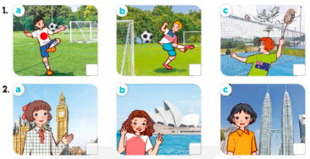  - T ask Ss to guess the answers.  + T writes Ss’guessing on the board.  - Listen to the tape:  + Plays the recording  + Plays the recording again for pupils to do the task.  + Plays the recording a third time for pupils to check their answers.  - Gets Ss to swap books with their partner, then check answers as a class.  + Writes the answers on the board for Ss to correct their answers. Then checks Ss’ guessing.  - Plays the recording, sentence by sentence, for Ss to listen and repeat individually and in chorus  Key: 1. a 2. b  Activity 2. Read and circle  *Aims: Ss will be able to circle correct words in four exchanges with the help of picture cues.  *Procedure:  - Has Ss read the sentences and elicits the answer to fill in the gap.  (ex: America).  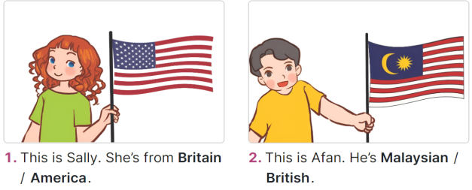  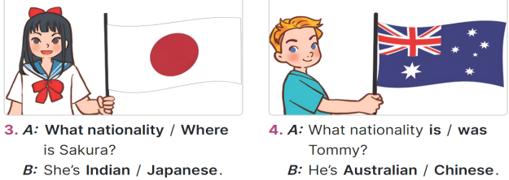  - Gives Ss a time limit to read the gapped dialogues, look at the pictures and do the task independently.  - Gets Ss to swap books with a partner and check their answers before checking as a class.  + Invites one student to write the answers on the board.  + Asks questions to have Ss explain why they choose the options. Ex: for picture B, ask why do you choose Malaysian? - Because there’s a flag of Malaysia.  - Invites two pairs of Ss to act out the completed dialogues.  Key: 1. America 2. Malaysian  3. What; Japanese 4. is; Australian  Activity 3. Let’s sing  *Aims: Ss will be able to sing the song My friends with correct pronunciation, rhythm and melody.  *Procedure:  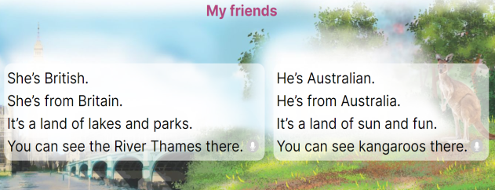  - Draws Ss’ attention to the title and lyrics of the song.  - Has Ss read and listen to the song.  - Plays the recording again and let ss listen to and practise singing the song, line by line.  - Asks Ss to listen to and sing the whole song while doing actions or clapping their hands when they hear the keywords such as British, Britain, Australian, Australia, land, see.  - Invites a few groups to the front of the class to sing the song.  3. Fun corner and wrap- up  Game: Lucky stars  - Divides the class into two groups. Have a student from each group play one, two, three to find the group going first.  - Has two Ss from each group choose a colour star, look at the picture given and ask and answer the question about someone’s nationality.  - Asks the class to check their friends’ pronunciation. If they are correct, they will get points for their group.  - Continues the game until all the words are said.  - The group with more points wins the game. Praise the winner. | -Ss listen to the teacher  -Ss play the game  - Ss open their books  -Look at the pictures and say:  + Picture 1a: a Japanese boy playing football  + Picture 1b: an American boy playing football  + Picture 1c: an Australian boy playing badminton  + Picture 2a: a British girl standing in front of Big Ben  + Picture 2b: an Australian girl standing in front of Sydney Opera House  + Picture 2c: a Malaysian girl standing in front of Petronas twin tower  -Ss guess the answers  - Ss listen to the tape  - Ss listen again and do the task.  - Ss listen and check their answers  - Ss swap books with their partner, then check answers as a class and guessing  -Ss listen and repeat  -Ss look at the picture and read, fill the gap  - Ss do the task independently.  - Ss swap books with a partner and check their answers.  - Ss write the answers on the board  -Ss explain why  - Pairs of Ss read the completed dialogues aloud  - Ss pay attention to the title and lyrics of the song.  - Ss read and listen to the song  - Ss listen to the recording again and practise singing the song  - Ss listen to and sing the whole song while doing actions  - Ss come to the front of the class to sing the song.  -Ss listen to the teacher  - Ss play the game.  - Ss continue playing the game.  - Ss praise the winner.
D. ADJUSTMENTS (if necessary):
………………………………………………………………………………………….…..……………………………………………………………………………...…..…

