Week 2 Preparing date: September 14th, 2024
Period 5 Teaching date: September 16th +17th, 2024
Classess 5A, 5B

Unit 1: All about me!
Lesson 1 (1, 2, 3)
A. OBJECTIVES:
By the end of the lesson, Ss will be able to:
1. Knowledge:
- Understand and correctly repeat the sentences in two communicative contexts focusing on asking and answering questions about personal information.
- Correctly say the words and use Can you tell me about yourself? - I’m in ………...; I live in the……………. to ask and answer questions about personal information.
- Use Can you tell me about yourself? - I’m in ………...; I live in the…………. in freer contexts.
- Vocabulary: city, class, countryside
- Structures:
A: Can you tell me about yourself?
B: I’m in class 5D. I live in the countryside.
- Skills: speaking and listening
2. Competences:
- Communication and collaboration: work in pairs and groups to complete the learning tasks.
- Self-control and independent learning: perform pronunciation and speaking tasks.
3. Attitude/ Qualities:
- Show their pride in their personal information and where they live.
B. TEACHING AIDS:
- Teacher: Teacher’s guide Pages 18, 19, 20, 21, audio Tracks 5,6, website hoclieu.vn, posters, laptop, pictures, textbook, lesson plan, TV or projector.
- Students: Students’ book Page 10, notebooks, workbooks, school things.
C. PROCEDURES:
Time | Teacher’s activities | Students’ activities
3ms  15ms  7ms  10ms | 1.Warm- up and review:  Sing a song: Hello, nice to meet you  *Aims: to create a friendly and active atmosphere in the class to beginning the lesson.  *Procedure:  - Shows the song on the screen.  https://www.youtube.com/watch?v=ANrSdZq8sCk  - Asks Ss to listen, sing and dance the song  - Says “Open your book page 10” and looks at “Unit 1, Lesson 1 (1,2,3)”.  2. Presentation (15’)  Activity 1. Vocabulary.  *Aims: Ss will be able to know the vocabulary in the new lesson.  *Procedure:  -T elicits the new words  + city : thành phố (picture)  + class : lớp học (picture)  + countryside : nông thôn (picture)  - T models (3 times).  - T writes the words on the board.  - Checking: Rub out and remember  Activity 2. Look, listen and repeat:  *Aims: Ss will be able to understand and correctly repeat the sentences in two communicative contexts focusing on asking and answering questions about personal information.  *Procedure:  - Has Ss look at Pictures a and b and identifies the characters in the pictures.  + Who is he/ she?  + Where is he/ she?  + What are they talking about?  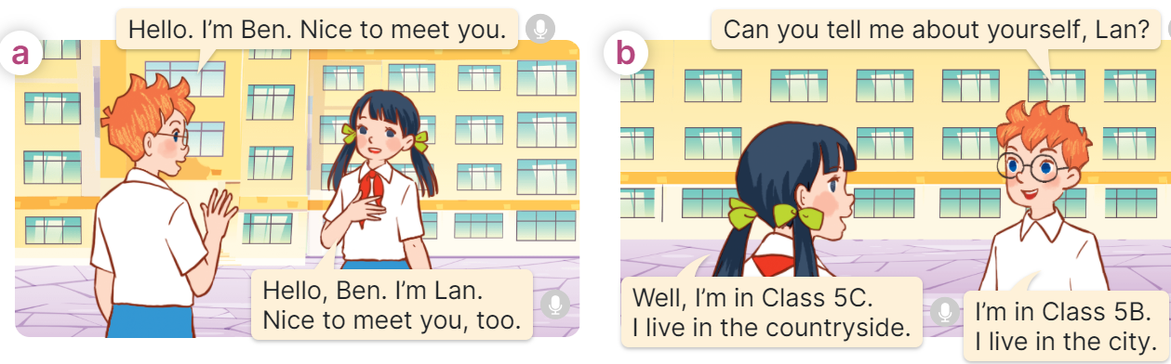  - Plays the audio twice (sentence by sentence). Correct their pronunciation where necessary.  - Has Ss to practice the dialogue  - T invites a few pairs to the front of the class to practice.  - T checks pronunciation for ss.  Activity 3 Listen, point and say.  *Aims: Ss will be able to correctly say the words and use Can you tell me about yourself? - I’m in ……..; I live in the ….. to ask and answer questions about personal information.  *Procedure:  * Structures:  - T asks Ss look at picture b in activity 1 and helps Ss know the structure from the dialogue.  - T introduces new structures for Ss.  - T explains, models and gives meaning.  - Has Ss repeat the model sentences.  A: Can you tell me about yourself?  B: I’m in class 5D. I live in the countryside.  3.Practice:  *Drill pictures  - Elicits and checks comprehension the personal information of each character.  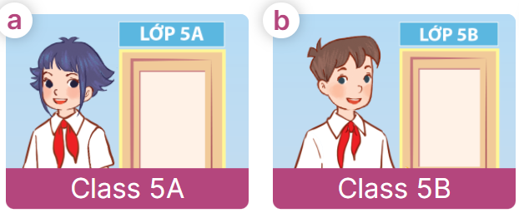  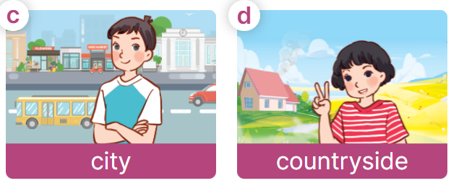  - Has Ss point at pictures, listen and run through all the pictures.  - Has Ss point at the bubbles, listen and run through model sentences.  - Has Ss to practise:  + T asks the first picture, Ss answer  + Ss asks the second picture, T answers  + Group A asks the third picture, group B  answers  + Group B asks the last picture, group A  - Asks Ss to work in pairs to practise asking and answering the question Can you tell me about yourself? - I’m in ……….; I live in the…….  - T controls and corrects.  - Invites a few pairs to point at the pictures and says the questions and answers in front of the class.  4. Production:  Activity 4. Let’s talk.  *Aims: Ss will be able to use Can you tell me about yourself? - I’m in …….; I live in the ……… in a freer context.  *Procedure:  - T asks ss to identify the character’s information in each picture  +What can you see in the picture?  +Who are they?  +Where does he/ she live?  +What class is he/ she in?  +When’s her/ his birthday?  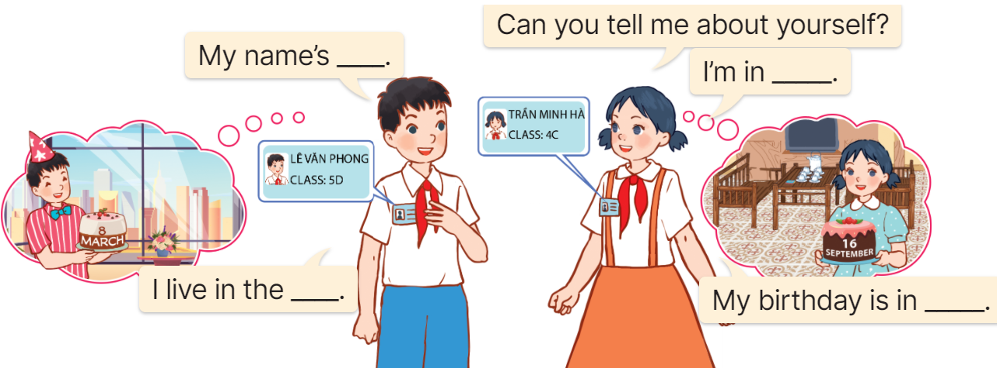  - Elicits the answer in the speech bubble and write it on the board. Get Ss to say the completed sentences.  - Has Ss role-play to practise asking the questions and giving their answers in pairs, using the picture cue.  - Invites a few pairs to point at the pictures and ask and answer questions.  5. Fun corner and wrap- up  Game: Pass the teddy bears  - Gives two different coloured teddy bears to two Ss, a black teddy bear (ask the question) and a white teddy bear (answer the question).  - Asks Ss to listen to music and pass the teddy bears.  - Stops music suddenly. Has the student with a black teddy bear make a question. Has the student with a white teddy bear answer the question.  - Repeats the game several times. | - Sing and dance the song together.  - Listen and open their books  - Listen and answer  - - listen and repeat  + Choral repetition (3 times).  + Individual repetition (3 ss)  - Take note  - Look, remember and write  - Look at the pictures and get to know the characters in the pictures.  +In picture a:  Ben: Hello, I’m Ben. Nice to meet you.  Lan: Hello, Ben. I’m Lan. Nice to meet you, too.  + In picture b:  Ben: Can you tell me about yourself, Lan?  Lan: Well, I’m in Class 5C. I live in the countryside.  Ben: I’m in Class 5B. I live in the city  - Listen and repeat in chorus (twice)  - Work in pairs to practice  - Come to the front of the classroom to practice.  - Listen  - Look at the picture and answer.  - Listen  - Listen and repeat  - Repeat to the structures  - Look, listen and repeat  +Picture a: a girl standing at the door of Class 5A.  + Picture b: a boy standing at the door of Class 5B.  + Picture c: high buildings in the city.  + Picture d: a girl standing in front of a house in the countryside.  - Point at pictures, listen and repeat  - Point at the bubbles, listen and repeat  - Practice in chorus  - Practice in chorus  - Work in pairs to practise asking and answering the question  - Pairs of Ss point at the pictures and say in front of the class  - Look at the picture and answer  + a picture of two pupils showing their personal information (classes they are in and places they live in).  - Say the completed sentences.  - Work in pairs to ask and answer  Can you tell me about yourself?  - My name’s ……. I’m in ………….  I live in the …… My birthday is in ……  - Perform in front of the class.  - Listen  - Listen and play the game  Ex:  A: Can you tell me about yourself?  B: I’m in Class 5A. I live in the city.  - Continue to play the game.
D. ADJUSTMENTS (if necessary):
………………………………………………………………………………………….…..……………………………………………………………………………...………………………………………….…..………………………………

