Week 3 Preparing date: September ….., 2024
Period 10 Teaching date: September ……, 2024

Unit 1: All about me!
Lesson 3 (4, 5, 6)
A. OBJECTIVES:
By the end of the lesson, Ss will be able to:
1. Knowledge:
- Read two paragraphs and circle the correct options.
- Make questions and answers about personal information and favourite things.
- Revise the target language by making a poster and presenting it to the class.
- Vocabulary: Review
- Skills: speaking, listening, reading and writing.
2. Competences:
- Communication and collaboration: work in pairs and groups to complete the learning tasks.
- Self-control and independent learning: perform reading and writing tasks.
3. Attitude/ Qualities:
- Show their love and interest in sports, colours, animals and food.
B. TEACHING AIDS:
- Teacher: Teacher’s guide Pages 31, 32; website hoclieu.vn, posters, laptop, pictures, textbook, lesson plan, TV or projector.
- Students: Student’s book Page 15, notebooks, workbooks, school things.
C. PROCEDURES:
Time | Teacher’s activities | Students’ activities
5ms  8ms  18ms  4ms | 1.Warm- up and review:  Game: “Jumping”  *Aims: to review the vocabulary and structure about greet and respond to greetings.  *Procedure:  - Sticks the flash cards (football, table tennis, Japan, England, dolphin, giraffe) on the board.  - Tells Ss they are going to play the game “Jumping”.  + If the teacher reads a word that is the same as a flash card on the board, Ss jump.  + If it is not, they keep still. Ask them to say the word on the flash card.  - Asks Ss to stand at their desks.  - Holds up a flash card from the vocabulary set and say a word. Have Ss play the game.  - Afterwards, raise all the flash cards for Ss to say the words.  - Says “Open your book page 15” and look at “Unit 1, Lesson 3 (4,5,6)”.  2.Practice:  Activity 1. Read and circle:  *Aims: Ss will be able to read two paragraphs and circle the correct options.  *Procedure:  - Draw Ss’ attention to the two paragraphs and read them as a class. 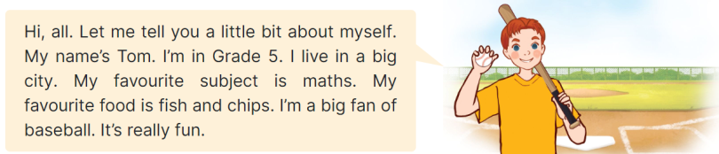  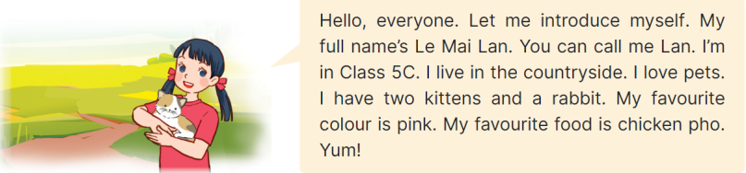  - Draws Ss’ attention to the incomplete sentences and answer options.  + Has Ss pay attention to the sentences about personal information of Tom and Lan. + Have Ss read the text again and circle the correct answers.  - Tells Ss to swap books with a partner, then check answers as a class. Write the correct answers on the board.  - Gets Ss to look at the board and check their answers again.  + If time allows, ask Ss to read the paragraph aloud in front of the class.  Key: 1. b 2. c, 3. b, 4. a  3.Production:  Activity 2. Let’s write  *Aims: Ss will be able to complete a paragraph with students’ personal information and favourite things  *Procedure:  - Tells Ss the goal of this activity  - Writes the sentence with the first gap on the board: My name is ____, ask Ss to identify the information needed to complete the gap (their names) and encourage Ss to say the whole sentence (ex: My name is Huong.).  - Gives Ss time to complete the sentences.  - If time allows, invite a few Ss to read the sentences they have completed in front of the class.  Key: Pupil’s answer  Ex: My name is Huong. I live in the countryside. I am in Class 5D. My favourite sport is running. My favourite food is fish and vegetables. My favourite colour is yellow. My favourite animal is a rabbit.  What about you? What are your favourite things?  Activity 3. Project.  *Aims: Ss will be able to revise the target language by making a poster about favourite things and presenting it to the class.  *Procedure:  - Tell Ss the goal of this activity.  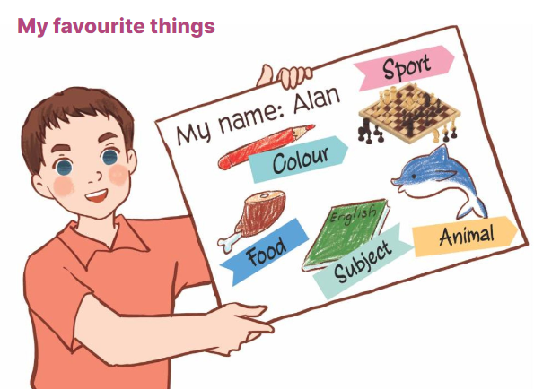  - Has Ss work in groups of five.  + Each student shows his / her poster that he / she has made at home and tells the group about their favourite things, ex: My favourite sport is chess. My favourite food is chicken.  - Invites some Ss to show their work and talk about their favourite things in front of the class.  4. Fun corner and wrap- up  Game: Number race  - Divides the class into two groups.  - Gives each student in one group a number so that each group has equal numbers.  - Asks the questions, ex: What’s your favourite animal, and allow time for Ss to think.  + Then call out a number, have Ss with that number from each group stand up and say the answers, ex: It’s a monkey. Ss are not allowed to give the same answers as their friends.  - Praises and gives points for the groups.  - The group with more points wins the game. | - Ss listen  - Ss listen to the rules  -Ss play game  Ex: if the word “England” is the same as the flash card “the flag of England”, pupils jump. If it isn’t, they keep still.  - Ss open their books  - Ss pay attention to the two paragraphs and read them as a class.  - Ss look at the incomplete sentences and answer options.  - Ss read the text again and circle the correct answers.  - Ss swap books with a partner, then check answers as a class.  - Ss look at the board and check their answers again.  -Ss read the paragraph aloud  -Ss listen and pay attention  - Ss read the sentence and identify the information needed to complete.  - Ss complete the other sentences.  - A few Ss read the sentences they have completed in front of the class.  - Ss listen  - Ss work in groups of five.  + Ss show his / her poster and tells the group about their favourite things.  - Ss show their work and talk about their favourite things in front of the class.  -Ss listen to the teacher  -Ss play the game  -Ss congratulate the winner
D. ADJUSTMENTS (if necessary):
………………………………………………………………………………………….…..……………………………………………………………………………...……

