**Date of preparation: 12/10/2024 Full name: Ho Thi Thuy Nga**

**UNIT 3: MUSIC**

**Total number of periods: 8 (from 18 to 25)**

**Lesson 3: READING Period: 20**

**Class(es): 10A6, 10A8**

**I. OBJECTIVES**

**1. Knowledge**

- read for specific information in a text about a famous TV music show;

- guess the meaning of words/phrases in context;

- talk about reasons why they want or don’t want to participate in a music competition.

**2. Competences**

- be collaborative and supportive in pair work and team work;

- access and consolidate information from a variety of sources;

- develop presentation skill;

- actively join in class activities.

**3. Personal qualities**

- recognise different musical shows;

- be eager to get more information about music shows.

**II. TEACHING AIDS AND MATERIALS**

- Grade 10 textbook, Unit 3, Reading.

- Computers connected to the Internet.

- Interactive board/ TV/ pictures and cards.

- sachmem.vn

**III. PROCEDURES**

**1. Warm up: 5 minutes**

a. Objectives:

-To arouse the classroom atmosphere.

-To get Ss be actively involved in the lesson

- To lead into the lesson.

b. Content:The words “ MUSIC SHOW”

c. Expected Students’ activities:

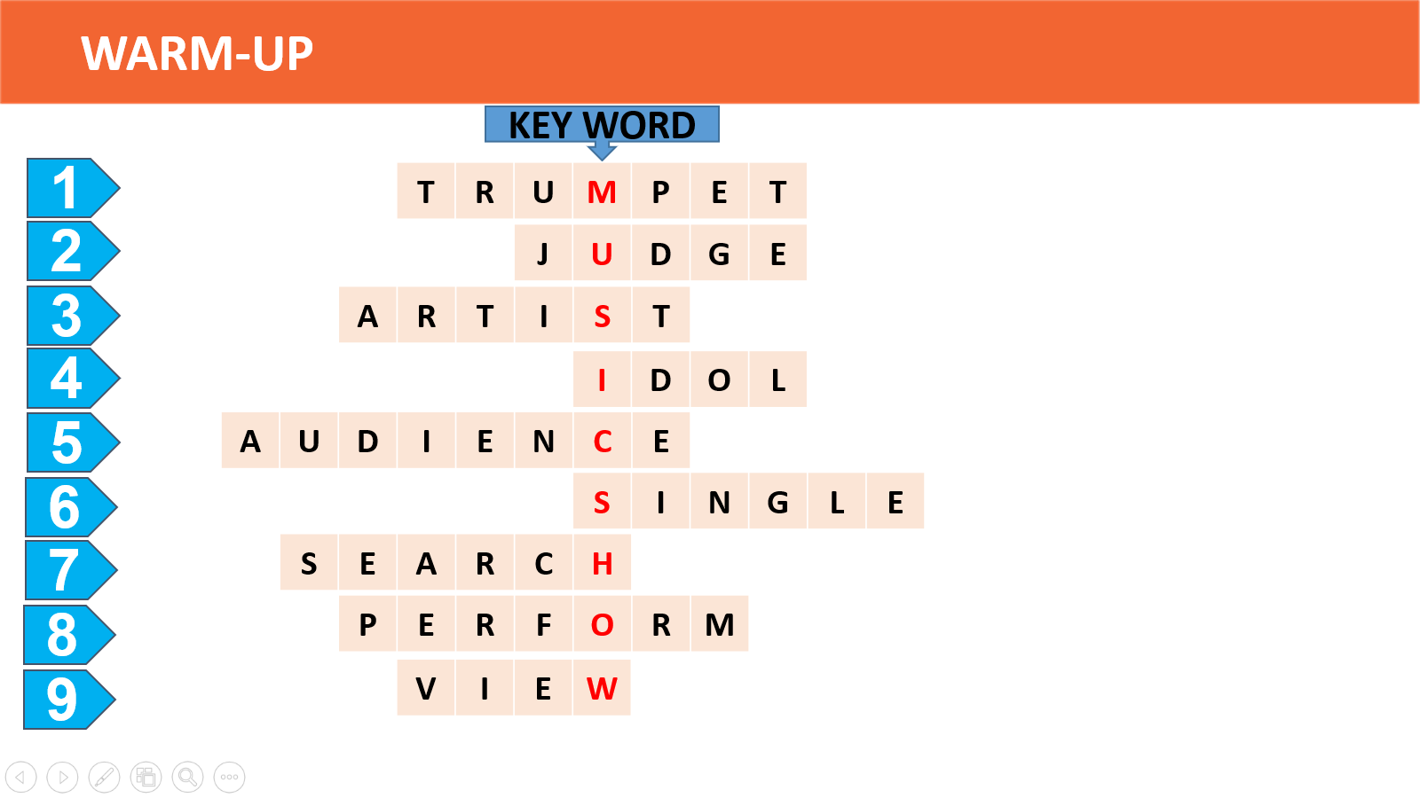

d. Organization:

**2. Knowlege formation activities: ( 5 mins)**

**VOCABULARY**

a. Aim: To introduce the vocabulary, the topic of the reading and get Ss involved in the lesson.

b. Content: vocabulary

c. Expected Students’ activities: reality (n), stage (n), semi-final (n), play a role in (idiom), ordinary (adj).

d. Organization:

|  |  |
| --- | --- |
| **Teacher’s activities** | **Students’ activities** |

|  |  |
| --- | --- |
| - Ask Ss to look at the explanation and the photos to guess the meaning of new words.  - Ss say the Vietnamese meaning of the word.  1. reality (n): using real people (not actors) in real situations, presented as entertainment    2. stage (n): a period or state that something/ somebody passes through while developing or making progress    3. semi-final (n): one of the two games or parts of a sports competition that are held to decide who will compete in the last part (the [final](https://www.oxfordlearnersdictionaries.com/definition/english/final_1))    4. play a role in (idiom): be involved in or have an effect on  Ex: *Deciding to travel instead of going straight to college after high school played a major role in my life*  5. ordinary (adj): not unusual or different in any way  - Other Ss correct if the previous answers are incorrect.  - Teacher shows the Vietnamese meaning, says the words aloud and asks Ss to repeat them.  - Ask Ss to work in pairs to look at the pictures and discuss the questions. Focus their attention on the logos and the names of the shows.  - Invite some pairs of Ss to share their answers with the class.. | - Ss show/take great interest in the new lesson.  1. American idol: a famous TV music show.  2. The XFactor: a television singing competition originated in the United Kingdom. Competitors  go through weeks of auditions before judges until the winner is decided by a public vote.  The prize is usually a recording contract. In addition to giving comments on the contestants’  performance, the judges help them with choosing the songs and style of their songs. The format of the XFactor has been adopted in many countries around the world. |

**3. Practice activities (20 mins)**

**Activity 1**

*What are these shows? What do you know about them?*

a. Objectives:

- To introduce the topic of the reading and get Ss involved in the lesson.

b. Content:  **look at the pictures and discuss the following questions:**  *What are these shows? What do you know about them?*

c. Expected Students’ activities:

*- American Idol*: a famous TV music show.

*- The X Factor*: a television singing competition originated in the United Kingdom. Competitors go through weeks of auditions before judges until the winner is decided by a public vote. The prize is usually a recording contract. In addition to giving comments on the contestants’ performance, the judges help them choose the songs and style of their songs. The format of the *X Factor* has been adopted in many countries around the world.

d. Organization:

| **Teacher’s activities** | **Students’ activities** |
| --- | --- |
| **TASK 1: Work in pairs. look at the pictures and discuss the following questions.** (Ex.1, p.31)  - asks Ss to work in pairs to look at the pictures and discuss the questions.  - focuses their attention on the logos and the names of the shows.  - gives comments and leads in. | - do as instructed.  - work in pairs to compare their answers. |

**Activity 2. Read a text about a famous music show. match the highlighted words and phrases in the text to the meanings below.**

a. Aim:

- To help Ss practise guessing the meanings of words in context.

b. Content: read a text about a famous music show. match the highlighted words and phrases in the text to the meanings below.c. Expected Students’ activities:

*1. b 2. a 3. d 4. c*

d. Organization:

|  |  |
| --- | --- |
| **TASK 2: Read a text about a famous music show. match the highlighted words and phrases in the text to the meanings below.**  - Ask Ss to read the whole text once to get an overall idea.  - Have Ss read it again. Remind them to pay attention to the context of each highlighted word /phrase and look for clues that they can use to guess the meaning, e.g. 1. there were manymovies and TVseries —> programmes on TV.  - Put Ss into groups to discuss the clues and do the matching.  - Check answers as a class. | - Ss can greatly enhance their skill at guessing the meanings of words in context.  Key:l.b 2.a 3.d 4.c |

**Activity 3. Read the text again and choose the best answers.**

a. Objectives:

- To help Ss practise reading for specific information.

b. Content: **read the text again and choose the best answers.** *(ex.3, p.32)*

c. Expected Students’ activities:

d. Organization:

|  |  |
| --- | --- |
| **Task 3: read the text again and choose the best answers**  - Ask Ss to read the questions and underline the key words in each of them.  - Check the key words Ss have underlined,  e.g. 1. What, American idol;  2. Which, statements, correct;  3. Who, wins;  4. Which, statements, judges, NOTmentioned;  5. What, inferred, competition, Viet Nam.  - Ask Ss to read the questions and try to answer them before reviewing the options.  - Ss read the answer options and eliminate the ones that are absolutely wrong.Then they search the text to ﬁnd evidence to support the right answers.  - Have Ss work in pairs or groups to compare answers.  - Check answers as a class. In stronger classes, ask Ss to give reasons for their answers.  *Extension: Divide the class into two teams. Ask each team to prepare 6 - 8 quiz questions based*  *on the reading text and write them on a piece of paper, e.g. When was American idol first shown?*  *(January 2002), What kind ofpeople are the participants? (Ordinary people). Make sure teams know*  *the correct answer to each of their questions. Ss close their books. Have Ss from each team take*  *turns to ask their questions. Give a point for each correct answer. The team with more points is the winner.* | - Ss show good evidence of significantly improving the target reading skill.  *1. B 2. A 3. A 4. C 5. C* |

**4. Application activities (10 mins)**

**Activity 4. Post-reading**

**work in pairs. discuss whether you want to participate in vietnam idol. give your reasons.**

a. Aim:

- To help Ss use the ideas and language in the reading to talk about whether they want to take part in *Vietnam Idol* and give reasons.

b. Content: **discuss whether you want to participate in vietnam idol. give your reasons.**

c. Expected Students’ activities:

- Ss work in pairs to decide whether they want to participate in the show in Viet Nam and state their reasons.

d. Organization:

|  |  |
| --- | --- |
| **TASK 4: work in pairs. discuss whether you want to participate in vietnam idol. give your reasons.**  **Aim:** To help Ss use the ideas and language in the reading to talk about whether they want to take part in Vietnam idol and give reasons.  - Ask Ss to read the text again and make notes of things they like and things they don't like about the show.  - Have Ss work in pairs to decide whether they want to participate in the show in Viet Nam and state their reasons.  - Tell Ss that there are no right or wrong answers, and encourage them to think of as many reasons as they can to support their opinions.  - Invite Ss from different pairs to present a summary of their discussion. | - Stronger Ss can talk with relative ease about their own community.  - Weeker Ss can talk with some prompts/cues from their teacher. |

**5. Consolidation: ( 5mins)**

**Wrap -up**

Teacher asks: What have you learnt today?

- American Idol

**Homework:**

- Ask each student to prepare a short talk (1-2 min) about their favorite music show and get ready to present his/her talk in class next lesson.

- Prepare the lesson for the next period (unit 3, lesson 4: speaking)

**Evaluation and adjustment (if any)**

………………………………………………………………………………………………………………………………………………………………………………………………………………………………