Date of preparation: 06/12/2025 Full name: Kinh Quốc Bảo

UNIT 5: GLOBAL WARMING Total numbers of periods: 8 (from 39 to 46)
Lesson: READING Period: 41
Classes: 11A1, 11A6, 11A7

I. OBJECTIVES: By the end of this lesson, Ss will be able toachieve all the goals set in the following areas.
1. Knowledge
- Read for general ideas and for specific information in the news about the UN Climate Change Conference.
2. Competences
- Develop communication skills and creativity;
- Be collaborative and supportive in pair work and teamwork;
- Develop presentation skills;
- Actively join in class activities.
3. Personal qualities
- Be aware of global issues and find solutions for them
- Develop self-study skills.
II. TEACHING AIDS AND MATERIALS
- Grade 11 textbook, Unit 5, Reading
- Computer connected to the Internet
- Projector / TV/ pictures and cards
- hoclieu.vn
- sachmem.vn
III. PROCEDURES
1. Warm-up (5 minutes)
a. Objectives:
- To stir up the atmosphere and activate students’ knowledge on climate change;
- To set the context for the reading part;
- To enhance students’ skills of cooperating with teammates.
b. Content: Describing game
c. Expected outcomes: Students can find out all the words as well as the key word based on the pictures given by the teacher.
d. Organisation:
Teacher’s activities | Students’ activities
- Divide Ss into 3 groups and gives instructions: look at the pictures and describe the situations before and after.  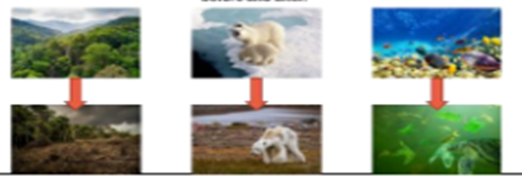  - Observe the groups, collects their answers and gives feedback.  - Lead to the new lesson. | - Work in 3 groups  - Look at the pictures and describe the situations before and after.  - Raise hands to take turns describing the pictures.  - Listen and may give their opinions.

2. Pre-Reading: (5 minutes)
a. Objective: To activate prior knowledge about the topic and get Ss involved in the lesson.
b. Content:
- Lead students in the reading passage;
- Task 1. Work in pairs. Look at the pictures and discuss the environmental problems you see (p.55)
c. Expected outcomes: Students can use key language more appropriately before they read.
d. Organisation
Teacher’s activities | Students’ activities
Task 1. Work in pairs. Look at the pictures and discuss the environmental problems you see.  - Ask Ss to work in pairs to discuss the pictures  and identify the environmental problems.  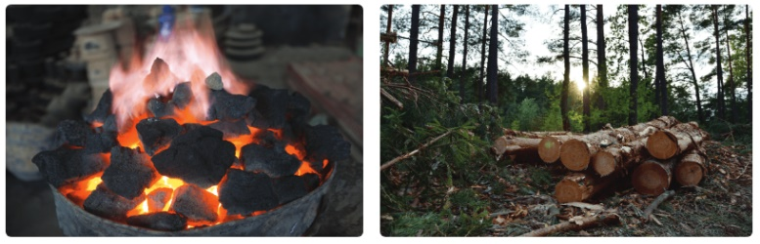  - Ask some guiding questions.  Questions:  What can you see in the pictures?  Do you think human activities like farming can cause any negative impacts on the environment?  How does deforestation contribute to global warming?  Have you heard about global efforts to deal with climate change?  - Invite individual Ss to share their answers with the class.  - Check students’ pronunciation and gives feedback.  - Introduce the topic of the reading text. | - Work in pairs and discuss the pictures and identify the environmental problems.  - Share their answers with the class.  - Listen to the teacher.
3. While-Reading: (20 minutes)
a. Objective: To help Ss practise reading for main ideas in an article about the climate change conference.
b. Content:
- Task 2. Read the article and choose the best title for it. (p.55)
- Task 3. Read the article again. Match the highlighted words with their meanings. (p.56)
- Task 4. Read the article again and choose the correct answers A, B, or C. (p.56)
c. Expected outcomes: Students can understand the content of the text and complete the tasks successfully
Answer keys:
Task 2. C - Main goals of this year’s COP
Task 3.1. d 2. C 3. B 4. a
Task 4. 1. C 2. A 3. C 4. B 5. B
d. Organisation:
Teacher’s activities | Students’ activities
ACTIVITY 1: Read the article and choose the best title for it. (p.55)  - Have Ss read the whole text quickly to get an overall idea. In weaker  classes, go through the answer options and check understanding.  - Ask Ss to work in pairs to compare their answers. Walk round the  class and provide help if necessary.  - Remind them that incorrect headings for a section are often  “irrelevant” (i.e., not mentioned in the section), “too narrow” (i.e., only  representing part of the section) or “too general” (i.e., not specific to  that section only).  - In weaker classes, have Ss read the article and find the most important pieces of information and summarise them. This can help them  recognise the right title.  ACTIVITY 2: Read the article again. Match the highlighted words with their meanings. (p.56)  - Ask Ss to read the article. T focuses their attention on the context of the highlighted words and have them look for clues offering direct or  indirect suggestions about their meanings, e.g. CO2 in paragraph 2  suggests that emissions are gases while methane is a gas as in paragraph  5 it is defined ‘a greenhouse gas’. Preposition between used after  balance prompts equal things in a situation.  - Check answers as a class.  - Ask Ss to make sentences with each of the words to check  understanding if time allows.  ACTIVITY 3: Read the article again and choose the correct answers A, B, or C. (p.56)  - Ask Ss to read the multiple-choice questions. Check Ss’ understanding and explain new or difficult vocabulary if necessary.  - Ask Ss to read the article again. T has Ss work individually to answer  the questions. T encourages them to discuss and compare their answers  with a partner.  - Check answers as a class.  - Have Ss explain the answers by providing evidence from the article, e.g. Choices A and B in question 1 are (the paraphrases of) key goals 2 and 3 while choice C is not (Paragraph 5 says, ‘The last key goal is to reduce methane emissions’). | - Do the task individually  - Share their answers with a partner.  - Listen to the teacher.  - Do the task individually first.  - Share their answers with a partner.  - Listen to the teacher.  - Work individually  - Share their answers with a partner  - Listen to the teacher.
4. Post-Reading: (10 minutes)
a. Objectives:
- To check students’ understanding about the reading passage;
- To help some students enhance presentation skills;
- To practise team working;
- To give students authentic practice in using target language.
b. Content: Task 5: Discussion (p.56)
c. Expected outcomes: Students can use the ideas and language in the reading passage to talk about their opinions
Suggested solutions
1) Use less energy at home 2) Plant trees
3) Walk, bike, or use public transport 4) Eat more vegetables and less meat
5) Choose eco-friendly products 6) Switch to green power
7) Follow 4Rs: Reduce, reuse, repair, recycle.
d. Organisation
Teacher’s activities | Students’ activities
Task 5. Discussion  - Ask Ss to work in groups of three or four.  - Tell Ss to brainstorm and suggest some possible solutions to global warming. T has Ss think about things they can do as individuals to help fight global warming.  - Suggest that Ss make use of graphic organisers for  brainstorming, e.g., spidergrams. An example is at  https://www.savecoastalwildlife.org/solutions-to-global warming  - Ask Ss from different groups to share their ideas with  the rest of the class. T encourages them to explain how each action will help limit of stop global warming, e.g., Use less energy at home (less greenhouse gas emissions); Plant trees (more oxygen, less CO2)  - Praise for workable solutions and fluent delivery. | - Work in groups  -Brainstorm and suggest some possible solutions to global warming  - Share their ideas with the rest of the class.  - Listen to the teacher.

Homework: (5 minutes)
1. Do the exercises in the workbook
2. Write a short paragraph about effective methods to live healthily and increase life
expectancy.
3. Prepare for the next lesson – Speaking.

