Date of preparation: 20/4/2025 Full name: Kinh Quốc Bảo

UNIT 10: ECOTOURISM Total number of periods: 8 (from 92 to 99)
Lesson: WRITING Period: 97
Classes: 10A1, 10A7

I. OBJECTIVES
By the end of this lesson, Ss will be able to write a website advertisement for an ecotour.
1. Knowledge :
- Use the lexical items related to the topic Ecotourism
- Write a website advertisement for an ecotour
2. Competences:
- Develop communication skills and creativity
- Be collaborative and supportive in pair work and team work
- Actively join in class activities
3. Personal qualities/ Attributes
- Develop a sense of an ecotourist
- Be aware of tourism and their impact on the environment
II. TEACHING AIDS AND MATERIALS
- Grade 10 textbook, Unit 10, Writing
- Computer connected to the Internet
- Projector/ TV/ pictures and cards
- Sachmem.vn
III. PROCEDURES
1. Warm up: 5 minutes
a. Objectives: To introduce the topic of writing.
b. Content:Watch the video and guess the name of the place.
c. ExpectedStudents’ activities:Students guess the place in the video.
d. Organization:
Teacher’s activities | Students’ activities
Watch a video and guess the place  - Teacher plays a video and ask students to guess the place in the video.  - Teacher confirms the answer as a class.  Video link: https://www.youtube.com/watch?v=ZSyoQflfkyU | - Students raise hands to provide the name of the place.  - Students discuss their friends’ answers.  Answers:  Hoi An Ancient Town
2. Pre-Writing: 15 minutes
a. Objectives: To brainstorm ideas for their writing task
b. Content: Students revise expressions and structures to use in their writing task.
c. ExpectedStudents’ activities: Students write the answers.
d. Organization:
Teacher’s activities | Students’ activities
Task 1: Look at the photos of an ecotour to Hoi an villages (Da Nang, Viet Nam),and complete the notes below. Then discuss your ideas in pairs.  - Teacher tellsstudents that they are going to write about an ecotour in Hoi An.  - Teacher putsstudents in pairs to work on the notes together:  + Ask Ss to focus attention on the pictures on page 54 and study them.  + Ask each question and have students read the examples.  - Teacher checks the answers as a class.  Task 2: Rewrite these sentences about Hoi an villages. use the expressions belowto help you.  - Teacher asksstudents to study the useful expressions in the box, then focuses attention on the sentences and checks comprehension.  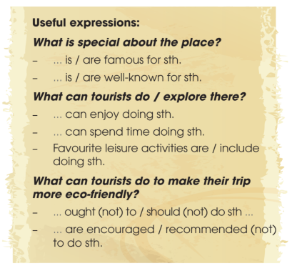  -Teacher asksstudents to rewrite them, using the suggested words and the structures in the box.  - Teacher asksstudents to swap their textbook for peer checking.  - Teacher checks answers as a class. | - Students discuss their answers.  Suggested answers:  What do you think is special about Hoi An villages?  – coconut palms near Thu Bon River  – traditional crafts such as colourful paper lanterns  What do you think tourists can do there?  – do the gardening at a local farm  – ride bicycles through the villages  – travel on basket boats  – visit craft villages  What can tourists do to make their trip more eco-friendly?  – use eco-friendly transport such as bicycles  – buy traditional crafts to help local people  -Students write them on the board and use coloured chalk to underline the structures in the answers.  Suggested answers:  1. Hoi An villages are well-known for their beautiful vegetable and herb gardens.  2. Tourists can spend the morning working on a local farm.  3. Tourists are recommended to buy handmade products to help local businesses
3. While – Writing: 15 minutes
a. Objectives: To help students practise writing a website advertisement for an ecotour to Hoi An villages.
b. Content: Write a website advertisement for an ecotour to Hoi An villages
c. ExpectedStudents’ activities: Ss can produce their first drafts.
d. Organization:
Teacher’s activities | Students’ activities
Task 3: Write a website advertisement (120 – 150 words) for an ecotour to Hoi An villages. Use what you have learnt in Task 1 and Task 2 and the suggested outline below to help you.  - Teacher asksstudents to study the suggested outline in their Student’s Book.  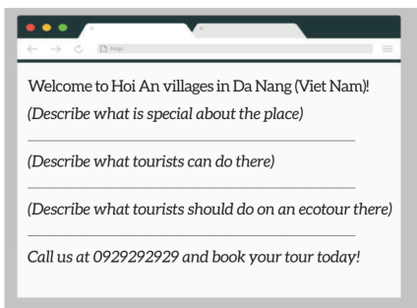  - Teacher givesstudents a time limit to do the writing task.  - Teacher walks round the class to provide help when necessary. | - Ss can produce their first drafts.
4. Post – Writing : 7 minutes
a. Objectives:To do a cross-check and final check on students’ writing.
b. Content: Write a website advertisement for an ecotour to Hoi An villages
c. ExpectedStudents’ activities:Students swap their draft letters for peer review
d. Organization:
Teacher’s activities | Students’ activities
-Teacher has the groups swap and give feedback on each other’s writing.  - Teacher then gives feedback on one writing as a model.  -Teacher collects Ss’ writings to mark and provide written feedback in the next lesson. | -Students work in pairs and swap their draft letters for peer review.  -Sample answer :  Welcome to Hoi An villages in Da Nang , Viet Nam !  Hoi An villages are famous for their beautiful vegetable and herd gardens . They are also well-known for the coconut palms near the Thu Bon River and traditional crafts such as colourful paper lanterns.  Here in Hoi An villages , you can spend the morning gardening on the local farms .Other leisure activities include riding bicycles through the villages , travelling on basket boats and visiting craft villages.  We offer an ecotour to Hoi An villages , and tourists are encouraged to use eco-friendly transport such as bicycles to avoid polluting the environment . You can also buy local products and beautiful crafts to help local businesses !  Call us at 0929292929 and book your tour today !

* HOMEWORK : (3 minutes)
- Rewrite the paragraph in the notebooks.
- Exercises in the workbook.
- Prepare for the next lesson: Unit 10: Communication and culture/ CLIL
Evaluation and adjustment (if any)
…………………………………………………………………………………………………………………
…………………………………………………………………………………………………………………

