**Date of preparation: September 19th, 2024 Full name: Ha Thi Thu Thao**

**UNIT 2: A MULTICULTURAL WORLD**

**Total number of periods: 8 (from 10 to 17)**

**Lesson 4: Speaking – Planning a Cultural Diversity Day, Period:13**

**Classes: 12A7, 12A8**

**I. OBJECTIVES**

By the end of this lesson, Ss will be able to:

**1. Knowledge**

- Gain an overview about how to plan a culture day;

- Memorise vocabulary to talk about plans for a culture day.

**2. Competences**

- Develop communication skills;

- Be collaborative and supportive in pair work and teamwork;

- Actively join in class activities.

**3. Personal qualities**

- Be proud and respectful of the cultures of Vietnam.

**II. MATERIALS**

- Grade 12 textbook, Unit 2, Speaking

- Computer connected to the Internet

- Projector / TV

- *hoclieu.vn*

**III. PROCEDURES**

**1. WARM-UP** (5 mins)

**a. Objectives:**

- To stir up the atmosphere and activate students’ knowledge on the topic;

- To set the context for the speaking part.

**b. Content:** Guessing game

**c. Expected outcomes:** Ss join the game enthusiastically and gain knowledge on the topic.

***Questions:***

1. What is the name of this music band?

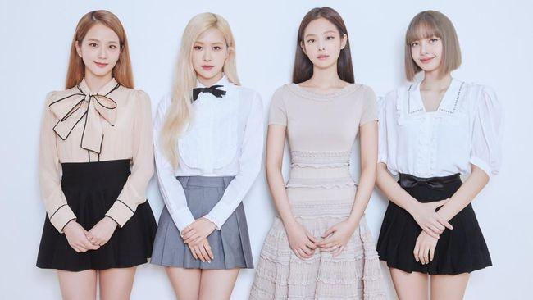

(Blackpink)

2. Who are they?

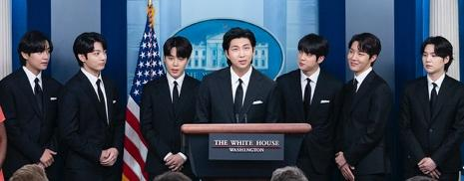

(BTS)

3. Fill in the blank:

They’re going to organise a ______ Diversity Day next weekend.(Cultural)

4. What is the name of a spicy food which is mainly made from Chinese cabbage?

(kimchi)

-> KEY WORD: South Korea

**d. Organisation:**

|  |  |
| --- | --- |
| **TEACHER’S ACTIVITIES** | **STUDENTS’ ACTIVITIES** |
| **Guessing game**  - Divide the class into two groups.  - There are four questions, the answers of which provide four clues for the keyword.  - Each group chooses a question. If they have a correct answer, they get one point.  - If a team can guess the keyword, they will get 5 points.  - The team with more points is the winner.  - Lead in the lesson.  **-** Observe and give feedback. | - Take turns, choose a number and answer the question.  - Guess the keyword.  - Explain their keyword. |

**2. PRESENTATION** (10 mins)

**a. Objectives:**

- To provide knowledge and language input for the main speaking task;

- To activate prior knowledge about the topic and get Ss involved in the lesson.

**b. Content:**

- Task 1: Work in pairs. Discuss the differences between Vietnamese culture and some other cultures you know about. Use the ideas in Getting Started and Reading, and the table and examples below to help you. (p.25)

- Pre-teach vocabulary

**c. Expected outcomes:** Ss can identify and gain some vocabulary to complete speaking tasks.

**Suggested answers:**

**- Task 1:**

**A:** South Koreans seem to eat a lot of spicy food, such as kimchi and tteokbokki, while our traditional dishes, like bun cha and pho, are not very spicy in general.

**B:** I agree. How about music? I think in both countries, young people like to listen to pop music, but K-pop focuses mainly on dance groups while our pop music is usually produced by solo artists.

***- New words:***

1. spicy (adj) 2. focus on (v) 3. professional (adj)

**d. Organisation**

|  |  |
| --- | --- |
| **TEACHER’S ACTIVITIES** | **STUDENTS’ ACTIVITIES** |
| **Task 1: Work in pairs. Discuss the differences between Vietnamese culture and some other cultures you know about. Use the ideas in Getting Started and Reading, and the table and examples below to help you. (10 mins)** | |
| - Remind Ss of the reading text about the Korean Wave, and elicit what its effects on the life of Vietnamese people.  - Ask, *How much do you know about Korean culture?* and encourage Ss to come up with as many points as they can (tradition, cuisine, clothes, music, …)  - Then ask Ss to read the table to see if any of their points are included there. Have them work in pairs and discuss the similarities and differences between South Korean and Vietnamese cultures.  - Check answers as a class.  - Recap the comparison Ss have found and write some of them on board, e.g.  * **Similarities**: *both countries eat rice and noodles, a lot of vegetables and soups; use chopsticks; street food is a big part of both cultures. They both worship ancestors, celebrate Lunar New Year, Middle Autumn Festival, Buddha’s Birthday. They have traditional clothes.*  * **Differences**: *Koreans eat spicy food and a lot of kimchi; each person eats their own bowl, plates and dishes; they don’t talk when eating and don’t hold their bowl; greetings…* | - Share what they know about the two people.  - Read and understand the information on their cards. |
| **Vocabulary pre-teaching** (5 mins) | |
| - Introduce the vocabulary.  - Explain the meaning of the new vocabulary with different techniques (pictures, actions, synonyms …)  - Check Ss’ understanding with the “Rub out and remember” technique.  - Ask Ss to take notes on their notebooks. | - Listen to the teacher’s explanation and guess the words.  - Write down the new words on their notebook. |

**3. WHILE-SPEAKING** (20 mins)

**a. Objective:** To help Ss practise talking about and taking notes about the similarities and differences in Vietnamese and Korean cultures.

**b. Content:** Task 2: Work in groups. Your school is organising a Cultural Diversity Day. Discuss what the event should include. Use the ideas in 1 to create the event programme. (p.26)

**c. Expected outcomes:** Ss can come to the final plan for a culture day.

**Suggested answers:**

**Task 2**

**A:** We’ve decided to organise a Cultural Diversity Day in our school. Let’s discuss what activities

to include.

**B:** First, we should set up some food stalls offering traditional dishes from different cultures.

**C:** That sounds fun! We can call them ‘Taste the World’. We can also show visitors how to cook

these dishes.

**D:** I like your idea, but we don’t have any cooking experience. We may need to involve professional cooks.

**d. Organisation**

|  |  |
| --- | --- |
| **TEACHER’S ACTIVITIES** | **STUDENTS’ ACTIVITIES** |
| **Task 2: Work in groups. Your school is organising a Cultural Diversity Day. Discuss what the event should include. Use the ideas in 1 to create the event programme.** (15 mins) | |
| - Put Ss in groups and have them discuss their own plan for a Cultural Diversity Day. Remind Ss to think of the popularity of culture diversity in Viet Nam (regarding to the reading section)  - In weaker classes, write some guiding questions on the board and ask Ss to think of the answers to these questions. E.g. *What activities will you include in the programme? ; Who will be the participants? Where/when will you organise the event?*...  - Walk around and provide help if necessary.  - Invite Ss to share their plans with the class.  - Give corrections and feedback.  - Observe Ss’ writing of vocabulary in their notebooks. | - Work in groups to discuss how to organise the event.  - Compare their notes with their partners. |

**4. POST-SPEAKING** (8 mins)

**a. Objectives:**

- To give Ss an opportunity to present their group discussion to the class;

- To help some Ss enhance presentation skills.

**b. Content:** Task 3: Report your group’s ideas to the whole class. Vote for the best Cultural Diversity

Day programme. (p.26)

**c. Expected outcomes:** Ss can use the language and ideas from the unit to talk about their ideas for the Cultural Diversity Day.

**d. Organisation**

|  |  |
| --- | --- |
| **TEACHER’S ACTIVITIES** | **STUDENTS’ ACTIVITIES** |
| **Task 3: Report your group’s ideas to the whole class. Vote for the best Cultural Diversity Day programme.** | |
| - Have a representative from all groups share their plan in front of the class.  - Praise for good effort, well-structured responses and fluent delivery.  - After all groups present their plans to a situation, ask the class to vote for the best programme (suggested criteria: number of activities, duration, participants, preparation for the event…). Remind Ss not to vote for their own plan. Count the votes for each group and announce the best plan.  - Check Ss’ pronunciation and give feedback. | - Work in pairs, use the notes and talk about their ideas of a culture day they want to organise.  - Add more details if they can.  - Vote for the best story. |

**\* Homework** (2 mins)

- Write a paragraph about the similarities and differences in Vietnamese and Korean cultures.

- Do exercises in the workbook.

- Prepare for the next lesson – Listening.