Date of preparation: October 2nd , 2024 Full Name: Nguyen Thi Phuong
UNIT 3: CITIES OF THE FUTURE
Number of periods: 8 (Period: 18 to 25)
Lesson 1: GETTING STARTED - Period : 18
Classes: 11A2, 11A7

I. OBJECTIVES: By the end of this session, Ss will be able to:
1. Knowledge
- Gain an overview about the topic cities of the future
- Gain vocabulary to talk about cities and smart living.
- Get to know the grammar point of stative verbs in the continuous form and linking verbs.
2. Competences
- Develop communication skills and creativity;
- Be collaborative and supportive in pair work and teamwork.
- Actively join in class activities
3. Personal qualities
- Arouse interests in life in cities of the future
- Develop self-study skills.
II. TEACHING AIDS AND MATERIALS
- Grade 11 textbook, Unit 3, Getting started
- Computer connected to the Internet
- Projector/ TV/ pictures and cards
- hoclieu.vn
III. PROCEDURES
1. Warm up: (5 minutes)
a. Objectives :
- To get Ss to know the topic about cities of the future
- To create a friendly and lively atmosphere in the classroom and activate students’ knowledge on the topic of an exhibition of future cities
- To lead into the unit
b. Content: Game: Hot potato (Revise some of the target words learnt in Unit 2).
c. Expected outcomes: Students can revise some target words learnt in Unit 2.
d. Organization:
Teacher’s activities | Students’ activities
Game: Hot potato  - Have Ss stand in a circle or two rows facing each other and set a time limit for the game.  - Throw the ball to one student and has him/her call out one target word or phrase from Unit 2. Then he/she throws the ball to another student, who has to say another target word.  - The game continues until the time is up or all Ss have had a chance to say a word or phrase.  Target words in Unit 2  (generation gap, conflict, extended family, nuclear family, characteristic, digital native, argument…)  - Observe the groups and gives feedback | * Do as instructed.  - Play the game  - Listen to the teacher
2. Presentation: (5 minutes)
a. Objective: To get students to learn vocabulary related to the topic.
b. Content: Pre-teach vocabulary related to the content of the dialogue.
c. Expected outcomes: Students can use key language more appropriately before they read.
d. Organisation

Teacher’s activities | Students’ activities
Vocabulary pre-teaching  - Introduce the vocabulary.  - Explains the meaning of the new vocabulary  New words:  1. impact (n) /ˈɪmpækt/: the powerful effect that something has on somebody/something  2. public transport (n) /ˌpʌblɪk ˈtrænspɔːt/: The system of buses, trains, etc. provided by the government or by companies, which people use to travel from one place to another  E.g: Most of us use public transport to get to work.  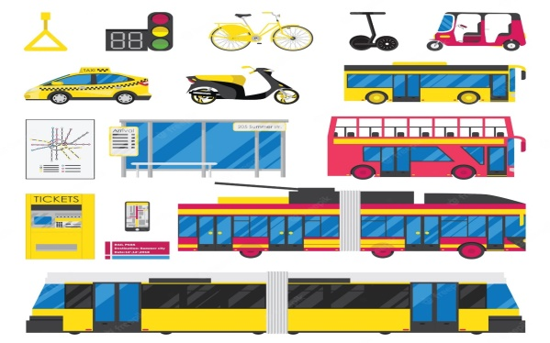  3. infrastructure (n) /ˈɪnfrəˌstrʌktʃə/: the basic systems and structures that a country or organization needs in order to work properly  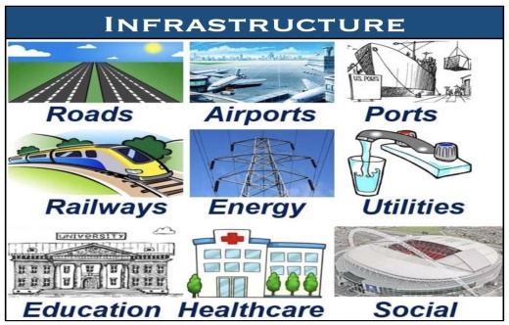  4. traffic jam (n): /ˈtræfɪk dʒæm/: a long line of vehicles on a road that cannot move or can only move very slowly  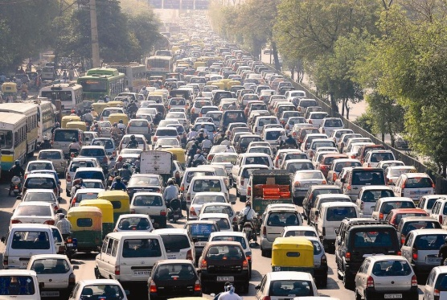  5. carbon footprint (n): /ˈkɑːbən ˈfʊtˌprɪnt/: the amount of carbon dioxide that a person or organization produces by the things they do  - Check students’ understanding with the “Rub out and remember” technique.  - Reveal that these five words will appear in the reading text and asks students to open their textbook to discover further  - Check students’ pronunciation and give feedback.  - Observe Ss’ writing of vocabulary in their notebooks. | - Say the Vietnamese meaning of the word.  - Other Ss correct if the previous answers are incorrect.  - Repeat the words in chorus.  - Write down new words.
3. Practice: (20 minutes)
a. Objectives:
- To check Ss’ comprehension of the conversation.
- To introduce words and phrases related to healthy lifestyles.
b. Content:
- Task 1: Listen and read (p.28)
- Task 2. Read the conversation again and complete the notes. Use no more than TWO words for each blank. (p.29)
- Task 3. Match the words to make phrases mentioned in 1. (p.29)
- Task 4. Complete the sentences with phrases from 1. (p.29)
c. Expected outcomes: Students can thoroughly understand the content of the text and complete the tasks successfully.
- Suggested answers:
Task 1
+ Tall buildings, roads in the air, flying private vehicles
+ People travel by flying objects instead of going by car or bus. …
+Life will be more convenient without pollution. …
Task 2.
1. green areas 2. traffic jams 3. Technology 4. housin
Task 3.
1. public transport 2. private vehicles 3. modern infrastructure
4. high-rise buildings 5. smart city
d. Organisation
Teacher’s activities | Students’ activities
Task 1. Listen and read. (5 mins)  - Ask Ss to look at the pictures in the book as well as the dialogue and answer the questions.  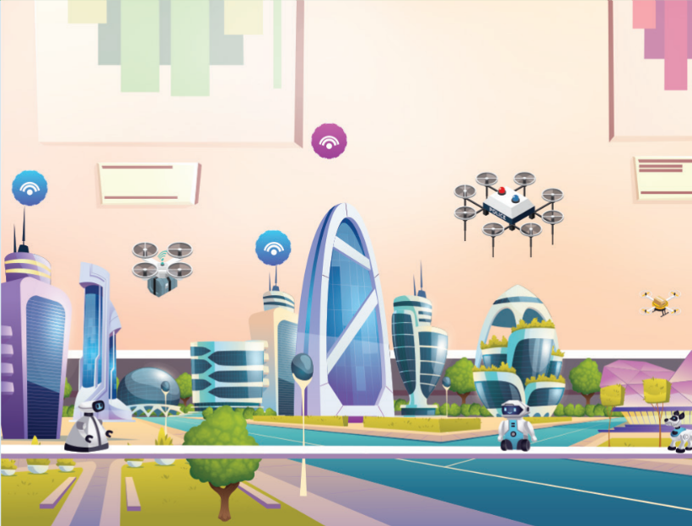  Questions:  + What can you see in the picture?  +How is the city different from that now?  +What do you benefit from living in this city?  - Play the recording twice. Ss listen and read.  - Check Ss’ prediction. T calls 2 Ss to read the conversation aloud.  Task 2. Read the conversation again and complete the notes. Use no more than TWO words for each blank. (5 mins)  - Tell Ss to read the conversation again and work independently to find the answers.  - Let Ss compare the answers in pairs before checking with the whole class.  - Check the answers as a class and gives feedback.  Task 3. Match the words to make phrases mentioned in 1. (5 mins)  - Have Ss look at task 3, and ask Ss to do the matching.  - Ask Ss to read out the phrases they have found and explain the meaning of them.  - Check answers as a class.  Task 4. Complete the sentences with phrases from 1. (5 mins)  - Ask Ss to read the three statements.  - Ask Ss to complete the sentences, using the correct phrases from the text.  - Check answers as a class.  - Observe on Ss’ performance.  - Feedback and peers’ feedback. | - Look at the picture and answer the questions  - Share their answers with a partner.  - Read the conversation  - One pair reads aloud.  - Do the task individually first to find the answers..  - Share and discuss with their partners about the key words  - Do the task in pairs.  - Work individually  - Share their answers with a partner  - Do the task individually
4. Production: (6 minutes)
a. Objectives:
- To help Ss practice speaking skills;
- To help Ss imagine their cities of the future.
b. Content: Interview
c. Expected outcomes: Students can give a short talk about their cities of the future.
d. Organisation
Teacher’s activities | Students’ activities
Task 5. Interview  - Ask Ss to work in pairs. Ask them to draw their city of the future. Then, look at the picture and ask each other.  - Invite 1 or 2 pairs to come to the stage and do the interview.  - Ask other students to listen and give comments.  - Give feedback and gives marks to the students with good performance.  - Observe on Ss’ performance.  - Feedback and peers’ feedback. | - Do as instructed  - Listen and draw experience.
* Homework: (5 minutes)
- Exercises in the workbook
- Project preparation
- Have Ss look at the last page of Unit 1, the Project lesson and ask them what topic of the project is.
- Tell them the project requirements: Design a poster about the ideal city
+ suggest activities, provide the reasons and expected results of the activities;
+ present their plans in the last lesson of the unit.
- Remind Ss that besides brainstorming activities, they:
+ can search for ideas on the Internet, in the newspaper, etc. for reference.
+ should use poster to illustrate their ideas.
- Put Ss into groups and have them choose their group leader. Ask them to assign tasks for each member, making sure that all group members contribute to the project work.
- Help Ss set deadlines for each task.

