UNIT 3: MUSIC Total number of periods: 8 (from 18 to 25)
Lesson: LISTENING Period: 22
Classes: 10A1, 10A7

I. OBJECTIVES
By the end of this lesson, Ss will be able to: acquire all the knowledge, competency and qualities stated in the following areas.
1. Knowledge :
- Listen for gist and specific information in an interview about a music festival;
- Talk about the reasons why they want/ don’t want to go to a music festival.
2. Competences :
- Be collaborative and supportive in pair work and team work;
- Actively join in class activities;
- Develop presentation skills;
- Be critical in thinking.
3. Personal qualities/ Attributes
- Be more interested in music and music events.
- Be able to self-study.
II. TEACHING AIDS AND MATERIALS
▪ Equipment: Flashcards/ pictures, realia, worksheets, audio CD, CD player, computer and screen, sound system, Projector/ TV.
▪ Materials: Tiếng Anh 10 Global Success (Student book, Teacher’s book), handouts, online resources
III. PROCEDURES
1. Warm up: 5 minutes
a. Objectives:
- To arouse the classroom atmosphere.
- To get Ss be actively involved in the lesson
- To lead into the lesson.
b. Content:Watch the video and write down the name of the music festivals.
c. Expected Students’ activities:
- The music makes people feel uplifted with hope and love.
d. Organization:

Teacher’s activities | Students’ activities
Video watching: Watch the video and write down the name of the music festivals.  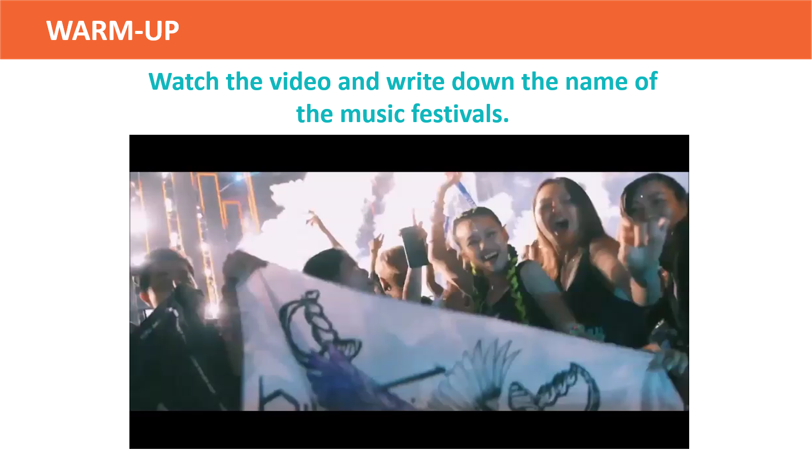  - Give the instructions and plays the recording.  - Ss watch the video and write down the name of the music festivals.  - Ss share their answers with a partner.  - Check by having some Ss to call out the answers.  - Ask Ss if they know anything about these music festivals | By the end of the activity, students can take some notes about the music festivals they hear  -Yamaha Revolution Music Festival  -Asia Artist Award  -Monsoon Music Festival  -Coachella  -Epizode  -Tomorrow Land

2. Pre-Listening: (10 minutes)
Activity 1: VOCABULARY – Task 1
a. Objectives:
- To pre-teach the pronunciation and the meaning of some vocabulary so that Ss can understand the content of the listening.
- To introduce the topic of the listening and get Ss involved in the lesson.
b. Content: vocabulary
c. Expected Students’ activities: background, stage, free of charge, overcrowding
d. Organization:
Teacher’s activities | Students’ activities
Vocabulary  - Show the words one by one, plays the recording and has Ss repeat the sound of the words.  - Have Ss guess the meaning of the words based on pictures, explanations and examples.  1/    2/    3/    4/  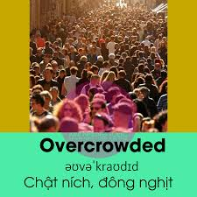  - Ss do as instructed  - Teacher confirms the meaning, calls on some individual Ss to make sentences with each word.  TASK 1: look at the picture and answer the following questions.  - What kind of event is it?  - Where does the event usually take place?    - Ask Ss to work in pairs to look at the picture and discuss the questions.  - Ss discuss in pairs.  - Brainstorm more ideas about the picture in a whole-class discussion.  - Ask Ss what they know about this type of event or if they have been to a music festival or an outdoor concert.  - To introduce the topic of the listening and get Ss involved in the lesson. | By the end of the activity, students can learn some vocabulary for the listening activity.  - stage (n): a raised area, usually in a theatre, etc. where actors, dancers, etc. perform  - free of charge (adv): without having to pay  - overcrowding (adj): the situation when there are too many people or things in one place  - in advance (idiom): before the time that is expected; before something happens  - background (n): sounds that can be heard behind other sounds that are louder  By the end of the activity, students can focus on what they will listen to for the listening activity.  Suggested answers:  1. a music festival / an outdoor concert  2. outdoors: on a farm / at a stadium / a park / a beach

3. While-Listening (20 mins)
Activity 3: Listen to an interview about preparations for an international youth music festival. tick the information that you hear in the recording. (Ex.2, p.33) (10 minutes)
a. Objectives:
- To help Ss practise listening for gist.
- To help Ss practise listening for specific information
b. Content: listen to an interview about preparations for an international youth music festival. tick the information that you hear in the recording.
c. Expected Students’ activities:
- Students listen for gist
- Expected answer:
Key: A, D
d. Organization:
Teacher’s activities | Students’ activities
TASK 2: listen to an interview about preparations for an international youth music festival. tick the information that you hear in the recording.  - Ask Ss to look through the list of topics and guess what they are going to hear in the recording.  - Ss do as instructed.  - Call on individual Ss to talk about their predictions.  - Ask Ss to listen and check if their guesses are correct.  - Check answers as a class and asks Ss to support their answers with clues from the recording, e.g. A: on the beach, country park; D: sold the tickets in advance.  - Play the recording a second time, pausing after the clues in weaker classes. | Activity 4: WHILE-LISTENING (12 min)  By the end of the activity, students can listen for gist and specific information.  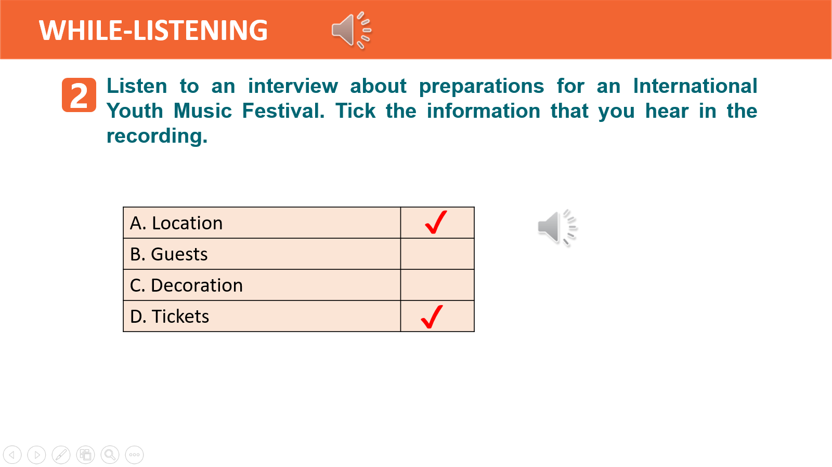  Suggested answer: A, D

Activity 4: Listen again and decide whether the following statements are true (t) or false (f). .
a. Objectives: To help Ss practise listening for specific information.
b. Content: listen again and decide whether the following statements are true (t) or false (f).
c. Expected Students’ activities:
- Students listen for specific information.
- Expected answer:
Key: 1. F (first -> second); 2. F (They are still setting up the main stage and there’s still a lot to do.); 3. T; 4. F (They have sold the tickets in advance.); 5. T
d. Organization:

Teacher’s activities | Students’ activities
TASK 3: listen again and decide whether the following statements are true (t) or false (f). (Ex.3, p.33) (6 min)  - Ask Ss to read the sentences and underline the key words.  - Have Ss identify the True / False statements based on what they have remembered from the first listening in 2.  - Play the recording and encourages Ss to note down key words or phrases.  - Ss do as instructed.  - Ss work in pairs or groups to compare answers.  - Check answers as a class and plays the recording again, pausing at the sentences that contain the clues in weaker classes.  - Have Ss correct the false sentences. | Suggested answer:  1. F (first -> second); 2. F (They are still setting up the main stage and there’s still a lot to do.); 3. T; 4. F (They have sold the tickets in advance.); 5. T  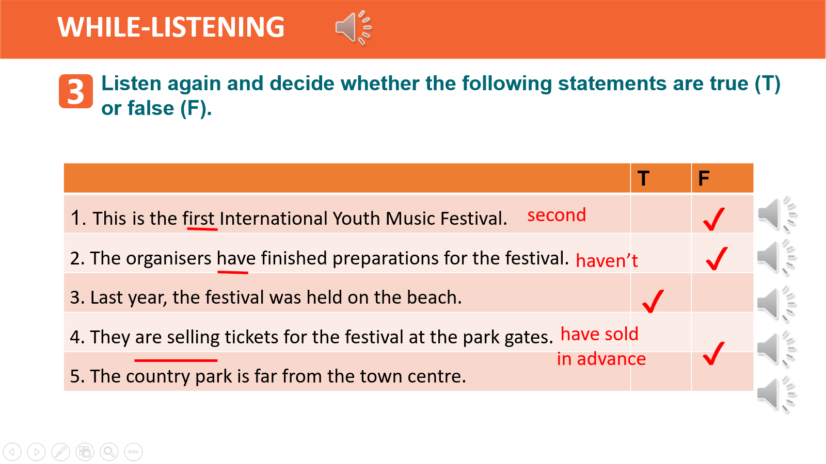

4. Post-Listening (5 mins)
Activity 5: work in groups. discuss the following questions:Do you want to go to a music festival? Why or why not? (Ex.4, p.33)
a. Objectives: To give Ss an opportunity to personalise the language and ideas from the listening in a speaking task.
b. Content: discuss the following questions:Do you want to go to a music festival? Why or why not?
c. Expected Students’ activities:
- Students have a chance to apply what they have learnt.
- Students memorise what they have learned.
d. Organization:
Teacher’s activities | Students’ activities
TASK 4: work in groups. discuss the following questions.  Do you want to go to a music festival? Why or why not?  - Ask some lead-in questions to see whether Ss have taken part in any music festivals, and how much experience they have, e.g. Have you ever taken part in a music festival? How many times have you participated in such events? What did you do there? How did you feel?  - Put Ss in groups to discuss the two questions.  - Remind them that they can use the ideas from the warm-up activity and the ideas in their homework in the speaking lesson.  - Ss do as instructed  - Ss share their ideas with the rest of the class.  - Invite some individuals to share their ideas to the whole class, and give comments. | By the end of the activity, students can talk about a music festival.  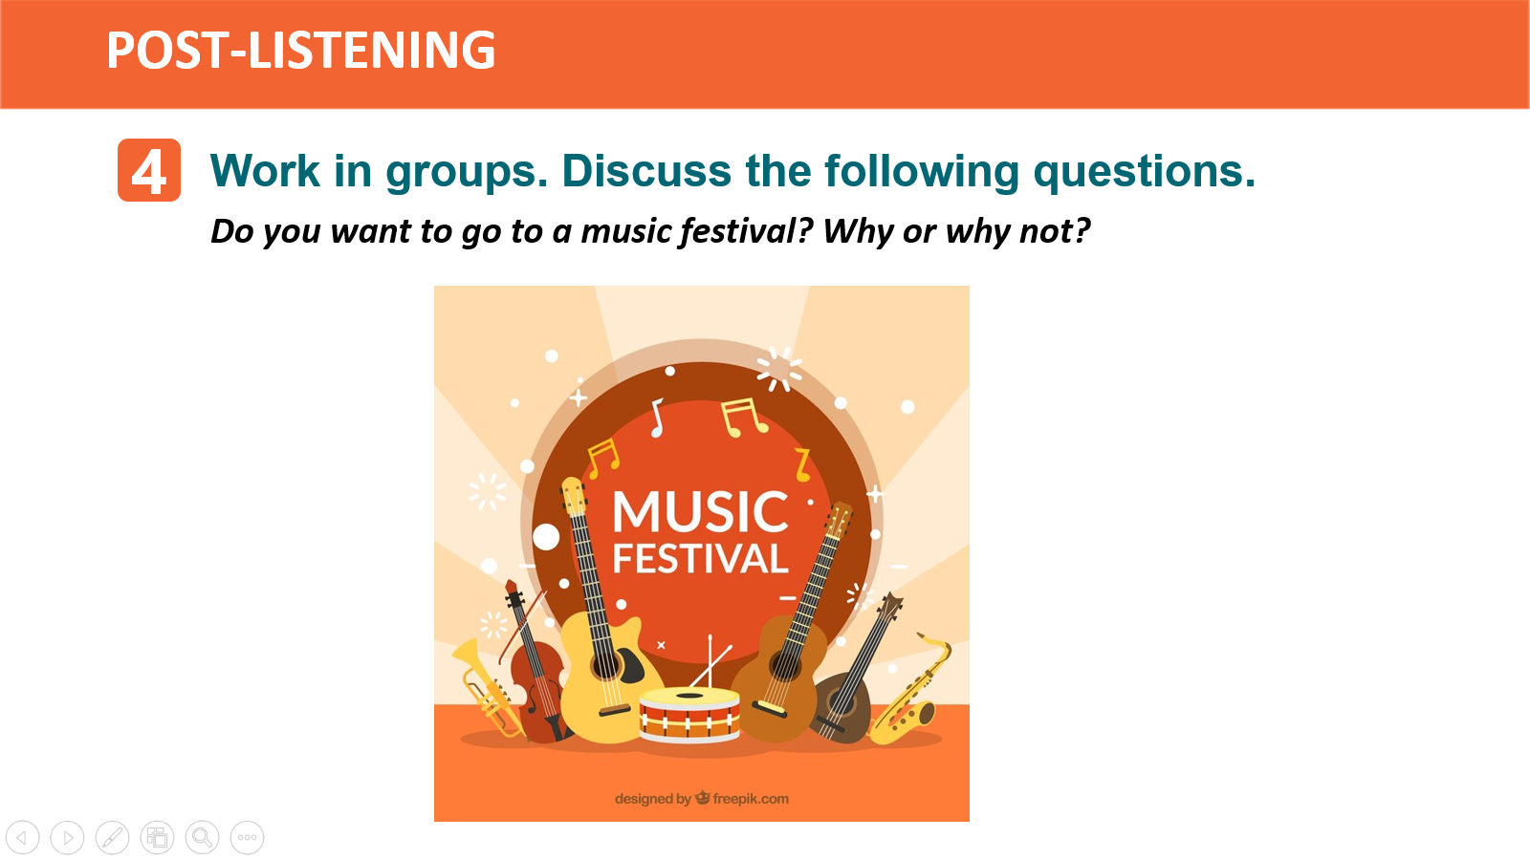
Homework: (5mins)
- Do the exercises in the workbook
- To consolidate what students have learnt in the lesson.
- Search the Internet for some information about music festivals.
- Prepare for Writing lesson - Prepare for Writing lesson

