Theme: Me and the world around

Week: 33 Period: 131 Number of periods: 3

Unit 20: At summer camp
Lesson 1 (4, 5, 6)
Classes:4A, 4B, 4C, 4D, 4E
Teaching time : from 2nd May to 4th May 2024

A. OBJECTIVES:
By the end of the lesson, Ss will be able to:
1. Knowledge:
- Use the phrases building a campfire, putting up a tent, taking a photo and telling a story in relation to the topic “At summer camp”
- Listen to and understand four communicative contexts in which characters ask and answer questions about what someone is doing at a camp and match the correct pictures.
- Complete four gapped exchanges with the help of picture cues.
- Vocabulary: Review
- Skills: speaking, listening, reading and writing.
2. Competences:
- Co-operation: ready to help friends in pair work/ group work.
- Self-control and independent learning: perform listening tasks.
3. Attitude/ Qualities:
- Kindness: Help partners to complete learning tasks.
- Honesty: tell the truth about feelings and emotions.
B. TEACHING AIDS:
- Teacher: Teacher’s guide Pages 283, 284; audio Tracks 94; website hoclieu.vn, posters, laptop, pictures, textbook, lesson plan, TV or projector.
- Students: Pupil’s book Page 65, notebooks, workbooks, school things.
C. PROCEDURES:
Time | Teacher’s activities | Students’ activities
5ms  27ms  3ms | 1.Warm- up:  Game: Who says faster?  *Aims: to create a friendly and active atmosphere in the class to beginning the lesson.  *Procedure:  - Holds a activity card, then reveal it slowly.  - Asks What’s he/ she doing?  - Asks the Ss guess the answer as fast as possible.  - Then has Ss do the same with the rest.  - This can be played in groups to make it more interesting.  - Says “Open your book page 65” and look at “Unit 20, Lesson 1 (4,5,6)”.  2.Practice:  Activity 1. Listen and match:  *Aims: Ss will be able to listen to and understand four communicative contexts in which characters ask and answer questions about what someone is doing at a camp and match the correct pictures.  *Procedure:  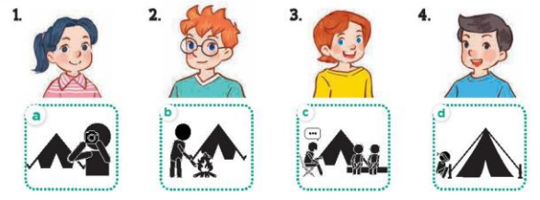  - Plays the recording for Ss to listen to.  - Plays the recording again for them to do the task by matching the characters to their activities.  - Plays the recording a third time to give Ss another listening opportunity.  - Checks answers as a class.  - Plays the recording, sentence by sentence, for the class to listen and repeat individually and in chorus.  Key: 1. c 2. d 3. a 4. b  Activity 2. Look, complete and read  *Aims: Ss will be able to complete four gapped exchanges with the help of picture cues.  *Procedure:  - Has Ss look at the pictures and gets them to identify the characters and their activities in the pictures  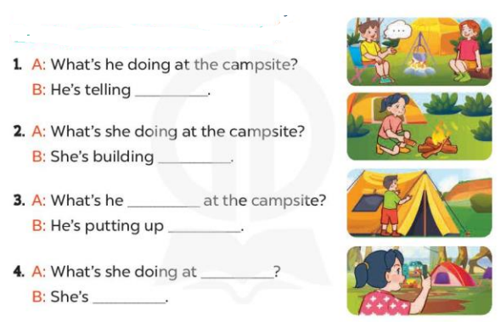  - Has Ss look at the four sentences and the pictures. Elicit and model with picture 1  + Asks Ss to read the sentence 1 in chorus.  + Asks them what is missing in the question (a story). Then has them complete the gap (He’s telling a story).  -Has Ss work in pairs and complete the dialogue 2, 3, 4.  - Ask a few Ss to stand up and reads the sentences aloud.  -T gives feedbacks.  Key:  1. a story 2. a campfire  3. doing; a tent 4. the campsite; taking a photo  Activity 3. Let’s play  *Aims: Ss will be able to revise target words about what someone is doing at a camp by playing “Guess what they are doing”.  *Procedure:  - Explains how the game is played.  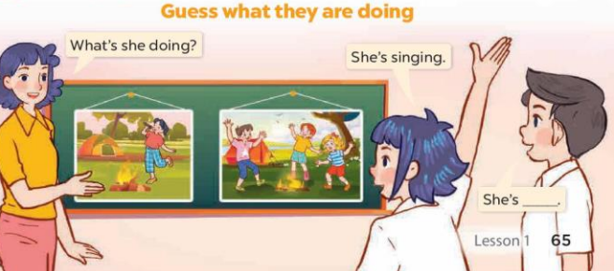  - Divides Ss into groups of five  + Has Ss look at the first picture and answer the question What’s she doing?  + The Ss in each group guess the girl’s activities in the picture and give the answers  (Ex: She’s singing. She’s dancing….)  - Has Ss practise asking and answering questions about what the pupils are doing with the help of picture.  *Consolidation  *Aims: Ss will be able consolidate and wrap up the content of the lesson.  *Procedure:  - T asks ss to answer the following questions:  + What have you learnt from the lesson today?  - T praises some Ss who are hardworking / active/ good…. as well as encourage others to try more.  - Prepare the new lesson: Unit 20, Lesson 2 (1,2,3). | - Ss listen  - Ss play the game  - Ss open their books  -Look at the pictures and say:  1. Mai 2. Ben 3. Lucy 4. Nam  - a. a person taking a photo (stick figure)  - b. a person building a campfire (stick figure)  - c. a person telling a story and two friends listening (stick figures)  - d. a person putting up a tent (stick figure)  - Ss listen to the tape  - Ss listen again and tick  - Ss listen again and check  - Ss check their answers  -Ss listen and repeat, sentence by sentence,  -Ss look at the picture and say  -Ss look and answer  -Ss read  -Ss say and complete  -Ss work in pairs and complete  -Ss read aloud the sentences  - Ss listen  -Ss listen how to play a game  -Ss play the game  -Ss answer the questions  -Ss listen and clap their hands  -Ss listen and take note
D. ADJUSTMENTS (if necessary):
………………………………………………………………………………………….…..……………………………………………………………………………...………………………………………….…..……………………………………………………………………………….……………………………………………………………………...

Theme: Me and the world around

Week: 33 Period: 132 Number of periods: 4

Unit 20: At summer camp
Lesson 2 (1, 2, 3)
Classes:4A, 4B, 4C, 4D, 4E
Teaching time : from 2nd May to 4th May 2024
A. OBJECTIVES:
By the end of the lesson, Ss will be able to:
1. Knowledge:
- Use the phrases dancing around the campfire, playing card games, playing tug of war, singing songs in relation to the topic “At summer camp”.
- Use What are they doing? – They’re ……. to ask and answer questions about what people are doing at a camp
- Vocabulary: dancing around the campfire, playing card games, playing tug of war, singing songs
- Model sentences: A: What are they doing?
B: They’re playing card games.
- Skills: speaking and listening
2. Competences:
- Co-operation: ready to help friends in pair work/ group work.
- Sociability: Talk to each other, say good words to others.
3. Attitude/ Qualities:
- Kindness: Help partners to complete learning tasks.
- Honesty: tell the truth about feelings and emotions
B. TEACHING AIDS:
- Teacher: Teacher’s guide Pages 285, 286; audio Tracks 95, 96, website hoclieu.vn, posters, laptop, pictures, textbook, lesson plan, TV or projector.
- Students: Pupil’s book Page 66, notebooks, workbooks, school things.
C. PROCEDURES:
Time | Teacher’s activities | Students’ activities
3ms  16ms  7ms  7ms  2ms | 1.Warm- up:  Game: Pass the ball  *Aims: to create a friendly and active atmosphere in the class to beginning the lesson.  *Procedure:  - Stands up and passs the ball with music.  - When music stops, those who keep the ball must look at a picture on the board and say a sentence: He’s/ she’s…….  - Says “Open your book page 66” and look at “Unit 20, Lesson 2 (1,2,3)”.  2. Presentation  Activity 1. Vocabulary.  *Aims: Ss will be able to know the vocabulary in the new lesson.  *Procedure:  -T elicits the new words  + play tug a war : chơi kéo co (picture)  + play card games : chơi bài (picture)  + dance around the campfire: nhảy múa quanh lửa trại (explain)  + sing songs: hát hò (mime)  - T models (3 times).  - T writes the words on the board.  - Checking: Rub out and remember  Activity 2. Look, listen and repeat:  *Aims: Ss will be able to understand and correctly repeat the sentences in two communicative contexts focusing on asking and answering questions about what people are doing at a camp.  *Procedure:  - Has Ss look at Pictures a and b and identifies the places, characters and their activities.  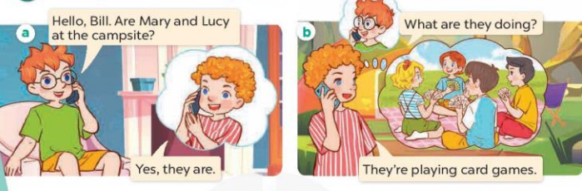  - Plays the audio twice (sentence by sentence). Correct their pronunciation where necessary.  - Has Ss to practice the diaguage  - T invites a few pairs to the front of the class to practice.  - T checks pronunciation for ss.  Activity 3. Listen, point and say.  *Aims: Ss will be able to correctly say the phrases and use What are they doing? – They’re ……. to ask and answer questions about what people are doing at a camp. *Procedure:  * Model sentences:  - T asks Ss look at picture b and helps Ss know the structure from the dialogue.  - T introduces new structure for Ss.  - T explains, models and gives meaning.  - Has Ss repeat the model sentences.  A: What are they doing?  B: They’re playing card games.  3.Practice:  *Drill pictures  - Has Ss look at the pictures and elicit the activities.  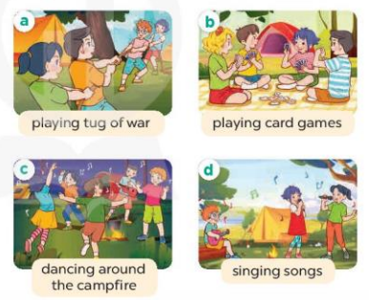  - Runs through all the pictures.  - Runs through model sentences.  +Runs through the question sentences  +Runs through the answer sentences  - Has Ss to practise:  + T asks, Ss answer picture a  + Ss ask, T answers picture b  + Group A ask, group B answer picture c  + Group B ask, group A answer picture d  - Asks Ss to work in pairs.  - T controls and corrects.  - Invites a few pairs to come to the front of the classroom, point at the pictures and say in front of the class.  - T gives feedbacks.  4.Production:  Activity 4. Let’s talk.  *Aims: Ss will be able to enhance the correct use of What are they doing? – They’re …… to ask and answer questions about what people are doing at a camp in a freer context.  *Procedure:  - Drawa Ss’ attention to the pictures and ask questions to help them identify the context.  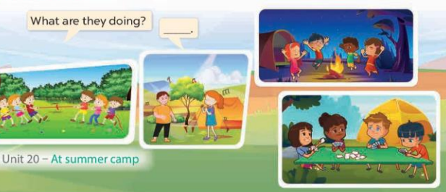  - Elicita the missing words in the bubble and writea them on the board. Geta Ss to say the completed sentences.  - Puta Ss into pairs and encourages them to ask and answer questions about what people are doing at the camp, using What are they doing? – They’re ……..  - Invites a few pairs to the front of the class to perform their conversations.  *Consolidation  *Aims: Ss will be able consolidate and wrap up the content of the lesson.  *Procedure:  - T asks ss to answer the following questions:  + What have you learnt from the lesson today?  - T review the vocabulary and model sentences.  - T praises some Ss who are hardworking / active/ good…. as well as encourage others to try more.  - Learn the vocabulary and model sentences by heart  - Prepare the new lesson: Unit 20, Lesson 2 (4,5,6). | - Ss listen  - Ss play the game  - Ss open their books  -Ss listen and answer  - - Ss listen and repeat  + Choral repetition (3 times).  + Individual repetition (3 ss)  - Ss take note  - Ss look, remember and write  -Look at the pictures and get to know the characters in the pictures.  + In picture a:  Ben: Hello, Bill. Are Mary and Lucy at the campsite?  Bill: Yes, they are.  – In picture b:  Ben: What are they doing?  Bill: They’re playing card games.  -Ss listen and repeat in chorus  -Ss work in pairs to practice  -Ss practice the diaguage  -Ss listen  -Ss look at the picture and answer.  -Ss listen  -Ss listen and repeat  -Ss repeat  -Ss listen and answer  +Picture a. Two teams of friends playing tug of war  +Picture b. Some friends playing card games  +Picture c. Some friends dancing around a campfire  +Picture d. Some friends singing songs  - Ss look, listen and repeat  - Ss look, listen and repeat  - Ss practice in chorus  -Ss work in pairs to practice  -Ss listen  -Ss go to the board and point and say  -Ss listen  -Ss look at the picture and answer  + two teams playing tug of war, two characters singing songs, four characters playing card games and four characters dancing around the campfire.  -Ss pay attention and say  -Ss work in pairs to ask and answer the questions  -Ss practise in pair in front of the class.  -Ss answer the question  - Ss listen  -Ss listen and clap their hands  -Ss listen and take note
D. ADJUSTMENTS (if necessary):
………………………………………………………………………………………….…

