Theme: Me and the world around
Week: 29 Period: 113 Number of periods: 1

UNIT 17: IN THE CITY
Lesson 1 (4, 5, 6)
Classes:4A, 4B, 4C, 4D, 4E
Teaching time : from 1st April to 5th April 2024

I. OBJECTIVES:
By the end of the lesson, Ss will be able to:
1. Knowledge:
- Use What does it say? – It says ʽ_____ʼ. ask and answer questions to identify road signs.
- Listen to and demonstrate understanding of simple communicative contexts in relation to the topic “In the city”
- Vocabulary: Review
- Skills: speaking, listening, reading and writing.
2. Competences:
- Co-operation: ready to help friends in pair work/ group work.
- Self-control and independent learning: perform listening tasks.
3. Attitude/ Qualities:
- Kindness: Help partners to complete learning tasks.
- Diligence: complete learning tasks.
II. TEACHING AIDS:
- Teacher: Teacher’s guide Pages 243, 244; audio Tracks 64, 65; website hoclieu.vn, posters, laptop, pictures, textbook, lesson plan, TV or projector.
- Students: Pupil’s book Page 47, notebooks, workbooks, school things.
III. PROCEDURES:
Time | Teacher’s activities | Students’ activities
5ms  27ms  3ms | 1.Warm- up:  Game: Lucky Number (PPT)  *Aims: to create a friendly and active atmosphere in the class to beginning the lesson.  *Procedure:  - Divide the class into 2 teams.  - Have Ss from each team choose a number, then answer the question.  + If the Ss answer correctly, they get the points for that question.  - After 5 numbers, the team with the most points is the winner.  - Say “Open your book page 47” and look at “Unit 17, Lesson 1 (4,5,6)”.  2.Practice:  Activity 1. Listen and tick or cross:  *Aims: Ss will be able to listen to and understand four communicative contexts in which pupils ask and answer questions about the road signs and tick or cross the pictures.  *Procedure:  - Elicit the meaning of the road signs..    - T ask Ss to guess the answers.  + T writes Ss’guessing on the board.  - Listen to the tape:  + Play the recording  + Play the recording again and get Ss to swap books with their partners.  + Play the recording again to check answers together as a class.  + Write the answers on the board for Ss to correct their answers. Then checks Ss’ guessing.  - Play the recording, sentence by sentence, for the class to listen and repeat in chorus.  Key: 1. ✓ 2. x 3. ✓ 4. x  Activity 2. Look, complete and read  *Aims: Ss will be able to complete four gapped exchanges with the help of picture cues  *Procedure:  - Have pupils read the exchange and guess the missing word in the answer.  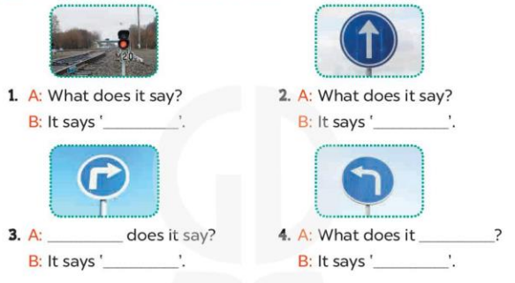  - Have Ss look at the four sentences and the pictures. Elicit and model with picture 1  + Ask Ss to read the sentence 1 in chorus.  + Ask them what is missing in the question (stop). Then have them complete the gap (It say ‘stop’).  -Have Ss work in pairs and complete the dialogue 2, 3, 4.  - Ask a few Ss to stand up and read the sentences aloud.  -T gives feedbacks.  Key: 1. stop 2. go straight  3. What; turn right 4. say; turn left  Activity 3. Let’s sing  *Aims: Ss will be able to sing the song When I cross the road with the correct pronunciation and melody.  *Procedure:  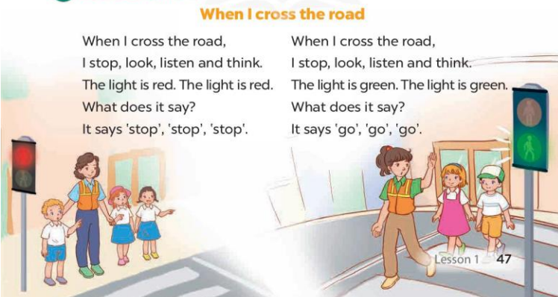  - Introduce the title and lyrics of the song: “When I cross the road”  - Play the recording for Ss to listen to the whole song.  + Have them repeat the title and lyrics line by line.  + Tell Ss to point at the pictures while singing.  - Play the recording all the way through for Ss to listen to pronunciation and melody of the song.  - Play the recording line by line for Ss to listen, repeat and point to the pictures  - Play the recording for Ss to sing and do actions.  - Ask Ss to practice singing and doing actions in pairs or groups.  - Invite groups to the front of the classroom to perform the song  -T gives feedback.  *Consolidation  *Aims: Ss will be able consolidate and wrap up the content of the lesson.  *Procedure:  - T asks ss to answer the following questions:  + What have you learnt from the lesson today?  - T praises some Ss who are hardworking / active/ good…. as well as encourage others to try more.  - Practice part 5 again.  - Prepare the new lesson: Unit 17, Lesson 2 (1,2,3). | - Ss listen  - Ss play game  - Ss open their books  -Look at the pictures and say:  + Picture a: a road sign for turn right  + Picture b: a road sign for turn left  + Picture c: a road sign for go straight  + Picture d: a red traffic light  -Ss guess the answers  - Ss listen to the tape and tick or cross  - Ss listen again, tick/ cross and swap books with their partners.  - Ss check their answers  -Write the correct answer and check Ss’ gussing  -Ss listen and repeat.  -Ss look at the picture and say  -Ss look and answer  -Ss read  -Ss say and complete  -Ss work in pairs and complete  -Ss read the sentences aloud  - Ss listen  -Ss listen to the song  - Ss listen and repeat line by line without the action.  -Ss point to the pictures while singing  -Ss listen to melody of the song  - Ss listen and sing line by line.  - Ss sing and do actions.  + Ss work in groups (two groups) to sing.  -Ss perform in front of the class.  -Ss listen  -Ss answer the questions  -Ss listen and clap their hands  -Ss listen and take note
IV. ADJUSTMENTS AFTER THE LESSON (if necessary):
………………………………………………………………………………………….…..……………………………………………………………………………...………………………………………….…..…………………………………………………………............…………………...

Theme: Me and the world around
Week: 29 Period: 114 Number of periods: 2

UNIT 17: IN THE CITY
Lesson 2 (1, 2, 3)
Classes:4A, 4B, 4C, 4D, 4E
Teaching time : from 1st April to 5th April 2024

I. OBJECTIVES:
By the end of the lesson, Ss will be able to:
1. Knowledge:
- Use the words and phrases get, turn round in relation to the topic “In the city”
- Use How can I get to the …….? – ………. to ask for and give directions.
- Vocabulary: get, turn round, excuse me
- Model sentences: A: How can I get to the bookshop?
B: Go straight and turn left.
- Skills: speaking and listening
2. Competences:
- Co-operation: ready to help friends in pair work/ group work.
- Sociability: Talk to each other, say good words to others.
3. Attitude/ Qualities:
- Kindness: Help partners to complete learning tasks.
- Honesty: tell the truth about feelings and emotions
II. TEACHING AIDS:
- Teacher: Teacher’s guide Pages 246, 247; audio Tracks 66, 67 website hoclieu.vn, posters, laptop, pictures, textbook, lesson plan, TV or projector.
- Students: Pupil’s book Page 48, notebooks, workbooks, school things.
III. PROCEDURES:
Time | Teacher’s activities | Students’ activities
3ms  9ms  7ms  7ms  7ms  2ms | 1.Warm- up:  Game: Angry bird (PPT)  *Aims: to create a friendly and active atmosphere in the class to beginning the lesson.  *Procedure:  - Divide the class into 2 teams.  - Ask Ss from each team choose a number, then choose the correct answer or answer.  + If the Ss answer correctly, they get the points for that question.  - After 8 numbers, the team with the most points is the winner.  - Say “Open your book page 48” and look at “Unit 17, Lesson 2 (1,2,3)”.  2. Presentation  Activity 1. Vocabulary.  *Aims: Ss will be able to know the vocabulary in the new lesson.  *Procedure:  -T elicits the new words  + get (to) : đến địa điểm (translation)  + turn round : quay lại (picture)  +excuse me : xin lỗi (situation)  - T models (3 times).  - T writes the words on the board.  - Checking: What and where  3.Practice:  Activity 2. Look, listen and repeat:  *Aims: Ss will be able to understand and correctly repeat the sentences in two communicative contexts (pictures) focusing on asking for and giving directions.  *Procedure:  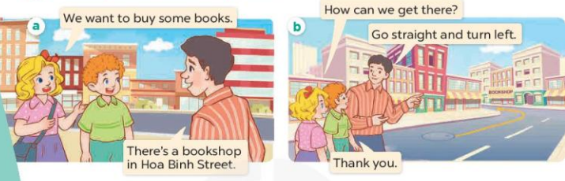  - Have Ss look at Pictures a and b and identify the characters and predict what they want to buy, where they can buy it  - Play the audio twice (sentence by sentence). Correct their pronunciation where necessary.  - Have Ss to practice the diaguage  - T invites a few pairs to the front of the class to practice.  - T checks pronunciation for ss.  Activity 3. Listen, point and say.  *Aims: Ss will be able to correctly correctly say the phrases and use How can I get to the …….? – ……. to ask for and give directions.  *Procedure:  * Model sentences:  - T asks Ss look at picture a, b and helps Ss know the structure from the dialogue.  - T introduces new structure for Ss.  - T explains, models and gives meaning.  - Have Ss repeat the model sentences.  A: How can I get to the bookshop?  B: Go straight and turn left.  *Drill pictures  - Ask Ss to look at Pictures a, b, c, and d and identify the places in the pictures and directions.  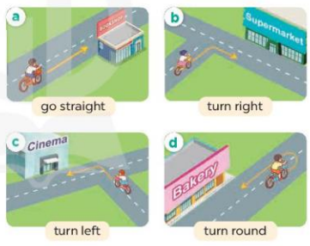  - Run through all the pictures.  - Run through model sentences.  - Ask Ss to work in pairs.  - T controls and corrects.  - Invite a few pairs to come to the front of the classroom, point at the pictures and say in front of the class.  - T gives feedbacks.  4.Production:  Activity 4. Let’s talk.  *Aims: Ss will be able to enhance the correct use of How can I get to the ..? – ……. to ask for and give directions in a freer context  *Procedure:  - Ask Ss to look at the picture and elicit the places on the map and the direction to each place. 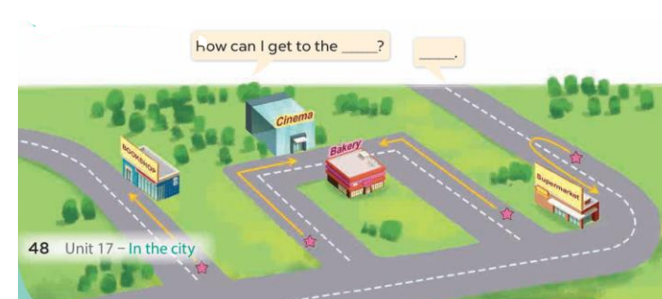  - Put Ss into pairs and encourage them to ask and answer using How can I get to the….?-….  - Invite some pairs to stand up to perform their exchanges.  *Consolidation  *Aims: Ss will be able consolidate and wrap up the content of the lesson.  *Procedure:  - T asks ss to answer the following questions:  + What have you learnt from the lesson today?  - T review the vocabulary and model sentences.  - T praises some Ss who are hardworking / active/ good…. as well as encourage others to try more.  - Learn the vocabulary and model sentences by heart  - Prepare the new lesson: Unit 17, Lesson 2 (4,5,6). | - Ss listen  - Ss play the game  - Ss open their books  -Ss listen and answer  - - Ss listen and repeat  + Choral repetition (3 times).  + Individual repetition (3 ss)  - Ss take note  - Ss look, remember and say  + In picture a:  Mary: We want to buy some books.  Man: There’s a bookshop in Hoa Binh Street.  – In picture b:  Mary: How can we get there?  Man: Go straight and turn left.  Mary: Thank you  -Look at the pictures and get to know the characters in the pictures.  -Ss listen and repeat in chorus  -Ss work in pairs to practice  -Ss practice the diaguage  -Ss listen  -Ss look at the picture and answer.  -Ss listen  -Ss listen and repeat  -Ss repeat  -Ss listen and answer  +Picture a: go straight to the bookshop  +Picture b. turn right to the supermarket  +Picture c. turn left to the cinema +Picture d. turn round to the bakery  - Ss look, listen and repeat  - Ss practice in chorus  - Ss work in pairs to practice  -Ss listen  -Ss go to the board and point and say  -Ss listen  -Ss look at the picture and answer  + A map and the directions to the bookshop, cinema, bakery and supermarket  -Ss work in pairs, ask and answer  -Ss ask and asnwer in front of the class  -Ss answer the questions  - Ss listen  -Ss listen and clap their hands  -Ss listen and take note
IV. ADJUSTMENTS AFTER THE LESSON
................................................................................................................................................................................................................................................................................................................

Theme: Me and the world around
Week: 29 Period: 115 Number of periods: 3

UNIT 17: IN THE CITY
Lesson 2 (4, 5, 6)
Classes:4A, 4B, 4C, 4D, 4E
Teaching time : from 1st April to 5th April 2024

I. OBJECTIVES:
By the end of the lesson, Ss will be able to:
1. Knowledge:
- Use How can I get to the ……? – …….to ask for and give directions.
- Listen to and demonstrate understanding of simple communicative contexts in relation to the topic “In the city”.
- Vocabulary: Review
- Skills: speaking, listening, reading and writing.
2. Competences:
- Co-operation: ready to help friends in pair work/ group work.
- Self-control and independent learning: perform listening tasks.
3. Attitude/ Qualities:
- Honesty: tell the truth about feelings and emotions.
- Diligence: complete learning tasks.
II. TEACHING AIDS:
- Teacher: Teacher’s guide Pages 248, 49 audio Tracks 68; website hoclieu.vn, posters, laptop, pictures, textbook, lesson plan, TV or projector.
- Students: Pupil’s book Page 49, notebooks, workbooks, school things.
III. PROCEDURES:
Time | Teacher’s activities | Students’ activities
5ms  27ms  3ms | 1.Warm- up:  Game: “Miming”  *Aims: to create a friendly and active atmosphere in the class to beginning the lesson.  *Procedure:  - Teacher divides the class into teams.  - One student in each team stands in front of the board and faces his/her team.  - Teacher writes/shows a phrase (stop).  - The rest Ss mime the action written on the board while their teammate guesses the action and gives the answer.  + The team that gives the correct answer first gets one point.  + The team with the most points is the winner.  - Say “Open your book page 49” and look at “Unit 17, Lesson 2 (4,5,6)”.  2.Practice:  Activity 1. Listen and tick:  *Aims: Ss will be able to listen to and understand two communicative contexts in which pupils ask and answer questions about directions and tick the correct pictures.  *Procedure:  - Have Ss look at the pictures and ask questions to elicit the places and directions to the places in the pictures.  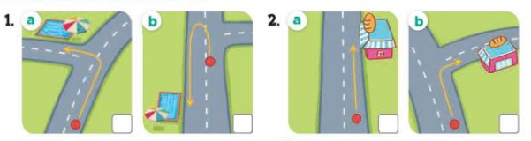  - T ask Ss to guess the answers.  + T writes Ss’guessing on the board.  - Listen to the tape:  + Play the recording  + Play the recording again and get Ss to swap books with their partners.  + Play the recording again to check answers together as a class.  + Write the answers on the board for Ss to correct their answers. Then checks Ss’ guessing.  - Play the recording, sentence by sentence, for the class to listen and repeat in chorus.  Key: 1.a 2. b  Activity 2. Look, complete and read.  *Aims: Ss will be able to complete two gapped dialogues with the help of picture cues *Procedure:  - Have Ss read the dialogue and guess the missing words.  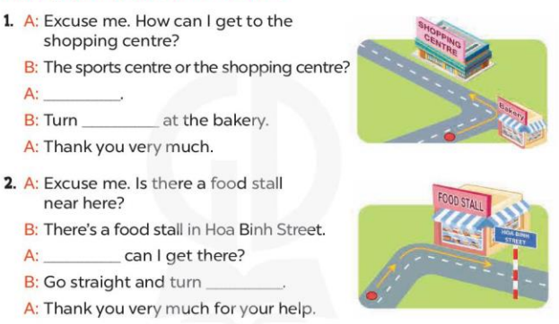  - T models with sentence 1.  + Have Ss look at the sentence.  + Ask them what is missing in the answer (the shopping centre).  + Have Ss complete the gap.  + Have Ss read the completed sentence in chorus.  -Have Ss work in pairs and complete the other sentences.  - Invite pairs of pupils to stand up and read aloud the sentences.  - T gives feedbacks.  Key: 1. The shopping centre; left 2. How; right  Activity 3. Let’s play.  Show me the way  *Aims: Ss will be able to review the target vocabulary related to the topic “In the city” by playing Show me the way.  *Procedure:  - Divide class into two teams.  - Have Ss look at the map listen to the teacher, fid the place and give the directions.  - If a student’s answer is correct, the team gets one star.  - After 5 minutes, the team that gets the most stars wins.  - Have Ss in one team give direction, and the other team listen and find the place.  *Consolidation  *Aims: Ss will be able consolidate and wrap up the content of the lesson.  *Procedure:  - T asks ss to answer the following questions:  + What have you learnt from the lesson today?  +What are the core values of the lesson? (if the teacher can take from the lesson).  - T praises some Ss who are hardworking / active/ good…. as well as encourage others to try more.  - Prepare the new lesson: Unit 17, Lesson 3 (1,2,3). | - Ss listen and play the game  - Ss open their books  -Look at the pictures and say:  + Picture 1a. a direction to the swimming pool: turn left  + Picture 1b. a direction to the swimming pool: turn round  + Picture 2a. a direction to the bakery: go straight  + Picture 2b. a direction to the bakery: turn right  -Ss guess the answers  - Ss listen to the tape and tick  - Ss listen again, tick and swap books with their partners.  - Ss check their answers and guessing  -Write the correct answer  -Ss listen and repeat.  -Ss look at the pictures and say  -Ss listen and answer  -Ss read and complete  -Ss complete the gap  -Ss read the competed sentence  -Ss work in pairs and do the task  -Ss read aloud the sentences  - Ss look and listen.  -Ss play the game  -Ss play the game  -Ss listen and answer  -Ss listen and take note

IV. ADJUSTMENTS AFTER THE LESSON (if necessary):
………………………………………………………………………………………….…..……………………………………………………………………………...………………………………………….…..…………………………………………………………………………..............…...

Theme: Me and the world around
Week: 29 Period: 116 Number of periods: 4

UNIT 17: IN THE CITY
Lesson 3 (1, 2, 3)
Classes:4A, 4B, 4C, 4D, 4E
Teaching time : from 1st April to 5th April 2024

I. OBJECTIVES:
By the end of the lesson, Ss will be able to:
1. Knowledge:
- Correctly pronounce of the words 'bookshop and 'campsite with the stress on the first syllable in isolation and in the sentences How can I get to the 'bookshop? and How can I get to the 'campsite?
- Listen to and demonstrate understanding of simple communicative contexts in relation to the topic “In the city”.
- Vocabulary: Review
- Skills: speaking, listening, reading and writing.
2. Competences:
- Co-operation: ready to help friends in pair work/ group work.
- Self-control and independent learning: perform listening tasks.
3. Attitude/ Qualities:
- Kindness: Help partners to complete learning tasks.
- Honesty: tell the truth about feelings and emotions
II. TEACHING AIDS:
- Teacher: Teacher’s guide Pages 249, 250; audio Tracks 69, 70,71; website hoclieu.vn, posters, laptop, pictures, textbook, lesson plan, TV or projector.
- Students: Pupil’s book Page 50, notebooks, workbooks, school things.
III. PROCEDURES:
Time | Teacher’s activities | Students’ activities
5ms  9ms  19ms  2ms | 1.Warm- up:  Game: memory game  *Aims: to create a friendly and active atmosphere in the class to beginning the lesson.  *Procedure:  - Invite two or three teams of four pupils to the front of the class.  - Stick four flashcards for turn left, turn right, turn round and go straight on the board.  - Have Sslook at the flashcards to memorise.  + Take a flashcard out quickly.  + Have the Ss at the front of the lines can hand up to say what flashcard is missing. + If it is correct, the team gets one star.  + The first pupil of each line goes to the end of the line.  + The team gets most stars wins.  - Play the game with other teams in the class  - Say “Open your book page 50” and look at “Unit 17, Lesson 3 (1,2,3)”.  2. Presentation  Activity 1. Listen and repeat:  *Aims: Ss will be able to correctly repeat the words 'bookshop and 'campsite with the stress on the first syllable in isolation and in the sentences How can I get to the 'bookshop? and How can I get to the 'campsite? with correct pronunciation and intonation.  *Procedure:  - T gives instruction to the words 'bookshop and 'campsite with the stress on the first syllable in isolation and in the sentences How can I get to the 'bookshop? and How can I get to the 'campsite?  - Play the recording for the words ‘bookshop and ‘campsite.  - Encourage Ss to point at the words sentence while listening.  - Play the recording again and encourage Ss to listen and repeat.  - Do this several times until Ss feel confident.  - T calls some Ss to practice.  - T gives feedbacks.  3.Practice:  Activity 2. Listen and circle.  *Aims: Ss will be able to identify the target words bookshop and campsite while listening.  *Procedure:  - Elicit the sentences and explain that they have to listen.  - T ask Ss to guess the answers.  + T writes Ss’guessing on the board.  - Listen to the tape:  + Play the recording  + Play the recording again and get Ss to swap books with their partners.  + Play the recording again to check answers together as a class.  + Write the answers on the board for Ss to correct their answers. Then checks Ss’ guessing.  - Play the recording, sentence by sentence, for the class to listen and repeat in chorus.  - Invite one or two Ss to stand up and read the completed sentences.  Key: 1.c 2.a  Activity 3. Let’s chant  *Aims: Ss will be able to say the chant with the correct rhythm and pronunciation.  *Procedure:  - Introduce the title and lyrics of the chant.  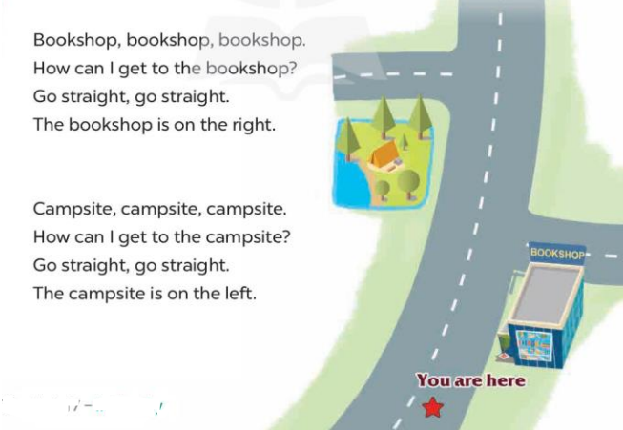  - Play the recording for Ss to listen to the whole chant.  + Have them repeat the title and lyrics line by line.  + Ask Ss to attend to the words bookshop and campsite  - Play the recording all the way through for Ss to listen to pronunciation and melody.  - Play the recording line by line for Ss to listen and repeat  - Play the recording for Ss to chant and clap along.  - Ask Ss to practice chant and clap along in pairs or groups.  - Invite groups to the front of the classroom to perform the chant  -T gives feedback.  *Consolidation  *Aims: Ss will be able consolidate and wrap up the content of the lesson.  *Procedure:  - T asks ss to answer the following questions:  + What have you learnt from the lesson today?  +What are the core values of the lesson? (if the teacher can take from the lesson).  - T praises some Ss who are hardworking / active/ good…. as well as encourage others to try more.  - Practice the chant more.  - Prepare the new lesson: Unit 17, Lesson 3 (4,5,6). | - Ss listen  -Ss play the game  -Ss play the game  - Ss open their books  - Ss recognize the differences about color and stress of the words  - - Ss listen  - Ss listen and point  - Ss listen again and repeat  -Ss listen again and repeat  -Ss practice  -Ss listen  -Ss listen and say  -Ss guess the answer  - Ss listen to the tape and circle  - Ss listen again, circle and swap books with their partners.  - Ss check their answers  -Ss write the correct answer and check Ss’ guessing  -Ss listen and repeat.  -Ss read the sentences  - Ss look and listen.  -Ss listen to the chant  - Ss listen and repeat line by line without clap their hands  -Ss note the sounds, words  -Ss listen to melody of the chant  - Ss listen and chant line by line.  - Ss chant and clap along.  - Ss work in groups (two groups) to chant  -Ss perform in front of the class.  -Ss listen  -Ss answer the questions  -Ss listen and clap their hands  -Ss listen and take note
IV. ADJUSTMENTS AFTER THE LESSON (if necessary):
………………………………………………………………………………………….…..……………………………………………………………………………...………………………………………….…..……………………………………………………………………………...

