Theme: Me and the world around
Week: 28 Period: 109 Number of periods: 1

UNIT 16: WEATHER
Lesson 2 (4, 5, 6)
Classes:4A, 4B, 4C, 4D, 4E
Teaching time : from 25th March to 29th March 2024

I. OBJECTIVES:
By the end of the lesson, Ss will be able to:
1. Knowledge:
- listen to and demonstrate understanding of simple communicative contexts in relation to the topic “Weather”.
- read and write about the weather and suggestions to go somewhere”.
- Vocabulary: Review
- Skills: speaking, listening, reading and writing.
2. Competences:
- Co-operation: ready to help friends in pair work/ group work.
- Self-control and independent learning: perform listening tasks.
3. Attitude/ Qualities:
- Kindness: Help partners to complete learning tasks.
- Diligence: complete learning tasks.
II. TEACHING AIDS:
- Teacher: Teacher’s guide Pages 235, 236; audio Tracks 58; website hoclieu.vn, posters, laptop, pictures, textbook, lesson plan, TV or projector.
- Students: Pupil’s book Page 43, notebooks, workbooks, school things.
III. PROCEDURES:
Time | Teacher’s activities | Students’ activities
5ms  27ms  3ms | 1.Warm- up:  Game: “Guessing game”  *Aims: to create a friendly and active atmosphere in the class to beginning the lesson.  *Procedure:  - Ask Ss to draw a place they want to go into the air, their friends try to guess and say Let’s go…. and respond accordingly.  - Say “Open your book page 43” and look at “Unit 16, Lesson 2 (4,5,6)”.  2.Practice:  Activity 1. Listen and match:  *Aims: Ss will be able to listen to and understand two communicative contexts in which pupils make suggestions to go somewhere and respond, and match the characters with the right pictures.  *Procedure:  - Have Ss look at the pictures and identify the two characters and the places 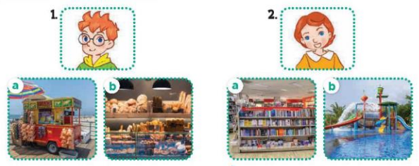  - T ask Ss to guess the answers.  + T writes Ss’guessing on the board.  - Listen to the tape:  + Play the recording  + Play the recording again and get Ss to swap books with their partners.  + Play the recording again to check answers together as a class.  + Write the answers on the board for Ss to correct their answers. Then checks Ss’ guessing.  - Play the recording, sentence by sentence, for the class to listen and repeat in chorus.  Key: 1.b 2. A  Activity 2. Look, complete and read.  *Aims: Ss will be able to complete two gapped exchanges with the help of picture cues.  *Procedure:  - Have Ss look at the pictures and identify the weather in the pictures.  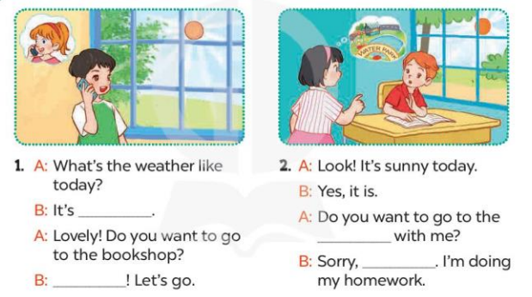  - T models with sentence 1.  + Have Ss look at the sentence.  + Ask them what is missing in the answer (sunny).  + Have Ss complete the gap.  + Have Ss read the completed sentence in chorus.  -Have Ss work in pairs and complete the other sentences.  - Invite pairs of pupils to stand up and read aloud the sentences.  -T gives feedbacks.  Key: 1. sunny; Great 2. water park; I can't  Activity 3. Let’s play  Slap the board and say  *Aims: Ss will be able to revise the target vocabulary items and structures by playing Slap the board and say game.  *Procedure:  - Tell Ss how to play the game.  + Put five flashcards or write the names of five places on the board.  + Divide the class into four teams.  + Ask one representative of each team to come to the front.  - Example: I want to go to the bookshop.  + The pupil who is the quickest to slap the correct picture / word gets one point for his / her team.  + Repeat the same procedure with the other pictures / words on the board.  - The team that gets the most points at the end of the game wins.  *Consolidation  *Aims: Ss will be able consolidate and wrap up the content of the lesson.  *Procedure:  - T asks ss to answer the following questions:  + What have you learnt from the lesson today?  +What are the core values of the lesson? (if the teacher can take from the lesson).  - T praises some Ss who are hardworking / active/ good…. as well as encourage others to try more.  - Prepare the new lesson: Unit 16, Lesson 3 (1,2,3). | - Ss listen and play the game  - Ss open their books  -Look at the pictures and say:  Number 1: a picture of Ben  - a picture of a food stall (a)  - a picture of a bakery (b)  Number 2: a picture of Lucy  + a picture of a bookshop (a  + a picture of a water park (b)  -Ss guess the answers  - Ss listen to the tape and draw the line  - Ss listen again, match and swap books with their partners.  - Ss check their answers and guessing  -Ss write he correct anwer  -Ss listen and repeat.  -Ss look at the pictures and say  -Ss listen and answer  -Ss say the missing word  -Ss read and complete  -Ss work in pairs and complete  -Ss read aloud the sentences  - Ss listen.  - Ss listen the rule of the game  -Ss play the game  -Ss listen and answer  -Ss listen and take note
IV. ADJUSTMENTS AFTER THE LESSON (if necessary):
………………………………………………………………………………………….…..……………………………………………………………………………...………………………………………….…..……………………………………………………………………………...

Theme: Me and the world around
Week: 28 Period: 110 Number of periods: 2
UNIT 16: WEATHER
Lesson 3 (1, 2, 3)
Classes:4A, 4B, 4C, 4D, 4E
Teaching time : from 25th March to 29th March 2024

I. OBJECTIVES:
By the end of the lesson, Ss will be able to:
1. Knowledge:
- Correctly repeat correctly pronounce the words 'sunny and 'rainy with the stress on the first syllable in isolation and in the sentences It’s 'sunny today. and I don’t like 'rainy weather.
– Listen to and demonstrate understanding of simple communicative contexts in relation to the topic “Weather”.
- Vocabulary: Review
- Skills: speaking, listening, reading and writing.
2. Competences:
- Co-operation: ready to help friends in pair work/ group work.
- Self-control and independent learning: perform listening tasks.
3. Attitude/ Qualities:
- Kindness: Help partners to complete learning tasks.
- Honesty: tell the truth about feelings and emotions
II. TEACHING AIDS:
- Teacher: Teacher’s guide Pages 237, 238; audio Tracks 59, 60, 61; website hoclieu.vn, posters, laptop, pictures, textbook, lesson plan, TV or projector.
- Students: Pupil’s book Page 44, notebooks, workbooks, school things.
III. PROCEDURES:
Time | Teacher’s activities | Students’ activities
5ms  9ms  19ms  2ms | 1.Warm- up:  Game: Find and circle the words  *Aims: to create a friendly and active atmosphere in the class to beginning the lesson.  *Procedure:  S B K K E P S C C T  U E T E E D D C L H  N E U A A E C O O I  N A M W F C C S U N  Y A B I N N L S D K  R A I N Y I S F Y B  S R O D R C V T A H  M M T Y H R S T A Y  D P P B E S E R S M  A C E B F A Z Y W  - Divide class into 2 groups  - Ask Ss to find and circle the words that they learnt.  - Which groups find the best correct words is winner.  - Give Ss time to play the game.  Rows: rainy  Columns: cloudy, windy, sunny  -T checks who’s winner?  - Say “Open your book page 44” and look at “Unit 16, Lesson 3 (1,2,3)”.  2. Presentation  Activity 1. Listen and repeat:  *Aims: Ss will be able to correctly pronounce the words 'sunny and 'rainy with the stress on the first syllable in isolation and in the sentences It’s 'sunny today. and I don’t like 'rainy weather. with correct pronunciation and intonation.  *Procedure:  - T gives instruction to the words 'sunny and 'rainy with the stress on the first syllable in isolation and in the sentences It’s 'sunny today. and I don’t like 'rainy weather.  - Play the recording for the words 'sunny and 'rainy and the sentence.  - Play the recording and encourage Ss to point at the word and sentence while listening  - Play the recording again and encourage Ss to listen and repeat.  - Do this several times until Ss feel confident.  - T calls some Ss to practice.  - T gives feedbacks.  3.Practice:  Activity 2. Listen and circle.  *Aims: Ss will be able to identify the target words sunny and rainy while listening.  *Procedure:  - Explain what pupils have to do and check comprehension.  - Play the recording for Ss to listen.  - Play the recording again for pupils to listen and circle the correct options.  - Have Ss to swap books with a partner, then check the answers as a class.  - Write the correct answers on the board.  - Invite one or two pupils to stand up, listen to and repeat the sentences  Key: 1.c 2.a  Activity 3. Let’s chant  *Aims: Ss will be able to say the chant with the correct rhythm and pronunciation.  *Procedure:  - Introduce the title and lyrics of the chant.  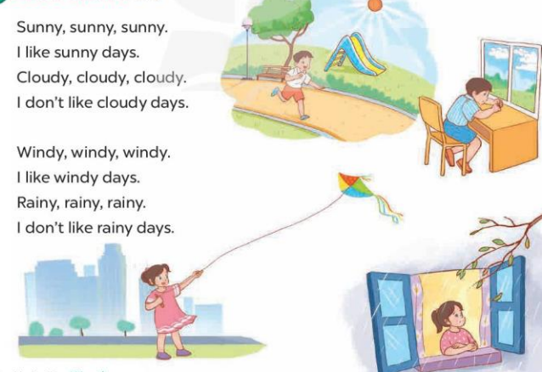  - Play the recording for Ss to listen to the whole chant.  + Have them repeat the title and lyrics line by line.  + Ask Ss to attend to two-syllable words with the stress on the first syllable in the chant, ex: sunny, cloudy, windy and rainy  - Play the recording all the way through for Ss to listen to pronunciation and melody.  - Play the recording line by line for Ss to listen and repeat  - Play the recording for Ss to chant and clap along.  - Ask Ss to practice chant and clap along in pairs or groups.  - Invite groups to the front of the classroom to perform the chant  -T gives feedback.  *Consolidation  *Aims: Ss will be able consolidate and wrap up the content of the lesson.  *Procedure:  - T asks ss to answer the following questions:  + What have you learnt from the lesson today?  +What are the core values of the lesson? (if the teacher can take from the lesson).  - T praises some Ss who are hardworking / active/ good…. as well as encourage others to try more.  - Prepare the new lesson: Unit 16, Lesson 3 (4,5,6). | - Ss listen  -Ss play game  - Ss open their books  - Ss recognize the what word stress is  - - Ss listen  - Ss listen and point  - Ss listen again and repeat  -Ss listen again and repeat  -Ss practice  -Ss listen  -Ss pay attention and say  - Ss listen to the tape  - Ss listen again and circle  - Ss swap books and check their answers  -Write the correct answer  -Ss listen and repeat.  - Ss look and listen.  -Ss listen to the chant  - Ss listen and repeat line by line without clap their hands  -Ss note the words  -Ss listen to melody of the chant  - Ss listen and chant line by line.  - Ss chant and clap along.  - Ss work in groups (two groups) to chant  -Ss perform in front of the class.  -Ss listen  -Ss answer the questions  -Ss listen and clap their hands  -Ss listen and take note
IV. ADJUSTMENTS AFTER THE LESSON (if necessary):
………………………………………………………………………………………….…..……………………………………………………………………………...………………………………………….…..……………………………………………………………………………...

Theme: Me and the world around
Week: 28 Period: 111 Number of periods: 3

UNIT 16: WEATHER
Lesson 3 (4, 5, 6)
Classes:4A, 4B, 4C, 4D, 4E
Teaching time : from 25th March to 29th March 2024

I. OBJECTIVES:
By the end of the lesson, Ss will be able to:
1. Knowledge:
- read and write about the weather and suggestions to go somewhere.
- make a weather chart, then tell the class about it at Project time.
- Vocabulary: Review
- Skills: speaking, listening, reading and writing.
2. Competences:
- Co-operation: ready to help friends in pair work/ group work.
- Self-control and independent learning: perform reading tasks.
3. Attitude/ Qualities:
- Kindness: Help partners to complete learning tasks.
- Honesty: tell the truth about feelings and emotions.
- Diligence: complete learning tasks.
II. TEACHING AIDS:
- Teacher: Teacher’s guide Pages 238, 239, website hoclieu.vn, posters, laptop, pictures, textbook, lesson plan, TV or projector.
- Students: Pupil’s book Page 45, notebooks, workbooks, school things.
III. PROCEDURES:
Time | Teacher’s activities | Students’ activities
5ms  8ms  19ms  3ms | 1.Warm- up:  Game: Miming game  *Aims: to review the vocabulary and structure about greet and respond to greetings.  *Procedure:  - Guide Ss to act the weather (sunny- wearing glasses/ pretend to wear a hat)  - Divide them into groups to take turns to mime and guess if their friends like or dislike the weather they mime.  - Say “Open your book page 45” and look at “Unit 16, Lesson 3 (4, 5, 6)”.  2.Practice:  Activity 1. Read and circle:  *Aims: Ss will be able to text about the weather, activities and places  – Four incomplete sentences, each with three answer options  *Procedure:  - Draw Ss’ attention to the text and read it as a class.  - Draw Ss’ attention to the incomplete sentences and answer options.  - Have Ss pay attention to the sentences about the weather and the places the characters go to.  - Ask S s to read the text again and circle the correct answers.  - Tell Ss to swap books with a partner, then check answers as a class.  - Write the correct answers on the board.  - Ask Ss to read the text aloud in front of the class.  Key: 1. c 2. c 3. a 4. a  3.Production:  Activity 2. Let’s write  *Aims: Ss will be able to complete a gapped paragraph about weather and suggestions to go somewhere. .  *Procedure:  - Explain to the class the goal of this activity.  - Ask Ss to read each gapped sentence, look at the picture and fill in the gap.  - Give Ss time to write their answers  - Ask Ss to swap and correct their answers in pairs.  - Check the answers as a class.  Key: Pupils’ own answers  Example: The weather is sunny today. My family want to go to the supermarket. My mother wants clothes. She is at the clothes shop. My father wants some food. He is at food stall. I want some books. I am at the bookshop. My brother wants some toys. He is at the toy store.  Activity 3. Project.  *Aims: Ss will be able to make a weather chart and present it to the class by using the target language.  *Procedure:  - Explain that they are going to show weather charts that they have made at home and tell the class about the weather last weekend and today in different places..  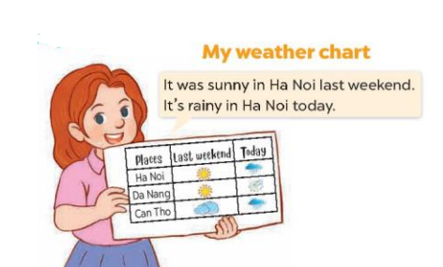  - Have Ss work in groups of five.  + Each pupil shows his / her chart that they have made at home and tells the group about the weather last weekend and today in different places, ex: It was sunny in Ha Noi last weekend. It’s rainy in Ha Noi today. It was sunny in Da Nang last weekend. It’s windy in Da Nang today.  - Invite some Ss to show their work and talk about the weather in front of the class.  *Consolidation  *Aims: Ss will be able consolidate and wrap up the content of the lesson.  *Procedure:  - T asks ss to answer the following questions:  + What have you learnt from the lesson today?  - T praises some Ss who are hardworking / active/ good…. as well as encourage others to try more.  - Prepare the new lesson: Unit 17- Lesson 1 (1,2,3). | - Ss listen  -Ss play game  - Ss open their books  - Ss read the text  -Ss attention to the incomplete sentences and answer  - Pay attention  -Ss read the text again and circle  -Ss swap books and check answer  -Ss write the correct answers  -Ss read the text aloud  -Ss listen  -Ss read and answer  -Ss write  -Ss swap books and check their answers  -Ss check the answer  -Ss listen  -Ss work in groups and tell about their chart  -Ss perform in front of the class.  -Ss answer the questions  -Ss listen and clap their hands  -Ss listen and take note
IV. ADJUSTMENTS AFTER THE LESSON (if necessary):
………………………………………………………………………………………….…..……………………………………………………………………………...………………………………………….…..……………………………………………………………………………..

