Theme: Me and my School
Week: 11 Period: 38 Number of periods: 2

Unit 6: Our school facilities
Lesson 3 (1, 2, 3)

Classes:4A, 4B, 4C, 4D, 4E
Teaching time : from 13th November to 17th November, 2023

I. OBJECTIVES:
1. Language focus/Knowledge:
- Correctly pronounce the sounds of the letters s and es as final consonants in the words mountains and villages, and in the sentences My school is in the mountains. and There are three villages near my school.
-Listen to and demonstrate understanding of simple communicative contexts in relation to the topic “Our school facilities”.
-Read about school locations and describe the surrounding
- Vocabulary: Review
- Skills: speaking, listening, reading and writing.
2. Competences:
- Co-operation: ready to help friends in pair work/ group work.
- Sociability: Talk to each other, say good words to others.
3. Attitude/ Qualities:
- Kindness: Help partners to complete learning tasks.
- Honesty: tell the truth about feelings and emotions
II. TEACHING AIDS:
- Teacher: Teacher’s guide Pages 96,97; audio Tracks 64, 65, 66; website hoclieu.vn, posters, laptop, pictures, textbook, lesson plan, TV or projector.
- Students: Pupil’s book Page 48, notebooks, workbooks, school things.
III. PROCEDURES:
Time | Teacher’s activities | Students’ activities
5ms  9ms  19ms  3ms | 1.Warm- up: (5’)  Game: play the Zootopia Game ( ppt)  *Aims: to create a friendly and active atmosphere in the class to beginning the lesson.  *Procedure:  - Divides the class into 3 teams.  - Pupils from each team choose a letter, then answer the question  - Pupils answer correctly get some points corresponding to the number of dollars for the letter they choose.  They can choose deal to get more or less points  - Says “Open your book page 48” and look at “Unit 6, Lesson 3 (1,2,3)”.  2. Presentation(9’)  Activity 1. Listen and repeat:  *Aims: Ss will be able to correctly pronounce the sounds of the letters s and es in isolation, in the words mountains and villages, and in the sentences My school is in the mountains. and There are three villages near my school  *Procedure:  - T gives instruction to the letter s and es in isolation, in the words mountains and villages, and in the sentences My school is in the mountains. and There are three villages near my school  - Plays the recording for the letter s, es  - Encourages Ss to point at the letter/ word/ sentence while listening.  - Plays the recording again and encourage Ss to listen and repeat.  - Does this several times until Ss feel confident.  - T calls some Ss to practice.  - T gives feedbacks.  3.Practice:  Activity 2. Listen and circle.  *Aims: Ss will be able to identify the target words mountains and village while listening.  *Procedure:  - Elicits the sentences and the gap-fill options.  - T asks Ss to guess the answers.  + T writes Ss’guessing on the board.  - Listen to the tape:  + Plays the recording  + Plays the recording again and get Ss to swap books with their partners.  + Plays the recording again to check answers together as a class.  + Writes the answers on the board for Ss to correct their answers. Then checks Ss’ guessing.  - Plays the recording, sentence by sentence, for the class to listen and repeat in chorus.  - Invites one or two Ss to stand up and read the completed sentences.  Key: 1.b 2.c  Activity 3. Let’s chant  *Aims: Ss will be able to say the chant with the correct rhythm and pronunciation.  *Procedure:  - Introduces the title and lyrics of the chant.  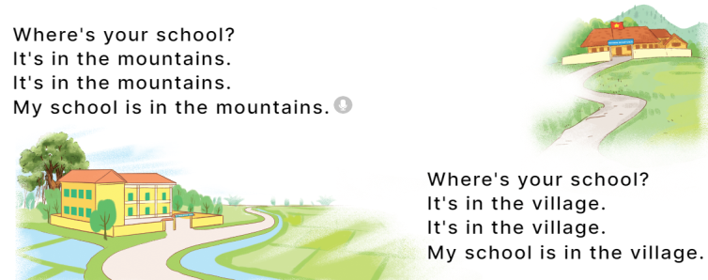  - Plays the recording for Ss to listen to the whole chant.  + Has them repeat the title and lyrics line by line.  + Asks Ss to attend to the sounds of the letters s and es and the words mountains and villages.  - Plays the recording all the way through for Ss to listen to pronunciation and melody.  - Plays the recording line by line for Ss to listen and repeat  - Plays the recording for Ss to chant and clap along.  - Asks Ss to practice chant and clap along in pairs or groups.  - Invites groups to the front of the classroom to perform the chant  -T gives feedback.  *Consolidation  *Aims: Ss will be able consolidate and wrap up the content of the lesson.  *Procedure:  - T asks ss to answer the following questions:  + What have you learnt from the lesson today?  +What are the core values of the lesson? (if the teacher can take from the lesson).  - T praises some Ss who are hardworking / active/ good…. as well as encourage others to try more.  - Practices the chant more.  - Prepares a poster about their school in order to introduce their school to a new pupil.  - Prepares the new lesson: Unit 6, Lesson 3 (4,5,6). | - Ss listen  -Ss play game  -Ss play game  - Ss open their books  - Ss recognize the differences about color of letter  - - Ss listen  - Ss listen and point  - Ss listen again and repeat  -Ss listen again and repeat  -Ss practice  -Ss listen  -Ss listen and say:  + Number 1: Our school is near two ……  + Number 2: There are two ……. not far from my school.  -Ss guess the answers  - Ss listen to the tape and circle  - Ss listen again, circle and swap books with their partners.  - Ss check their answers and guessing  -Ss listen and repeat.  -Ss read the sentences  - Ss look and listen.  -Ss listen to the chant  - Ss listen and repeat line by line without clap their hands  -Ss note the sounds, words  -Ss listen to melody of the chant  - Ss listen and chant line by line.  - Ss chant and clap along.  - Ss work in groups (two groups) to chant  -Ss perform in front of the class.  -Ss listen  -Ss listen.  -Ss answer the questions  -Ss listen and clap their hands  -Ss listen and take note

IV. ADJUSTMENTS AFTER THE LESSON (if necessary):
………………………………………………………………………………………….…..……………………………………………………………………………...………………………………………….…..…………………………………………………………

