Theme: Me and my School
Week: 13 Period: 50 Number of periods: 2

Unit 8: My favourite subjects
Lesson 1 (1, 2, 3)

Classes:4A, 4B, 4C, 4D, 4E
Teaching time : from 27th November to 1st December 2023

I. OBJECTIVES:
1. Language focus/Knowledge:
- Use the words and phrases art, music, PE, IT, an English teacher, a maths teacher, a painter and a singer in relation to the topic “My favourite subjects”.
- Use What’s your favourite subject? – It’s …..to ask and answer questions about someone’s favourite subject;
- Listen to and demonstrate understanding of simple communicative contexts in relation to the topic “My favourite subjects”.
- Vocabulary: PE, IT, favourite.
- Skills: speaking and listening
2. Competences:
- Self-control and independent learning: perform listening tasks.
- Communication and collaboration: work in pairs or groups.
- Sociability: talk to each other, say good words to others.
3. Attitude/ Qualities:
- Show pride in what they can do and great respect for other people’s abilities by using appropriate gesture and intonation when asking and answering about abilities.
II. TEACHING AIDS:
- Teacher: Teacher’s guide Pages 112, 113, audio Tracks 77, 78, website hoclieu.vn, posters, laptop, pictures, textbook, lesson plan, TV or projector.
- Students: Pupil’s book Page 56, notebooks, workbooks, school things.
III. PROCEDURES:
Time | Teacher’s activities | Students’ activities
3ms  16ms  7ms  7ms  2ms | 1.Warm- up:  Game: Who says faster  *Aims: to create a friendly and active atmosphere in the class to beginning the lesson.  *Procedure:  - Holds some flashcards about subjects, then reveal it slowly.  - Asks What is it?  - Asks the Ss guess the answer as fast as possible.  - Then has Ss do the same with the rest.  - This can be played in groups to make it more interesting  - Says “Open your book page 56” and look at “Unit 8, Lesson 1 (1,2,3)”.  2. Presentation  Activity 1. Vocabulary.  *Aims: Ss will be able to know the vocabulary in the new lesson.  *Procedure:  -T elicits the new words  + favourite : yêu thích (situation)  + PE= Physical Education: môn thể dục  (realia)  + IT= Information Technology : môn tin học (realia)  - Models (3 times).  - Writes the words on the board.  - Checking: Rub out and remember  Activity 2. Look, listen and repeat:  *Aims: Ss will be able to understand and correctly repeat the sentences in two communicative contexts focusing on asking and answering questions about someone’s favourite subject.  *Procedure:  - Has Ss look at Pictures a and b and identify the characters (Linh and Ben) in the pictures.  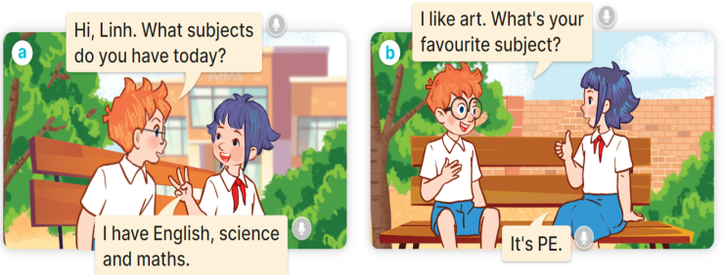  - Plays the audio twice (sentence by sentence). Correct their pronunciation where necessary.  - Has Ss to practice the dialogue  - Invites a few pairs to the front of the class to practice.  - Checks pronunciation for ss.  Activity 3 2. Listen, point and say.  *Aims: Ss will be able to correctly say the words and use What’s your favourite subject? – It’s …….. to ask and answer questions about someone’s favourite subject.  *Procedure:  * Model sentences:  - T asks Ss look at picture a and helps Ss know the structure from the dialogue.  - T introduces new structure for Ss.  - T explains, models and gives meaning.  -Has Ss repeat the model sentences.  A: What’s your favourite subject? B: It’s PE  3.Practice:  *Drill pictures  - Has Ss look at the pictures and elicit the subjects.  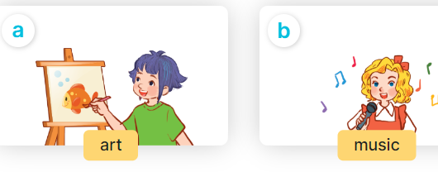  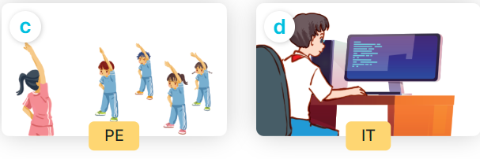  - Runs through all the pictures.  - Runs through model sentences.  - Has Ss to practise:  +Tells Ss to point the subjects in the picture when they are repeating the sentence  - T controls and corrects.  - Invites a few pupils to stand up, point at each school thing in the picture and say he sentence aloud.  - T gives feedbacks.  4.Production:  Activity 4. Let’s talk.  *Aims: Ss will be able to enhance the correct use of What’s your favourite subject? – It’s …… to ask and answer questions about someone’s favourite subject in a freer context.  *Procedure:  - Draws pupils’ attention to the two speech bubbles.  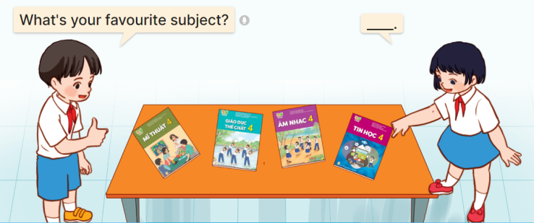  - Asks them to look at the girl’s speech bubble to identify what the answer should be. ex: It’s IT.  - Gets pupils to repeat the question and answer several times.  - Has pupils to work in pairs, point at the different books, ask and answer questions about their favourite subjects using What’s your favourite subject? – …..  - Invites some pairs to take turns asking and answering questions about their favourite subjects in front of the class.  *Consolidation  *Aims: Ss will be able consolidate and wrap up the content of the lesson.  *Procedure:  - Asks ss to answer the following questions:  + What have you learnt from the lesson today?  +What are the core values of the lesson? (if the teacher can take from the lesson).  - Review the vocabulary and model sentences.  - Praises some Ss who are hardworking / active/ good…. as well as encourage others to try more.  - Learn the vocabulary and model sentences by heart  - Prepare the new lesson: Unit 8, Lesson 1 (4,5,6). | - Ss listen  -Ss play the game  -Ss play the game  -Ss open the books  -Ss listen and answer  - - Ss listen and repeat  + Choral repetition (3 times).  + Individual repetition (3 ss)  - Ss take note  - Ss look, remember and write  -Look at the pictures and say  + In picture a:  Ben: Hi, Linh. What subjects do you have today?  Linh: I have English, science and maths.  + In picture b:  Linh: I like art. What’s your favourite subject?  Ben: It’s PE.  -Ss listen and repeat in chorus (twice)  -Ss work in pairs to practice  -Ss practice the dialogue  -Ss listen  -Ss look at the picture and answer.  -Ss listen  -Ss listen and repeat  -Ss repeat  - Ss look, listen and answer  + Picture a. A girl painting  + Picture b. Five children singing  + Picture c. A group of pupils doing physical exercise  + Picture d. A boy and a girl working on a computer  -Ss listen and repeat  -Ss practice in chorus, individuals.  -Ss point and say  -Ss listen.  -Ss look at the picture and answer  + a boy pointing at textbooks on a table, and asking a girl about her favourite subject.  -Ss look at the picture and answe  -Ss repeat the question and answer  -Ss work in pairs, point and say  -Ss ask and answer their favourite subjects in front of the class  -Ss answer the questions  - Ss listen  -Ss listen and clap their hands  -Ss listen  Ss listen  -Ss listen  -Ss listen and take note
IV. ADJUSTMENTS AFTER THE LESSON (if necessary):
………………………………………………………………………………………….…..……………………………………………………………………………...……………
------------------------------------

Theme: Me and my School
Week: 13 Period: 51 Number of periods: 3

Unit 8: My favourite subjects
Lesson 1 (4, 5, 6)

Classes:4A, 4B, 4C, 4D, 4E
Teaching time : from 27th November to 1st December 2023

I. OBJECTIVES:
1.Language focus/ Knowledge:
- Use the words and phrases art, music, PE, IT in relation to the topic “My favourite subjects”.
– Use What’s your favourite subject? – It’s ……... to ask and answer questions about someone’s favourite subject.
– Listen to and demonstrate understanding of simple communicative contexts in relation to the topic “My favourite subjects”.
– Read and write about someone’s favourite subject.
- Vocabulary: Review
- Skills: speaking, listening, reading and writing.
2. Competences:
- Written Communication: complete the sentences.
- Self-control and independent learning: perform listening tasks.
- Communication and collaboration: work in pairs or groups.
3. Attitude/ Qualities:
- Kindness: Help partners to complete learning tasks.
- Diligence: complete learning tasks.
II. TEACHING AIDS:
- Teacher: Teacher’s guide Pages 114, 115,116; audio Tracks 83; website hoclieu.vn, posters, laptop, pictures, textbook, lesson plan, TV or projector.
- Students: Pupil’s book Page 57, notebooks, workbooks, school things.
III. PROCEDURES:
Time | Teacher’s activities | Students’ activities
5ms  27ms  3ms | 1.Warm- up:  Sentence Puzzle  *Aims: to create a friendly and active atmosphere in the class to beginning the lesson.  *Procedure:  - Divides the class into groups of four.  - Gives each group a sentence that is broken/cut in to pieces.  - Asks Ss to arrange them to make a complete sentence, then read it aloud.  - The group makes it first will be the winner.  - Says “Open your book page 57” and look at “Unit 8, Lesson 1 (4,5,6)”.  2.Practice:  Activity 1. Listen and tick or cross:  *Aims: Ss will be able to listen to and understand four communicative contexts in which pupils ask and answer questions about their favourite subjects, and tick or cross the pictures.  *Procedure:  - Elicits the subjects in each picture.  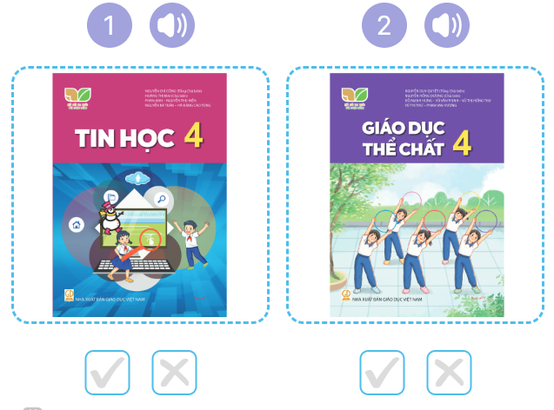  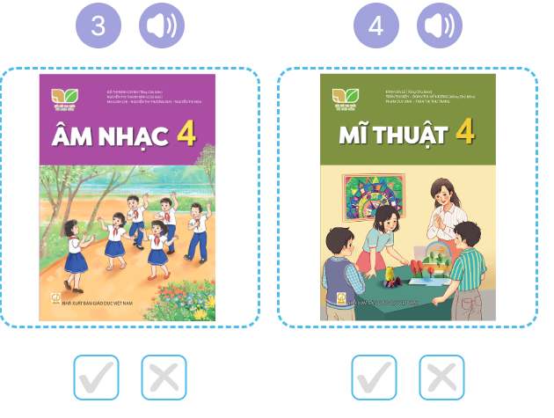  - T asks Ss to guess the answers.  + T writes Ss’guessing on the board.  - Listen to the tape:  + Plays the recording  + Plays the recording again and get Ss to swap books with their partners.  + Plays the recording again to check answers together as a class.  + Writes the answers on the board for Ss to correct their answers. Then checks Ss’ guessing.  - Plays the recording, sentence by sentence, for the class to listen and repeat in chorus.  Key: 1. v 2. x 3.v 4.x  Activity 2. Look, complete and read  *Aims: Ss will be able to complete four exchanges about characters’ favourite subjects with the help of picture cues *Procedure:  - Asks pupils to look at the pictures and identify the subjects. 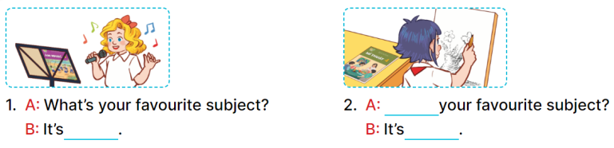  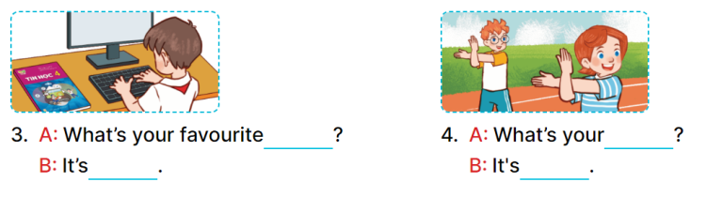  - Has Ss look at the four incomplete sentences. Elicit and model with picture 1  + Asks Ss to read the sentence 1 in chorus.  + Asks Ss what word is missing in the gap (music). Then have them complete the sentence (It’s music).  -Has Ss work in pairs and complete the sentences 2, 3, 4.  - Asks a few Ss to stand up and read the sentences aloud.  -T gives feedbacks.  Key:  1. music 2. What’s; art  3. subject; IT  4. favourite subject; PE  Activity 3. Let’s sing  *Aims: Ss will be able to sing the song My favourite subject with the correct pronunciation, rhythm and melody. *Procedure:  - Has pupils read the song to familiarize themselves with the lyrics  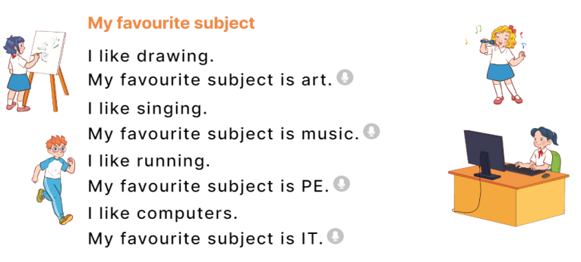  - Plays the recording for Ss to listen to the whole song.  + Has them repeat the title and lyrics line by line.  + Tells Ss to point at the pictures while singing.  - Plays the recording all the way through for Ss to listen to pronunciation and melody of the song.  - Plays the recording line by line for Ss to listen, repeat and point to the pictures  - Plays the recording for Ss to sing and do actions.  - Asks Ss to practice singing and doing actions in pairs or groups.  - Invites groups to the front of the classroom to perform the song  -T gives feedback.  *Consolidation  *Aims: Ss will be able consolidate and wrap up the content of the lesson.  *Procedure:  - T asks ss to answer the following questions:  + What have you learnt from the lesson today?  +What are the core values of the lesson? (if the teacher can take from the lesson).  - T praises some Ss who are hardworking / active/ good…. as well as encourage others to try more.  - Practice part 5 again.  - Prepare the new lesson: Unit 8, Lesson 2 (1,2,3). | - Ss listen  -Ss listen  - Ss arrange and read aloud  -Ss congratuate the winner  - Ss open their books  -Look at the pictures and say:  + Picture 1: An IT textbook  + Picture 2: A PE textbook  + Picture 3: A music textbook  + Picture 4: . An art textbook  -Ss guess the answers  - Ss listen to the tape and tick/ cross  - Ss listen again, tick/ cross and swap books with their partners.  - Ss check their answers and guessing  -Ss listen and repeat.  -Ss look at the picture and say  -Ss look and answer  -Ss read  -Ss say and write  -Ss work in pairs and complete  -Ss read aloud  -Ss read the song  -Ss listen to the song  - Ss listen and repeat line by line without the action.  -Ss point to the pictures while singing  -Ss listen to melody of the song  - Ss listen and sing line by line.  - Ss sing and do actions.  + Ss work in groups (two groups) to sing.  -Ss perform in front of the class.  -Ss listen  -Ss answer the questions  -Ss listen and clap their hands  -Ss listen and take note
IV. ADJUSTMENTS AFTER THE LESSON (if necessary):
………………………………………………………………………………………….…..……………………………………………………………………………...………………………………………….…..……………………………………………………………………………….……………………………………………………………………...

