Theme: Me and my School
Week: 12 Period: 45 Number of periods: 1

Unit 7: OUR TIMETABLE
Lesson 1(4, 5, 6)

Classes:4A, 4B, 4C, 4D, 4E
Teaching time : from 20th November to 24th November, 2023

I. OBJECTIVES:
1.Language focus/ Knowledge:
- Identity specific information by listen to conversation related to topic school subjects.
- Fill in the gaps using given picture cues.
- Recall some vocabularies related to topic school subject by doing the puzzle.
- Vocabulary: Review
- Skills: speaking, listening, reading and writing.
2. Competences:
- Critical Thinking: self-introduce
- Co-operation: ready to help friends in pair work/ group work.
- Self-control and independent learning: perform listening tasks.
3. Attitude/ Qualities:
- Kindness: Help partners to complete learning tasks.
- Show their responsibility to follow the timetable and prepare their subjects before school.
II. TEACHING AIDS:
- Teacher: Teacher’s guide Pages 102,103,104; audio Tracks 69; website hoclieu.vn, posters, laptop, pictures, textbook, lesson plan, TV or projector.
- Students: Pupil’s book Page 51, notebooks, workbooks, school things.
III PROCEDURES:
Time | Teacher’s activities | Students’ activities
5ms  27ms  3ms | 1.Warm- up: Game: Slap the board  *Aims: to create a friendly and active atmosphere in the class to beginning the lesson.  *Procedure:  - Divides class into 2 groups: Tom and Jerry.  - How to play:  + Each group chooses five Ss to play.  + Class will read aloud.  + Looks at the picture, listen and slap the picture you heard.  + Who faster will get 1 mark.  + Which group with higher mark is the winner.  - Says “Open your book page 51” and look at “Unit 7, Lesson 1 (4,5,6)”.  2.Practice:  Activity 1. Listen and tick or cross:  *Aims: Ss will be able to listen to and understand four communicative contexts in which pupils ask and answer questions about the subjects they have and tick or cross the pictures.  *Procedure:  - Draws pupils’ attention to the pictures and asks questions: What subject is it? 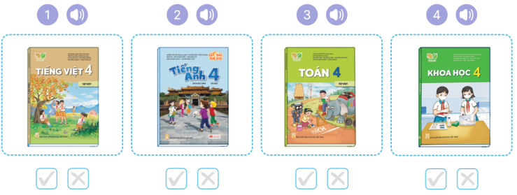  - Reminds them to look at the book covers of the subjects and tick or cross the boxes while listening.  - Plays the recording all the way through.  - Plays the recording for pupils to listen and tick or cross the boxes.  - Gets pupils to swap books with a partner to check their answers.  - Checks the answer together.  - Plays the recording, sentence by sentence, for pupils to listen and repeat in chorus. Key: 1. v 2. x 3. v 4. x  Activity 2. Look, complete and read  *Aims: Ss will be able to complete four gapped exchanges with the help of picture cues.  *Procedure:  - Gets Ss to look at the pictures and identify the subjects in each picture.  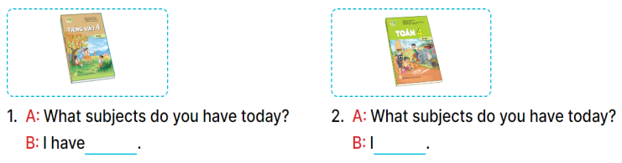  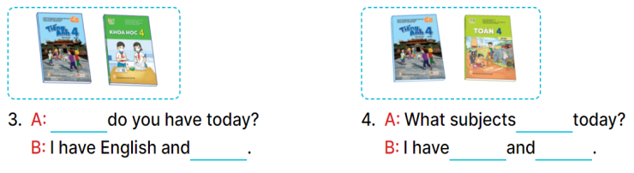  - Has Ss look at the four incomplete sentences. Elicits and models with picture 1  + Asks Ss to read the sentence 1 in chorus.  + Asks Ss what word is missing in the gap (Vietnamese). Then have them complete the sentence (I have Vietnamese).  - Has Ss work in pairs and complete the sentences 2, 3, 4.  - Asks a few Ss to stand up and read the sentences aloud.  -T gives feedbacks.  Key:  1. Vietnamese 2. have maths  3. What subjects; science  4. do you have; English; maths  Activity 3. Let’s play  *Aims: Ss will be able to review the target vocabulary items using the puzzle, then ask and answer questions about the subjects pupils have at school.  *Procedure:  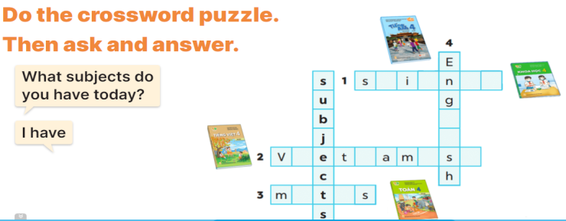  - Tells pupils the goal of the puzzle and how to play it. Then have them look at the spaces in the puzzle and given letters as well as picture cues to find appropriate lettersto complete the words.  - Gives pupils a time limit to do the puzzle individually.  - Has pupils work in pairs. One points at the completed words or the clues and asks What subjects do you have today? and their partner answers I have ………  - Invites a few pairs to the front of the classroom to ask and answer questions about what subjects they have today.  Key: 1. science 2. Vietnamese 3. maths 4. English.  *Consolidation  *Aims: Ss will be able consolidate and wrap up the content of the lesson.  *Procedure:  - T asks ss to answer the following questions:  + What have you learnt from the lesson today?  +What are the core values of the lesson? (if the teacher can take from the lesson).  - T praises some Ss who are hardworking / active/ good…. as well as encourage others to try more.  - Practice part 5 again.  - Prepare the new lesson: Unit 7, Lesson 2 (1,2,3). | - Ss listen  -Ss play game  - Ss play game  -Ss play game  - Ss open their books  -Look at the pictures and say:  + Picture 1: A Vietnamese textbook  + Picture2: An English textbook  + 3: A maths textbook  + P4: A science textbook  - Listen to the tape and tick or cross  - Listen and tick or cross  - Ss listen again, tick and swap books  - Check answer  -Ss listen and repeat.  -Ss look at the picture and say  -Ss look and answer  -Ss read  -Ss say and write  -Ss work in pairs and complete  -Ss read aloud  - Ss listen to the teacher  -Ss play game  -Ss play game  -Ss answer the questions  -Ss listen and clap their hands  -Ss listen and take note
D. ADJUSTMENTS (if necessary):
………………………………………………………………………………………….…..……………………………………………………………………………...………………………………………….…..…………………………………………………………

