*Date: 4 November 2024 Teacher: Phan Thị Nhu Cầu*

*Professional group: English – PE – Music – Art*

**Unit 4: ETHNIC GROUPS OF VIET NAM**

**Period : 28 : Lesson 1 - GETTING STARTED**

**Time expected: 45 mins**

**I. OBJECTIVES**

**1. Knowledge:** By the end of the lesson, students will be able to:

- Have an overview about the topic *Ethnic groups of Viet Nam*

- Pronunciation: -Sounds: pronounce and recognize the sounds /k/ and /g/

- Vocabulary: - Use the vocabulary relating to the topic *Ethnic groups of Viet Nam*

- Grammar: + *Yes / No* and *WH-*questions.

+ Countable and uncountable nouns.

**2. Competences**

- General competences:

+ Develop communication skills and creativity (students use language to communicate with other students about *Ethnic groups of Viet Nam*)

- Distinctive competences:

+ Linguistic competences (use pronunciation, vocabularyto express *Ethnic groups of Viet Nam*)

**3. Attributes:**

Students will form and develop some values: Patriots, hard work, honesty and responsibility (Love our country and people, respect the diversity of our culture through knowledge and understanding about *ethnic groups of Viet Nam*)

**II. TEACHING AIDS**

**1. Teacher**:

- Grade 8 textbook, Unit 4, Getting Started

- Computer connected to the Internet.

- Projector/ TV/ pictures and cards

- hoclieu.vn

**2. Students**:

- Grade 8 textbook, Unit 4, Getting Started

**III. PROCEDURES**

**1. ACTIVITY 1: WARM-UP (5ms) Network:**

**a. Aims of the activity:**

- To create an active atmosphere in the class before the lesson.

- to enhance students’ skills of co-orperating in teammates

**b. Content:**  writes the name of ethnic groups

**Network:**

The Tay

**Ethnic groups**

**c. Products:**

***Suggested answers:***

The Tay, the Nung, the Yao, the Kinh, the Brau, the Hani, the Hmong, the Bahnar, the Bru, the Muong, the Koho, the Giay,………

**d. Organization of implementation**

- Asks Ss to work in 2 groups and think of some ethnic groups in Viet Nam.

- Writes the name of one ethnic group as a modelling activity.

- Ss (one by one) go to the board and write the names of ethnic groups in Viet Nam that they know.

- Teacher checks Ss’ results.

- The group with more correct names of ethnic groups in Viet Nam becomes the winner.

**2. ACTIVITY 2: KNOWLEDGE FORMATION (9ms)**

**a. Aims of the activity: -** to help the students get the general knowledge about *Ethnic groups of Viet Nam*

**b. Content:** **-** to introduce the new words relating to the topic *Ethnic groups of Viet Nam*

**c. Products:**

*- Vocabulary*

1.ethnic (group) **/ˈeθnɪk / (/gru:p/):** (nhóm) dân tộc

*2.* post (n) **/pəʊst/: cột**

3.stilt house (n) **/stilt haus/** nhà sàn

4.costume (n) **/'kɔstju:m/:** trang phục

5.terraced field (n) **/ˈterəst fiːld /:** ruộng bậc thang

**d. Organization of implementation**

- Students listen, guess the meaning of words.

- Teacher guides students how to read chorally.

- Teacher calls some students to read in groups and individual.

- Teacher checks students’ pronunciation and gives feedback.

- Teacher checks students’ understanding with the “Slap the board” technique.

+ The teacher writes new words or sticks pictures on the board.

+ Call two groups to the board, each group of four to five students.

+ Ask groups to stand an equal distance from the board.

+ The teacher shouts out the Vietnamese word if the word on the board is English and vice versa (if using pictures, shout out the English word).

+ One by one, students in two groups run up to the board, tapping the word they are called.

+ The student in the group that gets it right and faster will score points.

+ The group that scores more points wins.

**3. ACTIVITY 3: PRACTICE (25ms)**

**3.1. Task 1: Listen and read.(7ms)**

**a. Aims of the activity: -**To help students understand the main idea of the conversation.

**b. Content: Listen and read.**

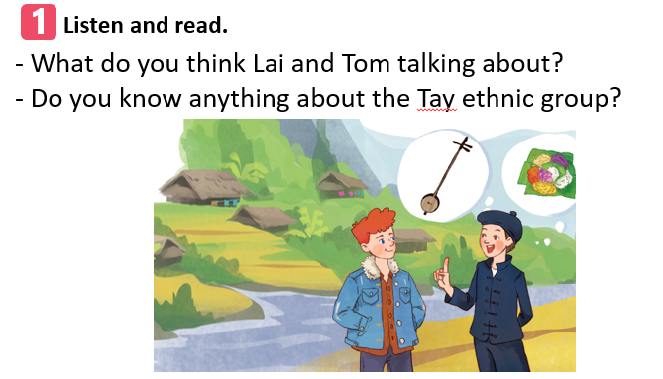

Tom: Hi, I’m Tom. You look new here.

Lai: I am. I’m Lai from Ha Giang.

Tom: Oh, I’ve heard about beautiful Ha Giang. Do you live in the mountains?

Lai: Yes, I do. I’m from the Tay ethnic group. We are the second largest ethnic group in Viet Nam, only after the Kinh.

Tom: Oh … I once saw a bamboo house on high posts in a travel brochure. Do you live in a home like that?

Lai: Yes, we call it a “stilt house”. Our house overlooks terraced fields.

Tom: Awesome. What is life in your village like?

Lai: It’s peaceful. There are 16 houses in my village. We live very close to nature.

Tom: I love it. Can you tell me something about your culture?

Lai: Certainly. We have our own culture. You can see it in our folk dances, musical instruments like the *dan tinh*, and our special five-colour sticky rice.

Tom: It sounds interesting. I hope to visit Ha Giang one day.

**c. Products:**

- They are talking about the Tay ethnic group/ an ethnic group/…

**d. Organization of implementation**

- Asks Ss to look at the title and the picture in the book then answer the questions.

- Ss answer the questions in pairs.

- Plays the recording twice. Ss listen and read.

- Asks some pairs of students to read the conversation aloud.

- Asks Ss if they would like to change or add anything to their previous answers.

**3.2. Task 2: Read the conversation again and circle the correct answers.(6ms)**

**a. Aims of the activity:**

-To help students understand more the text; to acquaint students with the grammar points and new vocabulary of the lesson.

**b. Content:**

1. What are Tom and Lai talking about?

A. Minority groups in Viet Nam. B. Ha Giang. C. Life of the Tay people.

2. A “stilthouse” _______________.

A. is a multi-storey home B. is on high posts C. always faces a field

3. Lai mentions ___________ of the Tay people.

A. folk dances B. popular festivals C. costumes

**c. Products:**

***Answer key:***

1. C 2. B 3. A

**d. Organization of implementation**

- Tells Ss to read the conversation again and work independently to find the answers.

- Ss work independently to find the best answers.

- Has Ss compare the answers in pairs before checking with the whole class.

- checks the answers as a class and gives feedback.

**3.3. Task 3: Match the pictures with the word and phrases from the conversation (6ms)**

**a. Aims of the activity: -**To develop students’ knowledge of the vocabulary about *Ethnic groups of Viet Nam*

**b. Content:** Match the pictures with the word and phrases from the conversation

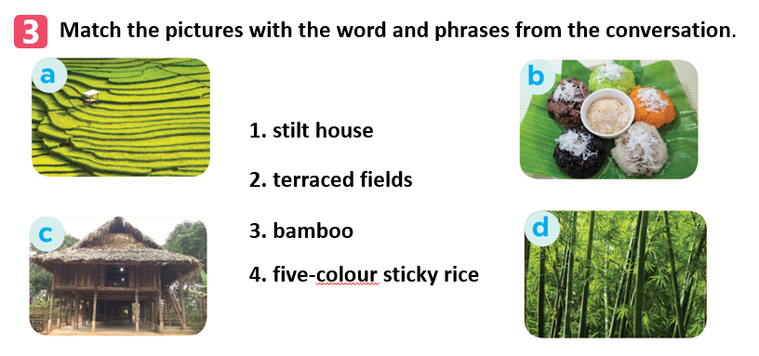

**c. Products:**

***Answer key:***

1. c 2. a 3. d 4. b

**d. Organization of implementation:**

- Asks Ss to look at the pictures and read the word and phrases.

- Ss work individually to match the word and phrases with the pictures.

- Ss compare their answers with a partner.

- Checks the answers as a class and gives feedback.

**3.4. Task 4: Complete the sentences with the words and phrases from the box (6ms)**

**a. Aims of the activity: -**To develop students’ knowledge of the vocabulary about *Ethnic groups of Viet Nam*

**b. Content:** Complete the sentences with the words and phrases from the box

1. I love mua sap, a popular _________ of the Thai people.

2. Their beautiful stilt house _________ a large rice field.

3. A: What is the name of a popular Tay’s _________? - B: It’s dan tinh.

4. Every ethnic group has their own _________ culture.

5. Of the 54 _________ in Viet Nam, the Kinh is the largest.

**c. Products:**

***Answer key:***

1. folk dance

2. overlooks

3. musical instrument

4. traditional

5. ethnic groups

**d. Organization of implementation:**

- Asks Ss to read 5 sentences (with gaps) carefully.

- Ss work independently to fill in each blank with a suitable word or phrase from the box.

- Checks the answers as a class and gives feedback.

**4. ACTIVITY 4: APPLICATION AND EXTENTION ACTIVITIES (4ms)**

**Task 5: The game “Where are they?”**

**a. Aims of the activity:** To allow Ss to locate the living places of some large ethnic groups in Viet Nam

**b. Content: The game “Where are they?”**

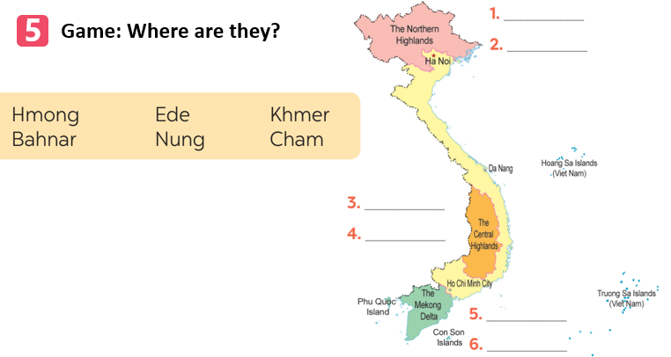

**c. Products**

*Students’ answer*

***Answer key:***

1. Hmong

2. Nung

3. Ede

4. Bahnar

5. Khmer

6. Cham

**d. Organization of implementation: Individually- pair work**

- Asks Ss to work individually, look at the map and read the words carefully.

- Divides the class into 2 teams.

- Asks Ss to play the game in 2 minutes.

- Ss from 2 teams (one by one) go to the board and write one name for each number.

- The team with more correct answers wins.

**\* HOMEWORK:2ms**

**-Asks the students to:**

+ Revise the content of **lesson : GETTING STARTED**

+ Prepare the new lesson : Lesson: **A CLOSER LOOK 1**

+ Do the exercises in the workbook