Date of preparation: January 10th, 2025 | Teacher: Vo Thanh Dat  Professional group: Gifted group

UNIT 7: TRAFFIC
Period 55: Lesson 1 - GETTING STARTED
Subject: English, Class 7a1,2
Time expected: 45 mins

I. OBJECTIVES
1. Knowledge: By the end of this lesson, Ss will be able to gain:
- Pronunciation: Practice and distinguish the differences between the sounds /aɪ/ and /eɪ/.
- Vocabulary: Master and know how to use vocabulary relating to means of transport.
+ Identify and talk about the benefits of means of transport .
- Grammar: Know how to use “should/ shouldn’t” and “It indicating distance” .
2. Competence:
- General competences:
+ Communicative and collaborative ( Help students to ask and answer means of transport)
+ Self- controlled and self- learning competence
- Distinctive competences:
+ Linguistic competence ( Students are able to talk about the benefits of means of transport )
+ Aesthetic competence
+ Natural and social inquiry competence
+ Physical competence
3. Values:
Students will form and develop some values: benevolence, hard work, honesty and responsibility.

II. TEACHING AIDS:
1. Teacher: Active board, laptop connected with the Internet, Teacher’s book. sachmem.vn
2. Students: Textbooks, work book,notebooks, posters, collect some picture relating to means of transport

III. PROCEDURES
1. ACTIVITY 1: WARM-UP (5’)
Task 1
a. Aims of the activity:
- To activate students’ knowledge on the topic of the unit
- To enhance students’ skills of cooperating with team mates
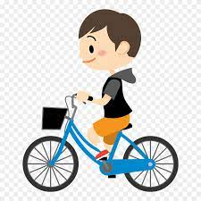
b. Content: Miming game: T asks Ss to look at the photos and answer the questions.
1. What is he doing?

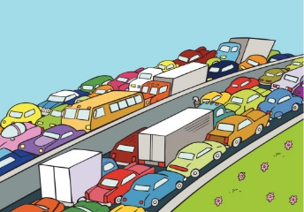
2. What is this picture about ?

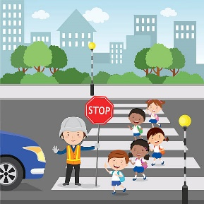
3. What are they doing?

4. Which time of the day usually has traffic jam?

** Ss say the words.

c. Products: Answer the questions
1. He’s riding a bike.
2.It is about traffic jam.
3.They are waiting for the red light.
d. Organization of implementation
* Teacher gives instructions
** In groups, Ss
- One of the students in the group go to the board.
- Teacher secretly show 1 picture of a mean of transport to that student. He/She has to mime the picture and the other has to guess. Of course the other groups will also be allowed to guess.
- take turns go to the board until finish all the pictures.
**** Teacher checks and corrects if Ss pronounce the words incorrectly.
* To help you know more about traffic, today we come to this lesson: Unit 7: TRAFFIC- Lesson: Getting started

2. ACTIVITY 2: KNOWLEDGE FORMATION (10’)
a. Aims of the activity:
- To provide the students with vocabulary.
- To help students distinguish the differences between the sounds/aɪ/ and /eɪ/.
- To introduce “It indicating distance”and “should/ shouldn’t”.
b. Content: Student will learn some new words and know “It indicating distance”and “should/ shouldn’t”..
c. Products: Read and understand the meaning of words.
New words
- cycle (v) /ˈsaɪkl/: đạp xe
- traffic jam (n.phr.) /ˈtræfɪk dʒæm/: tắc đường
- cross the road (v.phr.) /krɒs ðə rəʊd/: băng qua đường
- rush hour (n.phr.) /ˈrʌʃ aʊə(r)/: giờ cao điểm
5.take /teɪk/ (v):mất b nhiêu thời gian
Structures
It’s about two kilometers.
You should be careful
d. Organization of implementation
- Teacher introduces and teaches the vocabulary by using some techniques:
+ cycle (synonym),traffic jam (picture),cross the road (picture),rush hour (situation and picture ),
take ( situation)
- Teacher emphasizes and helps the students know the sound /aɪ/ and /eɪ/ through two words: “take /teɪk/ and cycle/ˈsaɪkl/ ”.
- Students listen, guess the meaning of words.
- Teacher guides students how to read chorally.
- Teacher asks some students to read in groups and individually.
- Teacher checks students’ understanding with the “Rub out and remember” technique.
- Teacher checks students’ pronunciation and gives feedback. Teacher reveals that these five words will appear in the reading text and asks students to open their textbook to discover further.

3. ACTIVITY 3: PRACTICE (25’)
3.1. Task 1: Listen and read:
a. Aims of the activity: To help students listen and read exactly about spelling and intonation.
b. Content: Listen and read
Students listen and read about the dialogue.
c. Products:
Students can listen and read exactly about the dialogue.
d. Organization of implementation
- Teacher plays the tape twice, asks students to listen.
- Teacher asks students to work in pairs to read the dialogue.
- Teacher calls some pairs to read the dialogue.
- Teacher calls some students to remark the mistakes.
- Teacher corrects the pronunciation mistakes.
3.2. Task 2: Read the conversation again and choose the correct answer.
a. Aims of the activity: To have students get specific information of the text.
b. Content: Read the conversation again and choose the correct answer.
1. How does Lan often go to school?  A. By bicycle.  B. By motorbike.  C. On foot.  2. It normally takes Lan ___ to get to school.  A. two minutes  B. ten minutes  C. twenty minutes  3. Lan and Mark agree to go cycling ______.  A. tomorrow  B. every day  C. at the weekend | 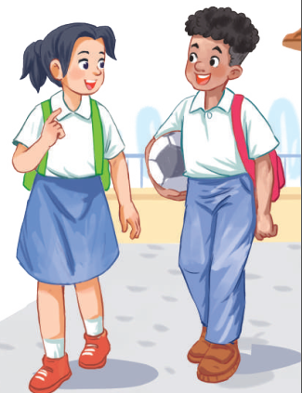
c. Products: Answer the questions correctly.
1.A 2.B 3.C
d. Organization of implementation
- Teacher tells students to read the conversation again and work independently to find the answers.
- Teacher has students compare the answers in pairs before checking with the whole class.
- Teacher calls some students to give their answers in front of class.
- Teacher calls some students to check the mate’s answers.
- Teacher checks the answers and gives feedback. T encourages students to explain where they have found the answers from the conversation.

3.3. Task 3: Write one word from the conversation to complete each sentence.
a. Aims of the activity: - To practise reading and listening for specific information
- To practise scanning
- To develop Ss' knowledge of vocabulary
b. Content: Write one word from the conversation to complete each sentence.
1. Last Sunday afternoon, Lan _______ round the lake near her home.
2. Mark says to Lan: "You _______ careful, especially when you cross the road.
3. Traffic _______ are a problem in big cities.
4. - _______ does your mum go shopping?
- She often walks.
5. This road is very _______ during the rush hours.
c.Products: Be able to state the sentences T or F and correct the false sentences.
1. cycled 2. should 3. jams 4. How 5. crowded
d. Organization of implementation
-Teacher asks Ss to work individually to read and listen to the conversation and find the words and phrases and then share their answers with their partners who sit next to them. (peer check)
- Ss do exercise 3 individually
- Ss share and discuss with their partners to write all words/ phrases down on the notebooks.
-Teacher corrects their answers as a class.
Task 4: Look at the pictures and write a word under each.
a. Aims of the activity:
- To help Ss deeply understand the text
- To get them to know more some vocabulary items related to means of transport.
- To practise scanning and intensive reading
b. Content: Look at the pictures and write a word under each.
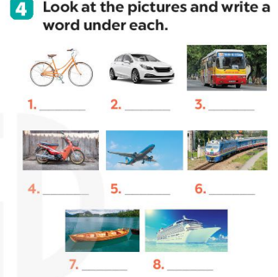
c. Products: Students write the corect word under the pictures.
1. bicycle 2. car 3. bus 4. motorbike
5. plane/air-plane 6. train 7. boat 8. ship
d. Organization of implementation
- Teacher asks students to name the pictures.
- Teacher has students work individually to write the words under the pictures. Have them compare their answers with a partner. Then ask for students’ answers.
-Teacher nominates Ss to read the words aloud
- Teacher checks and gives the correct answers.
4. ACTIVITY 4: APPLICATION AND EXTENSION ACTIVITIES (5’)
Task 5: Find someone who ... Write your friends' names in the blanks. Then report to the class.
a. Aims of the activity: - To help Ss practising talking about how they go to school
- To practise team working
- To give students authentic practice in using target language.
b. Content: Find someone who … Write your friends’ names in the blanks. Then report to the class
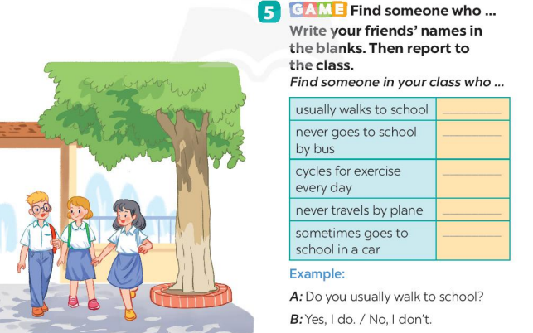
c. Products
+ doing things: riding a horse, gardening (others: travelling, skiing, doing yoga, etc.)
+ making things: making models, building dollhouses (others: painting, making pottery, etc.)
+ collecting things: collecting coins, collecting teddy bears (others: collecting toys, collecting books,etc.)
d. Organization of implementation
* Teacher gives Ss clear instructions in order to make sure Ss can do the survey effectively.
- Ask students to look at the survey and think of the needed structures to ask their friends.
+ Students goes around the class and ask at least 20 classmates and ask them (Do you usually walk to school? Have you ever gone to school by bus?…)
- Observer Ss while they are role playing, note their language errors
** Ss do as instructed
**** Teacher gives Ss feedback.
- Choose some useful or excellent words/ phrases/ expressions/ word choices Ss have used to suggest other students use them
- Choose some typical errors and correct as a whole class without nominating the students’ names.

