Date of preparation: October 30, 2024 Teacher: Võ Thành Đạt
Professional group: Gifted group
UNIT 4: MY NEIGHBOURHOOD
Period 27 - Lesson 1: GETTING STARTED

Subject: English, Class: 6
Time expected: 45 minutes

I. OBJECTIVES
1. Knowledge: By the end of the lesson, students will be able to:
- Pronunciation: Practice and distinguish the differences between the sounds /iː/ and /I/.
- Vocabulary: Master and know how to use vocabulary relating to places in a neighbourhood.
- Grammar: Know how to use comparative adjective: smaller, more expensive, …
2. Competences
- General competences: Communicative and collaborative ( Help students to ask for and give direction);Self- controlled and self- learning competence.
- Distinctive competences: Linguistic competence (Students are able to talk about a neighborhood); Aesthetic competence; natural and social inquiry competence; Physical competence.
3. Values
Students will form and develop some values: Patriots, benevolence, hard work, honesty and responsibility.
II. TEACHING AIDS
1. Teacher: Active board, laptop connected with the Internet, Teacher’s book.
2. Students: Student’s book, work book, collect some picture relating to their neighborhood .
III. PROCEDURES
1. ACTIVITY 1: WARM-UP (5’) Team work
a. Aims of the activity: To engage students to some situations relating to the neighbourhood.
b. Content: Students will listen to a song about Hoi An and write down some places mentioned in the song.
c. Products: Chua Cau, Tan Ky House,
d. Organization of implementation
- Divide class into 2 teams and asks students to listen to a song about Hoi An and write some places mentioned in the song
- Ask one student from each team to take turn to write his team’s answer on the board.
- The team who has more correct words is the winner.
- Lead to the new lesson.
* Chitchatting:
“Do you know where it is?”
“Have you ever been to Hoi An?”
“Do you remember anything special in Hoi An?”



Today we are going to travel around Hoi An; before we start the lesson, let’s get some vocabulary first.
2. ACTIVITY 2: KNOWLEDGE FORMATION (10’)
a. Aims of the activity: To provide students with vocabulary and structures relating to the topic: school things and activities
b. Content: Student will learn some new words and revise the present simple tense.
- Students will listen to the teacher, guess the meaning of the new words then repeat words by word in individual, groups and choral.
- Students will play the game to remember the words they learned.
c. Products
* Vocabulary
-. neighbourhood (n): /ˈneɪbəhʊd/: vùng lân cận / hàng xóm
- to be/get lost: /tuˈbɪ/ /get lost/: bị lạc
- Cross the road : băng qua đường
- Go / keep straight: đi thẳng
- Turn right / left: rẽ phải/ trái
d. Organization of implementation
- Teach word by word according to steps and principles of teaching new words. (using picture, real objects, examples, …)
- Check the students’ understanding by the game: “What and Where”
Puts the new words on the board (not in a list), each word is in a circle.
Reads new words and rubs out word by word but leaves the circles.
Goes on until all the circles are empty.
Gets the students to go to the board and write the words in their correct circles.
Gives remarks and feedback.
3. ACTIVITY 3: PRACTICE (20’)
3.1. Task 1: Listen and read
a. Aims of the activity: to help students listen and read correctly the dialogue about a conversation among three students: Phong, Nick and Khang
b. Content: Students will listen and read the dialogue correctly.
c. Products
- Students read and understand the meaning of the text.
- Students know how to role play
d. Organization of implementation
- Play the recording three times and asks students to listen to the recording.
- Ask three students to play roles of Phong, Nick and Khang to read the dialogue aloud in front of the class.
- Ask the whole class to work in groups of three to read the dialogue.
- Call some groups to read aloud to correct their spelling and intonation.
- Give feedback to the students.
3.2. Task 2: Find in the conversation the sentences used to make suggestions.
a. Aims of the activity: To help students know how to use let’s and shall to make suggestions.
b. Content: Students will read the conversation again and find the sentences used to make suggestions.
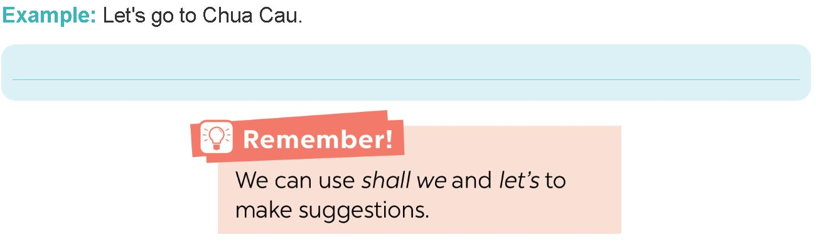
c. Products
1. Let’s go to Chua Cau!
2. Shall we go there first?
3. First cross the road, and then turn left.
4. Fine, let’s go.
5. Let’s ask her.
d. Organization of implementation
- Tell students to read the conversation again and work independently to find the answers.
- Have students work in pair to compare their answers before checking with the whole class.
- Call some students to give the answers.
- Call other students to support for the answers.
- Give feedback.
Model sentences: Making suggestions
Teacher asks:
- Where do Phong, Nick and Khang go first? Who suggests going there? What does he say? Do Nick and Khang agree? What do they say?
Teacher writes model sentences
3.3. Task 3: Read the conversation again. Put the action in order.
a. Aims of the activity: To practice the targeted language and the background knowledge of my neighbourhood.
b. Content: Read the conversation again put the actions in their correct orders.
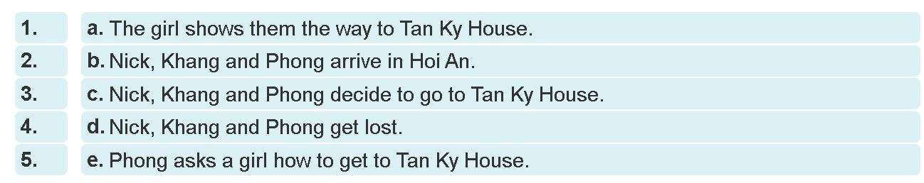
c. Products
1. b 2. c 3. d 4. e 5. d
d. Organization of implementation
- Tell students to read the conversation again and work independently to find the answers.
- Has the students to share their answers with their partner.
- Call some students to give their answers.
- Call some other students to give supports if necessary.
- Correct mistakes and gives feedback.
3.4. Task 4: Find and underline the following directions in the conversation. Pair work
a. Aims of the activity: To help students know how to give directions through the conversation
b. Content: Read the conversation and underline the following directions, then match these directions with the diagrams below.
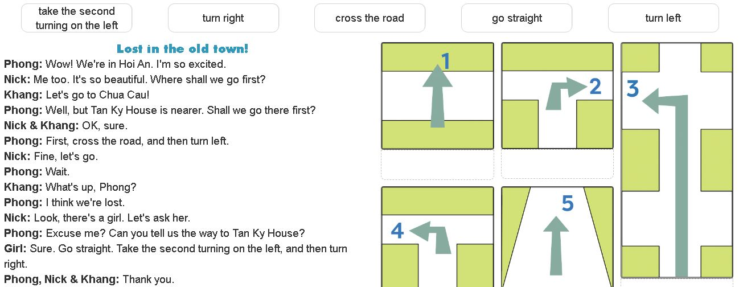

c. Products
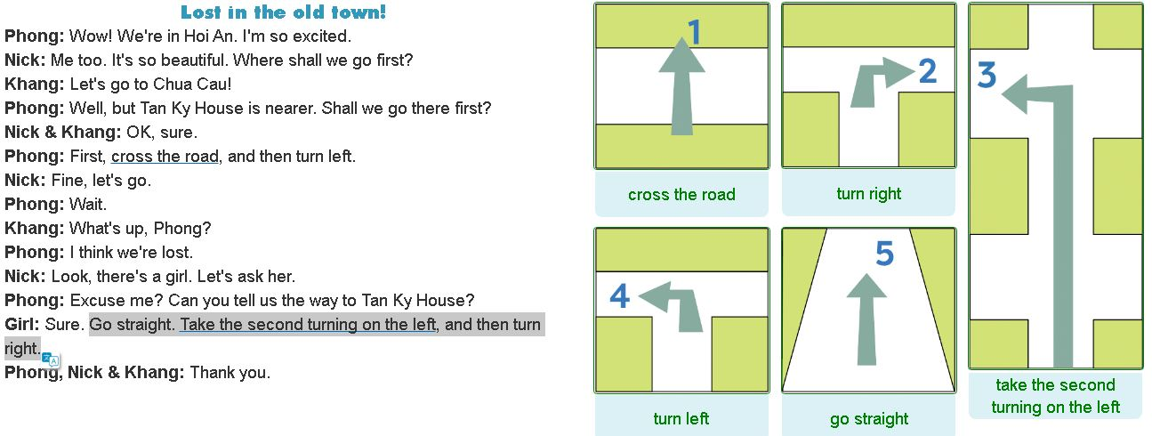
d. Organization of implementation: pair work
- Ask students to read the conversation again and underline the directions in pairs
- Ha students quickly match each direction with the diagram.
- Check their answers as a class.
If students do not understand the phrases, use the diagrams to work the meaning out from the context.
- If it is a weaker class, ask for translation to make sure they understand.
- With a stronger class, teacher may wish to ask some additional questions,
e.g. Can you tell me the way to the post office near here?, etc.
4. ACTIVITY 4: APPLICATION AND EXTENSION ACTIVITIES (5’)
a. Aims of the activity: to involve students in a real situation to practice their language.
b. Content: Work in pairs. Give your partner directions to one of the places on the map, and he/she tries to guess. Then swap.
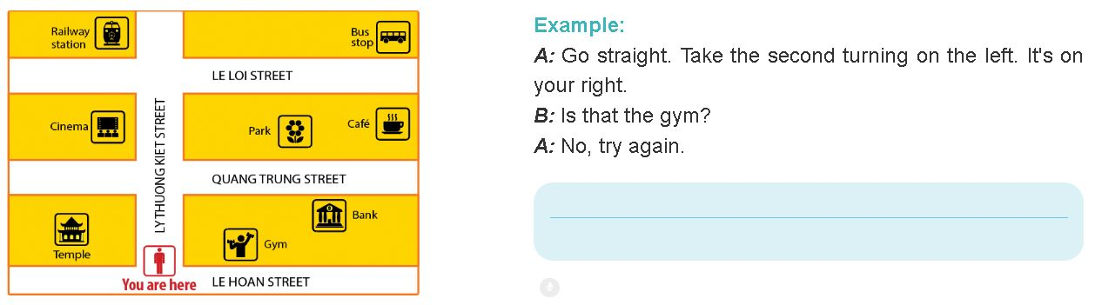
c. Products
Students can ask and answer the way to some places in the map.
d. Organization of implementation: Pair work.
- Demonstrate the game with a good student.
- Ask students to play the game in pairs. In a weaker class, work together with students first: asking about one or two different places on the map and eliciting the answers. Then when they know exactly what to do, ask them to work in pairs.
- Call some pair (close pairs and open pairs) to practice in front of the class.
- Take notes during students’ practice (some mistakes of spelling, pronunciation, and intonation, …)
- Give feedback.
5. HOMEWORK : ( 5’)
- Learn the lesson by heart
- Do the exercise 1,2,3 in the workbook
- Prepare : A closer look 1

