***Date: November 17th, 2024***  *Teacher:* *Huynh Thi Thuy*

*Professional group: English – Art- PE*

**UNIT 4: REMEMBERING THE PAST**

**Period 34 - Lesson 7: LOOKING BACK AND PROJECT**

**Subject: English – Class 9**

**Time expected: 45 mins**

**I. OBJECTIVES**

**1.Knowledge:** By the end of the lesson, students will be able to:

- Use the words related to the topic *Remembering the past*

- Help Ss revise the form and use of past continuous / Wish + past simple.

- Enable students to collect information and pictures about life in your area about 40 years old

**2. Competence**

- General competences: Students will form and develop competences: self-control and self-learning, communication and collaboration, problem solving and creativity.

- Distinctive competences: linguistic competences.

**3. Personal qualities:** Students will form and develop some values: benevolence, hard work, honesty, responsibility.

**II. TEACHING AIDS**

**1. Teacher**: Active board, laptop connected with the Internet, Teacher’s book.

**2. Students**: Student’s book, work book, collect some picture relating to their neighbourhood

**III.TEACHING PROCEDURES:**

**\* LOOKING BACK**

**1. ACTIVITY 1: WARM UP & INTRODUCTION ( 5ms)**

**a. Aims of the activity: -**To get sts to know the language items they will review vocabularies and grammars

- To lead into the new lesson

**b.Content:** The past continuous and Wish- clauses

**c. Products:** know more the form of the past continuous and Wish- clauses

**d. Organization of implementation :** Teacher’s instructions …

**-** Show the pictures , has Ss look at them and answer the question:

What do you think the pictures are about ?

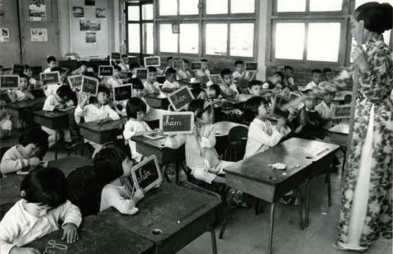 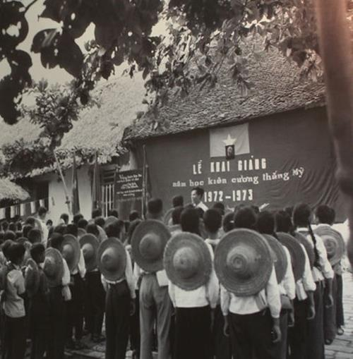

**-** Lead to the new lesson **:**

**2. ACTIVITY 2: KNOWLEGDE FORMATION (10ms)**

**a. Aims of the activity: -** Help the sts new words relating to the topic Remembering the past and review “ the past continuous and wish sentences”.

**b.Content:** the past continuous and wish sentences.

**c. Products:**

**1. THE PAST CONTINUOUS.**

a. Examples

• I was studying all night for the exam.

• He was running late for the meeting.

• They were playing well until the second half.

#### **b. Form:**

|  |
| --- |
| + **S + was/were + Ving…** |
| -**S + was not/were not + Ving…** |
| ? **Was/Were + S + Ving…?; WH- + was/were + S + Ving…?** |

Ex: The days were getting shorter as winter approached.

Ex: He was not listening to music.

Ex: Were you playing soccer?

#### **c. Signals:**

• At + clock + yesterday / last week

• At this time + yesterday / last week

• In + year

• In the past

• when, before, after, whenever, until.

**2.** **WISH + PAST SIMPLE**

|  |
| --- |
| ***S1 + wish + S2 + V-ed/2 …..*** |

Ex:I wish I **had** enough money to travel around the world.

I wish (that) my mother **didn't have** to work so hard.

**d. Organization of implementation :** Teacher’s instructions..

- Teacher draws students’ attention to the form of the sentences created in the game and asks them whether they know the target knowledge

* Teacher provides or confirms the answers and leads in the grammar focus of the lesson:

**3. ACTIVITY 3. PRACTICE ACTIVITIES ( 15ms)**

**Exercise 1*:*** **Choose the correct answer A, B, C, or D.**

**a. Aims of the activity: -** To help Ss revise the words and collocations they have learnt in the unit

**b. Content:** Choose the correct answer A, B, C, or D.

1. In keeping with _______, we cook five-colour sticky rice on the first day of a lunar month.

A. tradition B. habit C. ritual D. practice

2. Sam is very interested in history, and he remembers a lot of historical _______ and dates.

A. traditions B. events C. anniversaries D. practices

3. The fire of London in 1666 destroyed thousands of old _______ and damaged a large part of London's centre.

A. organisations B. structures C. associations D. connections

4. This practice was more common in _______ times than it is now.

A. beginning B. antique C. historic D. ancient

5. This complex of buildings was _______ by foreign troops during the war.

A. received B. busy C. occupied D. filled

**c. Products:**

**Answer key:** 1. A 2. B 3. B 4. D 5. C

**d. Organization of implementation :** Teacher’s instructions.

- Reads the example and explain

- Lets students to read through the sentences then asks them to do the task individually.

- Calls some students to say out their answers separately.

- Correct mistakes if necessary

**Exercise 2.** **Finish the sentence by completing each blank with a word. The first letter of each word is given.**

**a.Aims:-** To help Ss to complete the sentences by **using the correct forms of the verbs.**

**b.Content:** Finish the sentence by completing each blank with a word. The first letter of each word is given.

1. The custom of w_____ ancestors is a beautiful and rich tradition in Vietnamese culture.

2. The custom of sending a greeting card has become a d_____ tradition in many western countries.

3. A country's cultural h_____ is a valuable resource.

4. Festivals, which are handed down from one g_____ to the next, are an important way to promote tourism.

5. Besides the key i_____, another secret to achieving the perfect fish and chips is the temperature of the oil.

**c. Products:**

***1. The custom of worshipping ancestors is a beautiful and rich tradition in Vietnamese culture.***

***2. The custom of sending a greeting card has become a deep-rooted tradition in many western countries.***

***3. A country's cultural heritage is a valuable resource.***

***4. Festivals, which are handed down from one generation to the next, are an important way to promote tourism.***

***5. Besides the key ingredients, another secret to achieving the perfect fish and chips is the temperature of the oil.***

**Organization of implementation :** Teacher’s instructions.

- Asks Students to work in pairs completing the sentences

- Calls on some pairs to practice the sentences before the class

- Asks other studentts to correct mistakes .

- Gives correct answers .

**Exercise 3. Put the verb in brackets in the past continuous to complete each sentence.**

**a. Aims of the activity:** To help Ss to rewrite the past continuous .

**b.Content:** Put the verb in brackets in the past continuous to complete each sentence.

1. Luckily, the sun (shine) _______ brightly when we reached the campsite.

2. They (build) _______ Ho Chi Minh Mausoleum from 1973 to 1975.

3. When their mum came home, they (not study) _______, they (chat) _______ noisily.

4. _______ they still (wait) when _______ the tour guide arrived?

5. 1 (think) _______ of my grandmother for years after she died.

**c. Products: have Ss review the adverb phrases and the past continuous**

1. Luckily, the sun was shining brightly when we reached the campsite.

2. They were building Ho Chi Minh Mausoleum from 1973 to 1975.

3. When their mum came home, they weren’t studying; they were chatting noisily.

4. Were they still waitting when the tour guide arrived?

5. I was thinking of my grandmother for years after she died.

**d. Organization of implementation :** Teacher’s instructions.

-Teacher :Do the first sentence as an example , then asks Ss to write sentences individually .

- Calls on some Ss to write sentences on the board and ask others to correct mistakes

- Gives correct answers .

**Exercise 4. Rewrite the following sentences, using wish.**

**a. Aims of the activity:** To help Ss revise Wish + clause, and know how to rewrite sentences, using this structures .

**b.Content: Rewrite the following sentences, using wish.**

1. She doesn't have an iPhone. She'd like to have one.

2. I'm sorry that I don't have a three-month summer holiday as my grandma did.

3. I want my parents to let me make my own decisions, but they don't.

4. Mike wants to play musical instruments, but he can't.

5. My dad is very busy. I want him to have more time with me.

**c. Products:**

*1. She wishes she had an iPhone.*

*2. I wish I had a three-month summer holiday like my grandma did.*

*3. I wish my parents would let me make my own decisions.*

*4. Mike wishes he could play musical instruments.*

*5. I wish my dad had more time with me.*

**d. Organization of implementation :** Teacher’s instructions.

- Has Ss write full sentences about the activities

-Lets the students do the task and share the answers together

**4. ACTIVITY 4: APPLICATION AND EXTENSION ACTIVITIES (15’)**

**Project *\** Life in your neighbourhood 40 years old**

**a. Aims of the activity:** To provide an opportunity for Ss to develop their research and collaboration skills and to practice giving an oral presentation.

**b. Content:** Have Ss work in groups. Give them a few minutes to prepare for the presentation

**c. Products:** invite two or three groups to give their presentations.

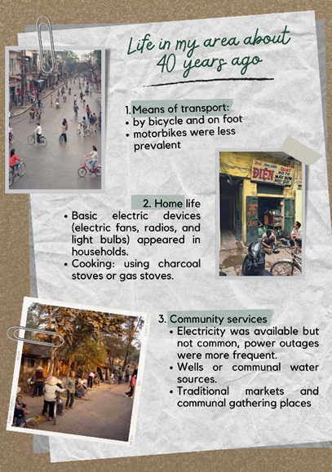

**Model writing:** Life in my area about 40 years ago:

- Means of transport: People often traveled by bicycle and on foot. Motorbikes were also used, but less prevalent than today.

- Home life: Basic electric devices such as electric fans, radios, and light bulbs appeared in households. However, larger appliances like refrigerators and washing machines might have been considered luxury items. Cooking was primarily done using charcoal stoves or gas stoves.

- Community Services: Electricity was available but not common, power outages might have been more frequent. Wells or communal water sources were popular. Traditional markets and communal gathering places played a significant role in community life.

**d. Organization of implementation**

Teacher divides students into 4 big groups. Each group will act as a representative of their presentation, come to the show to introduce and enroll new students.

Teacher asks the class to listen to the reports and ask questions if they would like to.

Students will critically evaluate all the performances, then give 1 vote for the most attractive performances.

- Teacher gives comments and feedback to all 4 performances and awards special prize to the group which has the most votes.

- Students can complete the project as homework if you are short of time.

**\*HOMEWORK**

- Teacher asks students to talk about what they have learnt in the lesson.

- Teacher asks students to rewrite their writing in their books.

- Teacher asks students to prepare the new lesson.