Date: October 10, 2024

UNIT 3: MY FRIENDS
Period 18: Lesson 3 - A CLOSER LOOK 2
Subject: English – Class 6
Time expected: 45 minutes
I. OBJECTIVES
1. Knowledge: By the end of the lesson, students will be able to:
- use the present continuous to talk about things happening now;
- ask about appearance and personality.
- Vocabulary: Master and know how to use vocabulary relating to friends lexical items.
- Grammar: Know how to use the present continuous; revise the present simple
2. Competences
-General competences: self control, self study, communicatiion, solution-creation
-Distinctive competences: linguistic, beauty, natural-social compentences
3. Personal qualities:
Students will form and develop some values: patriots, benevolence, hard work, honesty and responsibility.
II. TEACHING AIDS
1. Teacher: Active board, laptop connected with the Internet, Teacher’s book.
2. Students: Student’s book, work book, collect some picture relating to the lesson.
III. PROCEDURES
1. ACTIVITY 1: WARM-UP (5’)
a. Aims of the activity: To activate students’ prior knowledge and vocabulary related to the targeted grammar of present continuous and to increase students’ interest.
b. Content: Game: Chatting ( some questions related the introduction in the new lesson)
* Game: Chatting



1.What are these boys doing?
-They are playing football.

2. What is this girl doing?
-. She is watching TV.
c. Products: Students look at the picture and answer the questions correctly.
d. Organization of implementation
- T has students look at some pictures and asks them some questions.
- Students look at the P, listen and answer the questions.
- T feedback and lead in the new lesson.
→Lead in
- Teacher says: “This lesson today we are going to use the present continuous to talk about things happening now;
2. ACTIVITY 2: KNOWLEDGE FORMATION (10’)
a. Aims of the activity: To introduce targeted grammar of present continuous.
b. Content: * Grammar: The present continuous.
+We use the present continuous for actions happening now.
Example: - She’s talking.
- They’re not talking.
* Form: S + am/ is/ are + V-ing
+ We can use the present continuous with now, at present, or at the moment.
Example:
- I’m doing my homework at present.
- A: Are you reading now?
B: Yes, I am
c. Products
Understand and know how to use the present continuous.
d. Organization of implementation
- Teacher draws students’ attention to the form of the sentences from chatting and ask them whether they know the target tense.
- Teacher provides or confirms the answers and lead in the grammar focus of the lesson:
- T explains the usage and the form.
- Ss listen and copy down.
3. ACTIVITY 3: PRACTICE (25’)
3.1. Task 1: Put the verbs in the brackets in the present continuous.
a. Aims of the activity: To help students get to know the use of present continuous.
To help students practice with the correct form of the present continuous.
b. Content: practice the present continuous.
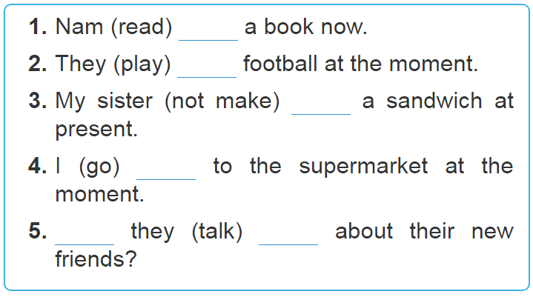
c. Products
- Students read and understand then put the correct form of the verbs in brackets.
- Students know how to use the present continuous.
1. is reading
2. are playing
3. isn’t making
4. am going
5. are; talking
d. Organization of implementation
- Teacher has students complete Ex. 1 (p. 29).
- Teacher then asks students to exchange their textbooks to check their friends’ answers.
- T reminds Ss to pay attention to the subject of each sentence.
- Some Ss read aloud their answers.
– T checks and confirms the correct ones.
3.2. Task 2: Look at the pictures. Write sentences like the example. Use positive or negative present continuous verbs
a. Aims of the activity: to enable students to give the correct form of verbs.
b. Content: Students will look at the pictures. Write sentences like the example. Use positive or negative present continuous verbs
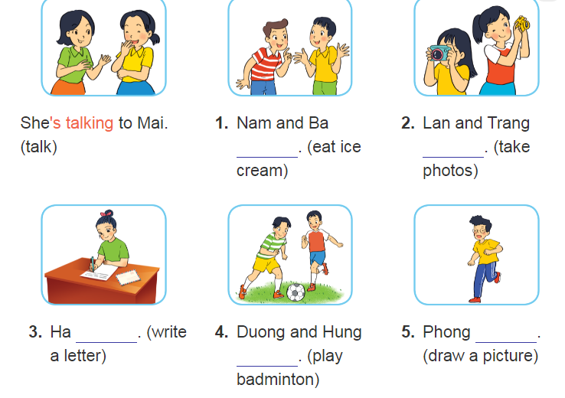
c. Products
1. Nam and Ba are not / aren’t eating ice cream.
2. Lan and Trang are taking photos.
3. Ha is / Ha’s writing a letter.
4. Duong and Hung are not / aren’t playing badminton.
5. Phong is not / isn’t drawing a picture.
d. Organization of implementation
- T asks Students to look at the pictures and briefly describe what the person is / people are doing.
- T asks students to write sentences, using positive or negative present continuous verbs.
Ss write sentences and compare their answers.
T invites some Ss to write their answers on the board.
- T checks and confirms the correct ones.
3.3. Task 3: Work in pairs. Look at the pictures. Ask and answer
a. Aims of the activity: To give students opportunities to use present continuous correctly in context.
b. Content: Look at the pictures. Ask and answer
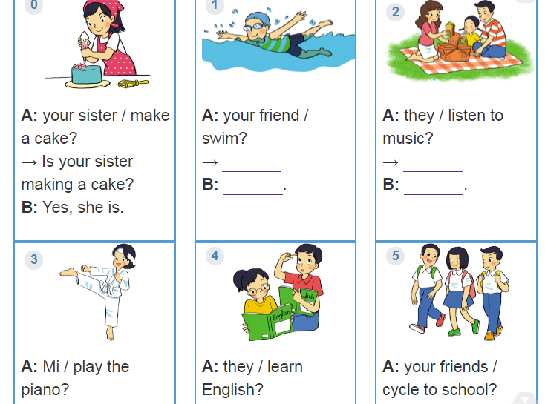
c. Products
1. Is your friend swimming?
– Yes, he is.
2. Are they listening to music?
– No, they aren’t. (They’re / They are having a picnic.)
3. Is Mi playing the piano?
– No, she isn’t.
(She’s / She is doing karate.)
4. Are they learning English?
– Yes, they are.
5. Are your friends cycling to school?
– No, they aren’t. (They’re / They are walking to school.)
d. Organization of implementation
- Teacher has students work by playing game : Lucky number.
1
4
2
3

6
5
7
8

- Class is divided into 2 groups.
- Teacher prepares 7 numbers which includes 5 questions in the textbook, and 2 lucky numbers.
- Each team takes turns and chooses a number and answers the question behind the number. If the team answers the question correctly, they will get 1 point. If the team chooses the lucky number, they get 1 point without answering the question and may choose another number.
3.4. Task 4: Put the verbs in brackets in the present simple or present continuous.
a. Aims of the activity: To help students distinguish and use correctly present simple and present continuous.
b. Content: Put the verbs in brackets in the present simple or present continuous
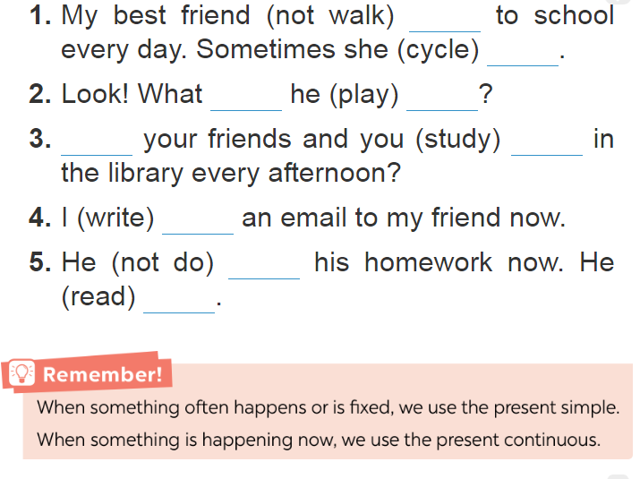
c. Products Know signals of 2 tenses. And write their correct answers on the board.
* signals of the present simple (every day, every afternoon, always, usually, etc.)
* signals of the present continuous (now, at the moment, at present, etc.).
1. doesn't walk/ cycles 2. is he playing
3. Does.... study
4. am writing 5. isn't doing/ is reading
d. Organization of implementation
- Have Ss read the Remember! box in the book.
- Ask Ss to give the form and usage of the present simple.
- Ask them about the signals used with the present simple and the present continuous
- Ask Ss to do this exercise individually and then compare their answers with a classmate.
- Invite some Ss to write their answers on the board. Confirm the correct answers.
4. ACTIVITY 4: APPLICATION AND EXTENSION ACTIVITIES (5’)
a. Aims of the activity: To help Ss practise using the present continuous.
b. Content: Game Charades
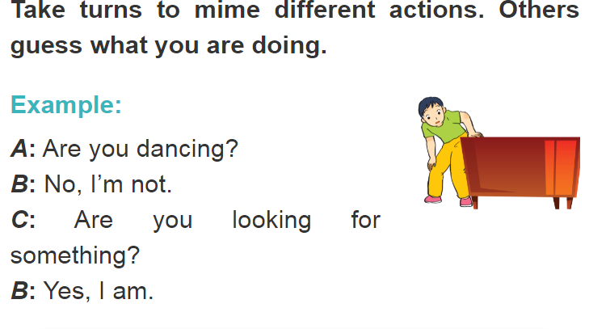
c. Products: Ask and answer in groups correctly.
Example:
A: Are you dancing?
B: No, I'm not.
C: Are you looking for something?
B: Yes, l am
d. Organization of implementation
* Characters. Take turns to mime different actions. Others guess what you are doing.
- Have Ss play the game in groups. Move around to observe and provide help if needed.
- Make sure Ss use English when they play the game.
* Homework
- Learn by heart all the words that they have just learnt.
- Do exercises in the workbook.
- Prepare for Lesson 4 - Communication.

