March 24th, 2025
Full name: Ho Thi Kim Uyen
Professional group: English – PE – Art - VEA

Unit 10: COMMUNICATION IN THE FUTURE (7 periods)
Period 85 - Lesson 5: SKILLS 1
Subject: English - Class: 8A1, 8A2, 8A7, 8A8
Time expected: 45 mins

I. OBJECTIVES:
By the end of this lesson, students will be able to:
1. Knowledge:
- To help students read for general and specific information about a way of communicating in the future.
- To help students talk about the advantages and disadvantages of a way of communicating.
+ To introduce some words related to the communication technology.
2. Competences:
- General competence:
+ Self-controlled and self-study competence (students know how to self-study about vocabulary and know about the advantages and disadvantages of a way of communicating).
+ Communicative and cooperative competence (students work with their partners to discuss the answers about the advantages and disadvantages of a way of communicating.)
- Distinctive competence:
+ Linguistic competence (students know how to use their language to talk about the advantages and disadvantages of a way of communicating).
3. Attributes:
+ Patriotism (students are aware of communicating in the future)
+ Studiousness (students are aware of joining in communicating)
+ Responsibility (students are aware of protecting the advantages of a way of communicating.)
II. TEACHING AIDS:
- Grade 8 textbook
- Computer connected to the Internet
- Projector / TV
III. PROCEDURES
1. ACTIVITY 1: WARM - UP (5ms)
a. Aims of the activity:- To help students remember some words related to ways of communication
b. Content: KIM’S GAME

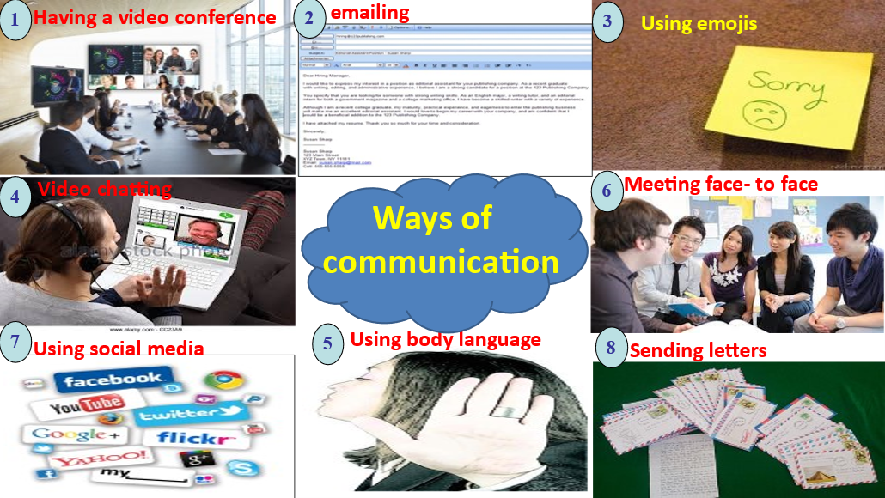

c. Products:
meeting face-to-face, sending letters, emailing, video chatting, having a video conference, etc.
d. Organization of implementation:
- Divide the class into two teams, explain the ways to play the game
- Show all the pictures and the words in one minute
- Remove all the pictures and the words.
- Has students in each teams write the words they have seen in the game on the board.
- Which team writes more right words wins the game.
2. ACTIVITY 2: KNOWLEDGE FORMATION (5 mins)
a. Aims: - To improve students’ knowledge of vocabulary related to ways of communication
b. Content: - Teaching vocabulary
New words:
1. telepathy (n) /ˈtɛləpæθi/ Thần giao cách cảm (picture + explanation)
2. keep in contact (v) /kiːp ɪn kənˈtækt/ Giữ liên lạc (synonym)
3. thought (n) /θɔːt/ Suy nghĩ (translation)
4. tiny (a) /ˈtaɪni/ Nhỏ bé (situation)
c. Products: - Students understand new vocabulary
d. Organization of implementation:
- Teacher explains the meaning of the new vocabulary by pictures.
- Teacher reveals that the words according to the pictures will appear in the reading text and asks students to open their textbook to find these words
- Teacher introduces the vocabulary.
- Teacher checks students’ understanding with follow up questions.
*Checking: What and where
3. ACTIVITY 3: PRACTICE ACTIVITIES (30’)
READING
3.1. Task 2: Read an interview with two students: Minh and Tom. Then tick the speaker of each sentence.
a. Aims of the activity:
- To improve students’ skill of reading for general and specific information
b. Content: Read an interview with two students, Minh and Tom. Then tick the speaker of each sentence.
c. Products:
1. Minh
2. Tom
3. Minh
4. Minh
5. Tom
d. Organization of implementation:
- Draw students’ attention to the word “telepathy”. Tell them that this is a way of communication. Challenge Ss to quickly find the word telepathy in the conversation and guess its meaning. Confirm their answer.
- Ask Ss who are in the interview (the MC, Minh and Tom). Tell them that in this exercise, they need to find out what Tom is saying and what Minh is saying, so they should focus on Tom and Minh’s lines in the conversation.
- Briefly tell Ss the steps to complete the exercise: Read the statements, underline the keywords in each statement, locate the keywords in the text, find the information and decide if Minh or Tom is saying that information.
- Ask Ss to do the exercise individually and then check their answers in pairs.
- Invite some Ss to share their answers. Confirm the correct answers.
3.2. Task 3: Read the interview again. Choose the correct answer A, B, or C.
a. Aims of the activity:
- To improve Ss’ knowledge of vocabulary related to telepathy
- To improve Ss’ skill of reading for general and specific information
b. Content: Read the interview again. Choose the correct answer A, B, or C.
1. What is the interview mainly about?
A. One way of future communication.
B. Voice chats and online calls.
C. Problems of telepathy.
2. Which way of communication below is NOT mentioned in the interview?
A. Meeting face to face.
B. Writing an email.
C. Telepathy.
3. According to Tom, telepathy means _____.
A. making phone calls via the Internet
B. talking on tiny devices
C. communicating by thoughts
4. The MC says that _____.
A. telepathy is perfect
B. not all people can do telepathy
C. she disagrees with Minh's opinion
5. What does the MC think may be a problem with telepathy?
A. People won't want to meet each other.
B. Telepathy devices can be expensive.
C. Some people won't want to talk anymore.
c. Products:
1. A 2. B 3. C 4. B 5. C
d. Organization of implementation:
- Conduct the game LUCKY NUMBER.
- Divide the class into two teams, explain the ways to play the game
- Briefly tell them the steps: Read the questions, underline the key words in each question, locate the
key words in the text and find the information to answer the question.
- Ask students to repeat the steps if necessary.
- Ask students to do the exercise in two teams.
- Invite some students to share their answers. Have them explain their answers. Confirm the correct answers.
- To connect the reading and the speaking parts, teacher can draw a table and ask students to fill in the table about the advantages and disadvantages of telepathy.
SPEAKING
3.3 Task 4: Work in pairs. Read the following ideas about online calls. Put the ideas in the correct column.
a. Aims of the activity:
- To help Ss prepare ideas for the next activity
- To provide an opportunity for students to practise talking about advantages and disadvantages of a way of communication
b. Content: Work in pairs. Read the following ideas about online calls. Put the ideas in the correct column.
a. They’re cheap or even free.
b. There must be an Internet connection.
c. You can talk to people from distant places.
d. You may receive unwanted calles.
e. You can make group calls.
f. You need a smart device.
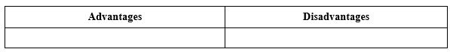
c. Products:
Advantages: a, c, e
Disadvantages: b, d, f
d. Organization of implementation:
- Ask students to work in pairs and complete the table about the advantages and disadvantages of online calls.
- Have students share their answers. Confirm the correct answers.
4. ACTIVITY 4: APPLICATION ACTIVITIES (5’)
Task 5: Work in groups. Choose a way of communication and discuss its advantages and disadvantages. Then report your answers to the class. (10 mins)
a. Aims of the activity: To develop reading skills for general and specific information.
b. Content: Work in groups. Choose a way of communication and discuss its advantages and disadvantages. Then report your answers to the class.
You can start your discussion as follows:
I think there are both advantages and disadvantages of online calls. ...
c. Products:- To start a talk about advantages and disadvantages:
+ I think there are both advantages and disadvantages of online calls.
- To introduce the advantages:
+ In terms of the advantages / good points, ...
+... can be beneficial in many ways. First, ...
- To introduce the disadvantages:
+ However, ... has some drawbacks. For example, ...
Suggested outcome:
I think there are both advantages and disadvantages of online calls. ...
d. Organization of implementation:
- Elicit from students some useful structures to start a talk, and to introduce the advantages and disadvantages.
- Encourage students to try using the structures to make sentences about online calls.
- Have students work in groups. Tell them that they will choose from the list of ways of communication in the Warm up and discuss its advantages and disadvantages. They should make a table like the one in Activity 4 first, and then talk.
- Set a time limit for group work. Go around, monitor and support when necessary.
- Invite some students to share their group’s discussion to the class.
- Have other groups put questions or give remarks to their friends
- Teacher give remarks (if necessary)
* HOMEWORK
- Revise the content of Skills 1
- Do the exercises in the workbook.
- Prepare the new lesson: Unit 10- Skills 2

