English Grade 5
Unit 9: Our outdoor activities
Lesson 1 (4, 5, 6)
Week : 15 Date of teaching: December 16th 2024
Period: 57

A. OBJECTIVES:
By the end of the lesson, Ss will be able to:
1. Knowledge:
- listen to and understand four communicative contexts in which characters ask and answer questions about where someone was in the past.
- complete four gapped exchanges with the help of picture cues.
- revise the target vocabulary items and structures through the game Memory game.
- Vocabulary: Review
- Skills: speaking, listening, reading and writing.
2. Competences:
- Communication and collaboration: work in pairs and groups to complete the learning tasks.
- Self-control and independent learning: perform pronunciation and speaking tasks.
3. Attitude/ Qualities:
- Show their love and interest in outdoor activities.
- Show their knowledge of doing outdoor activities safely.
B. TEACHING AIDS:
- Teacher: Teacher’s guide Pages 144, 145, 146; audio Tracks 88; website hoclieu.vn, posters, laptop, pictures, textbook, lesson plan, TV or projector.
- Students: Student’s book Page 63, notebooks, school things.
C. PROCEDURES:
Stages/ Time | Teacher’s activities | Students’ activities
1.Warm- up (5’)  2.Practice: (25’)  3. Fun corner and wrap- up (5’) | Game: Missing flashcard  *Aims: to revise the learned words  *Procedure:  - Divide the class into two groups.  - Place four flash cards (theatre, aquarium, campsite, funfair) on the board.  - Have ss play the game in turns. Have ss close their eyes. Teacher removes one picture.  - Invite one student from each group to speak out the picture which disappears.  - Continue the game until all the vocabulary sets are said.  - The group with more points wins the game. Praise the winner.  - Say “Open your book page 63” and look at “Unit 9, Lesson 1(4,5,6)”.  Activity 1. Listen and tick or cross:  *Aims: Ss will be able to listen to and understand four communicative contexts in which characters ask and answer questions about where someone was in the past.  *Procedure:  - Draw ss’ attention to the pictures and identify the characters and the places. 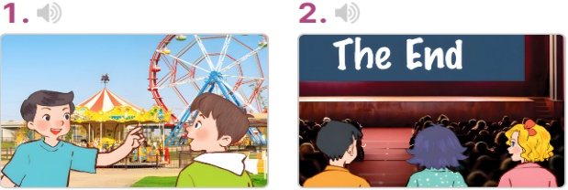  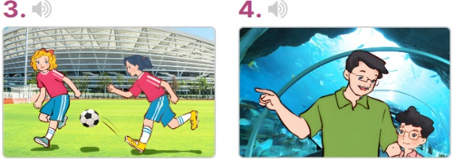  - T ask Ss to guess the answers.  + T writes Ss’guessing on the board.  - Listen to the tape:  + Play the recording  + Play the recording again for pupils to do the task.  + Play the recording a third time for pupils to check their answers.  - Get Ss to swap books with their partner, then check answers as a class.  + Write the answers on the board for Ss to correct their answers. Then checks Ss’ guessing.  - Have Ss to listen and repeat individually and in chorus  Key: 1. v 2. x 3. x 4. v  Activity 2. Read and complete  *Aims: Ss will be able to complete four gapped exchanges with the help of picture cues.  *Procedure:  - Have Ss look at the pictures and read the question and answer, and guess the missing word in the answer.  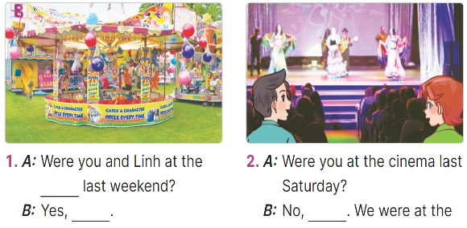  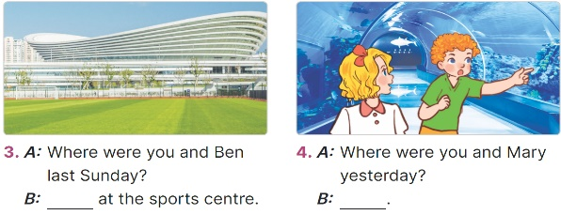  - T models: have Ss read the question and asks what words are missing (funfair)  - Give Ss a time limit to read the gapped dialogues, look at the pictures and do the task independently.  - Get Ss to swap books with a partner and check their answers before checking as a class.  + Invite one student to write the answers on the board.  - Invite two pairs of Ss to act out the completed dialogues.  Key:  1. funfair, we were  2. we weren’t, theatre  3. We were  4. We were at the aquarium  Activity 3. Let’s play  *Aims: Ss will be able to revise the target vocabulary items and structures through the game Memory game.  *Procedure:  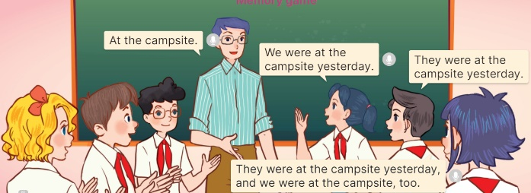  - Tell ss that they are going to revise the target vocabulary items and structures they have learnt in Lesson 1  - Invite two groups (three ss each) to the front of the class. Have ss listen to the topic (At the campsite).  + The first member of the first group (a girl) tells the place where she and her friends were yesterday (ex: We were at the campsite yesterday.)  + The second member (a boy) listens to the girl, repeats the information about the place where she and her friends were yesterday (ex: They were at the campsite yesterday.)  + The third member (a girl) repeats the boy’s information and adds in the place she and her friends were yesterday (ex: They were at the campsite yesterday. We were at the campsite, too).  - Set a time limit for ss to play the game. The group members discuss and decide the order of the speakers in the group.  - The game ends when all group members have done their roles.  - The group that says the most sentences in the shortest time will win the game.  Game: Lucky number  - Tell ss they are going to choose a number, look at the picture and answer the question or complete the question.  - Divide ss in 2 teams and play the game.  - Give points as the diamonds shown on the screen.  - Which team has more diamonds will be the winner. | -Ss listen to the teacher  -Ss play the game  -Ss play the game  - Ss open their books  -Look at the pictures and say:  + Picture 1: Minh and Nam at the funfair  + Picture 2: Mary and her friends at the cinema  + Picture 3: Mai and Mary at the sports centre  + Picture 4: A boy and his father at the aquarium  -Ss guess the answers  - Ss listen to the tape  - Ss listen again and do the task.  - Ss listen and check their answers  - Ss swap books with their partner, then check answers as a class and guessing  -Ss write the answer on the board  -Ss listen and repeat  -Ss look at the picture and say  -Ss follow the teacher  - Ss do the task independently.  - Ss swap books with a partner and check their answers.  - Ss write the answers on the board  - Pairs of Ss read the completed dialogues aloud  - Ss to the teacher  - Ss play the game  - Ss play the game  -Ss play the game  - Ss play the game.  -Ss praise the winner  - Ss to the teacher  - Ss play the game
D. ADJUSTMENTS (if necessary):
………………………………………………………………………………………….…..……………………………………………………………………………...

