Unit 9: Our sports day
Lesson 2 (1, 2, 3)
A. OBJECTIVES:
By the end of the lesson, Ss will be able to:
1. Knowledge:
- use the words and phrase December, July, June, November, October, September, sports day in relation to the topic "Our sports day".
- use When's your sports day? – It's in ……... to ask and answer questions about when a sport day is;
- listen to and demonstrate understanding of simple exchanges in relation to the topic "Our sports day"
- Vocabulary: December, November, October, September
- Skills: speaking and listening
2. Competences:
- Self-control and independent learning: perform listening tasks.
- Communication and collaboration: work in pairs or groups.
3. Attitude/ Qualities:
- Develop their interests in sports and show their responsibility by raising awareness of time and date.
B. TEACHING AIDS:
- Teacher: Teacher’s guide Pages 130, 131, audio Tracks 91, 92, website hoclieu.vn, posters, laptop, textbook, lesson plan, TV or projector.
- Students: Pupil’s book Page 64, notebooks, school things.
C. PROCEDURES:
Stages/Time | Teacher’s activities | Students’ activities
1.Warm- up:  (6’)  2. Exploration  (8’)  3.Knowledge construction (8’)  4.Practice:  (10’)  4.Fun corner and wrap up. (3’) | Board race  *Aims: to create a friendly and active atmosphere in the class to beginning the lesson.  *Procedure:  - Have the students listen and sing along Months of the year song.  - Divide the class into 2 teams and make two lines in front.  - Tell the rule: each sts of two teams take turn runs to the board and write a month of the year. Which team has more correct answers will win.  - Check the sts writing on the board and ask them to read aloud.  - Praise the winner, encourage the other team.  - Say “Open your book page 64” and look at “Unit 9, Lesson 2 (1, 2, 3)”.  *Procedure:  Activity 1. Look, listen and repeat:  *Aims: Ss will be able to understand and correctly repeat the sentences in two communicative contexts focusing on asking and answering questions about when a sports day is.  *Procedure:  - Have Ss look at Pictures a and b and identify the characters (Nam and Lucy) in the pictures.  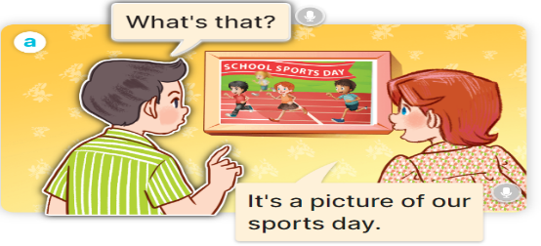  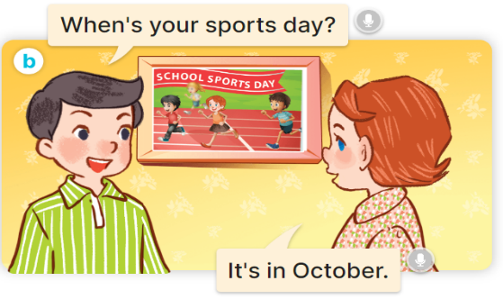  - Play the audio twice (sentence by sentence). Correct their pronunciation where necessary.  - Have Ss to practice the dialogue in pairs.  - T invites a few pairs to the front of the class to practice.  - T checks pronunciation for ss.  - Introduce new model sentence in picture b and ask the sts to read aloud.  Activity 2. Listen, point and say.  *Aims: Ss will be able to correctly say the words and use When's your sports day? – It's in……… to ask and answer questions about when a sports day is.  *Procedure:  * Model sentences:  - T explains, models and gives meaning.  - Have Ss repeat the model sentences.  A:When's your sports day? B:It's in Ocotber.  *Drill pictures  - Have pupils look at the pictures and elicit the name of each month.      - Ask the sts to listen and read aloud four months in pictures a,b,c and d.  - Play the recordings for the sts to listen and repeat the questions nad the answers in four pictures.  - Ask Ss to work in pairs.  - Monitor and offer help if necessary.  - Call on some pairs to read aloud.  Activity 3. Let’s talk.  *Aims: Ss will be able to enhance the correct use of When's your sports day? – It's in ……. to ask and answer questions about when a sports day is in a freer context.  *Procedure:  - Have Ss look at the survey and make model for sts to understand what they are going to do.  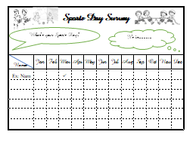  - Give each sts a sports day survey  - Ask the sts to walk around to ask at least four friends when a sports day is.  - Monitor and help if necessary.  - Invite 3 students to report their survey in front.  *Aims: Ss will be able consolidate and wrap up the content of the lesson.  *Procedure:  - Tell the sts what they have learnt in today lesson.  - Ask the sts to sing Goodbye song to wrap up the lesson. | - Ss listen and sing along.  -Move to two teams.  -Listen to the teacher.  -Check as class and read aloud  -Open the books and take notes.  -  -Look at the pictures and say  + He’s Nam and She’s Lucy  + Lucy is running on her school sports day.  -Ss listen and repeat in chorus  -Ss work in pairs to practice  -Ss practice the dialogue  -Ss listen  -Listen to the teacher and read aloud.  -Listen to the teacher.  -Ss listen and repeat  - Ss look, listen and answer  + Picture a. a calendar showing September  + Picture b. a calendar showing October  + Picture c. a calendar showing November  + Picture d. a calendar showing December  -Ss listen and repeat  -Listen and repeat.  -Work in pairs to practice.  - Practice.  -Perform in front.  -Look at the survey and listen to the teacher.  -Receive the survey.  -Walk around to ask and answer.  -Practice as class.  -Report their survey.  -Listen to the teacher.  -Sing the song together.
D. ADJUSTMENTS (if necessary):
………………………………………………………………………………………….…..……………………………………………………………………………...………………………………………….…..………………………………………

