Week 14 Preparing date: December 8th, 2024
Period 53 Teaching date: December 10th, 11th, 2024
Unit 8: In our classroom
Lesson 2 (4, 5, 6)
A. OBJECTIVES:
By the end of the lesson, Ss will be able to:
1. Knowledge:
- listen to and understand two communicative contexts in which characters ask and answer questions about the locations of school things and possession and tick the correct pictures.
- complete two gapped exchanges with the help of picture cues.
- revise target words about possession and school things by playing the game Whose pen is this?
- Vocabulary: Review
2. Skills: speaking, listening, reading and writing.
3. Attitude/ Qualities:
- Show their pride in school things they have and great respect for other people’s school things by using appropriate gestures and intonation when asking and answering about school things.
4. Competences:
- Communication and collaboration: work in pairs and groups to complete the learning tasks.
B. TEACHING AIDS:
- Teacher: Teacher’s guide Pages 122, 123 124; audio Tracks 82; website hoclieu.vn, posters, laptop, pictures, textbook, lesson plan, TV or projector.
- Students: Student’s book Page 59, notebooks, workbooks, school things.
C. PROCEDURES:
Stages/ Time | Teacher’s activities | Students’ activities
1.Warm- up and review: (5’)  2.Practice: (25’)  3. Fun corner and wrap- up (5’) | Game: Flower picking!  *Aims: to revise the sentence structures Whose ___ is this? - It’s ___. to ask and answer questions about possession.  *Procedure:  - Tell Ss that they are going to pick up the flowers, then look at the things and ask and answer questions about possession.  - Divide the class into two groups. Two Ss from each group will play the game in turns.  - If ss ask and answer the questions correctly, they will get points for their group.  - Continue the game until all the flowers are picked.  - The group with more points wins the game. Praise the winner.  - Say “Open your book page 59” and look at “Unit 8, Lesson 2 (4,5,6)”.  Activity 1. Listen and tick:  *Aims: Ss will be able to listen to and understand two communicative contexts in which characters ask and answer questions about the locations of school things and possession and tick the correct pictures.  *Procedure:  - Have Ss look at the pictures and help ss identify the locations of the three crayons and set squares  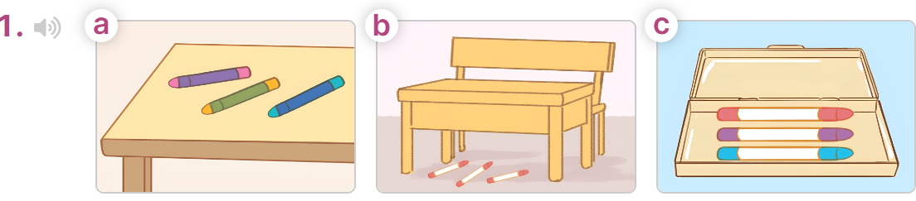  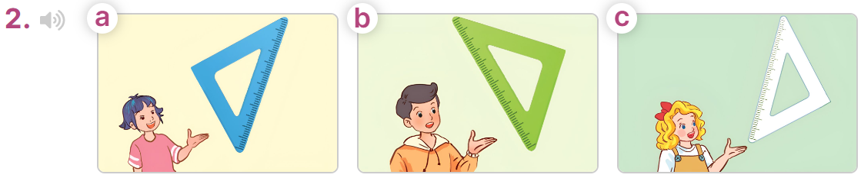  - T ask Ss to guess the answers.  + T writes Ss’guessing on the board.  - Listen to the tape:  + Play the recording  + Play the recording again for pupils to do the task.  + Play the recording a third time for pupils to check their answers.  - Get Ss to swap books with their partner, then check answers as a class.  + Write the answers on the board for Ss to correct their answers. Then checks Ss’ guessing.  - If time allows, play the recording, sentence by sentence, for Ss to listen and repeat individually and in chorus  Key: 1. b 2. a  Activity 2. Read and complete  *Aims: Ss will be able to complete two gapped exchanges with the help of picture cues.  *Procedure:  - Have Ss look at the pictures and identify the directions to the rooms in the pictures.  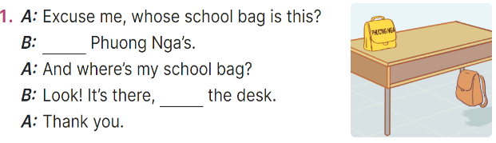  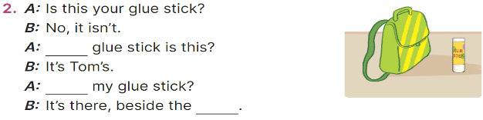  - Model the first sentence: have Ss read the question and ask what words are missing (It’s)  - Give Ss a time limit to read the gapped dialogues, look at the pictures and do the task independently.  - Get Ss to swap books with a partner and check their answers before checking as a class.  + Invite one student to write the answers on the board.  - Invite two pairs of Ss to act out the completed dialogues.  Key: 1. It’s; under,  2. Whose; Where’s; school bag Activity 3. Let’s play  *Aims: Ss will be able to revise target words about possession and school things by playing the game Whose pen is this?  *Procedure:  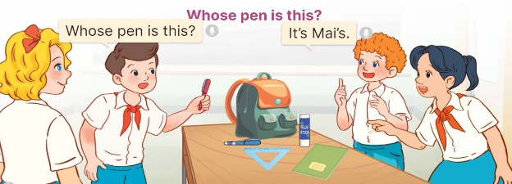  - Tell ss that they are going to play Whose pen is this? game in groups of four.  - The teams take turns asking and answering about possession.  - When a team gives a correct answer, they get one point. The winning team is the one that gets the most points.  - Have ss work in groups. Invite two groups to the front of the class to play the game.  Game: Pass the balls  - Give two different colored balls to two pupils, a red ball (ask the question) and a yellow ball (answer the question).  - Ask ss to listen to music and pass the balls.  - Stop music suddenly.  - Have the student with a red ball ask a question. Have the student with a yellow ball answer the question. | - Ss listen to the teacher’s explanation.  - Ss work in two groups and play the game  - Ss continue playing the game until all the flowers are picked.  - Ss praise the winner.  - Ss open their books  -Look at the pictures and say:  + Picture 1a: three pencils on a desk  + Picture 1b: three pencils under a desk  + Picture 1c: three pencils in a pencil case  + Picture 2a: Linh’s set square  + Picture 2b: Nam’s set square  + Picture 2c: Mary’s set square  -Ss guess the answers  - Ss listen to the tape  - Ss listen again and do the task.  - Ss listen and check their answers  - Ss swap books and check answers and guessing  -Ss write the answer on the board  -Ss listen and repeat  -Ss look at the picture and say  -Ss follow the teacher  - Ss do the task independently.  - Ss swap books with a partner and check their answers.  - Ss write the answers on the board  - Pairs of Ss read the completed dialogues aloud  - Ss listen to the teacher’s explanation.  - Ss work in two groups to ask and answer about possession.  - The team that gives a correct answer will get one point.  - Ss comes to the front of the class to play the game.  -Ss listen to the teacher  - Ss play the game.  Ex: A: Whose pen is this?  B: It’s Linh’s.
D. ADJUSTMENTS (if necessary):
………………………………………………………………………………………….…..……………………………………………………………………………...
* Start preparing for the Project: Tell Ss about the project on page 61, Lesson 3, Activity 6. Ask them to draw their study corners with the locations of school things, and present their group’s pictures to the class at Project time.

