UNIT 5: HEALTH
Lesson 2.1 (page 67)
I. Objectives:
- By the end of this lesson, students will be able to say how they feel.
- Get Sts to point out and say how they feel.
- Educate Sts support their friends to complete the learning tasks or play the games.
1.Vocabulary: terrible, sleepy, weak, sick, sore, stuffed up.
2.Sentence pattern: How do you feel?
I feel weak.
That's too bad.
3.Skills: Listening, Reading, Writing, and Speaking.
II. Teaching aids:
- Teacher’s aids: Tiếng Anh 5 i-Learn Smart Start Student’s Book and Teacher’s book, Class CDs, Flashcards, DCR & DHA on Eduhome, Projector/Interactive Whiteboard /TV (if any), PowerPoint slides.
- Students’ aids: Tiếng Anh 5 i-Learn Smart Start Student’s Book, Workbook, Notebook.
III. Procedures:

Time | Teacher’s activities | Students’ activities
5’ | Activiy 1: Warm-up
5’ | - Greet and have Ss sing “If you’re happy” song.  - Have Ss play “Guessing health problems” game.  - Explain the rules of the game.  - Show the definition of the health problems vocabulary on the screen.  For example: the pain you feel inside your head  => headache.  - Have students read the sentences on the screen and guess health problems by their definitions.  - Correct students’ answers. | - Greet and sing the song.  - Follow and do as guided then join the game.
10’ | Activity 2: Presentation
10’ | - 1. Listen and point. Repeat. (CD2 Track 33)  - Show the picture of health prolems and have sts listen and repeat in chorus.  - Have sts guess the meaning of the new words.  - Arrange the flashcards (terrible, sleepy, weak, sick, sore, stuffed up) on the board.  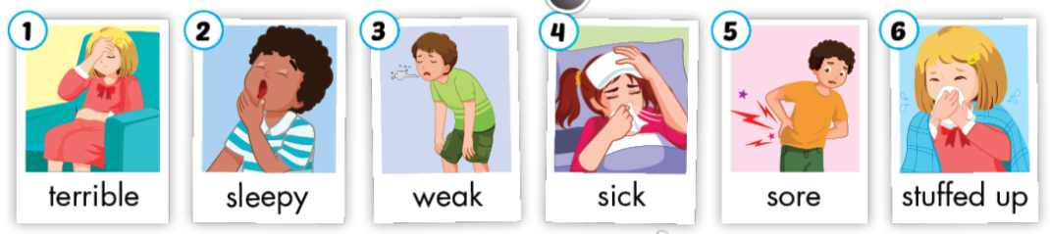  - Ask the students to listen and pay attention.  - Use DCR on Eduhome to play the audio and point to each flashcard.  - - Then play the audio again and have them point to the pictures in their Student’s Books.  - - Play the audio and require them to listen and repeat.  - - Help them with their pronunciation if necessary.  - - Have the class work in pairs. One student randomly points to the pictures in their book, and the other one says the words. Then have them swap roles and continue this activity.  - Walk around the class and support them if needed. | - Look, listen and repeat.  - Listen and follow their teacher’s instructions.  - Point to the pictures in their Student’s Books.  - Listen and repeat.  - Work with their partner to complete the task.
10’ | 2. Play the game Heads up. What's missing?  - Divide the class into two teams.  - Arrange the flashcards on the board and remove one card when students are not looking.  - One student from each team calls out the missing flashcard.  - Give a point for the team to have a faster correct answer. | - Play with their teammates.  - Follow the teacher’s instructions.  - Look at the flashcard covered with a piece of paper and quickly say the new word when their teacher slowly moves the paper.
10’ | Activity 3: Practice
10’ | - 1. Listen and practice. (CD2 Track 34)  - Show the picture and introduce the situation  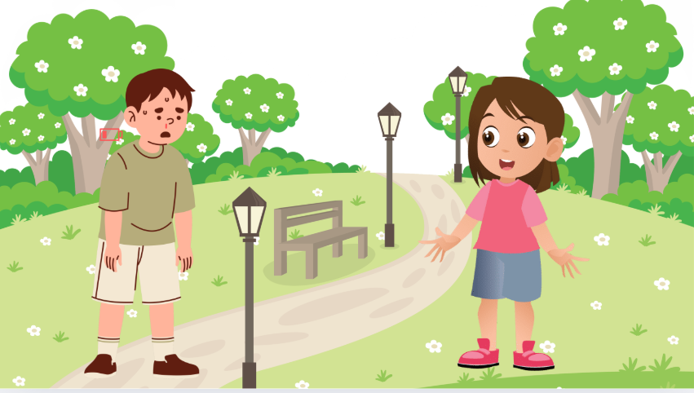  - Use DCR to show the useful language and have students look and read the useful language silently.  How do you feel?  I feel weak.  That's too bad.  - Explain that we often use this to talk about their feelings.  - Play audio. Have students listen to useful language.  - Have students practice the useful language.  - Have students practice using vocabulary from Part A.  - Go around the class and support them if necessary. | - Look at the picture and listen to T  - Look and read the useful language silently.  - Listen to the teacher’s explanation.  - Listen and look at the useful language again.  - Work in pairs and practice useful language.  - Use the new words from Part A when practicing the useful language.
10’ | 2. Look and write. Practice.  - Demonstrate the activity using the example.  - Have the students look, read, and write.  - Divide the class into pairs and have them check each  other’s work.  - Use DCR to check the answers as a whole class.  - Have pairs practice saying the sentences.  - Monitor the class and support if needed. | - Carefully look at the teacher demonstrating the activity.  - Look, read and write.  - Work in pairs and check their partner’s answers.  - Check the answers with the teacher and friends.  - Practice saying the sentences with a friend.
5’ | Activity 4: Production
5’ | - Have sts work in groups and make a situation of health problems using the sentence pattern.  - Call some groups to present.  - Give feedback. | - Work in groups and discuss.  - Present the answer.  - Listen to T
5’ | Activity 5: Consolidation and homework assignment
5’ | * Play the “Matching Game”  - Introduce the game and explain that teams should take turns choosing two squares. If the squares have the same matching word and image, then that team gets a point.  - Divide the students into teams.  - Have the students open 2 squares and read the words or pictures behind them.  - Have the students remember where the matching pairs are.  - Correct students’ answers.  - Keep score for each team. | - Follow and do as guided then join the game.
5’ | Homework Assignment  - - Require the students to do exercises on page 44 in the Workbook.  - - Have them copy letters and structure in their Tiếng Anh 5 i-Learn Smart Start Notebook.  - Ask them to prepare Parts C and D, Lesson 2.2, Unit 5 on page 68 in the Student’s Book. | - - Follow their teacher’s instructions.  - - Do homework, copy the new words, and prepare for the new lesson.
IV. Self - evaluation
Time:....................................................................................................................................
Knowledge:............................................................................................................................
Method:..................................................................................................................................

