Week 15: From December 15th to December 19th, 2025
Date of preparation: December 13th, 2025
Period: 57th
UNIT 4: HOME
Lesson 3 (Part A, B)
I. Objectives:
- By the end of this lesson, students will be able to ask where things are.
- Learn how to ask and answer about where things are.
- Educate sts support their friends to complete the learning tasks or play the games.
Vocabulary: mirror, picture, sofa, table, box, house.
Sentence pattern: Is the picture in the living room?/ Yes, it is./ No, it isn’t.
Skills: Listening, Reading, Writing, and Speaking.
II. Teaching aids:
- Teacher’s aids: Tiếng Anh 3 i-Learn Smart Start Student’s Book and Teacher’s book, Class CDs, Flashcards, DCR & DHA on Eduhome, Projector/Interactive Whiteboard /TV (if any), PowerPoint slides.
- Students’ aids: Tiếng Anh 3 i-Learn Smart Start Student’s Book, Workbook, Notebook.
III. Procedures:
Time | Teacher’s activities | Students’ activities
5’ | Activiy 1: Warm-up  - Greet and have sts sing “If you’re happy” song and do action.  - Show a picture and lead in the lesson | - Sing and do actions.  - Listen to T.
10’ | A 1. Listen and point. Repeat. (CD2 Track 36)  - Arrange the flashcards (mirror, picture, sofa, table, box, house) on the board.  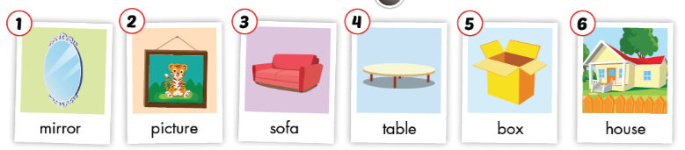  - Ask the students to listen and pay their attention.  - Use DCR on Eduhome to play the audio and point to each flashcard.  - Then play the audio again and have them point to the pictures in their Student’s Books.  - Play the audio and require them to listen and repeat.  - Help them with their pronunciation if necessary.  - Have the class work in pairs. One student randomly points to the pictures in their book, and the other one says the words. Then have them swap roles and continue this activity. Walk round the class and support them if needed. | - Look at the flashcard.  - Listen and follow their teacher’s instructions.  - Point to the pictures in their Student’s Books.  - Listen and repeat.  - Work with their partner to complete the task.
10’ | 2. Play Board race.  - Have the students look at the example.  - Divide the class into two teams and have one student from each team stand a distance from a board.  - Stick two flashcards on the board and then say one of the new words aloud.  - Have the students race to the board, touch that flashcard, and repeat the new word.  - The first student to touch the flashcard and say the word correctly gets a point for their team.  Continue with other students. | - Follow their teacher’s instructions and play with their teammates
10’ | Activity 3: Practice  - 1. Listen and practice. (CD2 Track 37)  - Use DCR on Eduhome to show the useful language and have the students look and read the useful language silently.  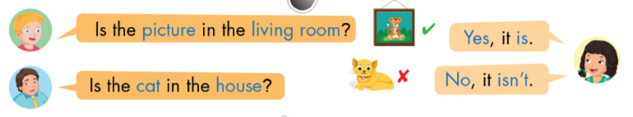  - Explain that we use this to ask yes/no questions about where a person or thing is. It can be used for rooms in a house as well as buildings, cities, and other places.  - Ask them to work in pairs and practice the useful language.  - Require them to use the vocabulary from Part A.  Go around the class and support them if necessary. | - Look and read the useful language silently.  - Listen to their teacher’s explanation.  - Work in pairs and practice the useful language.  - Use the new words from Part A when practicing the useful language.
10’ | 2. Look and write. Practice.  - Demonstrate the activity using the example.  - Have the students look and write their answers in their Student’s Books.  - Divide the class into pairs and have them check each other’s work.  - Use DCR on Eduhome to check the answers as a whole class.  - Have some pairs practice saying the sentences.  - Monitor the class and support if needed. | - Look at the T  - Look and write their answers in their St’s Books.  - Work in pairs and check their partner’s answers.  - Check the answers with the teacher and friends.  - Practice saying the sentences with a friend.
5’ | Activity 4: Production  - Show a picture of rooms in the house, ask Ss to work in groups and ask and answer about the things in the room.  - Have some sts present.  - Give feedback. | - Work in groups and discuss.  - Listen to T
5’ | Activity 5: Consolidation and homework assignment  * Consolidation  - Have the students play the game “Whispers”.  - Divide the class into two teams.  - Ask the students to form two lines.  - Whisper a word to the first student from each group. Then they whisper the word into the ear of the student standing next to them. They continue whispering the word until the end of the line. The last student has to say it out loud.  - The first student to say the correct word wins a point for their team.  The team having more correct answers will win the game. | - Follow their teacher’s instructions and play with their teammates.
5’ | * Homework Assignment  - Require the students to do exercises on page 42 in the Workbook.  - Have them copy each new word six times in their Tiếng Anh 3 i-Learn Smart Start Notebook, page 24.  - Ask them to prepare Parts C and D, Lesson 3 on page 59 in the Student’s Book. | - Follow their teacher’s instructions.  - Do homework, copy the new words, and prepare the new lesson.
IV. Self - evaluation
Time: .........................................................................................................................................
Knowledge:...............................................................................................................................
Method:......................................................................................................................................

