Date of preparing: September 20th, 2024

UNIT 2: HEALTHY LIVING
Total numbers of periods: 7 periods; from period 09 to period 15
LESSON 5: SKILLS 1
Period: 13 Class: 7A4
I. OBJECTIVES:
By the end of this lesson, students will be able to gain:
1. Knowledge:
+ Reading:
-read for specific information about acne.
+ Speaking:
-talk about how to deal with some health problems.
2. Competences:
- General competence:
+ Self-controlled and self-learning competence (students know words related to skin conditions)
+ Communicative and cooperative competence ( students know what they are going to read)
- Distinctive competence:
+Linguistic competence (sts know how to use their native language and foreign language to indicate the evidence for their answers)
3. Values:
+ Responsibility (sts are aware of protecting their skin of body)
+ Diligence (sts work better to get well-paid future jobs and help their families to have better skin)
II. TEACHING AIDS AND MATERIALS:
1. Materials: Grade 7 textbook, lesson plan, workbook, the teacher’s book, reference books
2. Equipment: TV, pictures, cards, handouts, extraboards, sachmem.vn, On-line websites ( Kahoot)…
III. PROCEDURES:
1. WARM-UP (5MS)
a. Aims: -To create an active atmosphere in the class before the lesson
- To lead into the new unit
b. Content: Matching game on Kahoot about the words related to skin conditions.
c. Expected Products: Students match the words about the words related to acne.
d. Organization of activities:
-Divide the class into 4 groups and chooses a group leader for each group
-Introduce the app KAHOOT and guides sts how to play matching game with KAHOOT
-Show the pictures of the skin conditions and 3 words related to 3 kinds of skin contions.
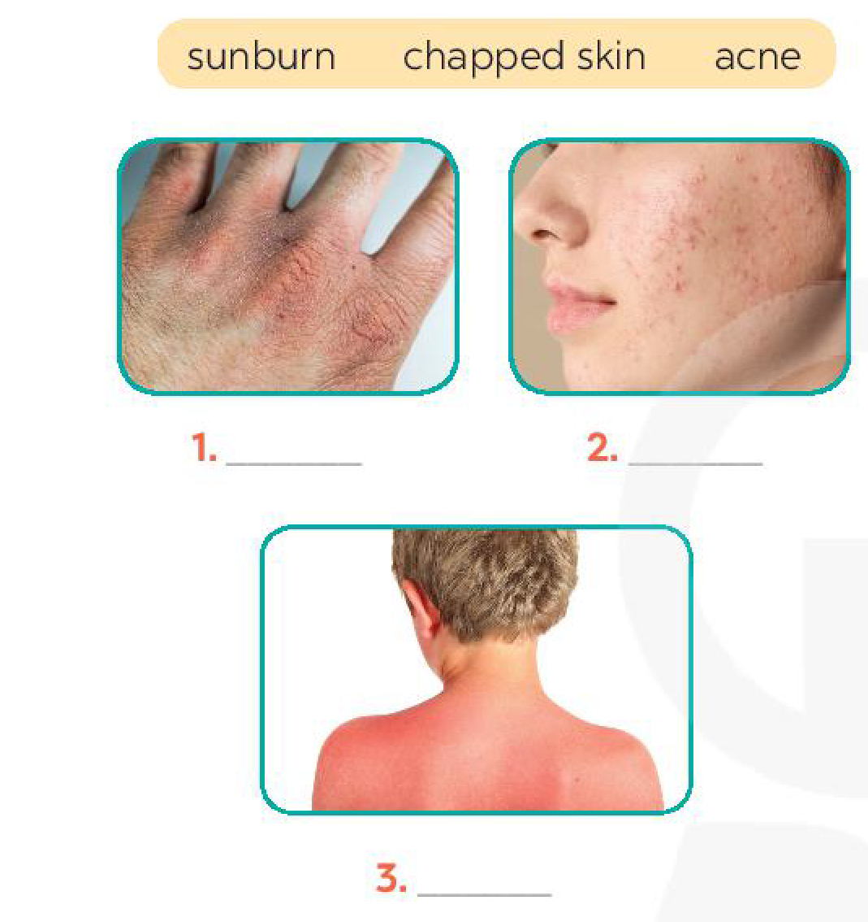
-Nominate a representative from each group to join the game
-Decide the winner who has the correct answers with the least running time
-Lead to SKILLS 1 of Unit 2 ( and writes the lesson title “SKILLS 1” on the board
-Ask sts to have a guess about what they are going to learn about in Lesson 5 of Unit 2

2. KNOWLEDGE FORMATION ACTIVITIES (5MS)
a. Aims: -To draw sts’ attention to the context
-To supply sts with the main knowledge of new words about skin conditions.
b. Content: New words about skin conditions.
c. Expected products: Students know and pronounce the words about skin conditions correctly
d. Organization of activities:
-Pre-teach some new words using suitable techniques
√. skin condition (n) (picture +explanation)
-Get sts to repeat the words chorally, then individually
-Nominate individuals to read the words aloud and asks sts to copy down the words
-Check the understanding of the new words by conducting the game “SLAP THE BOARD”

3. PRACTICE ACTIVITIES (28MS)
Task 1: (7’)
a. Aims: To introduce words related to skin conditions to Ss.
- To help Ss have a general idea of what they are going to read.
b. Content: Work in pairs. Discuss and write each word or phrase under the correct picture. Which skin condition is the most common among teenagers?
c. Expected products: Suggested answers: 1. Chapped skin 2. Acne 3. Sunburn
d. Organization of activities:
- Show the picture in the textbook about skin coditions.
- Ask Ss to look at the pictures first and ask if they know the skin condition shown in each picture. This does not cause difficulty since these problems are popular for teenagers.
- Then ask them to read the words/ phrase and do the matching.
- Ask Ss to share their answers. Confirm the correct answers.
Task 2: (7’)
a. Aims: -To help sts develop their reading skill for specific information ( scanning)
- To help them focus on the problem of acne.
b. Content:. The problem of acne.
c. Expected products: *Suggested answers: 1. b 2. d 3. a 4. c
d. Organization of activities:
- Have Ss read the text in detail to do the exercise.
- Elicit answers from Ss. If needed, tell them to follow these steps.
- Read the biginning in A. They all start with “acne” plus the verbs (is, affects, causes)
- Locate the part of the text where they find the information. They all appear right in the first paragraph. Read that part and do the matching.
- Tell Ss to compare their answers in pairs befoe giving the answers to T.
Task 3: (7’)
a. Aims: To hep students further develop their reading skill for specific information ( scanning)
b. Content: The way to protect our skin from acne.
c. Expected products:
*Suggested answers: 1. A 2. C 3.B 4. B 5. A
* d. Organization of activities:
-Asks Ss to read each question, locate where the information appears in the text, read that part carefully and circle the correct answer.
- Have Ss compare their answers in pairs.
-Check and cofirm the correct answers.
- Ask them to explain their answers.
Task 4: (7’)
a. Aims: To develop Ss talk about how they apply the tips in the reading to themselves.
b. Content:. Work in pairs. Read the passage again. Pick the tips which you can easily follow. Share your ideas with your partner.
c. Expected products: The words about the skin conditions.
d. Organization of activities:
- Ask Ss work in pairs. Tell them to focus on the tips for acne in the text in 2.
- Allow them some time to talk about which tip they can easily follow.
- Go round and listen. Give help if needed.
- Then call on some Ss to share their answers with the class.
- If there is a tip they can not follow, ask them to explain why not.
- This task helps prepare Ss for task 5.
4. APPLICATION ACTIVITIES ( 7’)
Task 5: (7’)
a. Aims: To help sts an opportunity to practice giving tips for health probleems.
To develop sts’ self-controlled and self-learning competence,communicative and cooperative competence
To train sts as responsible and diligent people
b. Content:. Health problems and how to prevent them.
c. Expected products:
*Suggested tips:
1. Use some lip balm.
Use coconut oil.
2. Eat less fast food, beef, and ice cream.
Eat more fruit and vegetables
3. Get enough sleep, 7-8 hours a day.
Don’t go to bed too late.
4. Keep warm and stay in bed.
Drink plenty of water and eat light food.
5. Avoid washing your hair every day.
Take vitamins.
d. Organization of activities:
-These health problems are common and Ss are expected to have some ideas about how to deal with them. Have Ss work in groups.
- Ask them to take turns to give tips for each health problem.
- Go around and listen. Give help if needed.
- Then call on some groups to share their answers with the class.

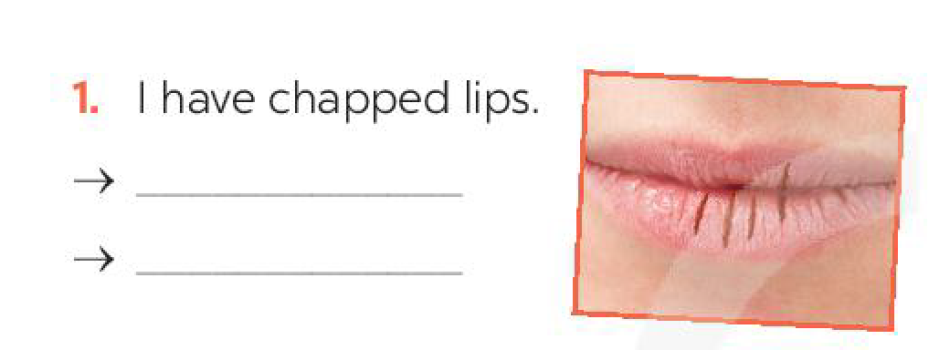 | 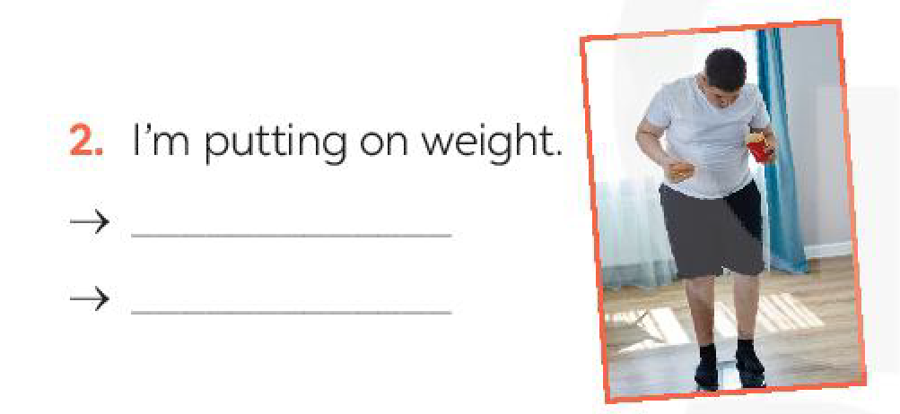

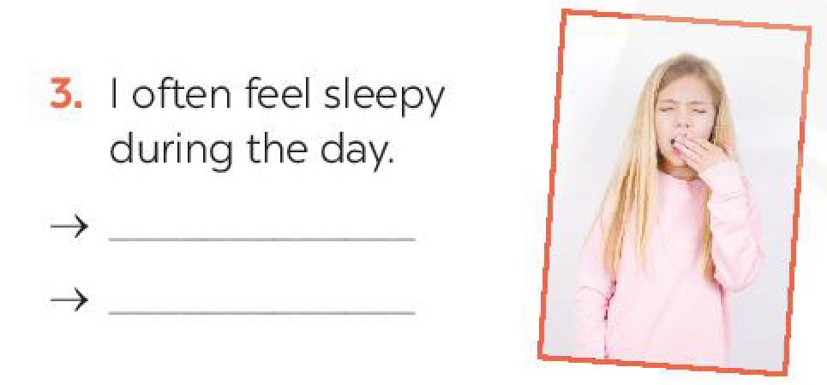 | 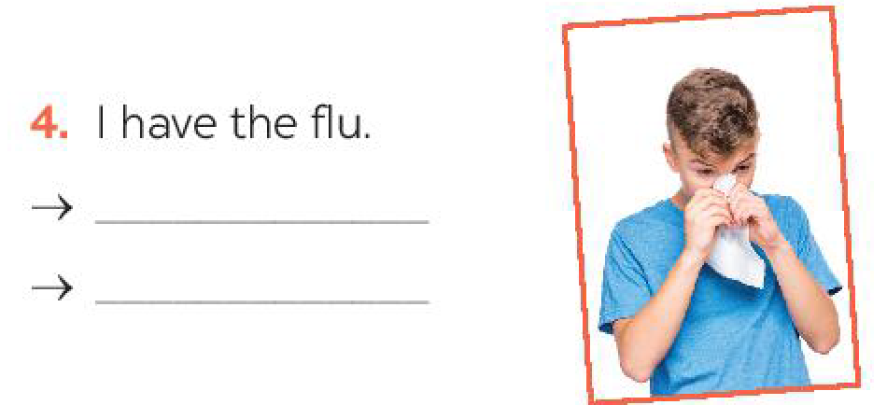

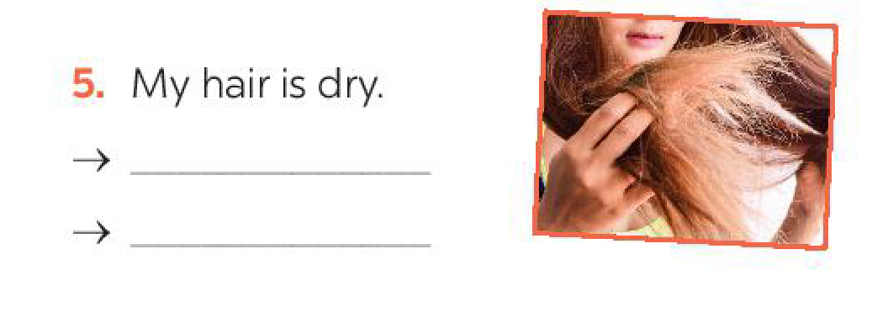

HANDOUT

Date of preparation: September 24th , 2024
Unit 3: COMMUNITY SERVICE
Total numbers of periods: 7 periods; from period 16 to period 22
LESSON 1: GETTING STARTED
Period: 16 Classes: 7A1,3,4,5
I. OBJECTIVES
1. Knowledge:
- Vocabulary: nursing home, community activity, donate, homeless.
- Grammar: Review the usage of the past simple tense.
By the end of the lesson, students will be able to:
- have an overview about the topic “Community Service”
- know community activities.
- understand the conversation between Minh and Tom to do the task below.
2. Competences
- General competences:
+ Communication: talking about community activities.
+ Collaboration: taking part in studying activities / helping in the community together.
- Distinctive competences: Linguistic competence: students can discuss and talk about what they can do to help in the community.
3. Values: Develop patriots and responsibility: enhance awareness of preserving the environment in their neighborhood or their school.
II. TEACHING AIDS AND MATERIALS:
1. Materials: Active board, laptop connected with the Internet, Teacher’s book.
2. Equipment: Student’s book, work book, collect some picture relating to their school thing and activities.
III. TEACHING PROCEDURES
1. WARM-UP (5MS) Picture describing
a. Aims: To engage students to some situations relating to some community activities.
b. Content: Look at the pictures and answer the question: What are these people doing?
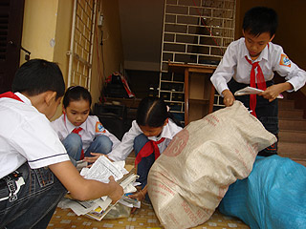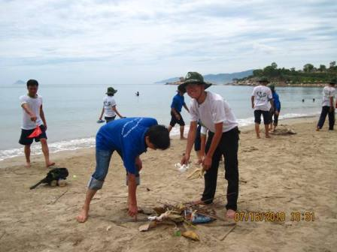

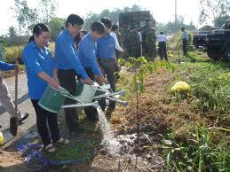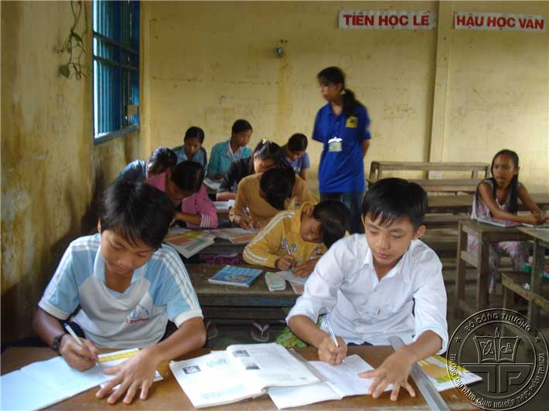
c. Expected products: Students look at the pictures and answer what they are doing.
d. Organization of activities:
- Show the picture and asks students questions.
- Ask students to raise hands to answer the questions.
- Get all students’ answers and explain the term “Community service” (work that people do without payment to help other people), and lead to the lesson.
- Keys:
+ Collecting books and paper.
+ Cleaning the beach.
+ Planting the trees.
+ Tutoring poor students.
2. KNOWLEDGE FORMATION (10MS)
a. Aims: To provide students with vocabulary related to the topic: community activities; review the simple past.
b. Content: Learn some new words and play the game “Slap the board”
c. Expected products: Students know and pronounce the words about community service.
d. Organization of activities:
- Teach word by word according to steps and principles of teaching new words. (using picture, real objects, explanation, …). Students listen, repeat the words in class, in group, then in individual and after that guess the meaning of the new words.
+ nursing home (n.phr.) (using picture) viện dưỡng lão
+ community activity (n.phr.) (using picture and explanation) hoạt động cộng đồng
+ donate (v) (using picture) quyên góp, ủng hộ
+ homeless (adj) (picture and explanation) vô gia cư
Ex: We donated clothes to the homeless children last week
- Ask ss to remind the use of the simple past.
- Checks the students’ understanding by the game: “Slap the board”
+ Divide the class into two teams.
+ Four students from each team go to the board and stand in two lines.
+ Each time one student from each team takes turn to listen to the teacher reading a word on the board and slap the word he/she hear.
+ The team who slaps more right words is the winner.
- Give feedback, and lead to the next part.
3. PRACTICE ACTIVITIES (25MS)
Task 1. Listen and read (6ms)
a. Aims: - To help students listen and read correctly the dialogue between Minh and Tom.
b. Content: Listen and read the dialogue correctly.
c. Expected products: - Students read and understand the meaning of the text.
- Students know how to role play.
d. Organization of activities:
- Play the recording twice and asks students to listen to the recording and read the dialogue.
- Ask two students to play roles of Minh and Tom to read the dialogue aloud in front of the class.
- Ask the whole class to work in pair to read the dialogue.
- Call some pairs (close pair and open pair) to read aloud
- Give feedback and correct their spelling and intonation.
- Introduce the situation to the next activity.
Task 2: Read the conversation again and tick the appropriate box. (6ms)
a. Aims: - To help students read for specific information about Minh and Tom’s community activities.
b. Content: Read the dialogue again and tick the appropriate box.
c. Expected products: - Students listen and tick the box; Students know how to role play.
- Keys:
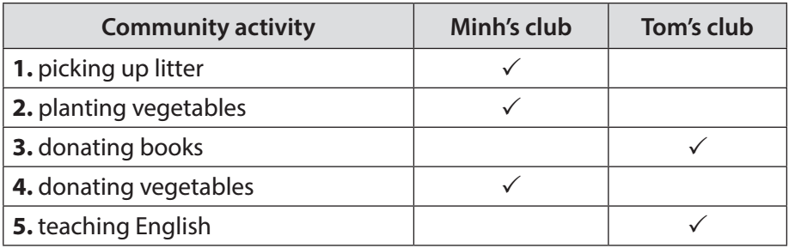
d. Organization of activities:
- Ask the students to read the dialogue again to complete the table.
- Reminds students to underline the information in the dialogue.
- Allow students to share their answers before discussing as a class and encourages them to pronounce the words / phrases correctly.
- Call some students to give the answers.
- Call other students to support for the answers.
- Give feedback
Task 3: Complete the phrases under the pictures with the verbs below (5ms)
a. Aims: To help students use phrases related to community activities.
b. Content: Look at the pictures and complete the phrases with the verbs in the box.

pick up clean donate recycle help

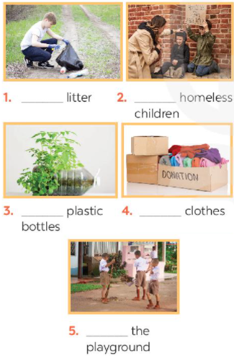
c. Expected products: Ss can match the words to the right pictures.
- Keys:
1. pick up
2. help
3. recycle
4. donate
5. clean
d. Organization of activities:
- Ask students to work individually to complete the phrases under the pictures with the given verbs.
- Ask students to say the phrases aloud and make sure they pronounce the words and phrases correctly.
- Give feedback.
Task 4: Complete the sentences with the correct words or phrases below (6ms)
a. Aims: To help students use the vocabulary related to community activities in the right contexts.
b. Content: Read the sentence and complete the sentence with the correct words or phrases below
c. Expected products: Ss can complete the sentence with the correct words or phrases.
- Keys:
1. homeless children
2. litter
3. old people
4. taught
5. planted
d. Organization of activities:
- Ask students to work independently to complete each sentence with a word or phrase from the box.
- Ask students to fill in the blanks with the most suitable words / phrases.
- Allow students to share answers before discussing as a class.
- Ask students to read aloud the full sentences and correct their pronunciation if needed.
4. APPLICATION ACTIVITIES (5MS)
Task 5. Vocabulary ping-pong game
a. Aims: - To help students review and reuse the learnt vocabulary.
- To create a fun atmosphere in the class.
b. Content: Students work in two teams. Team A provides a cue word. Team B makes up a sentence with it. Then switch roles.
c. Expected products:
Ss know some community activities.
Ss know to do some community activities.
Ss gain self-controlled and self-learning competence, communicative and cooperative competence, responsibility and diligence
Suggested answer:
Team A: Litter
Team B: We often pick up litter in the park. Trees.
Team A: We plan trees in our school every year. Book.
d. Organization of activities:
- Ask students to think of the topic Community Service.
+ One student from team A shouts out a word or phrase related to the topic. Then one student from team B makes a sentence with that word or phrase. Then switch roles.
+ The team that cannot give a phrase or make a correct sentence loses and the other team gets a point.
- Ask students to play the game.
- Go around to help weaker students.
- Stop the game when time is up. The team that makes the most correct sentences wins.
- Give comment.
HANDOUT

Date of preparation: September 26th , 2024

Unit 3: COMMUNITY SERVICE
Total numbers of periods: 7 periods; from period 16 to period 22
LESSON 2: A CLOSER LOOK 1
Period: 17 Classes: 7A1,3,4,5

I. OBJECTIVES:
1. Knowledge:
* Vocabulary: donate (v), exchange (v), liter (v), water (v)
* Grammar: The present continuous tense, the present simple tense
By the end of the lesson, students will be able to:
- have an overview about the topic “Community Service”
- know some volunteer activities in the neighbourhood
- know how to find the difference of the sounds “t”/ “d”/ “id”
2. Competences:
- General competence:
+ Self-controlled and self-learning competence (students know how to do some volunteer activities)
+ Communicative and cooperative competence (students know how to persuade their friends and
relatives to do volunteer activities)
- Distinctive competence:
+ Linguistic competence (sts know how to use their native language and foreign language to indicate
the evidence for their answers)
3. Values:
+ Responsibility (sts are aware of doing some volunteer activities)
+ Diligence (sts can donate some things for people in need)
II. TEACHING AIDS AND MATERIALS:
1. Materials: Grade 7 textbook, lesson plan, workbook, the teacher’s book, reference books
2. Equipment: TV, cassettes, pictures, cards, handouts, extraboards, sachmem.vn, On-line
websites (Kahoot)…
III. PROCEDURES :
1. WARM-UP (5ms)
a. Aims:
- To create an active atmosphere in the class before the lesson
- To lead into the new unit
b. Content: Matching game about the words related to community service
c. Expected Products: Students match the pictures with the correct word
Pic 1: plant trees/ Pic 2: help children/ Pic 3: collect used paper/
Pic 4: donate blood/ Pic 5: pick up litter/ Pic 6: water trees
d. Organization of activities:
- Divides the class into 2 groups and chooses a group leader for each group
- Gives the groups a list of verbs: collect/ pick up/ donate/ recycle/ help/ plant/ clean/ water/ tutor and match with some words: trees/ vegetables/ children/ books/ primary students/ used paper/ blood and litter and a set of some pictures illustrating
- Aks them to match the pictures with the correct verbs
1 2 3
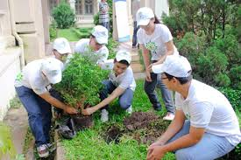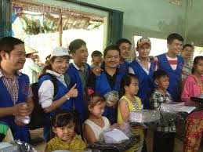
4 5 6
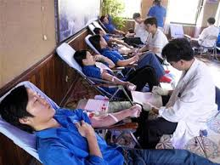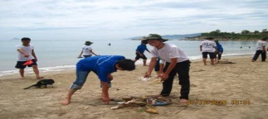
- Nominates a representative from each group to join the game
- Decides the winner who has the correct answers with the least running time
- Leads to the new lesson
2. KNOWLEDGE FORMATION ACTIVITIES (6ms)
a. Aims:
- To draw sts’ attention to the context
- To supply sts with the main knowledge of new words about community service and volunteer work
b. Content: New words about community service and volunteer work
c. Expected products: Students know some words relating to community service and volunteer work
d. Organization of activities:
- Pre-teaches some new words using suitable techniques
√. donate (v) (picture +explanation)
√. tutor (v) (picture +explanation)
√. exchange (v) (picture +explanation)
√. water (v) (picture +explanation)
√. rural (adj) (picture +explanation)
- Gets sts to repeat the words chorally, then individually
- Nominates individuals to read the words aloud and asks sts to copy down the words
- Checks the understanding of the new words by conducting the game “SLAP THE BOARD”
3. PRACTICE ACTIVITIES (26ms)
Task 2: (7’)
a. Aims:
- Students know the importance of doing volunteer work and community service
b. Content: Fill in the gaps
c. Expected products:
- Students understand and complete some sentences about volunteer work and community service
Key: 1.litter 2. used paper for notebook 3.water 4. donate 5.tutor
d. Organization of activities:
- Shows some sentences and asks them to complete the sentences using the given words from the box
- Calls some students to give their answers
- Checks students’ answers and asks others to repeat the answer
- Confirms the correct answers
Task 3: (7’)
a. Aims:
- To help sts practice some sentences by matching with the correct pictures
b. Content:
- Practice some sentences by matching with the correct pictures
c. Expected products:
- Match some sentences with the correct pictures
Key:
1. She is reading books to the elderly
2. They are giving gifts to old people
3. They are exchanging used paper for notebooks
4. They are donating clothes to poor children
5. She is planting trees in the park
d. Organization of activities:
- Shows them some pictures
- Asks them to work in pairs to match with some sentences
- Calls some pairs to present their answers
- Confirms the correct answers.
Task 4 (5’)
a. Aims:
- To draw sts’ attention to the context
- To assist the students in recognizing the correct pronunciation, and pronounce the sound /t/, /d/, /id/ correctly
b. Content:
- Some words with sounds: “t”/ “d”/ “id”
c. Expected products: Students can pronounce the sounds “t”/ “d”/ “id” exactly and fluently
/t/ | /d/ | /id/
Cooked  Passed  Helped | Watered  Cleaned  Volunteered | Collected  Donated  Provided
d. Organization of activities:
- Open the tapes two times
- Asks students to pay attention to the sounds “t”/ “d”/ “id”
- Calls some students to put the words into the correct columns
Gives them some rules for pronounce three sounds
Task 5: (7’)
a. Aims:
- Helps students practice listening the sounds “t”/ “d”/ “id” and choose correctly
b. Content: Listen and tick the sounds correctly
c. Expected products: Students can find the words with the correct sounds
 | /t/ | /d/ | /id/
1.cooked | x
2.watered |  | x
3.prdovided |  |  | x
4.donated |  |  | x
5.volunteered |  | x
d. Organization of activities:
- Shows some sentences and asks them to listen to the tape
- Opens the tape two times and has them listen carefully
- Has them choose which words in the correct sounds “t”/ “d”/ “id”
- Calls some students to give their answers
- Checks students’ answers and asks others to repeat the answer
- Confirms the correct answers
4. APPLICATION ACTIVITIES (8’)
Task 5: (8’)
a. Aims:
- To help sts practice some ways of doing volunteer work and community servive
- To train sts to become a responsible and diligent people to community
b. Content: a word web of some verbs relating to community service to complete
c. Expected products:
- Sts know more about some activities of community service
- Sts know to how to help the community effectively
- Sts gain self-controlled and self-learning competence, communicative and cooperative competence, responsibility and diligence
Key: - Donate: books, blood, money, clothes, toys, etc.
- Help: children, street people, old people, the poor, etc.
- Clean: streets, walls, lakes, rivers, beaches…
- Provide : food, attention, education, help, books, life skills…
- Recycle: used paper, bottles, cans,………
d. Organization of activities:
- Draws the word webs on the board.
- Has Sts work in groups to complete the words webs in 4 minutes on a sheet of paper at their tables.
- Has the students discuss in groups to create word -webs about volunteer work
- Asks them to share the answers with a partner, then give the answer as a class.
Recycle
Donate
- Gives feedbacks
Help

Provide
Clean

HANDOUT

Date of preparation: September 27th , 2024
Unit 3: COMMUNITY SERVICE
Total numbers of periods: 7 periods; from period 16 to period 22
LESSON 3: A CLOSER LOOK 2
Period: 18 Classes: 7A1,3,4,5
I. OBJECTIVES:
1. Knowledge:
* Grammar: The past simple
By the end of the lesson, students will be able to:
- know how to use the past simple of the verbs
2. Competences:
- General competence:
+ Self-controlled and self-learning competence (students know how to use the past simple of the verbs.
- Distinctive competence:
+Linguistic competence (sts know how to use the structures of the past simple)
3. Values:
+ Responsibility (sts are aware of the things in the past
+ Diligence (sts work better to support their things in the past)
II. TEACHING AIDS AND MATERIALS:
1. Materials: Grade 7 textbook, lesson plan, workbook, the teacher’s book, reference books
2. Equipment: TV, cassettes, pictures, cards, handouts, extraboards, sachmem.vn, On-line websites
( Kahoot)…
III. PROCEDURES :
1. WARM-UP (5MS)
a. Aims: -To create an active atmosphere in the class before the lesson
- To lead into the new lesson
b. Content: Say one activity they did last summer.
c. Expected Products: Students can use the activities they learnt in the previous lesson.
d. Organization of activities:
Give Ss a few minutes to take turn to stand up and say what they actually did.
-Decides the winner whose correct statements with the least running time
-Leads to Unit 3 and writes the lesson title “A CLOSER LOOK 2” on the board
-Asks sts to have a guess about what they are going to learn about in A CLOSER LOOK 2.
2. KNOWLEDGE FORMATION ACTIVITIES (5MS)
a. Aims: -To use the past simple correctly.
-To supply sts with the main point of new grammar.
b. Content: The past simple.
c. Expected products: Students know how to use the past simple.
d. Organization of activities:
- Pre-teaches some new structures using suitable techniques
√. Use the past simple to talk about completed actions in the past.
√. Time expressions, such as yesterday, last month, three weeks ago, or in 1998 with the past simple.
3. PRACTICE ACTIVITIES (28MS)
Task 1: (7’)
a. Aims: To review Ss’ knowledge of the past simple tense.
b. Content: use the past simple perfectly.
c. Expected products:
*Suggested answers:
1. B 2. C 3. B 4. A 5. C
d. Organization of activities:
- Ask Ss to work individually to circle the correct answers.
- Ask Ss to take turn to give their answers.
- Ask several Ss to read aloud full sentences with the correct answers.
- Correct their pronunciation if necessary.
Task 2: (7’)
- Aims: -To raise sts’awareness of the past simple tense of the past form of some verbs
b. Content:. Finish the sentences with the past simple form of the given verbs.
c. Expected Products:
*Suggested answers:
1. took 2. did ….. join 3. Helped 4. Sent 5. Volunteered
d. Organization of activities:
- Tell Ss to do the task independently first. Tell them to complete the sentences with the past simple form of the given verbs.
- Call on some Ss to read out their sentences.
- Correct grammar and pronunciation mistakes.
Task 3:(7’)
a. Aims: To help Ss distinguish between the present simple, present continuous, and past simple in specific context.
b. Content:. Complete the sentences with the correct forms of the verbs from the box.
c. Expected Products:
*Suggested answers:
1. cook 2. Did … plant 3. Are picking up 4. Recycled 5. read
* d. Organization of activities:
- Asks the whole class to read aloud the verbs in the box.
- Has Ss work individually to complete the sentences with the correct forms of the verbs from the box.
- Asks Ss to read out the complete sentences.
- Corrects grammar and pronunciation mistakes.
Task 4:(7’)
a. Aims: To help Ss write full sentences using the correct form of trhe verbs.
b. Content: Write complete sentences from the prompts.
c. Expected products:
*Suggested answers;
1. Last year, our club donated books to children in rural areas.
2. Did children send you thank-you cards a week ago?
3. I taught two children in grade 2 last summer.
4. Last spring, we helped the elderly in a nursing home.
5. How did you help the people in flooded areas last year?
d. Organization of activities:
- Has Ss work individually to write complete sentences from the prompts.
- Asks them to work in paits to wrap their answers.
- Has the class read out the sentences .
- Corrects grammar and pronunciation mistakes.
4. APPLICATION ACTIVITIES ( 7’)
Task 5:(7’)
a. Aims: To enable Ss to ask and answer questions related to past activities.
To help Ss be aware of some community activities that Ss in other countries do.
b. Content: Work in pairs. Tom is from the Red Cross. Look at the fact sheet and ask Tom about his project in 2016 and 2020.
c. Expected Products:
- Sts know how to make a conversation between two people.
- Sts gain self-controlled and self-learning competence, communicative and cooperative competence, responsibility and diligence.
d. Organization of activities:
- Introduce the Red Cross project and activities in 2016 and 2020.
- Has ss work in pairs to practice asking and answering questions based on the fact sheet.
- Tells Ss to follow the example..
- Reminds them to use the past simple when they ask and answer questions about the past activities.
- Invites some pairs to make short conversations as an example
- Corrects only common errors after Ss finish speaking.

HANDOUT

