Tam Quan Bac Secondary School 2025 - 2026
Dang Kieu Oanh English 6
Date of preparing: 06/02/2026

UNIT 9: CITIES OF THE WORLD
Total numbers of periods: 7 periods; from period 69 to period 75

LESSON 6: SKILLS 2
Period: 74 Class: 6A1,2,3

Objectives:
    - Knowledge:
      - Vocabulary lexical items related to the topic 'Cities of the World'
      - Grammar: The present simple ( review ) By the end of the lesson, Ss will be able to:
- Listen to a descpiption of a city
- Write a holiday postcard

Competences:
- General competence:
+Self-controlled and self-learning competence (Ss can get general and specific information about a city)
+ Communicative and cooperative competence ( Ss know how to describe a city and express their thought about this city)
-Distinctive competence:
+Linguistic competence (Ss know how to use their native language and foreign language to indicate the evidence for their answers)

Values :
+ Responsibility (being aware of the cities and beautiful spots in your countries or in the world)
+ Diligence (Ss works and study hard to visit some cities around the world in the future)

Teaching aids and materials:
    - Materials: Grade 6 textbook, lesson plan, workbook, the teacher’s book, reference books
    - Equipment: TV, cassettes, pictures, cards, handouts, extraboards, sachmem.v

TEACHING PROCEDURES:
    - WARM-UP (5MS)

Aims:
- To introduce the topic of the listening tasks.
- To enhance Ss’ skills of cooperating with team mates.

Content: * Game: Relay-race to capital cities of ASEAN countries.
- Expected products: Ss know the capital cities of ASEAN countries
Suggested answer:
- Ha Noi of Viet Nam
- Phnom Penh of Cambodia
- Jakarta of Indonesia
- Manila of Philippines
- Naypyitaw of Myanmar
- Kuala Lumpur of Malaysia
- Singapore of Singapore
- Vientiane of Laos
- Bangkok or Krung Thep of Thailand
- Banda Seri Begawan of Brunei Darussalam

Organization of activities:

* Game: Relay-race to capital cities of ASEAN countries.
- Teacher sticks the map of ASEAN countries on the board.
- Teacher divides the class into 2 teams. Each team will have to take turns to run in a relay-race to write the correct names of the capital cities of ASEAN countries.
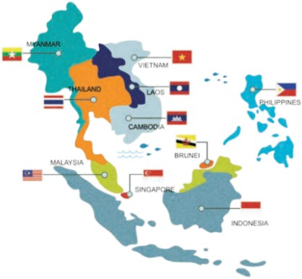
- Each team will write on the board with different colour of chalk so that the teacher can count the correct answers easily.

KNOWLEDGE FORMATION ACTIVITIES (8MS)
a.Aims:- To help Ss brainstorm about Bangkok.
- To set the context for the listening part. b.Content: Discuss in groups and answer the questions.
c. Expected products: Ss can answer the questions in groups.
Suggested answer:
- Bangkok is in central Thailand.
- It's famous for its temples, markets, shopping centres, silk, street food, friendly people, and many types of entertainments.

d. Organization of activities:
- Teacher tells Ss that they will listen to a talk about Bangkok, the capital of Thailand.
- Teacher asks Ss to work in groups of four to answer the 2 questions and discuss with them to see what they know about Bangkok or Thailand.
- Where is Bangkok?
- What is Bangkok famous for?
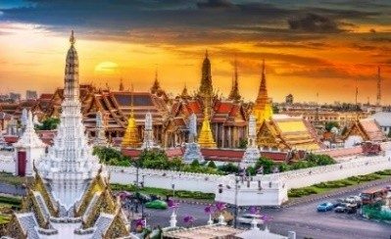

PRACTICE ACTIVITIES ( 22MS)

Task 2 (7ms)
- Aims:To help Ss develop listening skill for specific informationss (T / F).
- Content: Listen and tick T/ F to get specific informationa talk about Bangkok, the capital of Thailand
- Expected products: Ss can tick T/F correctly while they are listening.
Suggested answer:
- F (markets and street food)
- F (cheap)
- F (on the river)

- T

Organization of activities:
- Ask Ss to go through the statements (1 - 4) to make sure that they understand them and know what information they have to catch for the answers. (Ss may underline the key word(s) in each statement.)
- Play the recording. Ask Ss to listen and tick the answers.
- Call on some Ss to read aloud their answers and correct the false one(s).
- Check and confirm the correct answers.

Task 3: (7ms )
- Aims: To help Ss develop listening skill for specific information ( gap- filling)
- Content: Listen againand fill each gap with One word/ number..
- Expected products: - Ss understand more informationabout Bangkok, the capital of Thailand.
Suggested answers
1. 15,000 2. 5 3. life 4. delicious

Organization of activities:
- Ask Ss to read the questions carefully and determine what information they need to fill the gaps (numbers, words).
- Play the recording for Ss to fill the gaps.
- Ask them to exchange answers in pairs before checking their answers as a class

Task 4: (8ms)
- Aims: To help Ss talk about a holiday city and collect information for their later writing.
- Content: Group work and talk about city intheir country using questions given..
- Expected products: Ss can talk about city they know.

Organization of activities:
- Ask Ss to work in groups. Choose a city they know and discuss guided by the questions.
- Ask Ss to take short notes of the answers for later use.
- Goroundandhelpifneeded.
- Go around and give help If necessary.
- Call on some Ss to speak in front ofthe class.T and other Ss listen and make comments.

APPLICATION ACTIVITIES ( 10’)

Task 4: (10’)
- Aims: To teach Ss how to write a postcard
- Content: Write a postcard about their holiday.
- Expected products: Ss can write a postcard completely.
Suggested answers Dear Mum and Dad,
Hue is a great city. The weather is fine, sunnyall the time. The food is cheap and delicious. The people here are friendly and hospitable. The hotel where we’re staying is small but comfortable. Yesterday we visited the historic monuments. Tomorrow we’re going on a trip along Huong River. I bought a small present for you yesterday.
You must visit this place/ city someday. You’ll love it.
Love Trang

Organization of activities:
- Ask Ss to use their ideas in 4 to write a postcard to their family.

- Ask Ss to refer to Reading 2 if needed.
- If there is time, pair Ss and ask them to write postcards to each other. Have them swap and give feedback on eachother's writing once they have finished.
- Go around and give help If necessary.

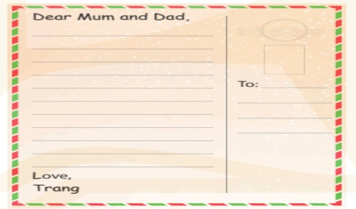
- Call on some Ss to read their notes in front ofthe class.T and other Ss listen and make comments

