Tam Quan Bac Secondary School 2025 - 2026
Dang Kieu Oanh English 6
Date of preparing: 06/02/2026

UNIT 9: CITIES OF THE WORLD
Total numbers of periods: 7 periods; from period 69 to period 75

LESSON 4: A COMMUNICATION
Period: 72 Class: 6A1,2,3

OBJECTIVES:

Knowledge:
      - Vocabulary: Words/ phrases related to cities and landmarks..
      - Grammar: The present simple ( review ) By the end of the lesson, Ss will be able to:
- Expressing exclaimations with What.
+ What a nice city!
+ What tall buildings!
- use the words related to cities and landmarks.

Competences: -
-General competence:
+Self-controlled and self-learning competence (Ss know about some famous citiy landmarks in the world )
+Communicative and cooperative competence ( Ss know how to express exclaimations with
What.)
-Distinctive competence:
+Linguistic competence (Ss know how to use their native language and foreign language to indicate the evidence for their answers)

Values :
+ Responsibility (being aware of the cities and beautiful spots in your countries or in the world)
+ Diligence: (Ss work better to get well-paid future jobs to visit cities in the world )

TEACHING AIDS AND MATERIALS:
    - Materials: Grade 6 textbook, lesson plan, workbook, the teacher’s book, reference books
    - Equipment: TV, cassettes, pictures, cards, handouts, extraboards, sachmem.v

TEACHING PROCEDURES :
    - WARM-UP (5MS)
- Aims: - help Ss have an overview about all landmarks around the world and specific information about it
-To lead into the new unit
- Content: Find out some landmarks they know around the world
- Expected products: Famous cities on the board

Organization of activities
+ Divides class into 2 teams.
- T. writes the unit title on the board.
- Then asks Ss to name some landmarks they know and where they are.

Landmarks
Sydney Opera
Big Ben

KNOWLEDGE FORMATION ACTIVITIES (10MS)
- Aims: To introduce some new words and exclamations with What
- Content: Introduce some new words.Look and repeat the exclamations

Expected products:
Ss can learn some new words and how to form and use exclamations with what:What a nice city

Organization of activities:
-Pre-teaches some new words using suitable techniques
+ shell (n) (explanation)
+ climb (v) (gesture+example)
+ head (n) (picture)
+ proud of (adj) (explanation)
+ ancient (adj)) (explanation)
- Gets Ss to repeat the words chorally, then individually
- Nominates individuals to read the words aloud and asks Ss to copy down the words
- Checks the understanding of the new words by conducting the game What and Where

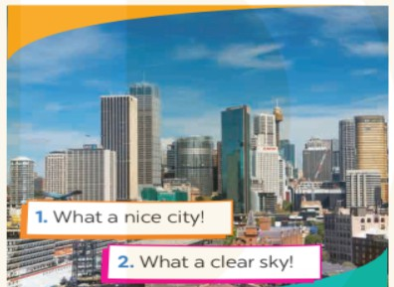
- Ask Ss to look at the picture and read the exclamations. Ask them to find the similarity / similarities among the three exclamations.
- Write the three exclamations on the board since it is easier for Ss to observe. (They all begin with What followed by a noun phrase. An exclamation mark (!) is usually put at the end.)
- Present the sentences like the following.
+ What a nice city!
+ What a clear sky!
+ What tall buildings!

=>What + adj + noun + exclamation mark (!)
*Note: use a/an with countable nouns which are singular
- Check the answers
- Correct their pronunciation.
- Give the comments

PRACTICE ACTIVITIES ( 25MS)
Task 2: (10’)
- Aims: To help Ss practise making exclamations with What.
- Content: Look atthe picture and say what you think by using exclaimations
- Expected products: Ss can make exclamations using the cues given.
Suggested answer:
- What happy and beautiful children!
- What a colourful and nice picture!
- What sunny and beautiful weather!
- What a small and cute boy!
- What beautiful and colourful apple trees!

Organization of activities:
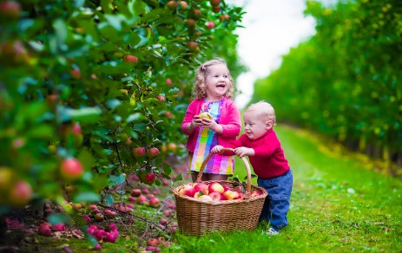
- Allow Ss to work in pairs and take turns to make exclamations from the picture.
- Call on some pairs to say their exclamations aloud in front of the class.
-Check and correct if needed.
Task 3:(7’)
- Aims:- To help Ss get used to some famous landmarks in big cities.
- Content: Write the names of the landmarks under the correct pictures.
- Expected products:- Ss can write the names of the landmarks undercorrect pictures.
Suggested answer:
1. Merlion 2. Big Ben 3. Sydney Opera House 4. Eiffel Tower

Organization of activities:
- Show Ss photos of the four landmarks of different cities and ask Ss what they are
- Have Ss work in pairs. Ask them to read the names in the and write them under the correct pictures of the landmarks.
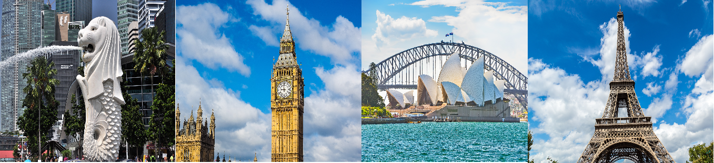
- CheckSs'answers as a class.
- Elicit from Ss any information they know about the landmarks: Which cities are they in?
- Ask other Ss to comment. Ask Ss if they can add more things to each room.
Task 4:(8’)
- Aims: To help Ss to recognise each landmark through its description.
- Content: Write the names of thelandmark for the descriptions

- Expected products: Ss can know more the landmarks.
Suggested answer:
1. Big Ben 2. Sydney Opera House 3. Eiffel Tower 4. Merlion

Organization of activities:
- Have Ss read the descriptions about the four landmarks. Set a time limit.
- Have them work individually. Ask them to write the names of the landmarks in 3 next to the descriptions.
- Call on some Ss to give their answers. Ask them to support theirs.
- Comment on their performance.

APPLICATION ACTIVITIES ( 5ms)
Task 5 (5ms’)
- Aims: To check how much Ss know about different cities and their landmarks.
- Content: Do the quiz. Read and circle the correct answers.
- Expected products: Ss can answer the questions correctly by choosing the A, B or C
Suggested answer:
1. B 2. A 3. C 4. A

Organization of activities:
Game: Lucky number
- Teacher divides the class into 2 big groups.
- Each group will take turns to choose a number and answer the question in each number. There will be 4 questions in Exercise 5 page 31.
- If the answer is correct the group will receive 10 points. If no, the other group will have chance to answer the question and get 5 points.
- There will be one lucky number that gives the group 10 points without answering the question.
- The group with higher scores will win the game.

