Date of preparation: 02/04/2025

1. **​Knowledge:**

## UNIT 11: TRAVELLING IN THE FUTURE

*Total number of periods: 7; from period 88 to period 94*

## LESSON 7 : LOOKING BACK & PROJECT

***Period: 94 Class: 7A4,7A5,7A10,7A11***

**I.OBJECTIVES:**

- To teach doing for general and specific information about future means of transport. Students get acquainted with all skills. To learn how to do the exercises. Also to write a paragraph.

+ Vocabulary: - use the words related to the topic *travelling in the future.*

+ Grammar:- To use the future simple tense to talk about things in the future and revise the possessive pronouns;

1. **​Competence:**

r.

* + General competence:

+ Self-controlled and self-learning competence (students know how to use the words about future means of transport)

+ Communicative and cooperative competence (students can talk about why a means of transport will/won’t popular)

* + Distinctive competence:

+ Linguistic competence (students know how to use their native language and foreign language to make predictions)

1. **Values:**
   * Diligence (students know how to use means of transport in the future)
   * Responsibility (students are aware of the advantages of a future means of transport)

## TEACHING AIDS AND MATERIALS:

1. **Materials:** Grade 7 textbook, lesson plan, workbook, the teacher’s book, reference books
2. **Equipment:** TV, cassettes, pictures, cards, handouts, ex sachmem.vn,

## PROCEDURES:

### Aims:

## WARM UP ( 7MS)

* + - * To prepare Ss with some general ideas before they read friendliness and atmosphere in the class before the lesson;
      * To give T and Ss a chance to introduce themselves;
      * To lead into the content of the lesson
  1. **Content:** To have some warm-up activities to create a friendly and relaxed atmosphere to inspire Ss to warm up to the subject and new lesson.
  2. **Expected Products:** the content of the textbook, book map and the curriculum. ways of studying and doing the test, Present forms of test
  3. **Organization of activities :** Teacher’s instructions …
     + - Game: Who’s faster?

-Shows the pictures and asks Ss to gives descriptions to them.

-Divides the class into 2 teams and run the game Who’s faster?

-Members of each team take turns to raise hands to give description for each picture.

-Asks Ss to discuss their friends’ answers.

-Confirms the answers and give feedback. The team having correct answers is the winne

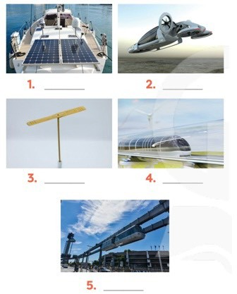

### KNOWLEDGE FORMATION ACTIVITIES (8ms)

**Task 1 .**

1. **Aims**: To help Ss revise the learnt vocabulary
2. **Content:** Use the right adjectives / phrases to describe the appropriate means of transport.
3. **Expected products:** Listening find the words correctly.

-Gives suggested answers.

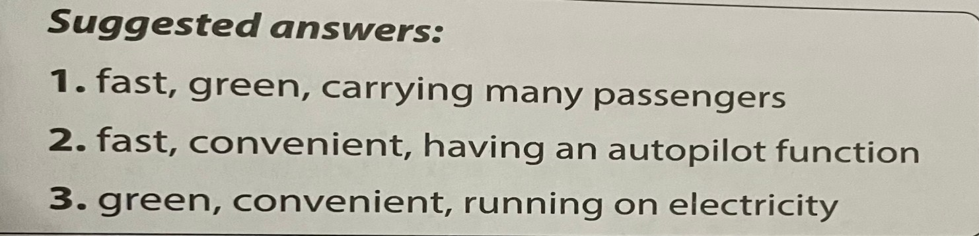

1. **Organization of activities** :Teacher’s instructions…..

-Asks Ss to recalls the adjectives and phrases they have learnt to describe means of transport.

* + - * 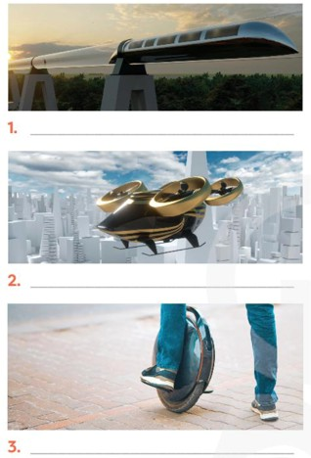Has Ss work individually to write three adjectives or phrases under to describe it.

-Checks answers.

-Gives suggested answers.



### ACTIVITY 3: PRACTICE ACTIVITIES (20ms)

* 1. **Task 2 ( 7’)**
     1. Aims: To help Ss revise rhe learnt vocabulary
     2. Content: Use the right adjectives / phrases to describe in the right context.

### Expected Products:

1.eco-friendly 2. runs on 3. bamboo-copter 4.driverless 5.bullet trains

* + 1. **Organization of activities** :Teacher’s instructions…..

-Has Ss work individually to put the right words / phrases in to the correct blanks.

1. A teleporter is so it does not cause pollution.
2. A solowheel electricity, so it is safe for the environment.
3. A convenient way to go to school is by . Just put it on and fly away.
4. You can sleep when you travel by car.
5. are faster and greener than normal trains.

-Checks answers.

-Asks some Ss to read aloud the sentences.

-Gives keys1.eco-friendly 2. runs on 3. bamboo-copter 4.driverless 5.bullet trains

### Task 3 (7’)

* 1. **Aim:**To help Ss revise the possessive pronouns.
  2. **Content:** Find one mistake and correct it.
  3. **Expected Products:** Understand the meaning of words.

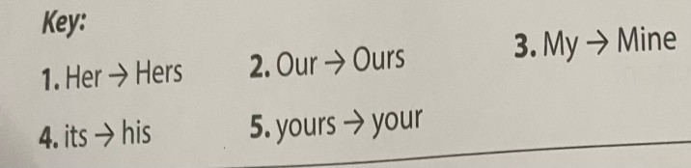

* 1. **Organization of activities:** Teacher’s instructions.…..

-Asks Sts to work in pairs to find one mistake in each sentence and correct it

-Checks answer.

-Asks some pairs to read out the correct sentences.

-Gives key.

### Task 4 (6’)

**a.Aim:**To help Ss revise the **simple tense**. **b.Content:**Read the passage and put the verbs. **c.Expected Products:**

### Suggested answers

1. will travel
2. will go
3. will need
4. will carry
5. will come

**d. Organization of activities :** Teacher’s instructions.…..

- Has Ss work individually to put the verbs in brackets in the correct form.

-Calls some Ss remind the usage and structure of the future simple tense.

-Has Ss compare their answers in pairs.

-Checks answers.

-Calls some Ss to read out the complete pasaage.

In the future, we will travel much further than we do now. We will also visit new places for our holidays. Some scientists think we (1. travel) to new planets. We (2. go) there by spaceship, but we (3. need) new special means of transport. These new means of transport (4. carry)

one or two passengers, but many our dream (5. come) true soon? Let's wait and see.

-Gives suggested answers.

## APPLICATION ACTIVITIES (10 MS)

1. **Aim:**To prepare Ss revise vocabulary about various future means of transport and their advantages. To improve Ss ‘creativity, teamwork, and public, speaking skills.
2. **Content:**. Choose one future means of transport and present.
3. **Expected Products:** Ss can identify different functions of a car.
4. **Organization of activities :** Teacher’s instructions

-Asks Ss work in groups, tells them to imagine a future means of transport they would like to see in the future.

-Tells them to look at the pictures or think various future means of transport they have learnt and the suggested questions as clues to brainstorm their ideas.

-Asks Ss to be able to draw picture to illustrate their ideas.

-Calls groups of Ss to pin the picture / photo on a large piece and present to the class.

-Asks Ss in other groups comment and vote for the best picture / photo.

-Confirms and correct.

Now I can …………

-Asks Ss to complete the self- assessment table

-Identify an difficulties, weak areas, and provide further practice.