Date of preparation : 01/4/2025

**UNIT** 11: OUR GREENER WORLD

***Total numbers of periods: 7 periods; from period 88 to period 94***

**LESSON 3:** A closer look 2

***Period: 90 Class: 6A8,9***

# OBJECTIVES:

## Knowledge:

+ Vocabulary: vocabulary about green world

+ Grammar: First conditional

By the end of the lesson , students will be able to:

* Use the words relating to the topic : *Our houses in the future*
* Introduce first conditional and article

## Competence:

* + - * General competence:

+ Self-controlled and self-learning competence (students know how to help the environment to be greener)

+ Communicative and cooperative competence ( students Know how to preserve and protect environment )

* + - * Distinctive competence:

+Linguistic competence (sts know how to use their native language and foreign language to express the love of the environment)

## Values:

+ Responsibility (students are aware of the importance of environment)

+ Diligence (students know how to keep houses clean and tidy as well as protect our environtment peacefully)

# TEACHING AIDS AND MATERIALS:

* + 1. **Materials:** Grade 6 textbook, lesson plan, workbook, the teacher’s book, reference books
    2. **Equipment:** TV, cassettes, pictures, cards, handouts, extraboards, sachmem.vn, On-line websites…

# PROCEDURE:

* + 1. **ACTIVITY 1: WARM UP (5’)**

## Aims:

* To inspire sts to warm up to the new lesson
* To lead into the new lesson

1. **Content:** Having some warm-up activities to creat a friendly and relaxed atmostphere to inspire Ss to warm up to the subject and new class.
2. **Expected Products:** Having a chance to use English fluently

## Organization of activities:

* Divides the class into 2 groups.
* Delivers a set of word cards which are jumble.
* Asks sts to work in groups to put in the correct column and The group with correct column will be the winner.
* Sts work in groups to play game. Leading to the new lesson:

Questions: Can you guess the unit today?

* Asks Ss a question for the unit of the lesson.
* Sts answer the T’s question.
* Leads in the new lesson.
* Asks Sts to open their book and introduces what they are going to study.
* Sts open their book and write.

# ACTIVITY 2: KNOWLEGDE FORMATION ACTIVITIES ( 10’) GRAMMAR

## Aims:

– The introduce First conditional and articles

1. **Content:**Definite *the conditional sentences - type 1*
2. **Expected Products:students** can use *the conditional sentences - type 1and article exactly.*

## Organization of activities: :

* Writes 2 sentences with articles on the board : This is a book. The book on the table is my favourite
* Underlines a/ the and Explains the difference between these two articles telling them that ***a*** is an indefinite article and ***the*** is a definite article

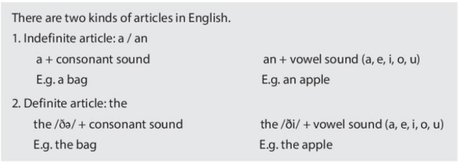

* + Explains how the first conditional is used and how it is formed

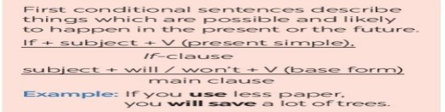

* + Has ss read the examples in the remember box and draw the attention to the aim of first conditional
  + Gets Sts to take note

# ACTIVITY 3: PRACTICE ACTIVITIES ( 25’ )

**Task 1(7ms)**

1. **Aim:** To give Sts practice with a , an and the
2. **Content:** Complete the sentences with a/ an/ the
3. **Expected Products: :**To know how to use a/ an/ the

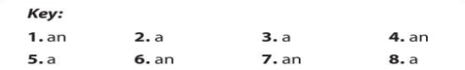

## Organization of activities:

**Write a or an**

* + Asks Sts to read the instructions to understand how to do the activity
  + Has sts do the exercise individually and then compare their answers and invites some Sts to read their answers aloud .
  + Goes around and offers help if necessary
  + Checks their answers in front of the class.
  + Draws students’ attention to the Remember box.
  + Has sts read the information.
  + Confirms the correct answers.



**Task 2(6ms)**

1. **Aims:** To give ss further practice with a /an or the
2. **Content:** Practice definite and indefinite articles
3. **Expected Products: :** Complete the sentences with a/an or the



## Organization of activities: :

**Write a/an or the**

* + Has Sts read the requirements of the task.
  + Guides Sts how to do the task.
  + Asks Sts to work independently.
  + Calls 5 Sts to write their answers on the board, checks their answers sentence by sentence.



* + Sts listen to the T and take notes.

**Task 3:(5ms)**

1. **Aims:** To give sts practice with first conditional
2. **Content:** Understand the first conditional
3. 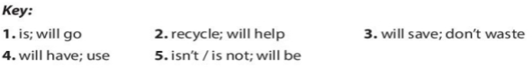**Expected Products: :** Write the correct form of each verb in brackets

## Organization of activities:

**Write the correct form of each verb in bracket**

* + Helps sts read the sentences carefully
  + has Sts read the requirements of the task.
  + Sts look at the task and read the requirements of the task.
  + Guides Ss how to do the task.
  + Asks Ss to do the task individually.
  + Asks some Ss to give their answer in the class.
  + Checks and corrects, gives the corrects answers.
  + Sts listen to the T, and copy the answers if necessary.

**Task 4(7ms)**

1. **Aims:** To give ss further practice with first conditional
2. **Content:** Understand the first conditional exactly
3. 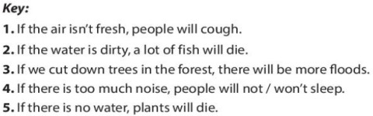**Expected Products:** Combine each pair of sentences to make the first conditional

## Organization of activities:

Combine each pair of sentences below to make a first conditional sentence

* + Sts look at the task and read the requirements of the task.
  + Explains the way to do the task.
  + Guides Ss how to do the task.
  + Asks Ss to do the task individually.
  + Asks some Ss to give their answer in the class.
  + Checks and corrects and gives the corrects answers.

# ACTIVITY 4: APPLICATION ACTIVITIES

**Task 5:(5ms)**

1. **Aims**: To help Ss use the conditional sentences – type 1 correctly and appropriately.
2. **Content**: - Work in groups to use the conditional sentences – type 1
3. **Expected products**: To help Ss practise using the conditional sentences – type 1

## Organization of activities:

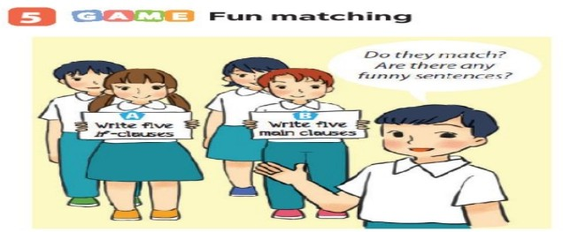

* Sts look at the task and read the requirements of the task.
* Guides Ss how to do the task: Work in groups, A and B. Group A secretly writes five if-clauses ona sheet of paper. Group B secretly writes five main clauses on another sheet of paper. Match the if- clauses with the main clauses.
* Asks Ss to do the task individually.
* Asks some Ss to give their answer in the class.
* Checks and corrects, gives the corrects answers.
* Sts listen to the T, and copy the answers if necessary.