**Date of preparation : 01 /04 /2025**

**UNIT** 11: OUR GREENER WORLD

***Total numbers of periods: 7 periods; from period 88. to period 94***

**LESSON 2:** A closer look 1

***Period: 89 Class: 6A8,9***

# OBJECTIVES:

## Knowledge:

+ Vocabulary: - reduce (v) reuse (v) recycle (v) material(n) plastic bottle (n) plastic bag (n)

+ Pronunciation : Rhythm in sentences

*By the end of the lesson, students will be able to:*

* Use the lexical items related to the unit
* Use the vocabulary and structures to describe about environment
* Practise pronouncing the rhythm in sentences

## Competence:

* + - General competence:

+ Self-controlled and self-learning competence (students know how to help the environment to be greener)

+ Communicative and cooperative competence ( students Know how to preserve and protect environment )

* + - Distinctive competence:

+Linguistic competence (sts know how to use their native language and foreign language to express the love of the environment)

## Values:

+ Responsibility (students are aware of the importance of environment)

+ Diligence (students know how to keep houses clean and tidy as well as protect our environment peacefully)

# II. TEACHING AIDS AND MATERIALS:

* 1. **Materials:** Grade 6 textbook, lesson plan, workbook, the teacher’s book, reference books
  2. **Equipment:** TV, cassettes, pictures, cards, handouts, extraboards, sachmem.vn, On-line websites…

# PROCEDURES:

* 1. **ACTIVITY 1: WARM UP ( 7’)**

## Aims:

-To brainstorm students about vocabulary relating to go green

- To lead into the unit 11

1. **Content:** Vocabulary relating to the environment
2. **Expected Products:** Students know names of type of garbage

## Organization of activities:



-Asks sts to watch the 3 R song and answer the questions

+What are they?

+Are they helpful?

-Sts give the anwser : they are REDUCE - REUSE -RECYCLE

* Leads in the new lesson.
* Asks Sts to open their book and introduces what they are going to study.
* Sts open their book and write.

# ACTIVITY 2: KNOWLEGDE FORMATION ACTIVITIES ( 11’)

1. **Aims:** Ss can know description some new words related to the topic “ our greener world “
2. **Content:** Learn some new words.
3. **Expected Products:** Know more new words and understand the meaning of 3R

+ Follows the steps of teaching vocabulary.

* reduce (v) (example): cắt giảm
* reuse (v) (example) tái sử dụng
* recycle (v) (explanation) tái chế
* material (n) (picture) nguyên liệu, vải
* plastic bottle (n) (picture) chai nhựa
* plastic bag (n) ( picture + explanation) túi nhựa

## Organization of activities:

**\* Teach vocabulary:**

+ Follows the steps of teaching vocabulary.

* reduce (v) (example): cắt giảm
* reuse (v) (example) tái sử dụng
* recycle (v) (explanation) tái chế
* material (n) (picture) nguyên liệu, vải
* plastic bottle (n) (picture) chai nhựa
* plastic bag (n) ( picture + explanation) túi nhựa

-Gets students to repeat the words chorally, then individually.

-Asks individuals to read the words aloud and asks students to copy down the words.

-Checks the understanding of the new words by conducting the game “Rub out and Remember”

# ACTIVITY 3: PRACTICE ACTIVITIES (20’) VOCABULARY

**Task 1(5ms)**

1. **Aim:** To teach the terms reduce, reuse and recycle
2. **Content:** Understand and use 3R for the right **situation**
3. **Expected Products:** Draw a line from the symbols to the terms

*Suggested answer:

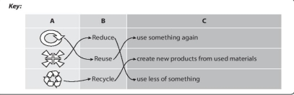

## Organization of activities:

**The three Rs for reduce -Reuse -Recycle .Draw a line from a symbol in column A to its matching word in column B and its meaning in column C**

-Has students read the information inle and draws a line from a symbol in column A to the matching word in column B and its meaning in column C

-Asks sts to work in pairs to compare their answers before giving the answers

-Checks and writes the correct answers on the board .

-Explains the difference between these terms again if necessary.



**Task 2: (5ms)**

1. **Aims:** To introduce the words things that can be reduced, reused and recycled
2. **Content:** write and remember new words
3. **Expected Products:** write a word / phrase in the box under each picture

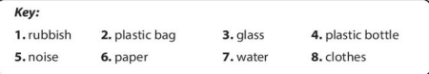

## Organization of activities:

**Write a word or phrase in the box under each picture**

Have students work in pairs to do this activity . Calls on some sts from different pairs to write the words

This activity can be organized as a competition whoever pair finishes the activity first wins and can write their answers . Confirm the correct answers

* students listen to the instructions clearly
* students *know how to do it*
* Sts work in pairs and share the answers
* Sts *copy down them*

**Task 3: (5ms)**

1. **Aims:** To help Ss categorise things that can be reduced, reused and recycled
2. **Content:**learn and know how to use the words into the right group
3. **Expected Products:** Classify the words

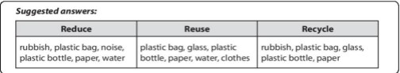

## Organization:

**Work in pairs. Put the words from 2 into groups .Some words can belong to more than one group**

-Ask ss work in pairs to put the words from 2 in appropriate groups .

* Draws the table board and calls three sts to write their answers .
* Asks sts to discuss the answer before class
* Elicts some words for each group from Ss .
* Give some suggested words:

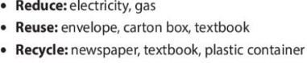

## Task 4: PRONUNCIATION(5ms)

1. **Aim:**

* To get ss familiar with rhythm in sentences

1. **Content:** explain the stressed and the unstressine to make rhythm
2. **Expected Products:** Ss practice listen and pay attention to the bold syllable

## Organization of activities:

**Listen to these sentences , then repeat .Pay attention to the bold syllable**

* Tells sts the stressed and the unstressed combine to make rhythm in a sentence
* Student listen to the stress in two syllable words
* Reminds them of the stress rule in two syllable words
* Plays the recording as many times as necessary for sts listen and repeat
* Has Ss practice reading the sentences
* Calls on some students to read the sentences in front of the class.
* Checks their pronunciation if necessary.

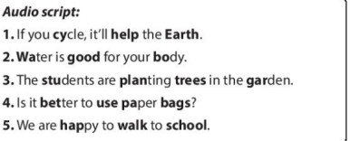

# ACTIVITY 4: APPLICATION ACTIVITIES (7’)

## Aim:

* To give ss further practice with rhythm in sentence

1. **Content:** Pay attention to the bold syllable s
2. **Expected Products:** Ss listen and read the syllables

## Organization of activities:

* Plays the recording or ss to listen to the conversation sentences.
* Has sts pay attention to the bold parts and the stress in the first syllable of the underlined words.
* Plays the recording of each sentence again for ss to repeat in chorus.
* Has sts work in pairs to practice reading the conversation
* Calls on some students to read the conversation in front of the class.
* Checks their pronunciation if necessary.

