*Date of preparation: 3/3/2025*

# UNIT 10: ENERGY SOURCES

***Total numbers of periods: 7 periods;from period 78,82to period 87***

# LESSON 7 : LOOKING BACK + PROJECT

***Period: 87 Class: 7A2***

## Objectives

* + 1. **Knowledge .**
* review the vocabulary and grammar of Unit 10
* apply what they have learnt (vocabulary and grammar) into practice through a project. By the end of this lesson, Ss will be able to:
  + review the vocabulary and grammar items in unit 10
  + have an overview about the topic “*energy sources* ”
  + know how to use types of energy souces effectively

## Competence:

-General competence:

+Self-controlled and self-learning competence (students know how to use types of energy sources)

+ Communicative and cooperative competence (students know how to persuade their friends to use energy effectively)

-Distinctive competence:

+Linguistic competence (students know how to use their native language and foreign language to do the tasks)

## Values:

+ Responsibility (students are aware of using types of energy sources )

+Diligence (students exercise regularly)

# TEACHING AIDS AND MATERIALS:

* + 1. **Materials:** Grade 7 textbook, lesson plan, workbook, the teacher’s book, reference books
    2. **Equipment:** TV, cassettes, pictures, cards, handouts, extra boards, sachmem.vn, …

# PROCEDURES:

* + 1. **WARM-UP (5MS)**

1. **Aims:** Teacher asks Ss to think of what they have learnt already in Unit 10.
2. **Content:** Ss work in pairs to do the task.
3. **Expected Products:** Teacher calls some students to retell.
4. **Organisation :** Teacher confirms and leads them to do all the exercises in books.

## KNOWLEGDE FORMATION ACTIVITIES ( 8ms)

**Task 1: Match the adjectives in A with the nouns in B to make phrases**

1. **Aims:** Teacher has Ss work individually.
2. **Content:** Ss do this activity individually, then compare their answers with their partners.
3. **Expected Products**: Teacher asks for Ss’ answers
4. **Organisation :** Teacher confirms the correct ones and asks students to make sentences using the phrases.

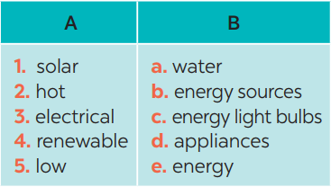

**Answer keys:**

*1. e 2. a*

*3. d 4. b 5. c*

## PRACTICE ACTIVITIES (20ms)

**Task 2: (5’)**

1. **Aims:** Teacher has Ss work individually.
2. **Content:** Ss do this activity then compare their answers with their partners.
3. **Expected Products:** Teacher asks for Ss’ answers.

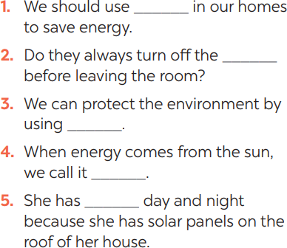

## Organisation :

* Show and ask students to read the words in the box and see if they remember their meanings
* Let students do the activity individually
* Ask them to compare their answers with their partners
* Call some students to read their answers aloud
* Confirm the correct answers.

## Task 3: (5’).

1. **Aims:** Teacher asks Ss to recall the structures of *“The present continuous”*, and tell them to do Ex 3 in the book.
2. **Content:** Ss do the exercise individually and swap with their partners.
3. **Expected Products:** Teacher calls some Ss to check their answer.

## Answer keys:

1. *is raining*
2. *start*
3. *is walking*
4. *does*
5. *am writing*

## Organisation :

* Remind students of the present coninuous first by writing example
  + Have students do the exercise individually, then exchange their answers with a classmate
  + Confirm the correct answers.
  1. Look! It (rain) heavily.
  2. Normally they (start) school at eight o’clock in the morning.
  3. He hasn’t got a bike at the moment, so he (walk) to school this week.
  4. He always (do) his homework in the evening.
  5. I’m afraid I have no time to help just now. I (write) an essay

## Task 4: (5’)

* + 1. **Aims:** Teacher asks Ss to do the task.
    2. **Content:** Ss work individually to do the task.
    3. **Expected Products:** Teacher calls Ss to give out their answers.

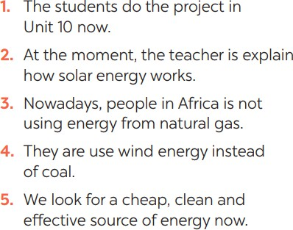

## Organisation :

* + - * Ask students to read each original sentence and find one mistake in each sentences
      * Have students do the exercise individually
      * Call some students to write their sentences on the board
      * Check their answers, and explains if needed

## Task 5: (5’)

1. **Aims:** To help Ss develop team work skills and pratice using what they have learnt to make a poster
2. **Content:** Teacher asks Ss to dicuss in groups of 4-6

## Expected Products:

**\* Key:**

1. Might 2. Might

3. Might not 4. Might not

5. Might, might

## Organisation :

* + Asks students to read some ways to save energy
  + Tells them to work in pair to decide which one is suitable for their school.

https://lh5.googleusercontent.com/Xu9OApiy0OVDLOF-eONhuYLY0H39nVRiaFlMYHpSNIpXffYi0eyczkulPDcnJPJ6zZTdNeOR1SqN_izAI3H1YW5nCTgUayedbSUzHBxTNXU6mmAzzkGchudf3pWfv50ocpg_l5y3Kr8_v-ksnbHeCg 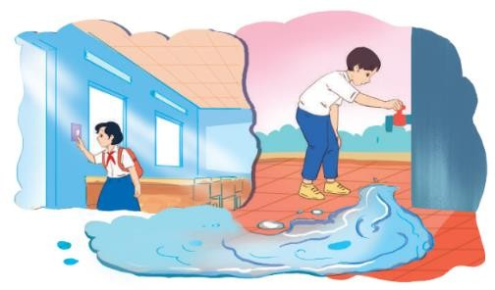

# 4. APPLICATION ACTIVITIES ( 12’)

## Task 6: : Poster presentation: How to save energy in your school

1. Aim: Teacher asks Ss to work in groups of 4 – 6 to stick their posters onto the classroom’s wall and present about them.
2. **Content:** Ss work in group to do the task.
3. **Expected Products:** Teacher calls some groups to present their poster to the class.

## Organisation :

* + Show the two pictures and asks sts which is “should” and which is “shouldn’t
  + Let students work in groups and discuss some tips to save energy in thei school.
  + Choose one, the work out some tips to reduce or get rid of it
  + Find or draw a picture to illustrate the bad habit and write the tip on a large piece of paper.
  + Call some to present it to the class

(- If time is limited. Teacher can assign the project in earlier lessons. Make sure teacher guides them carefully and checks their progress after each lesson.