***Date of preparation:*** 3/3/2025

# UNIT 10: ENERGY SOURCES

***Total numbers of periods: 7 periods; from period 78,82 to period 87***

# LESSON 6: SKILLS 2

***Period: 86 Class: 7A2***

# OBJECTIVES

## Knowledge:

* + - * Listening: listen for main ideas and specific information about how to save energy at home
      * Writing: write a paragraph of about 70 words about how you save energy at home

## Competence:

* + - * General competence:

+ Self-controlled and self-learning competence (students know how to study better)

+ Communicative and cooperative competence (students dicuss about how to save energy at home and join in class activities)

* + - * Distinctive competence:

+Linguistic competence (sts know information about how to save energy at home)

## Values

* + - * Responsibility (sts are aware of importance of saving energy at home)
      * Diligence (sts know effective ways of saving energy at home)

# TEACHING AIDS AND MATERIALS:

* + 1. **Materials:** Grade 7 textbook, lesson plan, workbook, the teacher’s book, reference books
    2. **Equipment:** TV, cassettes, pictures, cards, handouts, extraboards, sachmem.vn, …

# PROCEDURES :

* + 1. **WARM-UP (5MS)**

1. **Aims:** -To create an active atmosphere in the class before the lesson

- To lead into the new lesson

## Content: PASS THE CHALK

1. **Expected products:** writes the phrase relating to “HOW TO SAVE ENERGY”

## Organization of activities:

+ writes the phrase “HOW TO SAVE ENERGY” on the board and divides the class into 2 groups.

+ Lets Ss take turns to go to the board.

+ Calls some students to give their answers.

+ Listens and gives comments.

Teacher introduces students to the content of the lesson: *“In the lesson today, we are going to listen to a person talking about how to save energy at home.*”.

# KNOWLEDGE FORMATION ACTIVITIES (5MS)

1. **Aims:** To review students with some lexical items relating to the lesson
2. **Content:** New words about how to save energy.
3. **Expected products:** students retell the ways of saving energy.

## Organization of activities:

- Asks sts to retell the ways of saving energy the ways of saving energy

+ turn off the lights

+ use low energy light bulbs

+ use solar panels

………………….

- Listens and give more some ways.

# PRACTICE ACTIVITIES (28MS)

**Task 1**: **(7’)**

1. **Aims:** To help Ss brainstorm the topic and prepare for the listening text
2. **Content:** work in pairs to answer the questions.
3. **Expected products:** Students give the correct answers for the questions.

***Suggested answers:***

1. solar energy, …
2. turn off the tap while brushing your teeth, use a paper fan, …

## Organization of activities:

* Asks Ss to work in pairs to answer the questions.
* Lets Ss work with their partner to do the task.
* Calls on some Ss to answer.
* Gives comments and leads Ss to the next task.

**Task 2: (7’)**

1. **Aims:** To help Ss develop their skill of listening for specific information
2. **Content:**. Listen and circle the phrases you hear
3. **Expected products:** SS understand the phrases by giving explanations or the Vietnamese equivalents.

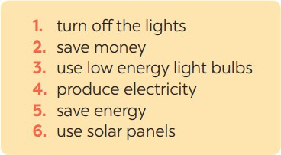

## Organization of activities:

* Asks Ss to read and underline the key words.
* Lets Ss work independently to guess then listen to the recording once to check their guess.
* Calls on some students to give the answers the have listened.

**Task 3:(7’)**

1. **Aims:** To help students develop their skill of listening for details
2. **Content:**. Listen to the recording and tick T or F.
3. **Expected products :** Sts develop their listening skill for details and do the task well

***Answer key:***

1. T

2. F

3. T

4. T

5. F

## Organization of activities:

* Asks Ss to read and underline the key words.
* Lets Ss work independently to listen to the recording and tick T or F.
* Calls on some students to give the answers.
* Corrects and confirms the answers.

**Task 4:(7’)**

## Aims:

To help Ss prepare ideas to write a passage

1. **Content:**. Work in pairs. Read some ways to save energy at home. Choose three ways and write them in your notebook.
2. **Expected products**: Ss know some ways to save energy at home

## Organization of activities:

* Asks Ss to write the methods they use to save energy at home then asks them to give out more if they can.
* Has Ss think of it and may discuss it with their partners.
* Calls on some Ss to raise their ideas.
* Listens and confirms.

|  |
| --- |
| **4. APPLICATION ACTIVITIES ( 7’)** |
| **Task 5:(7’)**   1. **Aims:** To help Ss practise writing a passage about70 words about how you save energy at home 2. **Content:**. Write a paragraph of about 70 words about how you save energy at home. 3. **Expected products:** Sts can write a passage about70 words about how you save energy at home 4. **Organization of activities:**    * Tells Ss that they are going to write a passage about how you save energy at home.    * Reminds Ss of the structure of a passage and steps to make an outline for the passage. |

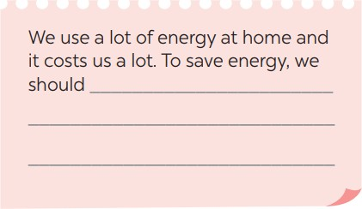

-Lets Ss work independently to do the task and try to use the notes from the previous tasks.

-Goes around and help if necessary.