*Date of preparation: 3/3/2025*

# UNIT 10: ENERGY SOURCES

***Total numbers of periods: 7 periods; from period 78,82 to period 87***

# LESSON 4 : COMMUNICATION

***Period: 84 Class: 7A2***

# OBJECTIVES

## Knowledge:

* + - * Everyday English: Asking for explanations
      * Speaking skill: how well your partner saves energy.

## Competence:

* + - * General competence:

+ Self-controlled and self-learning competence (students know how to study better)

+ Communicative and cooperative competence (students know how to ask for explanations and join in class activities)

* + - * Distinctive competence:

+Linguistic competence (sts know how to use foreign language to ask for explanations)

## Values

* + - * Responsibility (sts are aware of keeping their neighbourhood green)
      * Diligence (sts join different community activitives to make our life better)

# TEACHING AIDS AND MATERIALS:

1. **Materials:** Grade 7 textbook, lesson plan, workbook, the teacher’s book, reference books
2. **Equipment:** TV, cassettes, pictures, cards, handouts, extraboards, sachmem.vn, …

# PROCEDURES :

* + 1. **WARM-UP (5MS)**

1. **Aims:** -To create an active atmosphere in the class before the lesson

- To lead into the new lesson

## Content: BRAINSTORMING



**TYPES OF ENERGY**

- Ask sts to name types of energy they know.

1. **Expected Products:** Students know more types of energy

## Organization of activities:

+ Teacher divides class into 2 teams and asks them to think of “TYPES OF ENERGY”

+ Ss have 1 min to think of the words related to the topic or they can discuss with their partners.

+ Each member from each team turn by turn run to the board and write one word.

+ Teacher corrects their answers.

- The team which has more correct words will be the winner

**Suggested answers:**

*Solar, hydro, coal, natural gas, oil, wind,…*

# KNOWLEDGE FORMATION ACTIVITIES (5MS)

1. **Aims:** -To draw sts’ attention to the context

-To supply sts with the main knowledge of new words about types of energy

1. **Content:** New words about types of energy
2. **Expected products:** students know the structure to ask and answer for explanation.

## Organization of activities:

**-**Pre-teaches some new words using suitable techniques

√. *Puplic transport* (n) (picture +explanation)

√. *Light bulb* (n) (picture +explanation)

√. *Warm water* (n)( explanation)

-Gets sts to repeat the words chorally, then individually

-Nominates individuals to read the words aloud and asks sts to copy down the words

-Checks the understanding of the new words by the game “rub out and remember”

# PRACTICE ACTIVITIES (28MS)

**Task 1**: **(7’)**

## Aims:

- To help Ss know the structure to ask and answer for explanation.

1. **Content:** Listen and read the conversation and pay attention to the highlighted questions.
2. **Expected products:** Students listen and practice saying with their partners.

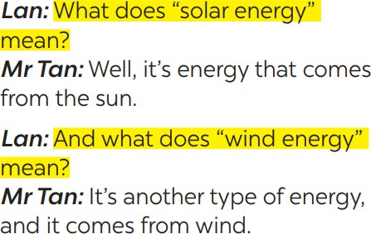

## Organization of activities:

+Plays the record for SS to listen and read the conversation.

+ Asks Ss listen and practice saying with their partners.

+ Calls some pairs to read aloud.

+ Corrects pronunciation if needed.

+ Asks Ss to pay attention to the highlighted parts and asks them some questions to elicit the new structure:

* *Which tense do we use to ask and answer?*
* *Which question word and verb do we use?*

*- …..*

*+ Aks* Ss answer teacher’s questions to find out new structure to ask and answer for explanations.

+ Corrects and writes on the board:

## Structure: to ask:

* + What do/does + S + mean?

## to answer:

* + S + mean(s)/be …

**Task 2: (7’)**

1. **Aims:** To help students practise on how to ask and answer for explanations.
2. **Content:**. Work in pairs. Make similar conversations to ask for explanations.
3. **Expected products:** SS look at the phrases in Ex 2 to make similar dialogue.

***Suggested answers:***

*A: What does hydro energy mean?*

*B: It’s energy that comes from the sun. What does nuclear energy mean? A: It’s energy that comes from the nuclear power.*

## Organization of activities:

* Teacher has SS look at the phrases in Ex 2 to make similar dialogue.

** Ss work in pairs to make similar dialogue.

*** Teacher calls some pairs to present it in front of the class.

**** Teacher gives feedback and some comments.

**Task 3:(7’)**

## Aims:

To provide students with more awareness of ways to save energy and help them practice the skill of speaking.

1. **Content:**. Work in pairs. Ask your partner the following questions and tick his or her answers in the boxes.
2. **Expected products :** Sts know the ways of saving energy

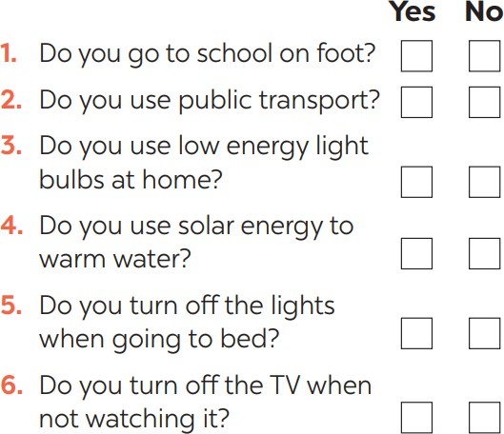

## * d. Organization of activities:

- Asks sts to work in pairs and then ask your partner the following questions and tick his or her answers in the boxes.

**Task 4:(7’)**

1. **Aims:** To help Ss practice the skill of speaking
2. **Content:**. Work in groups. Tell the group how well your partner saves energy.
3. **Expected products**: The sts practice speaking about saving energy better.

## Organization of activities:

* Gives students time to prepare. Meanwhile, teacher walks around the classroom to help students if they have difficulties finding proper words/ phrases/ structures.
* Lets Ss do the task in groups.
* Calls some Ss to read aloud their work.
* Lets Ss listen and correct mistakes (if needed).

|  |
| --- |
| **4. APPLICATION ACTIVITIES ( 7MS)** |
| **Task 5:(7’)**   1. **Aims:** To help students practicing speaking about saving energy 2. **Content:**. Answer the questions in 3 on your owner. Then tell the class how well you save energy. 3. **Expected products:** Sts can practicing speaking how well they save energy. 4. **Organization of activities:**    * Allows students time to answer the questions onto their notebooks and prepare.    * Lets Ss work individually.    * Lets Ss share to their partners    * Calls some students to read aloud their work.    * Lets Ss listen and correct mistakes (if needed). |