*Date of preparation:* 3/3/2025

# UNIT 10: ENERGY SOURCES

***Total numbers of periods: 7 periods; from period 78,82,to period 87***

# LESSON 1: GETTING STARTED

***Period: 78 Class: 7A2***

# OBJECTIVES:

## Knowledge

* + - Vocabulary: Words related to the topic *Energy sources.*
    - Grammar : The present continuous

By the end of the lesson, students will be able to:

* + - have some information about energy sources
    - talk about the different types of energy sources

## Competences:

+ General competence:

* Self- controlled and self-learning competence: know how to talk about the different types of energy sources .
* Communicative and cooperative: know how to to ask and answer the questions about renewable and non-renewable resources.

+ Distinctive competence:

- Linguistic competence (making questions and answer about renewable and non-renewable resources.)

## Values:

* Responsibility (sts are aware of saving energy)
* Diligence (Knowing more information about energy sources: renewable and non-renewable and being aware of the ways to save energy for the future.)

# TEACHING AIDS AND MATERIALS:

* 1. **Materials:** Grade 7 textbook, lesson plan, workbook, the teacher’s book, reference books
  2. **Equipment:** Active board, laptop connected with the Internet, TV, cassettes, pictures, cards, handouts, extraboards, sachmem.vn.

# PROCEDURES:

* 1. **WARM UP** (5ms)

## Aims:

* + To create an active atmosphere in the class before the lesson
  + To activate students’ knowledge on the topic of the unit.
  + To set the context for the listen and read.

1. **Content:** The sts play game “Network”

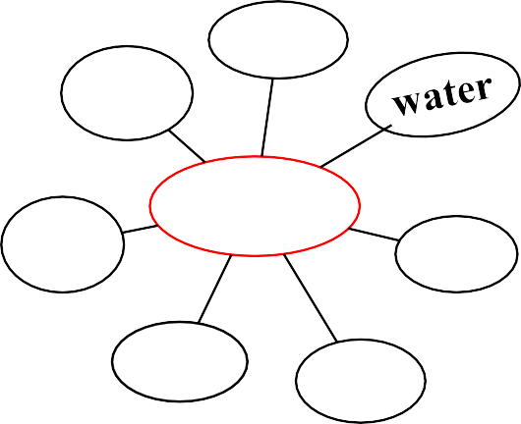

**wind**

**Sources of energy**

**coal**

1. **Expected products:** Ss can get the context of the lesson by playing the game.

## Organization of activities:

* T has Ss work in groups to give sources of energy (in 1 minute).
* Each group chooses a representative writing on the board in 2 minutes. The one which has more is the winner.
* Shows the picture and asks sts to answer some questions:

*+ Who can guess: What is this?*

*+ Does it have some impact on our environment?*

* Informs the class of the lesson objectives and leads to the lesson.
  1. **KNOWLEDGE FORMATION ACTIVITIES (10ms)**

**Task 1:**

1. **Aims:**

* To draw students’ attention to the context.
* To supply students with the main knowledge of new words about sources of energy.

1. **Content:** New words about sources of energy that are mentioned in the text.

## → Vocabulary

1. energy source (n.phr) /ˈenədʒi sɔːs/: nguồn năng lượng
2. coal (n) /kəʊl/: than
3. renewable (a) /rɪˈnjuːəbl/: có thể tái tạo
4. run out (phr v) /rʌn aʊt/: cạn kiệt
5. replace (v) / rɪˈpleɪs/: thay thế

## Expected products:

* Students understand and pronounce the new words correctly.

## Organization of activities:

* Teaches word by word according to steps and principles of teaching new words. (using picture, real objects, examples, …)
* Checks the students’ understanding by the game: “What and Where”
* Gives remarks and feedback.
* Has Ss listen and read the conversation silently.
* Then asks Ss if their predictions were correct.

## PRACTICE ACTIVITIES (23ms)

**Task 2:** (10ms)

1. **Aims:** to help students listen and read correctly the dialogue about sources of energy.
2. **Content:** Students will read the dialogue and get what it is about.

## Expected products:

* Students read and understand the meaning of the dialogue between Lan and Mr. Tan.
* Students know how to answer the question.

*What are Lan and her father talking about?* → **C**

## Organization of activities:

* Plays the recording three times and asks students to listen to the recording.
* Asks three students to play roles of Lan and Mr. Tan to read the dialogue aloud in front of the class.
* Calls some groups to read aloud to correct their spelling and intonation.
* Gives feedback to the students.

**Task 3:** (10ms)

## Aims:

* To practise reading and listening for specific information
* To practise scanning
* To develop Ss' knowledge of vocabulary

1. **Content:** Students will read the conversation again and answer the questions.

## Expected products:

* Suggested answers:
  1. *Lan is doing a project on energy sources.*
  2. *It’s power that we use to provide us with light, heat or electricity.*
  3. *It comes from many different sources like coal, oil, natural gas, … and renewable sources*
  4. *Renewable sources are those we can easily replace them such as: water, sun,…*

## Organization of activities:

* Tells students to read the conversation again and work independently to answer.
* Has students work in pair to compare their answers before checking with the whole class.
* Calls some students to give the answers.
* Calls other students to support for the answers.
* Gives feedback.

**Task 2:** (3ms)

1. **Aims:** - To help Ss gain more knowledge about the topic
2. **Content:** Students will look at the pictures and do the matching.

## Expected products:

* Suggested answers: 1. c 2. a 3. b 4. d

## Organization of activities:

* Tells students to read the words and look at these pictures.
* T has the sts match the words / phrases in the box with the correct pictures.

-Teacher nominates Ss to read the words aloud and

-Teacher checks and gives the correct answers.

* Gives feedback.

# APPLICATION ACTIVITIES (7’)

**Task 5** (7ms)

1. **Aims:** - To help Ss practice using what they have learnt in sentences.
2. **Content:** Complete each of the sentences with the correct word from the conversation.

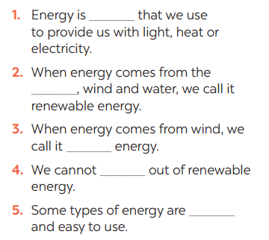

1. **Expected products** : students can understand the converstation well

## Organization of activities

* Teacher asks Ss to work individually to find the words/phrases from the conversation and then share their answers with their partners who sit next to them. (peer check)
* Sts do exercise 5 individually
* Teacher corrects their answers as a class. Answer keys
  1. *power*
  2. *sun*
  3. *wind*
  4. *run*
  5. *cheap*