*Date of preparing: 04/12/2024*

**UNIT 6: OUR TET HOLIDAY**

**LESSON 1: GETTING STARTED**

***Period: 42 Classes: 6A5***

**I. OBJECTIVES:**

**1. Knowledge:**

* Vocabulary: - words/ phrases related to Tet

* Grammar: - revise the present simple tense .

By the end of the lesson, students will be able to:

* have an overview about the topic *Our Tet holiday*

- use the vocabulary to talk about Tet holiday.

**2. Competences:** -

-General competence:

+Self-controlled and self-learning competence (students know how to behave well at Tet)

+Communicative and cooperative competence ( students know how to express their feelings through visiting, or giving gifts ... on Tet holiday.)

-Distinctive competence:

+Linguistic competence (sts know how to use their native language and foreign language to indicate the evidence for their answers)

3.**Values :**

+ Responsibility (students are aware of making their houses clean and beautiful on Tet holiday)

+ Diligence: (visit and give gifts for relatives, friends …on Tet holiday)

**II. TEACHING AIDS AND MATERIALS:**

**1. Materials:** Grade 6 textbook, lesson plan, workbook, the teacher’s book, reference books

**2. Equipment:** TV, cassettes, pictures, cards, handouts, extraboards, sachmem.vn.

**III. PROCEDURES :**

**1. Warm-up (5ms)**

a. **Aims:** -To create an active atmosphere in the class before the lesson

-To lead into the new unit

**b**.**Content:**  Game ‘Network’ about the words / phrases related to Tet holiday

**c. Expected products: -** Students write the words / phrases related to Tet holiday

**d.Organization of activities**

+ Divides class into 2 teams.

+ Asks students to list some words / phrases relating to Tet holiday.

+ Which team has more correct words is winner.

-Leads to Unit 6 and writes the unit title “Our Tet holiday” on the board

-Asks students to have a guess about what they are going to learn about unit 6

**2.Knowledge formation activities (6ms)**

**a.Aims:** - To draw students’ attention to the context.

-To supply students with the main knowledge of new words about Tet holiday .

**b**. **Content:** New words about Tet holiday that are mentioned in the text

**c. Expected products:** Students know and pronounce the words correctly

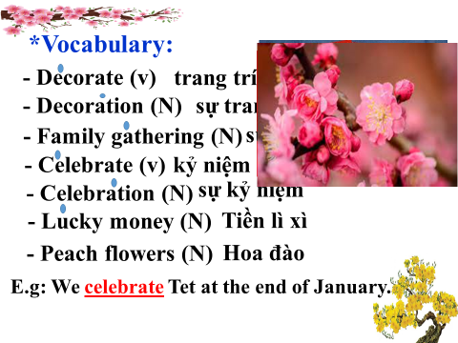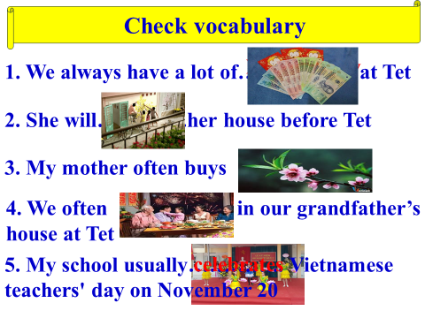

**d. Organization of activities**

**-**Pre-teaches some new words using suitable techniques (slide 3)



-Gets sts to repeat the words chorally, then individually

-Nominates individuals to read the words aloud and asks sts to copy down the words

-Checks the understanding of the new words by conducting the game : (slide 4)

**3.Practice activities ( 27ms)**

**Task 1**: **(10’)**

**a. Aims:**To set the context for the introductory text

- To introduce the topic of the unit

**b**. **Content:** Listen and read

**c.Expected products:** Students read and understand the meaning of the text.

Sts get an overview about Tet holiday from the text.

**d. Organization of activities**

- Sets the context for the listening and reading: asks students to look at the title of the conversation and the picture.

- Asks them some questions like:

What do you think they are talking about?

When is Tet?

Is it a holiday?

What do we do at Tet?

- Encourages students to give their answers, but do not confirm whether their answers are right or wrong.

- Plays the recording twice for students to listen and read along.

- Has students underline the words that are related to the topic of the unit while they are listening and reading.

- Invites some pairs to read the conversation loud.

- Has students say the words in the text that they think are related to the topic Tet.

**Task 2:(5’)**

**a.Aims:**-To get sts get the main idea of the text

**b**.**Content:** What are Linda and Phong talking about?

**c.Expected products:**-Sts can know what Linda and Phong talked about in the conversation.

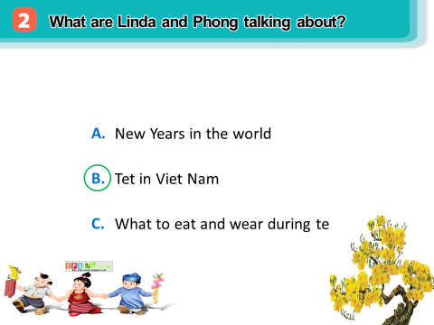

**d.Organization of activities** **(slide 7)**

- Asks students what exactly Linda and Phong talked about.

+ They talked about Tet in Viet Nam.

* Tells students to read three options carefully and see the difference among them.

- Calls some students to confirm the correct answer

**Task 3:(7’)**

**a. Aims:**To help students scan the text for the information to fill the blanks.

**b**. **Content:** Complete the sentences about Tet with the information from the conversation in 1.

**c.Expected products:**Sts know to choose the information in the text to fill the blanks.

*\*Suggested answers;*

1 - January 2 – homes 3 - gatherings

4- lucky money 5 - break

**d.Organization of activities**

* Instructs students how to do the exercise.
* Asks students to work individually and fill in each blank with the words from the conversation.
* Allows students to share answers before discussing as a class.
* Writes the correct answers on the board.

**Task 4:(5’)**

**a. Aims:**To develop sts’ knowledge of the vocabulary relating to Tet.

**b.Content:** Match the words/ phrases in the box with the pictures.

**c.Expected products**: The words about Tet.

*\*Suggested answers;*

1. b 2. a 3. c 4.d

**d.Organization of activities**

- Asks students to look at the pictures first to see if they know the English words for them.

- Lets students read the words/ phrases in the box and do the matching .

- Checks the answers as a class.

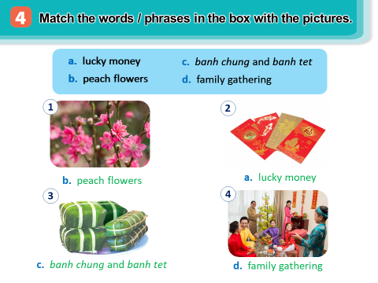

|  |
| --- |
| **4. Application activities ( 7’)** |
| **Task 5:(7’)**  **a.Aims:** To help sts practice talking about things or activities related Tet.  To develop sts’ self-controlled and self-learning competence, communicative and cooperative competence  To train sts as responsible and kind people  **b. Content:** Game Is it about Tet.  **c. Expected products:** Sts know things or activities related to Tet.  Sts gain self-controlled and self-learning competence, communicative and cooperative competence, responsibility and kindness.  **d.Organization of activities**   * Demonstrates the game by saying a word/ phrase and asks students if it’s related to Tet or not. * Asks students to write down two things/ activities. * Calls on some students to stand up and read their words . The class listens and says if it’s related to Tet or not |

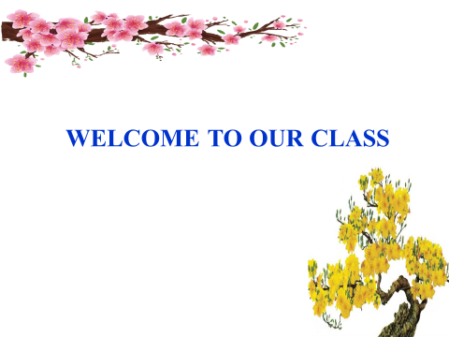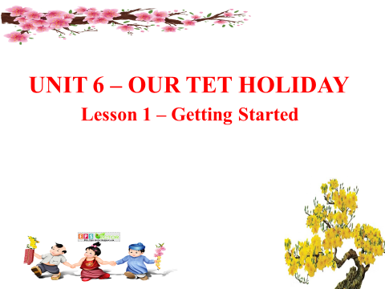

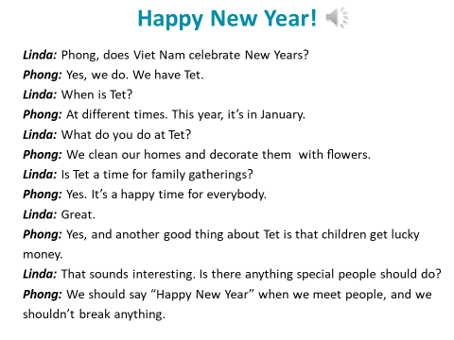

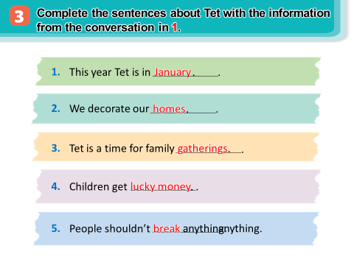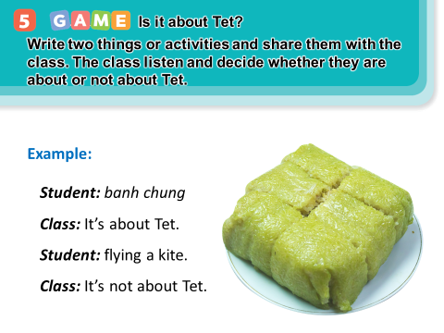

**

*Date of preparing: 04 /12/ 2024*

**UNIT 6: LIFESTYLES**

**LESSON 1: GETTING STARTED**

***Period: 42 Class: 8A7***

**I. OBJECTIVES:**

**1. Knowledge:**

* Vocabulary: *greet (v), greeting (n), serve (v), common practice (n), in the habit of*

* Grammar: - revise the present simple tense .

*By the end of the lesson, students will be able to:*

* have an overview about the topic lifestyles.

- use the vocabulary to talk about lifestyles.

**2. Competences:**

- General competence:

+ Self-controlled and self-learning competence (students know how to maintain traditional lifestyle).

+ Communicative and cooperative competence( students know how to express their feelings of lifestyle differences)

-Distinctive competence:

+Linguistic competence (sts know how to use their native language and foreign language to talk about lifestyles)

3.**Values :**

+ Responsibility (love and respect the lifestyles of Viet Nam and other countries around the world)

+ Diligence (students are aware of having a healthy lifestyle)

**II. TEACHING AIDS AND MATERIALS:**

**1. Materials:** Grade 8 textbook, workbook, lesson plan, the T’s book, reference books, hoclieu.vn

**2. Equipment:** TV, cassettes, pictures, cards, handouts, extraboards.

**III. PROCEDURES :**

**1. WARM-UP (5ms)**

a.**Aims:** -To create an active atmosphere in the class before the lesson

-To lead into the new unit

**b**.**Content:**  **- *Questions & answers***

**-** Video watching

**c.Expected products:** - Students know the topic of the unit and be ready for the conversation.

*- What is the video about?*

*→ About ways of greetings around the world.*

*- In Viet Nam, how do two men greet each other when they meet?*

*→ They shake hands or say hello.*

*- Do people in Thailand shake hands when meeting?*

*→ No. They greet each other with a “Wai” and say “Sawadee”.*

**d.Organization of activities**

- T asks Ss some questions.

- Ss answer the question individually.

- T shows students a video of different ways of greetings and asks students to guess what the video is about.

*- What is the video about?*

*→ About ways of greetings around the world.*

*- In Viet Nam, how do two men greet each other when they meet?*

*→ They shake hands or say hello.*

*- Do people in Thailand shake hands when meeting?*

*→ No. They greet each other with a “Wai” and say “Sawadee”.*

- T sets the context for the listening and reading text:

Write the title on the board *Lifestyles – Lifestyle Differences*

**2.KNOWLEDGE FORMATION ACTIVITIES (10 ms)**

**a. Aims:**

- To prepare vocabulary for students to understand the conversation.

**b. Content:** Introduce the vocabulary.

**c. Expected products:**

- Students know how to use the target vocabulary.

*1. greet (v)*

*2. greeting (n)*

*3. serve (v)*

*4. common practice (n)*

*5. in the habit of*

**d. Organization of activities:**

- T explains the meaning of the new vocabulary by pictures.

- T reveals that the words according to the pictures will appear in the reading text and asks students to open their textbook to find these words

- T introduces the vocabulary.

*1. greet (v)*

*2. greeting (n)*

*3. serve (v)*

*4. common practice (n)*

*5. in the habit of*

- T checks students’ pronunciation and gives feedback.

- Checks the understanding of the new words by conducting the game “SLAP THE BOARD”

**3. PRACTICE ACTIVITIES ( 22ms)**

**Task 1**+ 2 **(10’)**

**a.Aims:** - To help Ss understand some details of the conversation.

- To help students develop the vocabulary related to the topic.

**b**. **Content: *Listen and read. Complete the table.***

**c. Expected products:**

1. surnames

2. on the street

3. store / restaurant

**d.Organization of activities:**

- Asks Ss to look at the title of the conversation and the pictures and guess what the conversation between Nam and Tom might be about.

*- What do you think Nam and Tom are talking about?*

*→ They are talking about lifestyles and lifestyle differences.*

*-* Plays the recording once or twice for Ss to listen and read along silently or aloud.

- Has some pairs of Ss read the conversation aloud.

- Confirms the correct answer for the question at the beginning of the activity.

- T asks Ss to read the dialogue in detail to answer the questions.

- Asks them how to do this kind of exercise.

Explains the strategies, if necessary (e.g. reading the statements in the table, underlining the key words in the statements, locating the key words in the text, and then completing the table).

- Tells them to underline parts of the dialogue that help them with the answers. Sets a strict time limit to ensure Ss quickly read the text for information.

- Tells them to compare their answers in pairs before sharing them with the class. Asks them to give evidence to support their answers.

**Task 3:(6’)**

**a. Aims:**

- To introduce some vocabulary items related to lifestyles.

**b. Content:  *Complete each sentence with a word or phrase from the box.***

**c. Expected products:**

**\*Suggested answers:**

***Answer key:***

*1. lifestyle 2. greet 3. serve 4. practice 5. in the habit of*

**d. Organization of activities:**

- T tells Ss to read the conversation again and ask them to share their answers with one or more partners. T can ask for translation of some of the words and phrase in the box to check their understanding.

- T asks 2 students to write their answers on the board.

- Checks the answers as a class.

**Task 4:(6’)**

**a.Aims:**To develop sts’ knowledge of the vocabulary relating lifestyles

**b.Content:** ***Label each picture with a word or phrase from the box.***

**c.Expected products**:

*1. Street food 2. Food in restaurants 3. pizza 4.online learning 5. greeting*

**d.Organization of activities:**

- T has Ss work individually to label the pictures with the words and phrases in the box. Has them compare their answers with a partner. Then asks for Ss’ answers. Quickly writes their answers on the board without confirming the correct answers.

- T has Ss listen to the recording, check their answers, and repeat the words / phrases. Ask Ss to look at the answers on the board and say if they are right or wrong. Confirms the correct answers.

- T checks the answers as a class and gives feedback.

|  |
| --- |
| **4. APPLICATION ACTIVITIES ( 8ms)** |
| **Task 5**  **a. Aims:** - To introduce ways of greeting around the world.  **b. Content:**  ***QUIZZ: Greetings around the world***.  **c. Expected products: -** Students know about greetings around the world.  Ss gain self-learning competence, communicative and cooperative competence, and kindness.  **d.Organization of activities**  - Models this activity with a strong student.  - Asks Ss to work in pairs. ﻿Set a time limit (2 - 3 minutes) for Ss to finish the task. T goes around to help weaker Ss.  - Calls on some Ss to share the answers.  - Confirms the correct. |

|  |
| --- |
| **HANDOUT** |