Date of preparation : September 18th, 2023

Unit 2: LIFE IN THE COUNTRYSIDE

Total numbers of periods: 7 periods; from period 9 to period 15

LESSON 1: GETTING STARTED

Period 09 Class 8A2

I. OBJECTIVES:
1. Knowledge: By the end of the lesson, students will be able to:
- Vocabulary: + Master and know how to use vocabulary relating to life in the countryside.
+ Identify and talk about life in the countryside.
- Grammar: Know how to use comparative forms of adverbs.
2. Competences:
- General competences: students will form and develop competences: self-control and self-learning (use their knowledge to complete the tasks well), communication and collaboration (work in pairs effectively), problem solving and creativity (love talking about activities in the countryside )
- Distinctive competences: linguistic competence (use lexical items to practise asking and answering about some activities in the countryside), natural and social inquiry competence.
3. Values:
Students will form and develop some values: benevolence (help each other in pairwork), hard work (be enthusiastic in learning and discussing), honesty (share their own ideas in discussing) and responsibility (love activities in the countryside) .

II. TEACHING AIDS AND MATERIALS:
1. Materials: Grade 8 textbook, lesson plan, workbook, the teacher’s book, reference books
2. Equipment: TV, cassettes, pictures, cards, handouts, extraboards, hoclieu.vn, On-line websites.

III. TEACHING PROCEDURES
1. WARM UP (5ms)
Game: Asking questions:
a. Aims: To activate students’ knowledge on the topic of the unit.
b. Content: Answer the questions
Questions:
1. What did you do last summer?
2. What is the video about?
c. Expected Products:
1. I visited my ralatives in the countryside and played traditional games.
2. Life in the countryside
d. Organization of activities
- Asks Ss “What did you do last summer?”.
- Ss answer the question individually.
- Shows students a video of summer in the countryside and asks students to guess what the video is about.
- Sets the context for the listening and reading text: Write the title on the board Life in the countryside – Lesson 1 Getting started :Last summer holiday.

2. KNOWLEGDE FORMATION ACTIVITIES (7ms )
a. Aims: - To provide students with vocabulary and structures relating to the topic: life in the countryside.
b. Content: Students will learn some new words
- Students will listen to the teacher, guess the meaning of the new words then repeat words by word in individual, groups and choral.
- Students will play a game to remember the words they learned.
c. Expected Products: Read and understand the meaning of words.
1. harvest (v) /ˈhɑːvɪst/: thu hoạch
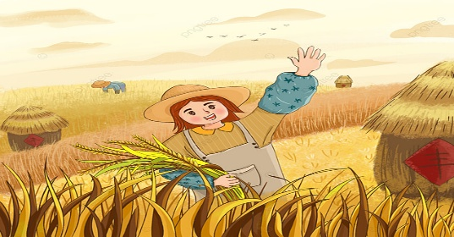
2. combine harvester (n) /kəmˈbaɪn ˈhɑːvɪstər /: máy gặt

3. herd (v) /hɜːd/ to make animals move together as a group: chăn thả (gia súc)
4. paddy field (n) /ˈpædi ˌfiːld/ a field planted with rice growing in water : cánh đồng lúa

d. Organization of activities
- Teacher introduces and teaches the vocabulary by using some techniques:
+ harvest (v) (picture ),combine harvester (n) (picture), herd (v) (explanation),paddy fields (n)( picture + explanation)
- Students listen, guess the meaning of words.
- Teacher guides students how to read chorally.
- Teacher calls some students to read in groups and individual.
- Teacher checks students’ pronunciation and gives feedback.
- Teacher checks students’ understanding with the “Slap the board” technique.
+ The teacher writes new words or sticks pictures on the board.
+ Call two groups to the board, each group of four to five students.
+ Ask groups to stand an equal distance from the board.
+ The teacher shouts out the Vietnamese word if the word on the board is English and vice versa (if using pictures, shout out the English word).
+ One by one, students in two groups run up to the board, tapping the word they are called.
+ The student in the group that gets it right and faster will score points.
+ The group that scores more points wins.

3: PRACTICE ACTIVITIES (28ms)
* Set the situation: Teacher draws students’ attention to the pictures in the textbook and asks them some questions about the pictures.
3.1. Task 1: (6ms) Listen and read
a. Aims: To help students listen and read correctly the dialogue about a conversation among two students: Mai and Nick.
b. Content: Students will listen and read the dialogue correctly.
c. Expected Products:
- Students read and understand the meaning of the text.
- Students know how to role play.
d. Organization of activities:
- Plays the recording three times and asks students to listen to the recording.
- Asks three students to play roles of Mai and Nick to read the dialogue aloud in front of the class.
- Asks the whole class to work in groups of two to read the dialogue.
- Calls some groups to read aloud to correct their spelling and intonation.
- Gives feedback to the students.
3.2. Task 2: (7ms) Read the conversation and choose the correct answer to each question.
a. Aims: to enable students to understand the main idea of the conversation.
b. Content: Read the conversation and choose the correct answer to each question.
1. How does Mai feel about her summer holiday?
A. She likes it. B. She doesn't like it. C. She thinks it was fine.
2. Where did she stay during her summer holiday?
A. At her friend's house. B. At her uncle's house. C. At her grandparents' house.
3. During harvest time, people harvest rice by.
A. themselves B. using a truck C. using a combine harvester
4. Mai thinks people in the countryside lead
A. a healthy life B. an exciting life C. an interesting life
c. Expected Products:
* Suggested answer: 1. A 2. B 3. C 4. C 5. A
d. Organization of activities:
- Asks Ss to read the dialogue in detail to answer the questions.
- Asks them how to do this kind of exercise. Explain the strategies, if necessary (e.g. reading the questions and the options (A, B, C), underlining the key words in the questions and options, locating the key words in the text, and then reading that part and answering the questions).
- Tells them to underline parts of the dialogue that help them to answer. Set a strict time limit to ensure Ss read the text quickly for information.
- Tells them to compare their answers in pairs before sharing them with the class. Asks them to give evidence to support their answers.
- Gives feedback.
3.3. Task 3: (6ms) Complete the sentences with the words and phrases from the box.
a. Aims: To help ss use words and phrases related to farm work in the countryside.
b. Content: Complete the sentences with the words and phrases from the box.
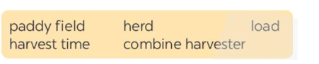
1. It took them an hour to …………… all the goods onto the truck.
2. Nowadays, people in my village use a …………….. to harvest their rice and separate the grains from the rest of the plant.
3. Today it is my turn to ………………… the cows.
4. A place in which people grow rice is called a ……………
5. A busy time when people cut and gather their crops is called …………………..
c. Expected Products: * Suggested answer:
1. load 2. combine harvester 3. herd 4. paddy field 5. harvest time
d. Organization of activities:
- Tells Ss to read the conversation again, work independently to do the task, and then ask them to share their answers with one or more partners. T can ask for translation of some of the words and phrases in the box to check their understanding.
- Asks 2 students to write their answers on the board.
- Checks the answers as a class.
3.4. Task 4: (6ms) Match the activities (1 - 6) that people living in the countryside often do with the pictures (a - f).
a. Aims: To introduce some vocabulary items related to activities that rural people often do.
b. Content: Match the activities (1 - 6) that people living in the countryside often do with the pictures (a - f).
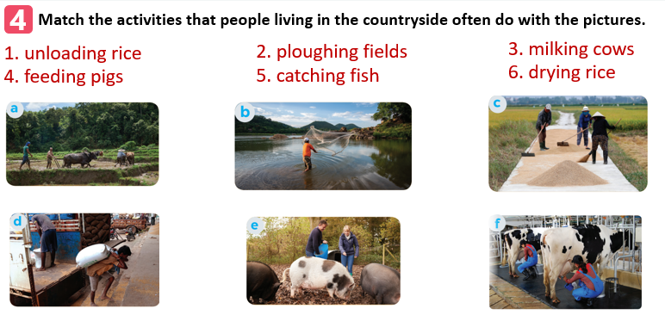
c. Expected Products:
* Suggested answer: 1. d 2. a 3. f 4. e 5. b 6. c
d. Organization of activities:
- Has Ss work individually to match the words and phrases in the box with the pictures. Have them compare their answers with their partners. Then ask for Ss’ answers. Quickly write their answers on the board without confirming the correct answers.
- Has Ss listen to the recording, check their answers, and repeat the words / phrases. Asks Ss to look at the answers on the board and say if they are right or wrong. Confirms the correct answers.
- Checks the answers as a class and gives feedback.

4. APPLICATION ACTIVITIES (5ms)
Task 5: Work in pairs. Ask and answer about the pictures in 4.
a. Aims: to provide students with practice in asking and answering about activities that rural people often do.
b. Content:. Work in pairs. Ask and answer about the pictures in 4.
c. Expected Products:
* Suggested answer:
Example:
- What are they doing in picture a? - What are they doing in picture b?
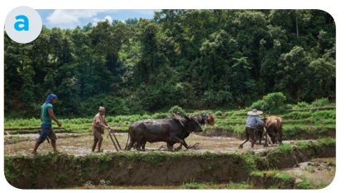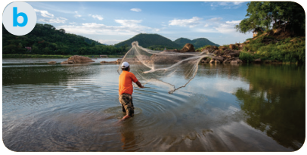
- They’re ploughing a field. They’re catching fish

- What are they doing in picture c? - What are they doing in picture d?
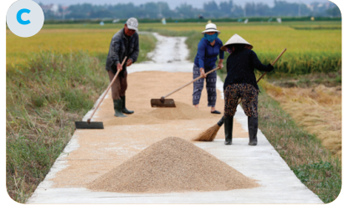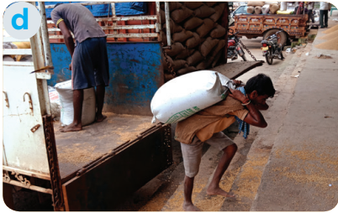
They’re drying rice They’re unloading rice

- What are they doing in picture e? - What are they doing in picture f?
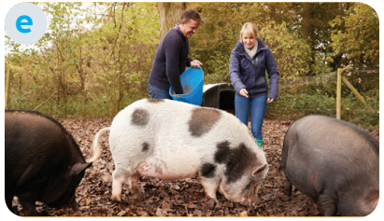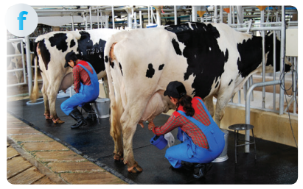
They’re feeding pigs They’re milking cows

d. Organization of activities:
- Models this activity with a student. Reminds Ss that they should only use the phrases and the pictures in 4 to ask and answer about activities that rural people often do.
- Asks Ss to work in pairs. T goes round to help weaker Ss. Then, calls on some pairs to practise in front of the class. Comments on their performance.

