TOPIC 10 : SPACE TRAVEL
Total number of periods:7; from 80th period to 86th period
Period 85: LESSON6: COMMUNICATION AND PROJECT

I. OBJECTIVES
1. Knowledge, skills, attitude
- Knowledge:
+To introduce some words relating to space travel.
+To help the students have more knowledge about space travel.
+ Grammar: review
+ Vocabulary: words relating to space travel.
- Skills:
+By the end of the lesson, students will be able to write sentences to describe space travel
+ To help Ss improve four skills, especially their skill of communication.
- Attitude:
+ To educate Ss to love space travel.
2. Orientation for competency development
+To make Ss be aware of the importance of learning from space travel.
+To enable Ss to use the language for practice correctly in order to develop students’ language competence, collaborative competence.
II. PREPARATION OF TEACHER AND STUDENTS
1. On the teacher’s part:
+ Appliances for studying (textbooks, references, teaching aids, etc.)
2. On the students’ part:
+ Lesson preparation
+ All the homework and the assignments given
III. TEACHING PROCEDURES
- START/ WARM UP ACTIVITY (5ms)
* Aims of the activity: To help Ss know what they are going to learn in order that students can come to the lesson naturally.
Content, techniques for organising students’  learning activities | Expected products and assessment  of student work
* Brainstorming  - Ask Ss to brainstorm anything they know about life on a space station.  -Make a list on the board.  -Ask Ss to choose which thing they think is the best and explain their choice. | - Ss’answers may vary.  - Suggested answer:  Sleeping bag  Microgravity  Rinseless shampoo

- KNOWLEDGE FORMATION ACTIVITIES (8 ms)
* Aims of the activity: To help Ss get some new materials about the reading exercise
ACTIVITY: Listen and guess
Content, techniques for organising students’  learning activities | Expected products and assessment  of student work
*Teaches word by word according to the steps and principles of teaching vocabulary:  + attach (v)  + maintenance (n)  + rinseless (adj)  + Mission Control Centre (n)  - Checks : matching  - Shows the picture of ISS and asks sts what they know about it  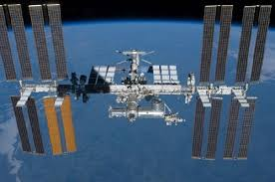  - Explains that Ss are as possible Ss may going to read about life aboard the ISS. As a class, create a list of as many questions have about how theythink astronauts live on the ISS. Write the liston the board.  The International Space Station (ISS) is a large spacecraft which was launched in 1998. It orbits the Earth and is the place where astronauts live and conduct research in a microgravity environment | + attach (v)  + maintenance (n)  + rinseless (adj)  + Mission Control Centre (n)  - Checks : matching  The International Space Station (ISS) is a large spacecraft which was launched in 1998. It orbits the Earth and is the place where astronauts live and conduct research in a microgravity environment
C. PRACTICE ACTIVITIES (20ms):
* Aims of the activity: Read the text and check the things you think ISS astronauts do
ACTIVITY 1: Put a tick ( ) under the things you think ISS astronauts do and a cross ( ) under the things they don’t. Then read the text and check your answers.
(10ms)
Content, techniques for organising students’  learning activities | Expected products and assessment  of student work
-Asks Ss to work in pair to complete the exercise after they have looked at the pictures (taking a shower, sleeping in a sleeping bag, listening to music, pouring salt)  -Accepts all answers from Ss and remember to ask them to explani their decisions. Do not give corrective feedback at this point.  -Now asks Ss to read the text. Tells them to pay special attention to any inforrmation that helps them to check their earlier answers. Tells them to notice any new worlds as well.  -Gets feedback. | - Suggested answer:  1. x 2. v 3. v 4.v
Activity 2: Match the subheadings with the paragraphs of the text in 1 (10ms)
Content, techniques for organising students’  learning activities | Expected products and assessment  of student work
Have Ss work individually and then in pairs for this task.  After Ss have finished, asks them to study the three photos of the texbook and connect these photos with the inforrmation in the text.  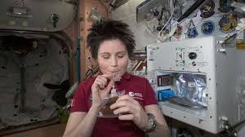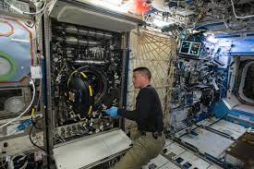 | Suggested answer:  1. D Sleeping in space 2. E Morning roitine in space  3. B Working in space 4. C Eating in space  5. A Time off in space

D. APPLICATION AND EXTENSION ACTIVITIES:(12 ms)
Aims of the activity: To help students develop their idea or their creativity by giving some sentences describing life on the ISS.
ACTIVITY 1: Work in groups. Imagine that you are going to spend one month aboard the ISS. Discussand agree on three things that your team will bring to the ISS to meet each need in 2.
Content, techniques for organising students’  learning activities | Expected products and assessment  of student work
This activity can be organised as a debate.  - Has Ss work in small groups and agree on the three items they will bring to the ISS for each need in 2. When all groups are ready with their list, the class gets together and decides on a new three item list.  - Each groups has to persuade the others that their items should be on this list, rather than those of the other groups.  - Write on a piece of paper one thing that you will take with you tothe ISS as a personal item because you can’t live without it.  - Explain why this item is so important to them. | - Suggested answer:  According to sts’answer  Sleeping bag  Microgravity  Rinseless shampoo
ACTIVITY 2: Project.
Content, techniques for organising students’  learning activities | Expected products and assessment  of student work
PROJECT: A holiday out of this world!  - organises a competition.  - Each group shows their advertisement or slide show, while the rest of the class acts as 'customers'. During each group presentation, allow time for, and encourage, questions and answers between the 'company' and the 'customers' about the trip.  - Has the class vote for the presentation they find most appealing. | - Suggested answer:  According to sts’answer
IV. QUESTIONS/ EXERCISES FOR TESTING AND ASSESSMENT FOLLOW COMPETENCY -BASED ORIENTATION
1. Description of the test and evaluation matrix according to the levels of perception
 | Knowledge | Comprehension | Application | High application
Content | Fill in each gap with a word to form a compound noun: solar, flight, fruit, sleeping, falling, scuba, zero, milky.
Real situation |  | Write as many compound nouns beginging with space as possible. | Make three sentences having the word : space station/spaceship/spacecraft
Communication |  |  |  | Make a short conversation talking about how to be an astronaut

2. Questions/ Exercises
a. Questions/ Exercises (Knowledge)
Fill in each gap with a word to form a compound noun: solar, flight, fruit, sleeping, falling, scuba, zero, milky.
1…………suit
2………… system
3……………diving
4………… way
5………….flies
6……………bag
7…………….star
8…………….gravity
Key :
1. Flight 2. Solar 3. Scuba 4. Milky
5. Fruit 6. Sleeping 7. Falling 8. Zero
b. Questions/ Exercises (Comprehension)
Write as many compound nouns beginning with “space” as possible.
Key: space station spaceship spacecraft spaceman space shuttle space suit
c. Questions/ Exercises (Application)
- Make three sentences having the word : space station spaceship spacecraft
d. Questions/ Exercises (High application)
- Make a short conversation talking about how to be an astronaut
V. Appendix (Optional)

HANDOUT 1:
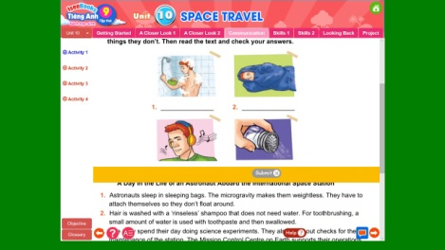

HANDOUT 2
