Date of preparation: November 11, 2025 Họ và tên giáo viên: Lê Nguyễn Ái Nguyệt
Tổ chuyên môn: Tiếng Anh-Nghệ Thuật-GDTC

UNIT 5: FOOD AND DRINK
Total numbers of periods: 7; from period 35 to period 41
LESSON 7: LOOKING BACK + PROJECT
Period 41: Class: 7A3, 7A4

I. OBJECTIVES:
1. Knowledge:
* Vocabulary: the words related to the topic food and drink (review).
* Grammar: quantities: some, a lot of, lots of.
By the end of the lesson, students will be able to:
- have an overview about the topic “Food and drink”
- Use the grammar that they have learnt to do some exercises correctly: Quantities (some, a lot of/ lots of)
- Have a project: “Eating habits around the world”
2. Competences:
-General competence:
+Self-controlled and self-learning competence (students know how to choose some food and drink that is good for their health.)
+Communicative and cooperative competence (students can persuade their family and friends to choose the healthy food and drink)
-Distinctive competence:
+Linguistic competence (Ss know how to use their English to talk about their favourite food and drink.
3. Values:
+ Responsibility (Ss are aware of the healthy food and drink)
+ Diligence (Ss can know how to prepare some simple dishes for their family)
II. TEACHING AIDS AND MATERIALS:
1. Materials: Grade 7 textbook, lesson plan, workbook, the teacher’s book, reference books
2. Equipment: TV, cassettes, pictures, cards, handouts, extra boards, sachmem.vn, On-line websites…
  - III. PROCEDURES :
1. WARM-UP (5MS)
a.Aims: - To create an active atmosphere in the class before the lesson
- To lead into the new unit
b. Content: Brainstorming game on Speedy race about the words related to food and drinks.
c. Expected Products: Students can list as many food and drink as possible.
d. Organization of activities:
- Divides the class into 4 groups.
- Asks them to discuss some food and drink.

Eel soup lemonade
Food and drink

……… ………
- Asks some students to write some food and drinks on the board.
-Decides the winner who has the correct answers with the least running time
-Leads to part LOOKING BACK and PROJECT.
2. KNOWLEDGE FORMATION ACTIVITIES (5MS)
a.Aims: -To help Ss revise the words or phrases related to the topic.
b. Content: Vocabulary related to food and drink and the grammar: quantities: some, a lot of/ lots of.
c. Expected products: -Students know and pronounce the words related to food and drink correctly
-Use exactly some quantities: (some, a lot of/ lots of)
d. Organization of activities:
- Reminds some words related to food and drink.
-Gets Ss to repeat the words chorally, then individually.
-Nominates individuals to read the words aloud and asks Ss to copy down the words.
-Checks the understanding of the new words by conducting the game “What and Where”
3. PRACTICE ACTIVITIES (24MS)
Task 1: (6’)
a.Aims: To help Ss revise the vocabulary items they have learnt in the unit.
b. Content: Find as many words and phrases as possible to add to the columns.
c. Expected products:
*Suggested answers:
Dishes | Ingredients | Units of measurement
Pancakes  Cakes  Rice  Pho  beefsteak | Rice  Rice noodle  Beef  Meat | Gram  Littre  Tablespoon  Teaspoon
d. Organization of activities:
- Tells Ss to find as many words and phrases as possible to add to the columns individually.
- Asks them to compare theirs with their partner’ to find out who has more words and phrases and add any words they did not write to their table.
- Asks some Ss to read the words/ phrases.
- Check their answers in front of the class.

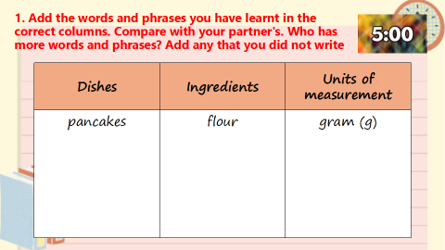

Task 2:(6’)
a.Aims: To help Ss revise the vocabulary items they have learnt in the unit.
b. Content: Read the recipe and write sentences.
c. Expected products:
*Suggested answers:
We need 5 eggs.
We need 2 tomatoes.
We need 2 tablespoons of cold water.
We need 40 grams of butter.
We need 5 grams of onion.
We need 1 teaspoon of salt.
We need 1 teaspoon of pepper
d. Organization of activities:
-Has Ss do this task individually.
- Asks Ss to compare their answers with their partners’.
- Asks some Ss to read out their answers in front of the class.

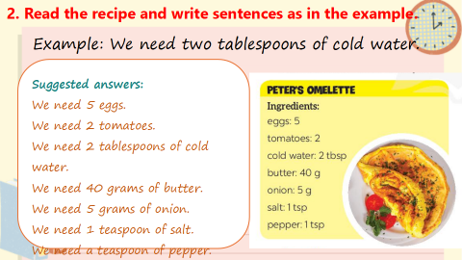

Task 3:(6’)
a.Aims:To help Ss revise the use of some, any, much and a lot of/ lots of
b. Content:. Complete the sentences with some, any, much or a lot of/ lots of.
c. Expected products:
*Suggested answers:
1. any 2. some 3. a lot of/ lots of 4. a lot of/ lots of 5. any, some
d. Organization of activities:
- Asks Ss to do the task individually first.
- Asks them to check their answers with their partner before discussing the answers as a class.
- Reminds Ss to record their original answers so they can use that information in their Now I can……statement.

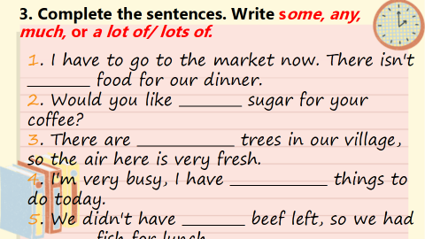

Task 4:(6’)
a. Aims: To help Ss revise the use of How much and How many.
b. Content: Make questions with How many / How much for the underlined words in the sentences.
c. Expected products:
*Suggested answers:
1. How many bottles of juice are there in the fridge?
2. How much butter do you need for your pancakes?
3. How many bottles of fish sauce do you / we have?
4. How many chairs do you / we need (for the party)?
5. How much sugar did she put in her lemonade?
d. Organization of activities:
- Asks Ss to do the exercise individually first.
- Tells Ss to swap and check their answers with a partner before discussing the answers as a class. Reminds Ss to record their original answers so they can use that information in their Now I can … statement.
- Gives feedback as a class discussion.

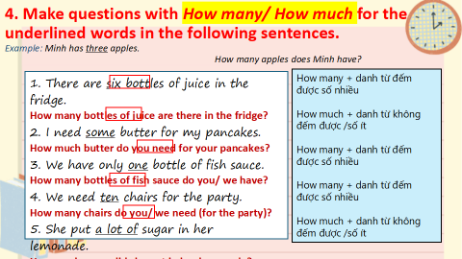

4. APPLICATION ACTIVITIES ( 11’)
* PROJECT
Task 1:(2’)
a.Aims: To help Ss make their posters about the eating habits in the area/ foreign country they know.
b. Content:. Discussing the eating habits in an area or a foreign country.
c. Expected products: Ss can design a poster about eating habits in an area or a foreign country. Sts gain self-controlled and self-learning competence, communicative and cooperative competence, responsibility and diligence.
d. Organization of activities:
- Asks Ss to work in group, discussing the eating habits in an area or a foreign country they know and deciding what information they should write and what pictures or photos they should use to illustrate the meals.
Draw their attention to:
+names of main meals and mealtimes.
+names of common food/ drink for each meal.
+ pictures or photos to illustrate the meals.
+The school facilities
Task 2:(3’)
a.Aims: To help Ss practice what they have learnt in Unit 5 through presenting their posters about the eating habits to the class.
b. Content:. Organize an exhibition of all the posters in the class and present the Ss posters’ to the class.
c. Expected products: -Sts can tell the class about the eating habits fluently.
-Sts gain self-controlled and self-learning competence, communicative and cooperative competence, responsibility and diligence
d. Organization of activities:
- Displays all or some of the posters on the wall or notice board.
- Asks each group to present their poster to the whole class.
- When all groups have presented their posters, has the whole class vote on the best poster.
-Asks Ss to do the project as homework and check it during the next period.

HANDOUT

