**Date of preparation: March 19th , 2025**

**UNIT 7. TEENS**

**Total numbers of period: 10 periods; From period 75 to period 88**

**Period 82 Lesson 2.1 NEWWORDS + READING**

**I. OBJECTIVES:**

**1. Knowledge:**

a. Vocabulary related to teens and problems teens

b. Grammar review possessive pronouns and reported speech

By the end of the lesson, Ss. will be able to:

- Learn and use vocabulary which is related to *Teens*

- Practice reading for gist and specific information.

**2. Competences:**

- General competence:

+ Self-controlled and self-learning competence (students know how to adapt their behaviour at home and at school)

+ Communicative and cooperative competence (students know to persuade their friends what they need to do for their responsibilities)

- Distinctive competence:

+Linguistic competence (sts know how to use their native language and foreign language to indicate the evidence for their answers)

**3. Values:**

+ Responsibility (sts are aware of important things to take for their duties.)

+Dilligence (Students have to make their aims to study well)

+ Patriotism(students will be proud of doing anything about school work)

**II. TEACHING AIDS AND MATERIALS:**

**1.Materials:** student’s book, lesson plan, the teacher’s book, reference books

**2.Equipment:** TV, laptop

**III. PROCEDURES :**

**1. WARM-UP (5ms)**

**a.Aims:** Introduce the new lesson and set the scene for Ss to acquire new language; get students' attention at the beginning of the class by enjoyable and short activities

**b.Content Game: CROSSWORD**

**c.Expected products**: Ss can guess the words they have learnt explained by their friends.

**d. Organization of activities:**

**Game: CROSSWORD**

- Explain the rules of the game.

- Design the game “Crossword Puzzle” with words and pictures about “Teens”

- Have Ss play the game, encourage Ss to guess the key words.

- If any S can give the correct key word, T hasn’t confirmed yet, the game will be continued until the keyword is opened (to check whether his/her answer is correct or not and to let other Ss take part in the game eagerly).

- Give a small gift to the Ss who is the fastest to give the correct key word.

- Ask Ss an extra question: *What is your dream job?*

- Give feedback and lead to the new lesson.

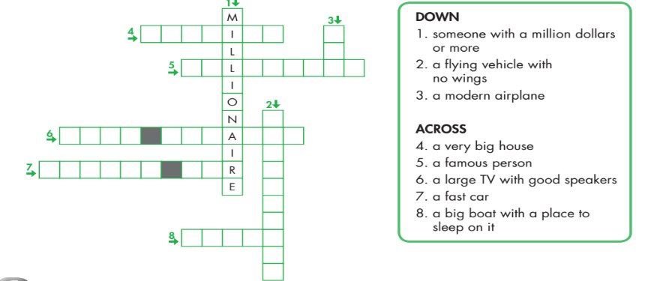

**Answer**

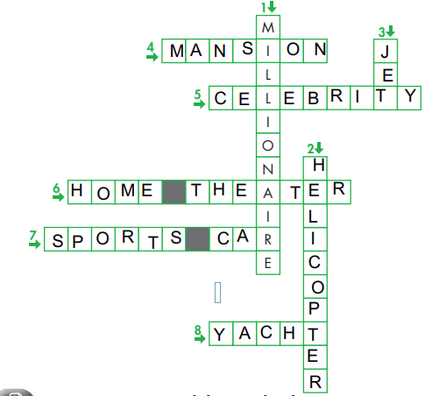

**2. KNOWLEDGE FORMATION ACTIVITIES (10ms)**

**a. Aims:** to provide the students some meanings of words

**b. Content**: **-** New words (*celebrity, millionaire, mansion, home theaters, sport cars, helicopter*).

**c. Expected products**: Students remember the knowledge to correct the test

**d. Organization of activities:**

Teach the students some newwords following the techniques: using pictures and explanation

*-Celebrity(n) : người nổi tiếng*

*-Millionaire (n) triệu phú*

*-Mansion (n) biệt thự*

*-home theaters(n) rạp chiếu phim tại nhà*

*- sport cars(n) xe hơi thể thao*

*-helicopter( n): máy bay trực thăng*

-Checking the understading using pictures

**3. PRACTICE ACTIVITIES (23MS)**

**+Task 1 (5ms)**

**a. Aims:** to help the students do matching well

**b. Content: Matching**

**c. Products:** Students can do matching correcly

**d. Organization of activities:**

* **Matching** *(If the teacher has used part a. for the Warm-up activity)*

- Have Ss review the words they have known in the warm-up activity by looking at the pictures and filling in the blanks. (use different pictures from those in the textbook).

- Call Ss to give answers (read or write).

- Check answers as a whole class.

- Call some Ss to read the words again.

- Correct Ss’ pronunciation if necessary.

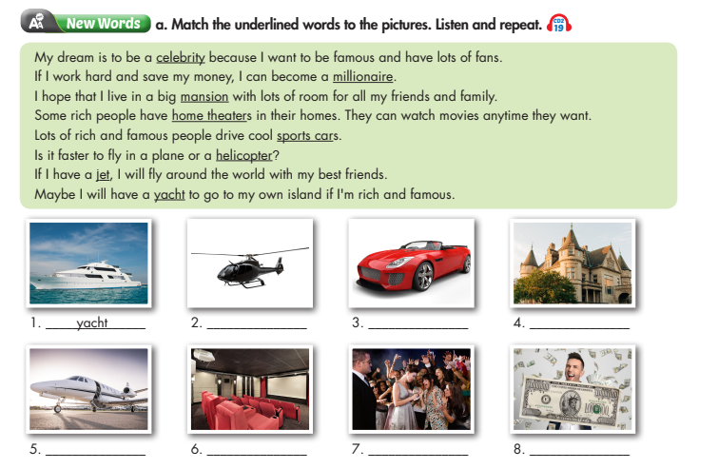

**Answer keys**

***1.Yacht 2.Helicopter 3.Sports cars 4.Mansion 5.Jet***

***6.Home theaters 7.Celebrity 8.Millionaire***

**+Task 2 (6ms)**

**a. Aims:** to help the students practice and find out the correct answers

**b. Content: What do you think are some good things about being a celebrity?**

**c. Products:** students can show their best answers

**d. Organization of activities:**

**Task b. What do you think are some good things about being a celebrity?**

- Have Ss discuss in pairs which are good things about being a celebrity.

- Have Ss share their ideas in front of the class.

- Give feedback and evaluation.

**Suggested answers**

*Celebrities usually have a lot of money, have luxury sports cars. They also live in mansions and some of them are billionaire.*

- Lead Ss to the Reading.

- Ask Ss read the two questions of the article.

- Instruct Ss underline the key words in each question, then compare the answer in the article to their normal lives.

- Check the meaning of the new words in the task b:  *sports cars, mansion, helicopter*.

- Instruct Ss how to scan the information to do the True False exercises.

**Answer keys**

**+Task 3 (6ms)**

**a. Aims:** to enable the students to get the correct answers

**b. Content: Read the article about an interview with a teenage celebrity. Does he live a normal teenager?**

**c. Expected products:** Students can have good predictions

**d. Organization of activities:**

**Read the article about an interview with a teenage celebrity. Does he live a normal teenager?**

- Have Ss read the questions.

- Have Ss read the article and answer the question.

- Call a S give the answer.

- Check the answers as a whole class and explain

**+Task 4 (6ms)**

**a. Aims:** to assist the students to get the correct answers

**b. Content: Read and circle the answer that best fits the numbered blank.**

**c. Expected products:** students can have correct answer

**d. Organization of activities:**

**Read and circle the answer that best fits the numbered blank.**

- Have Ss read the sentences.

- Have Ss read the text again and circle the correct answers – underline or highlight the supporting ideas which suggest the answers.

- Have Ss check answers with their partners.

- Call Ss to give answers as a whole class

- Give feedback and evaluation.

**4. APPLICATION ACTIVITIES ( 7ms)**

**a. Aims:** to help the students give their own ideas about the celebrity

**b. Content: In pairs**: **Would you like to live like TJ? Why (not)?**

**c. Expected products**: students can talk more about the famous person

**d. Organization of activities:**

**In pairs**: **Would you like to live like TJ? Why (not)?**

- Have Ss work in pairs to talk about a celebrity’s life to answer the question:

*Would you like to live like JT?*

- Call some Ss to share their ideas with the whole class.

- Give feedback and evaluation.