*Date of preparing: 20/ 11/2024*

**UNIT4: COMMUNITY SERVICES**

***Total numbers of periods: 9 periods; from period 32 to period 40***

**Period 35th LESSON 2.1. NEW WORDS + LISTENING**

**I. Objectives:**

**1. Knowledge:**

* Vocabulary: know more words about activities to help community.

* Grammar: use the present continuous for future plans and prepositions of place.

*By the end of the lesson, students will be able to:*

- talk about things to do to help community.- practice listening to an interview about how students help community (for general and specific details).

- Practice listening to 2 students having a phone call to make plans to meet each other (for

- Know how to start a friendly conversation and practice using it.

**2. Competences:**

**- General competences:**

+ Self-controlled and self-learning competence (students know about places of entertainment)

+ Communicative and cooperative competence (students know how to talk about their free time activities)

+ Critical thinking skills.

**- Distinctive competence:**

+ Linguistic competence (Ss know how to use their native language and foreign language to indicate the evidence for their answers)

**3. Values:**

+ Responsibility (Ss can be active to take part in social activities and help other people)

+ Diligence (Ss know how to make plans for an informal meeting)

**II. Teaching aids and materials:**

* student’s book, workbook, notebook, computer, projector/TV

bài tập bổ trợ anh 7,trắc nghiệm tiếng anh 7

**III. Procedures:**

**1. WARM-UP (5MS)**

**a.** **Aims:** Introduce the new lesson and set the scene for Ss to acquire new language; get students' attention at the beginning of the class by enjoyable and short activities as well as to engage them in the follow-up steps.

**b. Content:**  Introduce words about activities to help community.

**c. Expected products:** Ss get to know some new words they are going to study in the lesson.

**d. Organization of activities:**  **Fill in the table. Listen and repeat.**

- Uses the “New words” part a.– page 31 for the warm-up activity.

- Shows words and tables using DCR, have Ss fill in the table (in pairs).

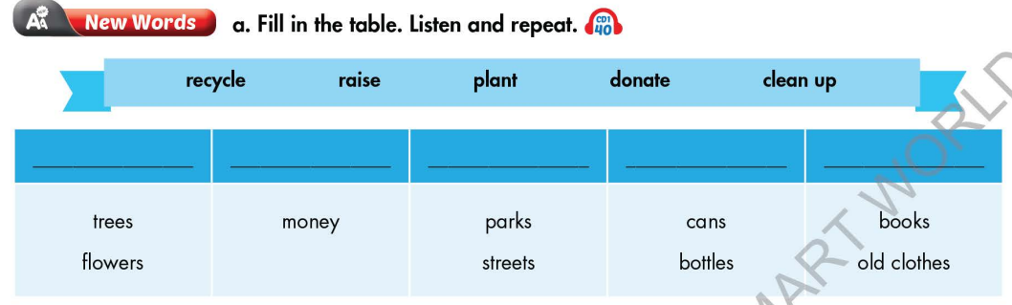

- Calls Ss to give answers.

- Gives feedback and show correct answers.

- Leads to the new lesson.

- Plays the audio (CD1 – Track 40), have Ss listen and repeat.

- Corrects Ss’ pronunciation if necessary

**Matching**

- Has Ss work in pairs and do the matching exercise.

- Calls Ss to give answers.

- Reads the words, have Ss listen and repeat.

- Gives feedback and evaluation.

- Leads to the new lesson. **Suggested answers**

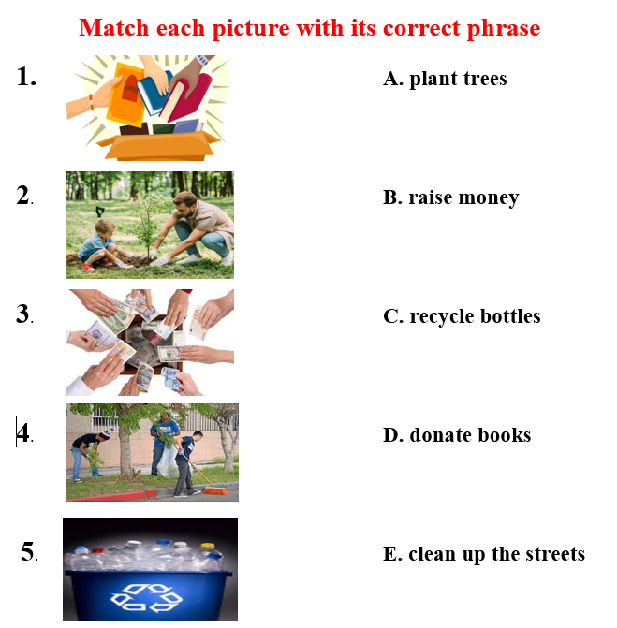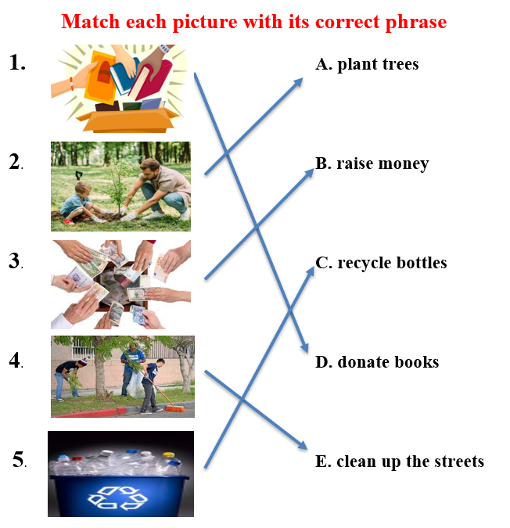

**2. KNOWLEDGE FORMATION ACTIVITIES (10MS)**

**a** **Aims:** Ss get to know words about activities to help community.

**b**. **Content: -** Vocabulary study *(recycle, raise, plant, donate, clean up).*

**-** Speaking: Ask and answer about activities to help community.

**c. Products:** Ss know how to pronounce the new words correctly and use them when talking about activities to help community.

**Task a. Fill in the table. Listen and repeat.**

- Demonstrates the activity on DCR, using the example.

- Has Ss fill in the table.

- Divides class into pairs and have them check their answers with their partners.

- Calls Ss to give answers (read or write).

- Checks answers as a whole class.

- Plays saudio (CD1 – Track 40). Have Ss listen and repeat. **Suggested answers**

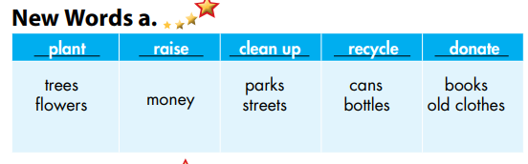

- Corrects Ss’ pronunciation.

* **Task b: Odd one out**
* - Gives 5 sets of words.

- Has Ss work in pairs to odd one out (Find a word which doesn’t belong to the group).

- Has Ss give answers and explain for their answers.

- Checks answers as a whole class.

- Calls some Ss to read the words again.

- Corrects Ss’ pronunciation if necessary. **Suggested answers**

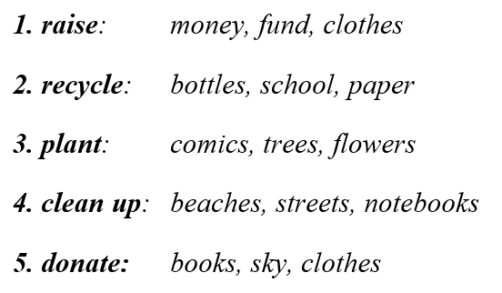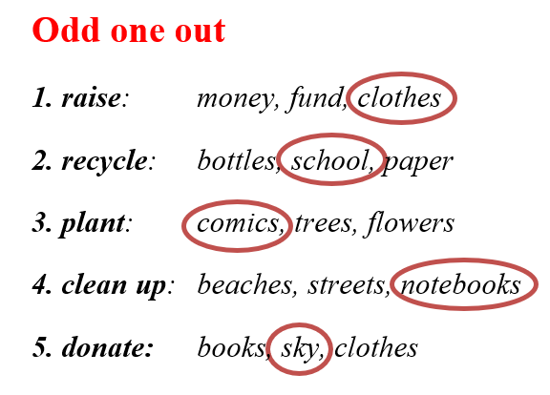

**Suggested answers**

***1. raise****: fund, awareness, …*

***2. recycle****: paper, plastic products, food waste, …*

***3. plant****: vegetables, herbs, …*

***4. clean up****: beaches, rooms, schools, …*

***5. donate:*** *blood, money, clothes, …*

**3. PRACTICE ACTIVITIES (24MS)**

**Task 1a. Match the words with the pictures. Listen and repeat. (5ms)**

**a.** **Aims:** Listen to two people talking. What is the purpose of the interview? + Circle the answers.

**b**. **Content:** Vocabulary: *sports center, bowling alley, theater, ice rink, water park, market, fair*

**c. Expected products:** Ss know how to pronounce the new words correctly and use them in appropriate situations.

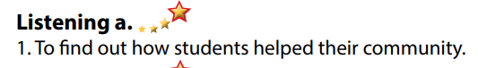

**d. Organization of activities:**

**Task 1b. Fill in the blanks using the words you have learnt***.* **(7ms)**

**a.** **Aims:** Ss get to know words about places of entertainment.

**b**. **Content:** Students can listen and understand general and specific information about activities to help community.

**c. Expected products: Task b. Now, listen and circle.**

- Has Ss read the through the content of task b, underline the key words.

- Plays the audio again (CD1 - Track 41)

- Has Ss listen and circle the correct answers.

- Has Ss check answers with their partners.

- Calls Ss to give answers.

- Gives feedback and show correct answers using DCR.

**d. Organization of activities:**

**4. APPLICATION AND EXTENSION ACTIVITIES (6MS)**

**Task 1. Conversation skill (2ms)**

**a**. **Aims:** Students can use the vocabulary and the content in listening part to develop their speaking skill.

**b**. **Content:**  staring a friendly conversation

**c. Expected products:** Ss know how to start a friendly conversation

**d. Organization of activities:**

- **Conversation skill**

- Has Ss look at the Conversation skill box and read.

- Plays audio (CD 1 - Track 42), have Ss listen and repeat.

**-** Asks Ss to find more ways to introduce a topic.

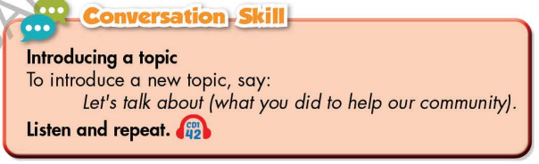

**Task c. In pairs: What kinds of things could you do to help your local community?**

**a**. **Aims:** Students can use the vocabulary and the content in listening part to develop their speaking skill.

**b**. **Content:**  Speaking: What kinds of things could you do to help your local community?

Has Ss work in pairs to discuss.

**c. Expected products:** Students can have a free-talk about things to do to help their local community

**d. Organization of activities** What kinds of things could you do to help your local community?

Has Ss work in pairs to discuss.

**Language to introduce a topic**: Let’s talk about … / Let’s begin with …

- Observes and give help if necessary.

- Calls some pairs to share their ideas with the class.

- Gives feedback and evaluation

|  |
| --- |
| **HANDOUT** |