Date of preparing: 10/09/2023

UNIT 1: HOBBIES
Total numbers of periods: 7 periods; from period 02 to period 08
LESSON 5: Skills 1
Period: 06 Class(es): 7A5

I.Objectives
1.Knowledge:
* Vovabulary: outdoor (adj)patient (adj)responsibility (n)maturity (n) valuable (adj)
By the end of the lesson , sts will be able to
- Develop reading skill for general and specific information about Gardening.
- Talk about their hobbies and the benefits of them.
2. Competence
By the end of the lesson, students will be able to form and develop competences:
-General competences:
Self-control and self-learning, communication and collaboration, problem solving and creativity.
- Distinctive competences:
Linguistic competences, natural and social skills, physical ability, informatic competence, technological competence, actively join in class activities.
3. Values:
- Understand more about their preference of different types of hobbies
- Develop self-study skills
II. Teaching aids and study materials
1. Materials: Grade 7 textbook, lesson plan, workbook, the teacher’s book, reference books
2. Equipment: TV, cassettes, pictures, cards, handouts, extra boards, sachmem.vn…
III. PROCEDURES
1.WARM-UP (5’)
a. Aims
- To create an active atmosphere in the class before the lesson;
- To lead into the new unit.
b. Content
-Introduces the objectives of the lesson and asks Ss to list out as many hobbies as possible within 1 minute.
Which teams can list out more correct answers wins.
Confirms answers as a class.

c. Expected Products
+Riding a bike
+Reading book
+Travelling
+Playing games ,….
d. Organization of activities:
-Sts discuss and work in groups ( 4 groups) ; one st of each group take notes on the board

2. KNOWLEDGE FORMATION ACTIVITIES (10’)
a.Aims
To introduce some words relating to hobbies
To set the context for the introductory text;
To introduce the topic of the unit.
b.Content
*Vocabulary
Sts look at pictures or realia
Sts listen to teacher’s explanation then give the words
Sts give example with one of the words
Read the words in chorus then invidually
Sts play game slap the board
c. Expected products
*Vocabulary
- outdoor (adj)( Example : I like joining outdoor activities )
- patient (adj)- Explanation
- responsibility (n) – Explanation
- maturity (n)-Explanation
- valuable (adj)- Explanation
d. Organization of activities:
- Teaches word by word according to steps and principles of teaching new words. (using picture, translation, examples, …)
- Checks the students’ understanding by the game: “slap the board”
+ Divides the class into two teams.
+ Four students from each team go to the board and stand in two lines.
+ Each time one student from each team takes turn to listen to the teacher reading a word on the board and slap the word he/she hear.
+ The team who slaps more right words is the winner.
- Gives feedback.

3. PRACTICE ACTIVITIES (20’)
TASK 1 (5’)
a.Aims
-To set the context for the introductory text;
-To introduce the topic of the unit.
b.Content
* Teacher asks Ss to look at the pictures in the book and answer the questions:
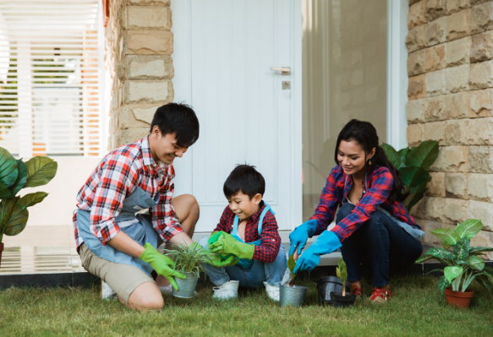
- What can you see in each picture?
- What may the hobby be?
- In your opinion, what is good about gardening?
c. Expected products
- They are growing green trees
- Their hobby is gardening
- Ss’s answers
d. Organization of activities:
-T has Ss look at the picture in the book or show the picture in the book on a slide.
- Ask Ss who they see in the picture and what they are doing.
-T has Ss work in pairs to discuss the two questions.
-T invites some Ss to share their answers.
-T tells Ss that they are going to read a text about gardening.

TASK 2: (5’)
a.Aims:
To help students read to find some words in context, and their meaning.
b. Content:
Students will read the passage carefully and :
+ Read the words in column A.
+ Locate each word in the text.
+ Read around the word to get the general meaning.
+ Read the definitions in column B, find the suitable meaning to match each word.
Students will give the evidence in the passage
c. Expected products
1. b 2. e 3. c 4. a 5. d
d. Organization of activities:
- T asks Ss how to do the exercise. Elicit answers from Ss.
- If needed, T will tell them to follow these steps:
- T asks Ss to repeat the steps (they can speak in Vietnamese).
-Ss do the exercise individually and then check answers in pairs.
-T invites some Ss to share their answers.
- Confirms the correct answers.

TASK 3: (5’)
a.Aims: To develop reading skill for specific information
b. Content
-Asks Ss to read the sentences, underline the key words in the sentences, locate the key words in the text and find the words to complete the sentences.
c. Expected products
1. doing things 2. insects and bugs 3. patient
4. join in 5. an hour
d. Organization of activities:
* T asks Ss what they are going to do.
– T has Ss share how to do this exercise.
– T asks Ss to repeat the steps (they can speak in Vietnamese).
- T asks Ss to do the exercise individually and then check their answers in pairs.
- T invites some Ss to share their answers. Have them explain their answers.
- Confirm the correct answers.
T asks Ss to tell the class the benefits of gardening as mentioned in the text.

TASK 4: (5’)
a.Aims: To help Ss form the ideas for their speaking.
b.Content
* T introduces some structures to talk about the benefits of hobbies:
+ to develop sth
+ to make sb + adj
+ to reduce sth
+ to help sb / sth do sth
– T asks Ss to name other benefits of these hobbies.
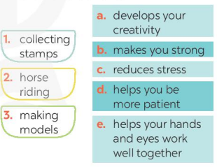
c. Expected products
1. c, d
2. b, c
3. a, c, d, e
d. Organization of activities:
– T gives some examples.
-Ss work in pairs to match the hobby with its benefit(s). Check as the whole class.
- T invites some Ss to share their answers.
- Confirm the answers.

4.APPLICATION ACTIVITIES (10’)
TASK 5:
a.Aims: To help Ss use what they have learnt so far to talk about hobbies.
b.Content
* Have Ss work in groups to ask and answer the two questions.
- What is your favourite hobby?
- What is it benefits ?
c. Expected products
- I like ……… / My favourite hobby is …….
- It helps me more patients, …..
d. Organization of activities:
-Ss work in groups to ask and answer the two questions.
- Ss share their partner’s answers to the questions.
– T Invites other Ss to comment on the answers.
-Ss do as required.
- T Calls Ss to share answer.

- T gives feedback and comments.

